**TITLE: Processing Non-Interfaced Quest Referred Labs**

**Principle:** To communicate stepwise procedure for non- interfaced referral lab test.

**Personnel:** Phlebotomist and Medical Technicians

**STEPWISE PROCEDURE:**

1. When specimens arrive in the send out processing area, **ALL** specimens must be received into send outs following the same procedure as receiving into LCC. After receiving all specimens, a pop up box for printing aliquot labels will appear, click on OK. Labels will print on the Zebra printer in the send out area. Only specimens that require a pour off will print labels.

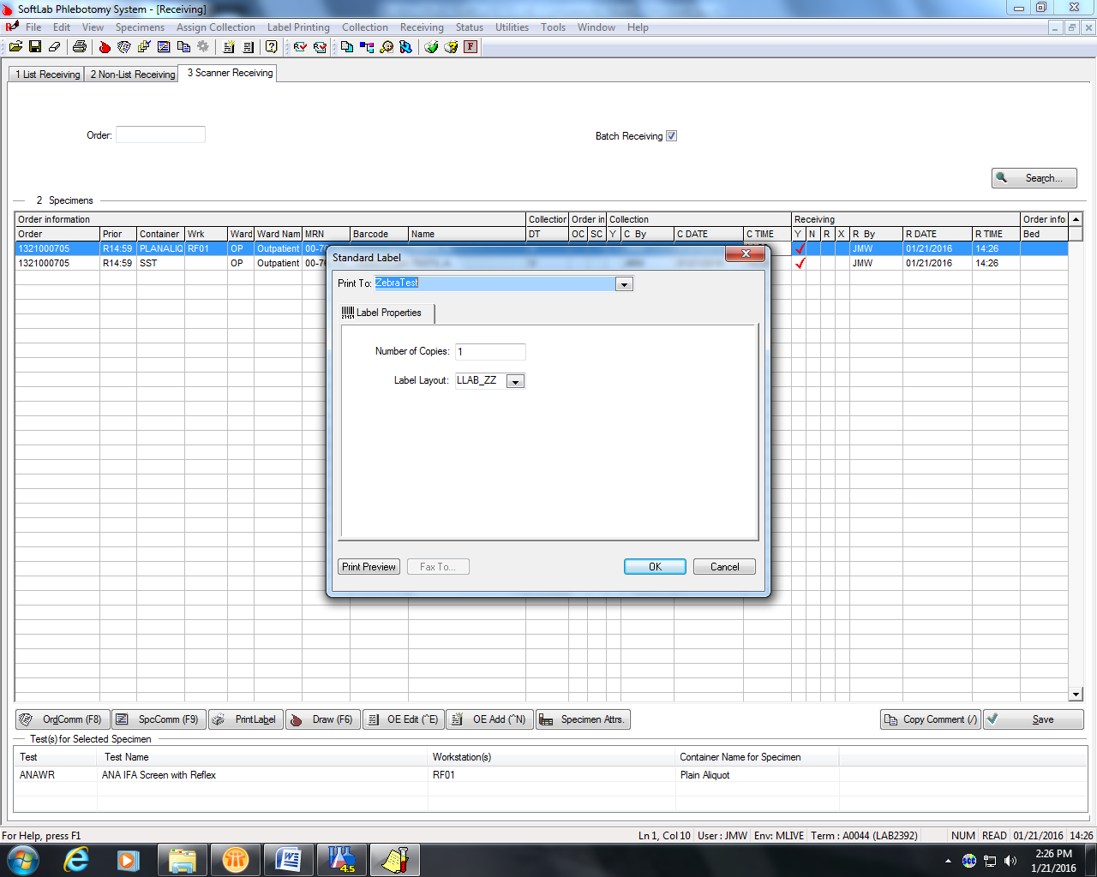

1. Specimens going to Quest, sign into Care 360 with your Quest username and password.

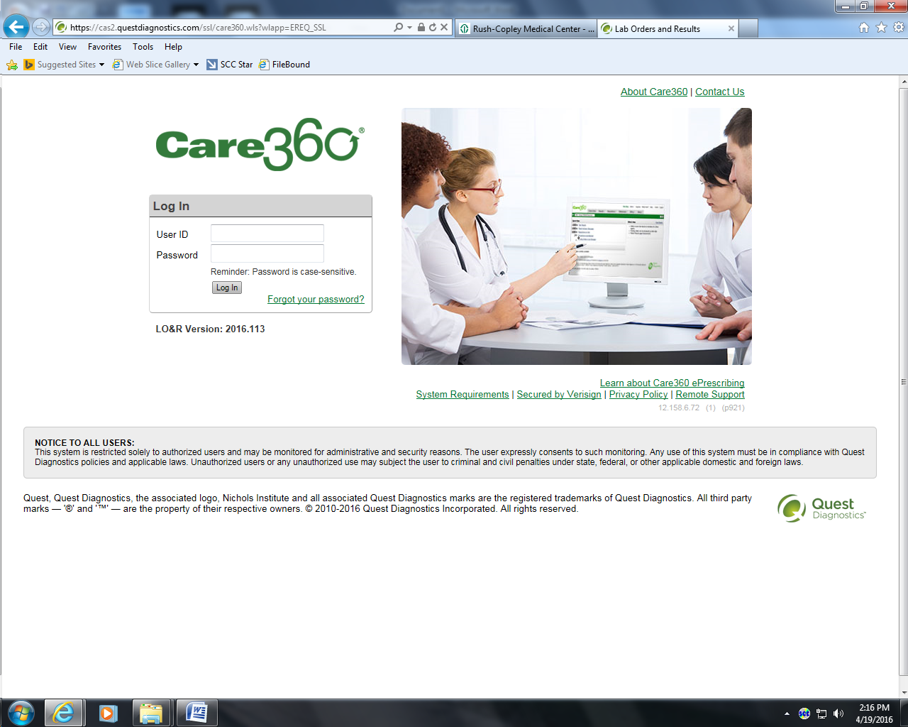

1. Go to order entry at top of screen

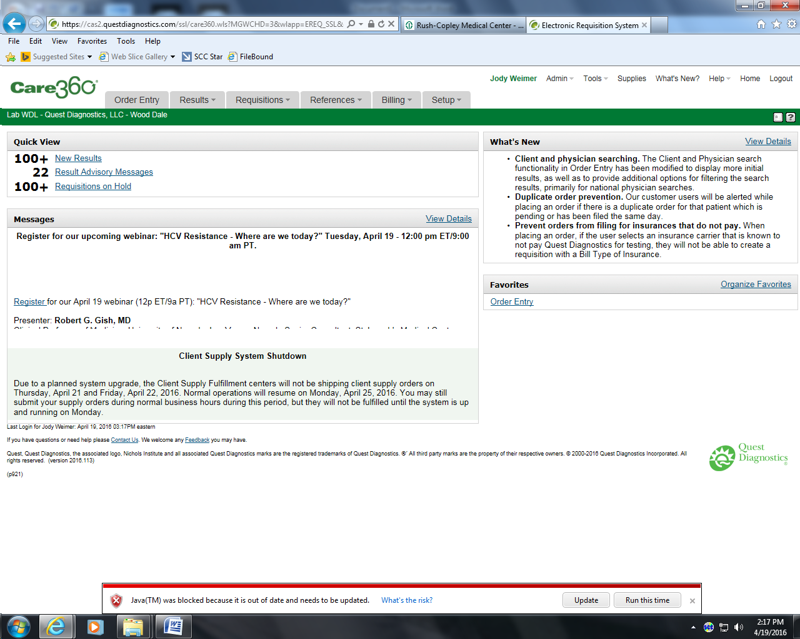

1. On the right side of the screen is the section for Patient Information. Type in the Medical Record number for the patient you are ordering for including the dashes. The patient will come up on the screen if Quest send outs have been processed here. “No Records Found” will appear if patient has never had Quest tests sent from here. If patient name comes up, click on name to continue. Check Room/Location and change if needed based on where patient had blood drawn. If No Records Found appears, click on Add New Patient. Complete all needed information and save by clicking on OK

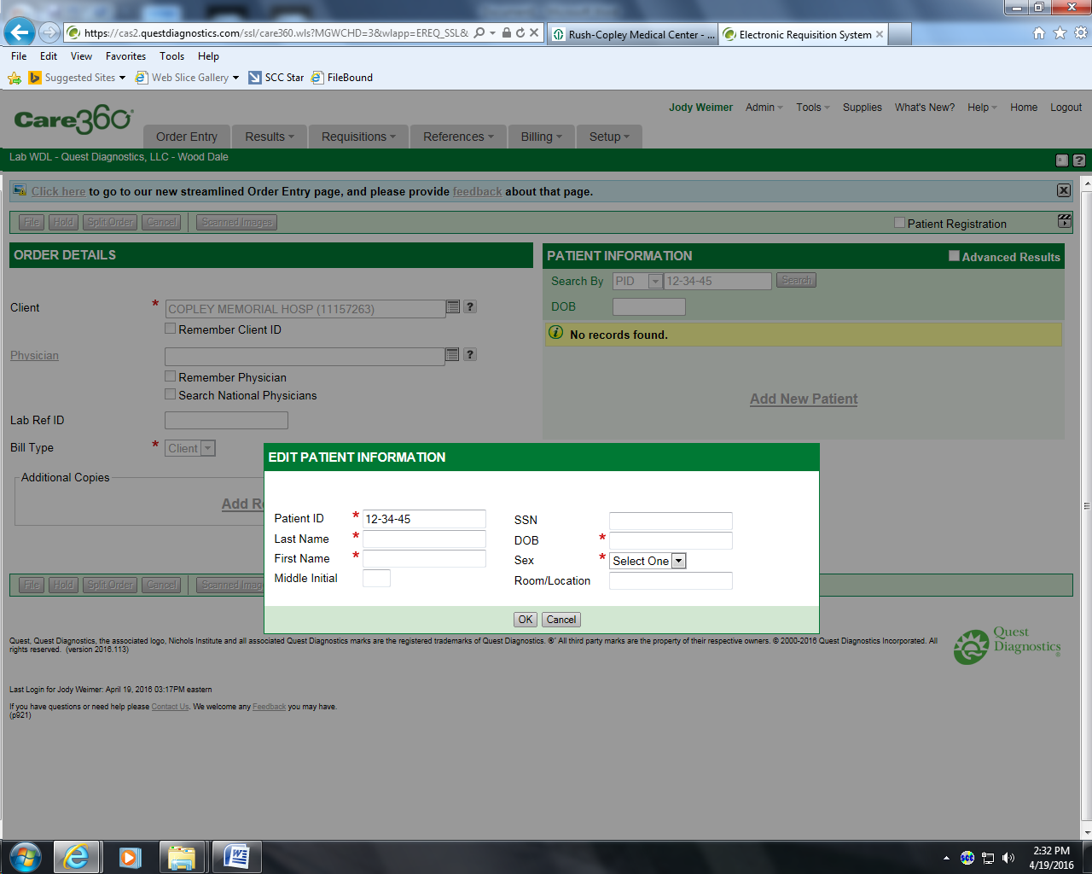

1. On left side of screen type in physician name. (Black Arrow)
2. Type in Lab Reference number which is the Soft Order number ( Red Arrow)
3. Comment Section (Purple Arrow) type in patient billing number.
4. Internal Comments, (Blue Arrow), type in fax number for doctor.
5. Order Codes, (Green Arrow), type in Quest test code of test requested and click on search, (Orange Arrow). Continue filling out this section which includes Date Collected, Time Collected, and if specimen is a 24 hour collection the total volume and duration of collection.
6. Scroll down to the bottom of the page with scroll bar (Yellow Arrow).

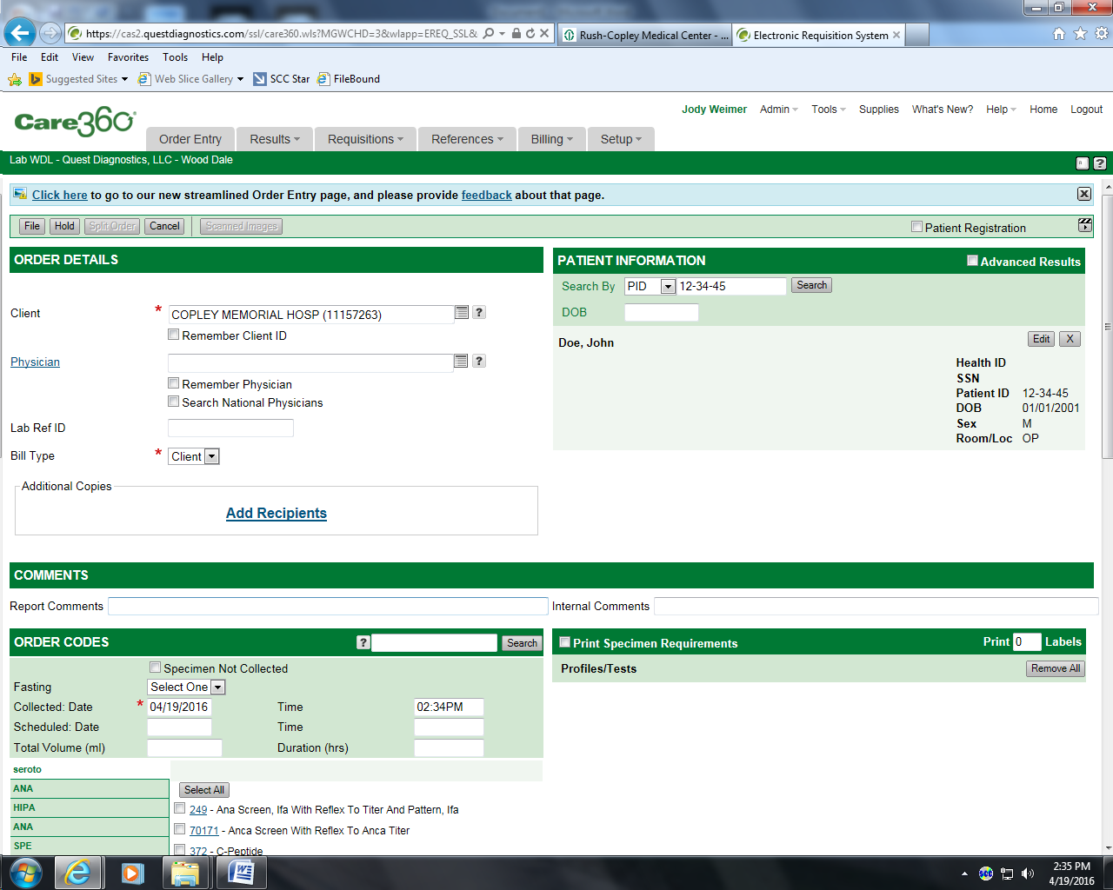

+

1. Click on File (Black Arrow)

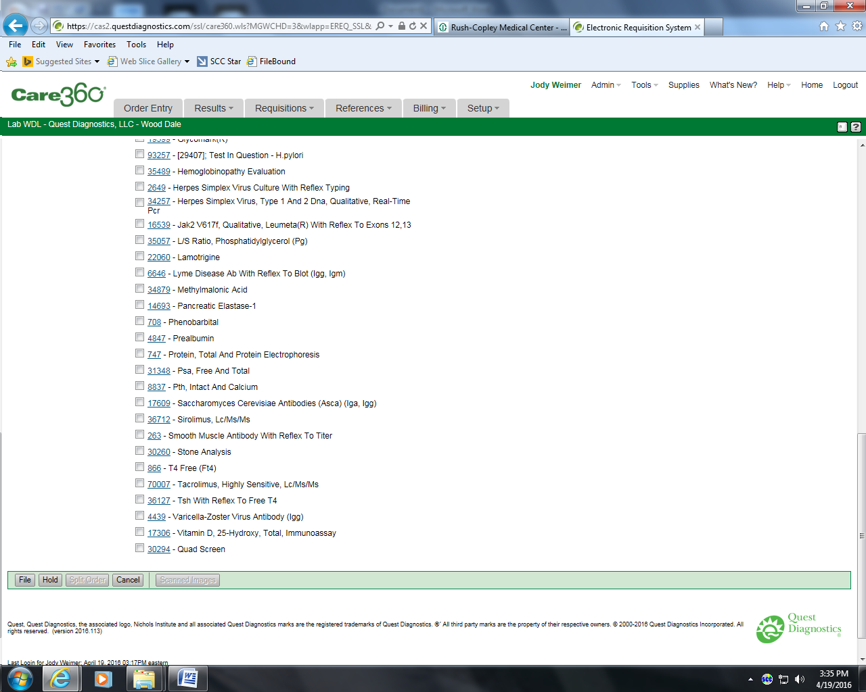

1. This page is Verify Order – File. Double check that all information and tests are correct. If there are any errors you can click on Edit buttons to correct (Black Arrows). When any information is not complete a Red triangle with a notation will appear as to what information is still required. A Red Asterisk will also appear next to the section that needs attention.
2. Click on Save, (Red Arrow)
3. Quest labels will print on DYMO printer in send outs.
4. A pop up screen to print test requisition will appear, click on print.

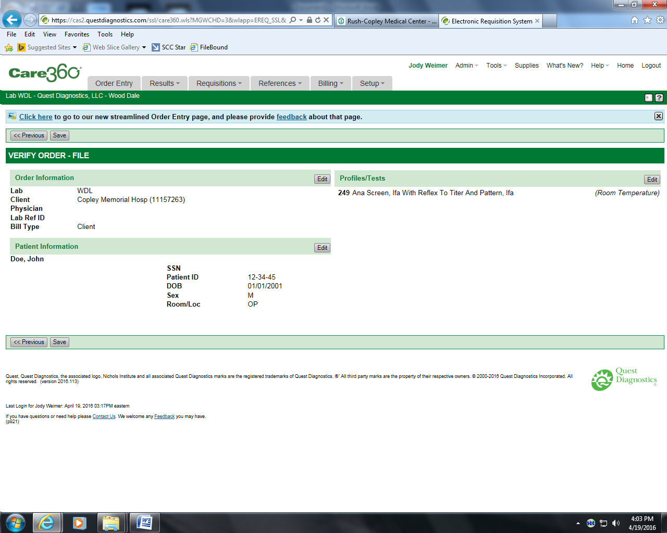

1. Label aliquot tube with Quest label and pour specimen into aliquot tube. If you are sending the draw tube place Quest label over the Soft label without covering the patient name and medical record number of Soft label.
2. Log test into send out log book.
3. Bag requisition and specimen into Quest Bio hazard bag and mark appropriate temperature box on bag.
4. Place bagged specimen in appropriate temperature holding area, freezer, refrigerator or room temperature container.

## REPORTING RESULTS:

## Results will appear in SCM under results as a hyperlink after they are scanned.