TITLE: Alere Triage Drugs of Abuse Panel Plus TCA

PURPOSE:
The Triage® Drugs of Abuse Panel plus Tricyclic Antidepressants is an immunoassay used for the qualitative determination of the presence of the major metabolites of drugs of abuse, (Phencyclidine, Benzodiazepines, Cocaine Metabolite, Amphetamines, THC, Opiates, Barbiturates), and Tricyclic Antidepressants in urine.

PRINCIPLE
The Triage® Drugs of Abuse Panel plus Tricyclic Antidepressants utilizes a patented immunochemistry, ASCENDTMMULTIMMUNOASSAY® (AMIA™). Each AMIA™ assay is a competitive binding immunoassay in which a chemically labeled drug (drug conjugate) competes with drug which may be present in the urine for antibody binding sites. After a brief incubation, the reaction mixture is transferred to the membrane in the Detection Area. Free drug conjugate that is displaced from antibody binding sites by drug in the urine, binds to a zone of monoclonal antibody that is immobilized on the membrane. The membrane is washed to remove the unbound conjugate and clear the background. Test results are visually read. A positive specimen produces a distinct colored bar in the Drug Detection Zone adjacent to the drug name. A negative specimen does not produce a colored bar.

PERSONNEL

Medical Technologists

SPECIMEN COLLECTION/TREATMENT
Freshly voided urine specimens should be collected in a clean, previously unused glass or plastic container. If the specimen is not tested immediately, it should be refrigerated at 2°-8°C for a maximum of 2 days. If longer storage is required, specimens may be stored frozen (-20°C or colder). Specimens that were refrigerated must reach room temperature (15°-25°C) prior to testing. Specimens that were frozen must be thawed and mixed thoroughly prior to testing. Specimens containing a large amount of particulate matter may be clarified by centrifuging or allowing to settle before testing.

REAGENTS AND EQUIPMENT
Triage® Drugs of Abuse Panel plus Tricyclic Antidepressants kit contains all the reagents necessary for the simultaneous detection and identification of the major urinary metabolites of 8 different, single drug classes.

TEST DEVICE
Mouse monoclonal antibodies against phencyclidine, benzodiazepine metabolites, benzoylecgonine, amphetamines, THC (11-nor-Δ9-THC-9-carboxylic acid), morphine,
barbiturates and tricyclic antidepressants immobilized on a membrane Mouse monoclonal antibodies against phencyclidine, benzodiazepine metabolites, benzoylecgonine, amphetamines,
THC (11-nor-Δ9-THC-9-carboxylic acid), morphine, barbiturates and tricyclic antidepressants lyophilized in a protein matrix containing <0.01% sodium azide Drugs and drug derivatives conjugated to colloidal gold, lyophilized in a protein matrix containing <0.01% sodium azide
Lyophilized buffer

WASHSOLUTION
Buffered solution containing preservative

Biosite® Triage® Drugs of Abuse Panel plus Tricyclic Antidepressants
Catalog No. 92000
Kit contains: 25 Test Kit
Test Devices 25 each

Wash Solution 1 x 8 mL
Pipet 1 each
Pipet Tips 50 each
The reagents contained in the Triage® Drugs of Abuse Panel plus Tricyclic Antidepressants are to be stored at room temperature (15°-25°C) and are stable until the date stamped on the box. The reagents in the foil pouch are moisture sensitive. Do not remove device from pouch until
ready to use.

Timer

CALIBRATION

None

QUALITY CONTROL
The Control Negative (CTRL NEG) Zone ensures that the antibody reagent bead is present and reactive. A color bar should not appear in this zone.

The Control Positive (CTRL POS) Zone ensures that the conjugate reagent bead and membrane are present and reactive. A color bar should appear in this zone.

A Positive Control above the specified threshold for each drug should produce a color bar on the membrane adjacent to the name of the specified drug designated on the Test Device.

Negative Controls should not produce a color bar adjacent to the names of any of the drugs at the Detection Zone.

If a positive result is NOT observed adjacent to the CTRL POS zone and/or a negative result is NOT observed adjacent to the CTRL NEG zone the test should be discarded. The test should be repeated using another device. If the same results are observed upon repeat analysis another
specimen should be obtained and retested. The use of a positive control urine, approximately 25% greater than the cut-off concentration, is recommended to initially test each shipment of
product, every 30 days thereafter, and if the product is stored under conditions outside the manufacturer’s recommendations.

NEGATIVE RESULTS
A sample is negative if no color bar appears in any of the Drug Detection Zones adjacent
to the drug names.

The Positive (CTRL POS) and Negative (CTRL NEG) controls contained in this product satisfy the requirements of testing a positive control and a negative control on a daily basis.

STEPWISE PROCEDURE

INSTRUCTIONS FOR USING THE BIOSITE PIPET
1. Before each use, attach a clean, disposable tip to the pipet.
2. Depress the plunger until it stops.
3. Holding the pipet vertically, place the end of the tip into the sample.
4. Release the plunger, allowing the tip to fill with sample. Withdraw
the tip from the sample when the plunger is fully released.
5. To dispense the sample, gently depress the plunger until it stops.
6. Withdraw the tip and fully release the plunger.
7. Discard the pipet tip immediately after each use.

TEST PROCEDURE

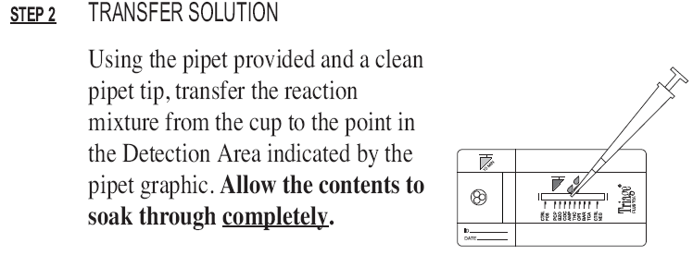

RESULTS
INTERPRETATION OF RESULTS
The Triage® Drugs of Abuse Panel plus Tricyclic Antidepressants is a qualitative immunoassay. The exact concentration of drug and/or drug metabolites present in the urine specimen cannot be estimated. The assay thresholds are minimally targeted to yield a positive result with 95% confidence at 120% of the following cutoff concentrations.
The following cut-off concentrations are established for the eight drugs:

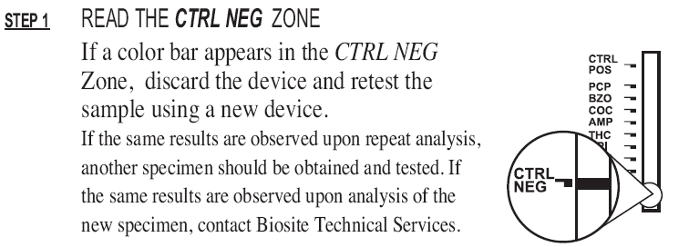

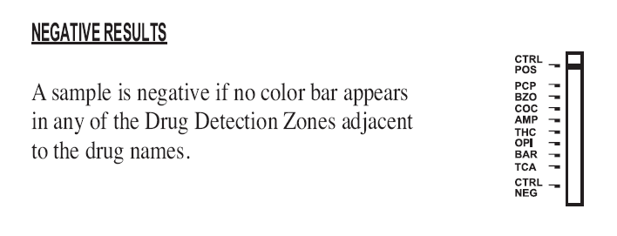

LIMITATIONS
There is the possibility that factors such as technical or procedural errors, as well as additional substances in the urine sample that are not listed below, may interfere with the test and cause erroneous results. Adulterants, such as bleach, added to urine specimens may produce erroneous results regardless of the method of analysis. If adulteration is suspected, obtain an additional specimen and retest. Addition of a strong oxidizing agent, eg. bleach (hypochlorite), to a urine specimen can oxidize the analyte, reducing the concentration of analyte that can be detected regardless of the method of analysis. A positive result indicates the presence of the drug or drug metabolites and does not indicate the level of intoxication, route of administration or urinary concentration. The serum concentration of tricyclic antidepressants cannot be determined using this test. If a quantitative result for total tricyclic antidepressants or a specific tricyclic antidepressant is desired, a confirmatory method such as HPLC or GC/MS should be performed. Similarly, if a negative result is obtained and ingestion of tricyclic antidepressants is suspected, a serum sample should be obtained and tested using an appropriate method. A negative result does not eliminate the possibility of the presence of tricyclic antidepressants in the urine specimen at concentrations lower than 1000 ng/mL.
Refer to the specific performance characteristics for information regarding the test specificity, a list of drugs and drug metabolites that produce a positive result in this test, and other potentially interfering substances.

REFERECNCES
Triage Drugs Of Abuse Panel Plus TCA, Biosite Incorporated 9975 Summers Ridge Road, San Diego, California 92121 USA
+1 (877) 441-7440
www.biosite.com

