TITLE: VITROS Microslide Lithium Assay

Principle:
The VITROS Li Slide method is performed using the VITROS Li Slides and the VITROS Chemistry Products Calibrator Kit 1 on the VITROS 5600 Integrated System.
The VITROS Li Slide is a multilayered, analytical element coated on a polyester support A drop of patient sample is deposited on the slide and is evenly distributed by the spreading layer to the underlying layers. The lithium in the sample is specifically bound by the crown-ether azo dye (6-dodecyl-6-(2'-hydroxy- 5’-(2’’-4’’-dinitrophenylazo)benzyl)-13, 13-dimethyl-1,4,8,11-tetraoxacyclotetradecane). As the lithium ion binds to the crown-ether, a shift in the peak absorbance of the dye occurs. The increase in absorbance is proportional to the concentration of lithium in the sample. The intensity of the dye is measured by reflectance spectrophotometry at the end of incubation

Test Type and Conditions

Test Type | VITROS System | Approximate Incubation Time | Temperature | Wavelength | Reaction Sample Volume
Colorimetric | 5600 | 2.3 minutes | 37 °C (98.6 °F) | 600 nm | 10 µL

Reaction Scheme

lithium + crown-ether dye | 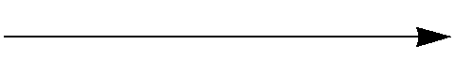 | dye complex

Warnings and Precautions
For in vitro diagnostic use only.

WARNING: | Take care when handling materials and samples of human origin. Since no test method can offer complete assurance that infectious agents are absent, consider all clinical specimens, controls, and calibrators potentially infectious. Handle specimens, solid and liquid waste, and test components in accordance with local regulations and CLSI Guideline M29 ³ or other published biohazard safety guidelines.

Clinical Significance:

Lithium is used in the treatment of bipolar (manic-depressive) illness. Lithium measurements are used to monitor patient compliance and therapy and to diagnose potential overdose. Symptoms of lithium intoxication include sluggishness, drowsiness, muscle weakness, and ataxia. ¹ , ²

Specimen Collection, Preparation and Storage

Specimens Recommended
Serum
Plasma-Heparin

IMPORTANT: | Certain collection devices have been reported to affect other analytes and tests. ⁴ Owing to the variety of specimen collection devices available, Ortho-Clinical Diagnostics is unable to provide a definitive statement on the performance of its products with these devices. Confirm that your collection devices are compatible with this test.

Specimens Not Recommended
Plasma:
Fluoride oxalate
Lithium heparin

Serum and Plasma

Specimen Collection and Preparation
Collect specimens using standard laboratory procedures. ⁵ , ⁶

Note: | For details on minimum fill volume requirements, refer to the operating instructions for your system.

Patient Preparation
No special patient preparation is necessary.
Special Precautions
- Samples are commonly drawn approximately 12 hours after the last dose of lithium has been taken. ⁷
Centrifuge specimens and remove the serum or plasma from the cellular material within 4 hours of collection. ⁸
Specimen Handling and Storage
Handle and store specimens in stoppered containers to avoid contamination and evaporation.
Mix samples by gentle inversion and bring to room temperature, 18–28 °C (64–82 °F), prior to analysis.
Specimen Storage and Stability

Storage | Temperature | Stability
Room temperature | 18–28 °C (64–82 °F) | ≤ 8 hours
Refrigerated | 2–8 °C (36–46 °F) | ≤ 24 hours
Frozen | ≤-18 °C (≤0 °F) | ≤ 6 months

Reagents
Slide Ingredients | 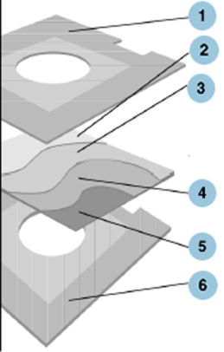 | - Upper slide mount  - Spreading layer (BaSO₄): buffer, pH 11.0  - Buffer layer: buffer, pH 11.0  - Reagent layer: crown-ether azo dye  - Support layer  - Lower slide mount
Reactive Ingredients per cm²
(6-dodecyl-6-(2’-hydroxy-5’-(2’’-4’’-dinitrophenylazo)benzyl)-13,13-dimethyl-1,4,8,11-tetraoxacyclotetradecane) (crown-ether azo dye) 40 µg.
Other Ingredients
Pigment, binders, buffer, surfactants, dye solubilizer and cross-linking agent.

Reagent Handling
Caution: | Do not use slide cartridges with damaged or incompletely sealed packaging.
- Inspect the packaging for signs of damage.
- Be careful when opening the outer packaging with a sharp instrument so as to avoid damage to the individual product packaging.
Reagent Preparation

IMPORTANT: | The slide cartridge must reach room temperature, 18–28 °C (64–82 °F), before it is unwrapped and loaded into the slide supply.
1 .Remove the slide cartridges from storage.
2. Warm the wrapped cartridge at room temperature for 60 minutes.
- Unwrap and load the cartridge into the slide supply.

Note: | Load the cartridges within 24 hours after they reach room temperature, 18–28 °C (64–82 °F).

Reagent Storage and Stability
VITROS Li Slides are stable until the expiration date on the carton when they are stored and handled as specified. Do not use beyond the expiration date.

Reagent | Storage Condition |  | Stability
Unopened | Frozen | ≤-18 °C (≤0 °F) | Until expiration date
Opened | On-analyzer | System turned on | ≤ 5 weeks
 | On-analyzer | System turned off | ≤ 2 hours
Verify performance with quality control materials:
- If the system is turned off for more than 2 hours.
- After reloading cartridges that have been removed from the slide supply and stored for later use.

Calibration
Required Calibrators
VITROS Chemistry Products Calibrator Kit 1

Calibrator Preparation, Handling, and Storage
Refer to the Instructions for Use for VITROS Calibrator Kit 1.

Calibration Procedure
Refer to the operating instructions for your system.

When to Calibrate
Calibrate:
- When the slide lot number changes.
- When critical system parts are replaced due to service or maintenance.
- When government regulations require.
For example, in the USA, CLIA regulations require calibration or calibration verification at least once every six months.
The VITROS Li test may also need to be calibrated:
- If quality control results are consistently outside acceptable range.
- After certain service procedures have been performed.
For additional information, refer to the operating instructions for your system.

Calculations
Reflectance from the slide is measured at 600 nm after the fixed incubation time. Once a calibration has been performed for each slide lot, lithium concentration in unknown samples can be determined using the software-resident endpoint colorimetric math model and the response obtained from each unknown test slide.

Validity of a Calibration
Calibration parameters are automatically assessed by the VITROS Integrated System,( see the Review Assay Data screen). Failure to meet any of the pre-defined quality parameters results in a failed calibration. The calibration report should be used in conjunction with quality control results to determine the validity of a calibration.

Measuring (Reportable or Dynamic) Range
0.02-4.00 mmol/L
For out-of-range samples, refer to “Sample Dilution.”

Traceability of Calibration
Values assigned to the VITROS Chemistry Products Calibrator Kit 1 for lithium are traceable to the Certified NIST (National Institute of Standards and Technology) Reference Material, SRM® (Standard Reference Material) 924. The Ortho-Clinical Diagnostics calibration laboratory uses SRM® 924 to calibrate the flame atomic absorption spectroscopy method ⁹ to support lithium value assignment for VITROS Calibrator Kit 1.

Quality Control
Refer to Chemistry Quality Control Procedure for Specifics
At least once each day of use, analyze two levels of a quality control material with known Acetaminophen concentrations. If the results fall outside of the laboratory’s acceptable limits, follow the Chemistry Quality Control Procedure.

Quality Control Material Selection
IMPORTANT: | VITROS Performance Verifiers are recommended for use with the VITROS Chemistry and Integrated Systems. Evaluate the performance of other commercial control fluids for compatibility with this test before using for quality control.
- Control materials other than VITROS Performance Verifiers may show a difference when compared with other lithium methods if they:
– Depart from a true human matrix.
– Contain high concentrations of preservatives, stabilizers, or other nonphysiological additives.
- Do not use control materials stabilized with ethylene glycol.
Quality Control Procedure Recommendations
- Choose control levels that check the clinically relevant range.
- Analyze quality control materials in the same manner as patient samples, before or during patient sample processing.
- To verify system performance, analyze control materials:
– After calibration.
– According to local regulations or at least once each day that the test is being performed.
– After specified service procedures are performed. Refer to the operating instructions for your system.
- If control results fall outside your acceptable range, investigate the cause before deciding whether to report patient results.
- For general quality control recommendations, refer to Statistical Quality Control for Quantitative Measurements: Principles and Definitions; Approved Guideline-Third Edition ¹⁰ or other published guidelines.
- For additional information, refer to the operating instructions for your system.

Quality Control Material Preparation, Handling, and Storage
Refer to the Instructions for Use for VITROS Chemistry Products Performance Verifier I and II or to other manufacturer's product literature.

Testing Procedure

Materials Provided
VITROS Chemistry Products Li Slides

Materials Required but Not Provided
- VITROS Chemistry Products Calibrator Kit 1
- Quality control materials, such as VITROS Chemistry Products Performance Verifier I and II
- VITROS Chemistry Products 7% BSA
- VITROS Chemistry Products FS Diluent Pack 2 (BSA/Saline) (for on-analyzer dilution)

Operating Instructions
- Check reagent inventories at least daily to ensure that quantities are sufficient for the planned workload.
- For additional information, refer to the operating instructions for your system.

IMPORTANT: | Bring all fluids and samples to room temperature, 18–28 °C (64–82 °F), prior to analysis.

Sample Dilution
Serum and Plasma
If lithium concentrations exceed the system’s measuring (reportable or dynamic) range:

Manual Sample Dilution
- Dilute the sample with VITROS 7% BSA.
- Reanalyze.
- Multiply the results by the dilution factor to obtain an estimate of the original sample’s lithium concentration.

On-Analyzer Sample Dilution (VITROS Integrated
Refer to the operating instructions for your system for more information on the On-Analyzer Dilution Procedure. For VITROS Integrated system use VITROS Chemistry Products FS Diluent Pack 2 for the dilution.

Results
Reporting Units = mmol/L

Reference Interval

These serum lithium concentrations are based on the 12-hour standardized concentration, measured on a serum sample obtained 12 hours after the last dose. ¹¹ , ¹²

 | Conventional Units (mmol/L)
Therapeutic ¹³ | 0.6–1.2
Toxic ¹⁴
Severely/Critical | > 2.5

Procedure Notes:

Known Interferences
The VITROS Li Slide method was screened for interfering substances following NCCLS Protocol EP7. ¹⁵ The substances listed in the table, when tested at the concentrations indicated, caused the bias shown.
For substances that were tested and did not interfere, refer to “Specificity.”

Interferent * | Interferent Concentration |  | Lithium Concentration | Average Bias
 |  |  | Conv. and SI  (mmol/L) | Conv. and SI  (mmol/L)
Methylparaben ** | 150 mg/dL | (10 mmol/L) | 1.0 | -0.17
N-Acetylcysteine | 180 mg/dL | (11.0 mmol/L) | 1.0 | -0.15
Hemoglobin | 100 mg/dL | (1 g/L) | 1.2 | +0.04
 | 250 mg/dL | (2.5 g/L) | 1.2 | +0.12
 | 500 mg/dL | (5 g/L) | 1.2 | +0.17
* It is possible that other interfering substances may be encountered. These results are representative; however, your results may differ somewhat due to test-to-test variation. The degree of interference at concentrations other than those listed might not be predictable.
** A preservative found in some controls, proficiency fluids, and sterile saline flushes

Other Limitations
Certain drugs and clinical conditions are known to alter lithium concentration in vivo. For additional information, refer to one of the published summaries. ¹⁶

Performance Characteristics
Method Comparison
The plots and table show the results of a comparison of serum samples analyzed on the VITROS 750 System with those analyzed using the Atomic Absorption comparative method. ⁹ Testing followed NCCLS Protocol EP9. ¹⁸
The table also shows the results of comparisons of serum samples between the VITROS 750 System and a commercially available method, comparisons of the VITROS 250 and 950 Systems with the VITROS 750 System, and comparisons of the VITROS 5,1 FS System with the VITROS 950 System.
In addition, the table shows the results of comparisons of serum and plasma samples on the VITROS 5600 Integrated System and the VITROS 5,1 FS Chemistry System. The testing followed NCCLS Protocol EP9. ¹⁹

Conventional and SI Units |  | Alternate Units
VITROS 750 System (mmol/L) | 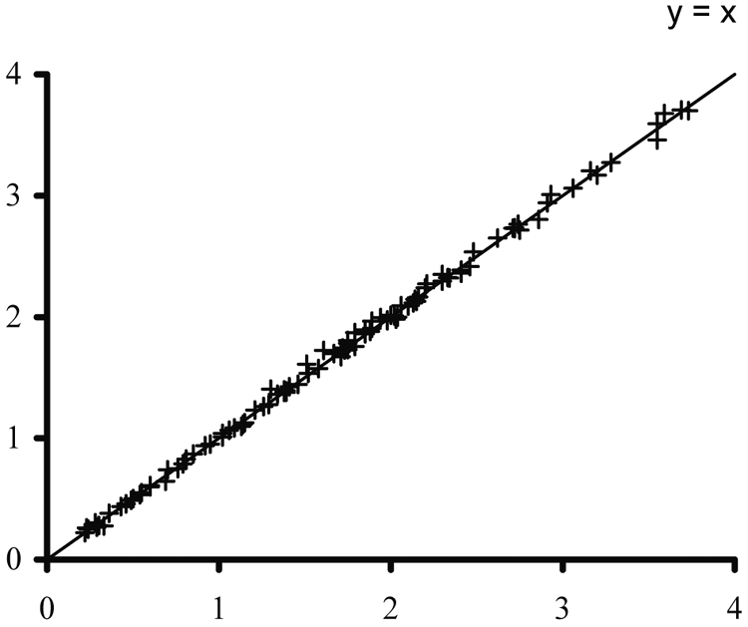 | VITROS 750 System (mEq/L) | 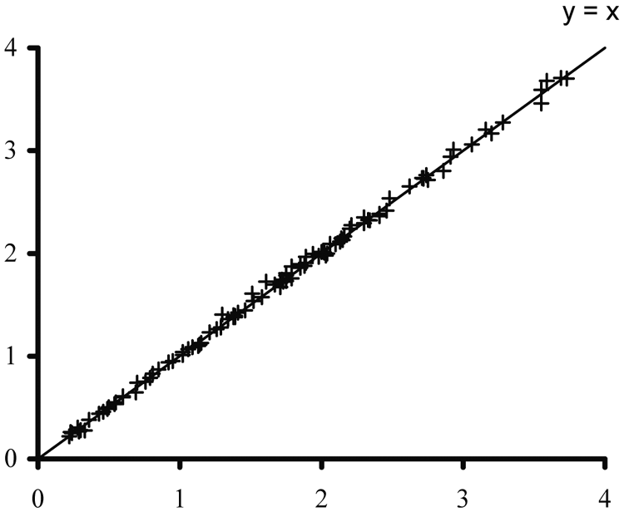
Comparative Method: Atomic Absorption |  | Comparative Method: Atomic Absorption

 | n | Slope | Correlation Coefficient | Conventional and SI Units (mmol/L)
 |  |  |  | Range of Sample Conc. | Intercept | Sy.x
750 vs. comparative method | 102 | 1.00 | 0.999 | 0.2–3.7 | +0.01 | 0.04
250 vs. 750 | 58 | 0.98 | 1.000 | 0.2–3.7 | +0.02 | 0.02
950 vs. 750 | 99 | 1.00 | 1.000 | 0.3–3.9 | 0.00 | 0.03
5,1 FS † vs. 950 | 125 | 1.00 | 1.000 | 0.2–4.0 | -0.01 | 0.02
750 vs. commercial method * | 197 | 1.00 | 0.992 | 0.2–3.8 | +0.04 | 0.05
5600 vs. 5,1 FS † | 109 | 0.99 | 0.998 | 0.2–3.8 | -0.01 | 0.06

* ISE method

Precision
Precision was evaluated with quality control materials on VITROS 250, 750, 950, and 5,1 FS Systems following NCCLS Protocol EP5. ²⁰ Precision was also evaluated with quality control materials on the VITROS 5600 Integrated System following NCCLS Protocol EP5. ²¹
The data presented are a representation of test performance and are provided as a guideline. Variables such as sample handling and storage, reagent handling and storage, laboratory environment, and system maintenance can affect reproducibility of test results.

 | Conventional and SI Units (mmol/L) |  |  | Alternate Units (mEq/L) |  |  | Within Lab CV% ** | No. Observ. | No. Days
 | Mean Conc. | Within Day SD * | Within Lab SD ** | Mean Conc. | Within Day SD * | Within Lab SD **
250 | 0.5 | 0.03 | 0.05 | 0.5 | 0.03 | 0.05 | 9.3 | 80 | 20
 | 1.0 | 0.04 | 0.05 | 1.0 | 0.04 | 0.05 | 5.4 | 80 | 20
 | 1.6 | 0.04 | 0.05 | 1.6 | 0.04 | 0.05 | 3.1 | 80 | 20
 | 2.2 | 0.04 | 0.07 | 2.2 | 0.04 | 0.07 | 3.2 | 80 | 20
 | 3.5 | 0.04 | 0.06 | 3.5 | 0.04 | 0.06 | 1.8 | 80 | 20
750 | 0.5 | 0.03 | 0.03 | 0.5 | 0.03 | 0.03 | 5.6 | 80 | 20
 | 1.0 | 0.03 | 0.04 | 1.0 | 0.03 | 0.04 | 3.8 | 80 | 20
 | 1.2 | 0.03 | 0.04 | 1.2 | 0.03 | 0.04 | 3.3 | 80 | 20
 | 2.1 | 0.05 | 0.05 | 2.1 | 0.04 | 0.05 | 2.5 | 80 | 20
 | 2.3 | 0.04 | 0.05 | 2.3 | 0.04 | 0.05 | 1.9 | 80 | 20
950 | 0.7 | 0.03 | 0.03 | 0.7 | 0.03 | 0.03 | 4.5 | 92 | 23
 | 1.9 | 0.04 | 0.04 | 1.9 | 0.04 | 0.04 | 2.3 | 92 | 23
5,1 FS † | 1.1 | 0.03 | 0.04 | 1.1 | 0.03 | 0.04 | 3.3 | 90 | 22
 | 2.5 | 0.03 | 0.05 | 2.5 | 0.03 | 0.05 | 2.0 | 88 | 22
5600 | 1.1 | 0.03 | 0.04 | 1.1 | 0.03 | 0.04 | 3.6 | 92 | 23
 | 2.4 | 0.04 | 0.06 | 2.4 | 0.04 | 0.06 | 2.5 | 92 | 23

* Within Day precision was determined using two runs/day with at least two replications.
** Within Lab precision was determined using a single lot of slides and calibrating weekly.
† Analytical processing hardware and software algorithms on the VITROS 4600 Chemistry System are designed to the same specifications as those applied to the VITROS 5,1 FS Chemistry System. Assay performance on the VITROS 4600 System has been demonstrated to be comparable to that on the VITROS 5,1 FS System. All performance characteristics for VITROS 5,1 FS System are therefore applicable to the VITROS 4600 System.

Specificity

The substances listed in the table were tested with VITROS Li Slides at a lithium concentration of 1.0 mmol/L following NCCLS Protocol EP7 ¹⁵ and found not to interfere, bias <0.13 mmol/L, at the concentration shown.

Compound | Concentration |  |  | Compound | Concentration
Acetate | 25 mmol/L | 25 mmol/L |  | Ibuprofen | 40 mg/dL | 2 mmol/L
Acetaminophen | 20 mg/dL | 1 mmol/L |  | Imipramine | 10 mg/dL | 357 µmol/L
N-Acetylcysteine | 90 mg/dL | 6 mmol/L |  | Intralipid | 800 mg/dL | 8 g/L
Acetylsalicylic acid | 50 mg/dL | 3 mmol/L |  | Iron | 124 µmol/L | 124 µmol/L
Acyclovir | 25 mg/dL | 1 mmol/L |  | Isoniazid | 7 mg/dL | 511 µmol/L
Albuterol | 18 mg/dL | 375 µmol/L |  | Keflin | 100 mg/dL | 3 mmol/L
Allopurinol | 5 mg/dL | 367 µmol/L |  | Lidocaine | 6 mg/dL | 256 µmol/L
Amitriptyline | 10 mg/dL | 360 µmol/L |  | Magnesium | 5 mmol/L | 5 mmol/L
Ammonia | 0.5 mmol/L | 0.5 mmol/L |  | Mannitol | 650 mg/dL | 36 mmol/L

Compound | Concentration |  | Compound | Concentration
Amphotericin B | 3.5 mg/dL | 38 µmol/L |  | Mannose | 350 mg/dL | 19 mmol/L
Ampicillin | 200 mg/dL | 6 mmol/L |  | Methadone | 1 mg/dL | 32 µmol/L
Ascorbic acid | 6 mg/dL | 341 µmol/L |  | Methotrexate | 10 mmol/L | 10 mmol/L
Azathioprine | 1 mg/dL | 36 µmol/L |  | Morphine | 0.1 mg/dL | 4 µmol/L
Bilirubin | 40 mg/dL | 684 µmol/L |  | Naproxen | 100 mg/dL | 4 mmol/L
Calcium | 5 mmol/L | 5 mmol/L |  | Neomycin | 12 mg/dL | 195 µmol/L
Captopril | 2 mg/dL | 92 µmol/L |  | Nickel | 0.3 mmol/L | 0.3 mmol/L
Carbamazepine | 12 mg/dL | 508 µmol/L |  | Nifedipine | 1 mg/dL | 29 µmol/L
Cefazolin | 400 mg/dL | 9 mmol/L |  | Pansporin | 30 mg/dL | 571 µmol/L
Ceftriaxone | 250 mg/dL | 5 mmol/L |  | Penicillamine | 4 mg/dL | 268 µmol/L
Chloral hydrate | 2 mg/dL | 121 µmol/L |  | Phenobarbital | 40 mg/dL | 2 mmol/L
Chloramphenicol | 25 mg/dL | 774 µmol/L |  | Phenylpropanolamine | 0.18 mg/dL | 12 µmol/L
Chloride | 140 mmol/L | 140 mmol/L |  | Phenytoin | 20 mg/dL | 793 µmol/L
Chlorpromazine | 1 mg/dL | 31 µmol/L |  | Phospholipid, lecithin | 500 mg/dL | 5 g/L
Cholesterol | 500 mg/dL | 13 mmol/L |  | Potassium | 10 mmol/L | 10 mmol/L
Cholic acid | 6 µmol/L | 6 µmol/L |  | Prednisone | 0.1 mg/dL | 3 µmol/L
Cimetidine | 10 mg/dL | 396 µmol/L |  | Procainamide | 10 mg/dL | 425 µmol/L
Clonidine | 2 µg/dL | 87 nmol/L |  | Promethazine | 0.2 mg/dL | 7 µmol/L
Codeine | 1.7 mg/dL | 57 µmol/L |  | Propranolol | 1 mg/dL | 39 µmol/L
Copper | 0.3 mg/dL | 47 µmol/L |  | Pseudoephedrine | 0.28 mg/dL | 17 µmol/L
Dexamethazone | 0.14 mg/dL | 4 µmol/L |  | Pyruvate | 2 mg/dL | 230 µmol/L
Dextran 40 | 3000 mg/dL | 750 µmol/L |  | Quinidine | 6 mg/dL | 185 µmol/L
Digoxin | 3 µg/dL | 38 nmol/L |  | Ranitidine | 15 mg/dL | 478 µmol/L
Diltiazem | 0.6 mg/dL | 14 µmol/L |  | Salicylate | 30 mg/dL | 2.2 mmol/L
Dopamine | 0.3 mg/dL | 20 µmol/L |  | Sodium | 160 mmol/L | 160 mmol/L
Erythromycin | 20 mg/dL | 273 µmol/L |  | Streptokinase | 700 U/L | 700 U/L
Ethanol | 350 mg/dL | 76 mmol/L |  | Theophylline | 20 mg/dL | 1 mmol/L
Fructose | 30 mg/dL | 1.7 mmol/L |  | Thioridazine | 1.2 mg/dL | 32 µmol/L
Furosemide | 10 mg/dL | 302 µmol/L |  | Tolazamide | 55 mg/dL | 2 mmol/L
Galactose | 60 mg/dL | 3 mmol/L |  | Total protein | 3 g/dL | 30 g/L
Gentamicin | 50 mg/dL | 1 mmol/L |  | Total protein | 10 g/dL | 100 g/L
Gentisic acid | 50 mg/dL | 3 mmol/L |  | Trichloroethanol | 2 mg/dL | 134 µmol/L
Glutathione | 1 mg/dL | 33 µmol/L |  | Triglycerides | 2000 mg/dL | 23 mmol/L
Glyburide | 0.64 mg/dL | 13 µmol/L |  | Trimethoprim | 25 mg/dL | 861 µmol/L
Hydrochlorothiazide | 2 mg/dL | 67 µmol/L |  | Valproic acid | 100 mg/dL | 7 mmol/L
β-Hydroxybutyric acid | 30 mg/dL | 3 mmol/L |  | Vancomycin | 50 mg/dL | 345 µmol/L
Hydroxychloroquine | 1 mg/dL | 30 µmol/L |  | Warfarin | 10 mg/dL | 324 µmol/L
Hypaque | 500 mg/dL | 8 mmol/L |  | Zinc | 5 mg/dL | 763 µmol/L

References:

1.Cade JFJ. Lithium Salts in the Treatment of Psychotic Excitement. Med. J. Aust. 2:349; 1949.
2.Baastrup PC, Schou M. Lithium as a Prophylactic Agent: Its Effect against Recurrent Depressions and Manic-Depressive Psychosis. Arch. Gen. Psychiat. 16:162; 1967.
3.CLSI. Protection of Laboratory Workers from Occupationally Acquired Infections; Approved Guideline – Third Edition. CLSI document M29-A3 (ISBN 1-56238-567-4). CLSI, 940 West Valley Road, Suite 1400, Wayne, PA 19087-1898 USA; 2005.
4. Calam RR. Specimen Processing Separator Gels: An Update. J Clin Immunoassay. 11:86–90; 1988.
5.CLSI. Procedures for the Collection of Diagnostic Blood Specimens by Venipuncture; Approved Standard – Sixth Edition. CLSI document H3-A6 (ISBN 1-56238-650-6). CLSI, 940 West Valley Road, Suite 1400, Wayne, Pennsylvania 19087-1898 USA; 2007.
6.NCCLS. Procedures and Devices for the Collection of Diagnostic Capillary Blood Specimens; Approved Standard—Fifth Edition. NCCLS document H4-A5 [ISBN 1-56238-538-0]. CLSI, 940 West Valley Road, Suite 1400, Wayne, PA 19087-1898 USA; 2004.
7.Tietz NW (ed). Fundamentals of Clinical Chemistry. ed. 5. Philadelphia: WB Saunders; 632; 2001.
8.Clinical Laboratory Handbook for Patient Preparation and Specimen Handling. Fascicle IV: Therapeutic Drug Monitoring/Toxicology. Skokie, IL: College of American Pathologists; 1985.
9.A Reference Method of the Determination of Lithium in Serum. U.S. Dept. of Comm., NBS Publication 260–69.
10.CLSI. Statistical Quality Control for Quantitative Measurements: Principles and Definitions; Approved Guideline-Third Edition. CLSI document C24-A3 (ISBN 1-56238-613-1). CLSI, 940 West Valley Road, Suite 1400, Wayne, PA 19087-1898 USA; 2006.
11.Gilman AG et al. Goodman and Gilman’s The Pharmacological Basis of Therapeutics. ed. 8. 418–422; 1990.
12.Ellenhorn MJ, Barceloux DG. Medical Toxicology: Diagnosis and Treatment of Human Poisoning. New York: Elsevier; 1042–1045; 1988.
13.Burtis CA, Ashwood ER, (eds) Fundamentals of Clinical Chemistry. ed. 5. Philadelphia: WB Saunders; 1023; 2001.
14.Burtis CA, Ashwood ER, (eds) Fundamentals of Clinical Chemistry. ed. 5. Philadelphia: WB Saunders; 632; 2001.
15.NCCLS. Interference Testing in Clinical Chemistry. NCCLS Document EP7. CLSI, 940 West Valley Road, Suite 1400, Wayne, PA 19087-1898 USA; 1986.
16.Young DS. Effects of Drugs on Clinical Laboratory Tests. ed. 4. Washington D.C.: AACC Press; 1995.
17.Friedman RB, Young DS. Effects of Disease on Clinical Laboratory Tests. Washington, D.C.: AACC Press; 1990.
18.NCCLS. Method Comparison and Bias Estimation Using Patient Samples; Approved Guideline. NCCLS Document EP9. CLSI, 940 West Valley Road, Suite 1400, Wayne, PA 19087-1898 USA; 1995.
19.NCCLS. Method Comparison and Bias Estimation Using Patient Samples; Approved Guideline. NCCLS document EP9-A2 [ISBN 1-56238-472-4]. CLSI, 940 West Valley Road, Suite 1400, Wayne, Pennsylvania 19087-1898 USA; 2002.
20.NCCLS. User Evaluation of Precision Performance with Clinical Chemistry Devices. NCCLS Document EP5. CLSI, 940 West Valley Road, Suite 1400, Wayne, PA 19087-1898 USA; 1992.
21.NCCLS. Evaluation of Precision Performance of Quantitative Measurement Methods; Approved Guideline – Second Edition. NCCLS document EP5-A2 [ISBN 1-56238-542-9]. CLSI, 940 West Valley Road, Suite 1400, Wayne, PA 19087-1898 USA; 2004.

