RUSH logo for emails

**CREATININE**

**SERUM, PLASMA OR URINE**

**ABBOTT ARCHITECT**

**Intended Use**

The Creatinine assay is used for the quantitation of creatinine in human serum, plasma, or urine.

**Clinical Significance**

Creatinine is eliminated from blood by glomerular filtration. Reduced renal function results in an increased serum creatinine concentration.

Measurement of serum creatinine is used to diagnose and monitor acute and chronic renal disease, estimate glomerular filtration rate (GFR), or assess the status of renal dialysis patients. Urine creatinine analysis is used to calculate creatinine clearance, confirm completeness of 24-hour collections, or serve as a reference quantity for other analytes, such as in calculation of the albumin/creatinine ratio.

In 1886 Jaffe developed an assay for creatinine based upon the reaction between creatinine and sodium picrate. In 1904 Folin used this reaction for the quantitative determination of creatinine in urine.

Kinetic procedures based on the observed reaction rates of various substances, including creatinine, with alkaline picrate have been proposed by Fabiny and Soldin. This improved Jaffe chemistry is a kinetic procedure which does not require deproteinization of the sample and is formulated to reduce the interference of serum proteins.

**Principle**

At an alkaline pH, creatinine in the sample reacts with picrate to form a creatinine-picrate complex. The rate of increase in absorbance at 500 nm due to the formation of this complex is directly proportional to the concentration of creatinine in the sample.

**Methodology:** Kinetic Alkaline Picrate

**Specimen Collection and Handling**

Serum, plasma, and urine are acceptable specimens.

• **Serum:** Use serum collected by standard venipuncture techniques into glass or plastic tubes with or without gel barriers. Ensure complete clot formation has taken place prior to centrifugation.

When processing samples, separate serum from blood cells or gel according to the specimen collection tube manufacturer’s instructions.

Some specimens, especially those from patients receiving anticoagulant or thrombolytic therapy, may take longer to complete their clotting processes. Fibrin clots may subsequently form in these sera and the clots could cause erroneous test results.

• **Plasma:** Use plasma collected by standard venipuncture techniques into glass or plastic tubes. Acceptable anticoagulants are lithium heparin (with or without gel barrier), EDTA, and sodium heparin. Ensure centrifugation is adequate to remove platelets.

When processing samples, separate plasma from blood cells or gel according to the specimen collection tube manufacturer’s instructions.

• **Urine:** Collect with no preservative. Random specimens or specimens timed over intervals shorter than 24 hours are acceptable for analysis.

• **24-Hour Urine:** May be collected with preservatives. The preferred preservatives are boric acid and hydrochloric acid.10 Reference ranges are provided for 24-hour excretion.

**Specimen Storage**

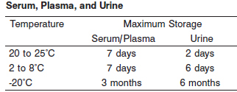

A tolerance of +/- 10% (+/- 2°C) is assumed not to change the stability of the specimen. (W. Guder, personal communication, August 6, 2001).

Each laboratory may establish a range around -20°C from either the freezer manufacturer’s specifications or your laboratory standard operating procedure(s) for specimen storage.

**NOTE:** Stored specimens must be inspected for particulates. If present, mix and centrifuge the specimen to remove particulates prior to testing.

**Materials and Equipment Required**

**TEST INSTRUMENT**: Abbott ARCHITECT System

**MATERIALS PROVIDED**

3L81 Creatinine Reagent Kit

**MATERIALS REQUIRED BUT NOT PROVIDED**

• 1E65 Multiconstituent Calibrator

• Control Material

• Saline (0.85% to 0.90% NaCl) for specimens that require dilution

**Reagent Handling and Storage:**

***CAUTION*:**

1. For in vitro diagnostic use.

2. Do not use components beyond the expiration date.

3. Do not pool reagents within a kit or between kits.

**CAUTION:** This product requires the handling of human specimens.

It is recommended that all human sourced materials be considered potentially infectious and be handled in accordance with the OSHA Standard on Bloodborne Pathogens. Biosafety Level 2 or other appropriate biosafety practices should be used for materials that contain or are suspected of containing infectious agents.

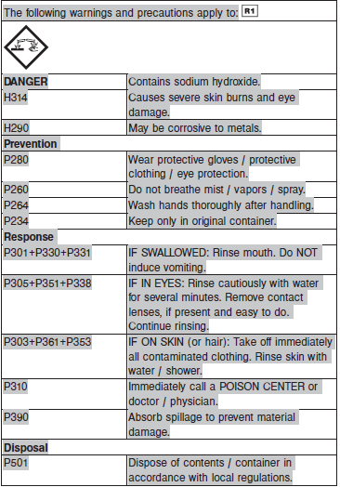

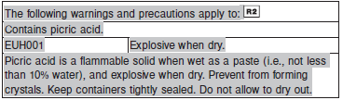

**Reagent Handling**

Remove air bubbles, if present in the reagent cartridge, with a new applicator stick. Alternatively, allow the reagent to sit at the appropriate storage temperature to allow the bubbles to dissipate. To minimize volume depletion, do not use a transfer pipette to remove the bubbles.

**CAUTION:** Reagent bubbles may interfere with proper detection of reagent level in the cartridge, causing insufficient reagent aspiration which could impact results.

**Reagent Storage**

Unopened reagents are stable until the expiration date when stored at 15 to 30°C.

Reagent stability is 5 days if the reagent is uncapped and onboard.

Reagent Preparation:

Creatinine is supplied as a liquid, ready-to-use, two-reagent kit which contains: R1 & R2

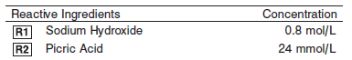

**Calibrator:** 1E65 Multiconstituent Calibrator

**Quality Control:** Minimum 2 levels of ChemistryControl (Normal and Abnormal), Urine controls

**Calibration**

**Frequency:**

Calibration is stable for 30 days (720 hours) for any one lot.

**A new calibration is required:**

1. If quality control results do not meet acceptance criteria defined by your laboratory, patient values may be suspect. Follow the established quality control procedures for your laboratory. Recalibration may be necessary.
2. Review quality control results and acceptance criteria following a change of reagent or calibrator lot.

**Calibration Procedure:**

Calibration is performed by running a water blank and the Multiconstituent Calibrator set. Water for the blank is provided by the instrument.

1. Verify that the correct calibrator values have been entered into the calibration file.

2. Allow calibrator to come to room temperature.

3. Mix bottle five times by gentle inversion.

4. Open bottle, place an appropriate amount of each calibrator in a separate sample cup, and place in the assigned positions.

5. Cap bottle tightly and return to refrigerated storage immediately after use.

6. Perform calibration as indicated in the **ARCHITECT System Operations Manual**.

**Troubleshooting and Overall Acceptance Criteria Failure**

See ARCHITECT Operations Manual for further calibration troubleshooting.

**Quality Control:**

Abbott recommends, refer to your laboratory standard operating procedure(s) and/or quality assurance plan for additional quality control requirements and potential corrective actions:

• Two levels of controls (normal and abnormal) are to be run every 24 hours.

Some controls may require addition of Liquid Stabilizer.

• If more frequent control monitoring is required, follow the established quality control procedures for your laboratory.

• If quality control results do not meet the acceptance criteria defined by your laboratory, patient values may be suspect. Follow the established quality control procedures for your laboratory.

Recalibration may be necessary.

• Review quality control results and acceptance criteria following a change of reagent or calibrator lot.

**Procedure**

For a detailed description of how to run an assay, refer to *Section 5* of the **ARCHITECT System Operations Manual**.

The Creatinine assay file must be installed on the ARCHITECT cSystem prior to performing the assay.

For detailed information on assay file installation and viewing and editing assay parameters, refer to the ARCHITECT System Operations Manual, Section 2.

For information on printing assay parameters or for a detailed description of system procedures, refer to the ARCHITECT System Operations Manual, Section 5.

**Calculations**

Refer to *Appendix C* of the **ARCHITECT System Operations Manual** for information on results calculations.

**Reporting Results**

The Conventional result unit for the serum Creatinine assay is mg/ dL. The corresponding SI result unit is μmol/L. To convert mg/dL to μmol/L, multiply mg/dL by 88.4.10 To convert μmol/L to mg/dL, divide μmol/L by 88.4.

The Conventional result unit for the urine Creatinine assay is mg/ dL. The corresponding SI result unit is mmol/L. To convert mg/dL to mmol/L, multiply mg/dL by 0.0884. To convert mmol/L to mg/dL, divide mmol/L by 0.0884.

**Specific Performance Characteristics**

**Reference Ranges**

It is recommended that each laboratory determine its own reference range based upon its particular locale and population characteristics.

**Serum/Plasma**

</= 2 months 0.50 to 1.0

Adult, Male: 0.72 to 1.25 mg/dL

Adult, Female: 0.57 to 1.11 mg/dL

**Urine**

Creatinine

Adult Male: 63 to 166 mg/dL

Adult Female: 47 to 110 mg/dL

Creatinine Clearance

Adult: 66 to 165 mL/minute

**Critical Values: N/A**

**Performance Characteristics**

**Linearity**

Creatinine serum is linear from 0.20 to 37.00 mg/dL (17.7 to 3,270.8 μmol/L) within } 10% or } 0.1 mg/dL, whichever is greater with 95% confidence. Creatinine urine is linear from 5.00 to

740.00 mg/dL (0.44 to 65.42 mmol/L) within +/- 10% or +/- 5 mg/dL, whichever is greater with 95% confidence.

**Dilution:**

**Serum and Plasma:** Specimens with creatinine values exceeding 37.00 mg/dL (3,270.8 μmol/L) are flagged and may be diluted using the configured Automated Dilution Protocol or the Manual Dilution Procedure.

**Urine:** Urine samples are automatically diluted 1:20 by the system using the Standard dilution option, then the system automatically corrects the concentration by multiplying the result by the appropriate dilution factor. This dilution extends urine Creatinine linearity to 740.00 mg/dL (65.42 mmol/L). Samples exceeding this concentration are flagged and may be diluted with the Automated Dilution Protocol or the Manual Dilution Procedure.

**Automated Dilution Protocol**

If using an Automated Dilution Protocol, the system performs a dilution of the specimen and automatically corrects the concentration by multiplying the result by the appropriate dilution factor. To set up the automatic dilution feature, refer to *Section 2* of the instrument-specific operations manual for additional information.

**Manual Dilution Procedure**

Manual dilutions should be performed as follows:

• Use saline (0.85% to 0.90% NaCl) to dilute the sample.

• The operator must enter the dilution factor in the patient or control order screen. The system uses this dilution factor to automatically correct the concentration by multiplying the result by the entered factor.

• If the operator does not enter the dilution factor, the result must be multiplied by the appropriate dilution factor before reporting the result.

**NOTE:** If a diluted sample result is flagged indicating it is less than the linear low limit, do not report the result. Rerun using an appropriate dilution.

**Limit of Quantitation (LOQ):** The LOQ for Creatinine serum is 0.10 mg/dL (8.8 μmol/L). The LOQ for

Creatinine urine is 5.00 mg/dL (0.44 mmol/L).

**Limit of Detection (LOD):** The LOD for Creatinine serum is 0.05 mg/dL (4.5 μmol/L). The LOD for

Creatinine urine is 4.00 mg/dL (0.35 mmol/L).

**Limitation of Procedure:**

N/A

**Precision:**

**Serum**

The imprecision of the Creatinine serum assay is ≤ 6% Total CV.

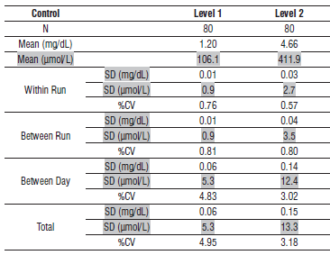

**Urine**

The imprecision of the Creatinine urine assay is ≤ 6% Total CV.

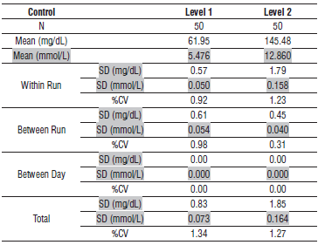

#### Interfering Substances:

**Interfering Substances**

Interference studies were conducted using an acceptance criteria of ≤ 10% of the target value. Interference effects were assessed by Dose Response and Paired Difference methods, at the medical decision level of the analyte.

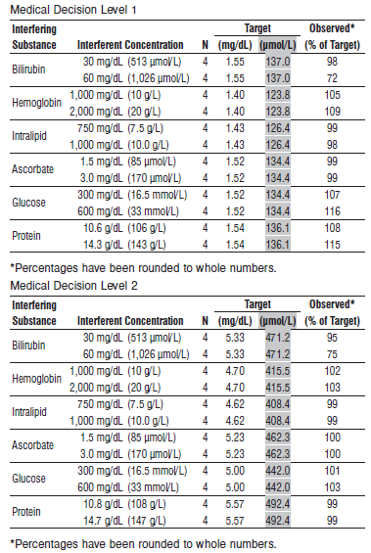

**Accuracy**

The bias for Creatinine serum or plasma is ≤ 10% or +/- 0.1 mg/dL (8.8 μmol/L), whichever is greater, and the Total Error is ≤ 22%.

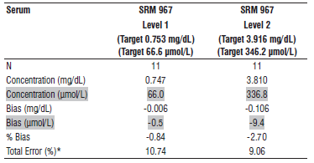

**References:**

1. ABBOTT ARCHITECT Creatinine package insert

Abbott Laboratories

Diagnostics Division

Abbott Park, IL 60064

April 2016 306941 / R05

1. ABBOTT Multiconstituent Calibrator

Abbott Laboratories

Diagnostics Division

Abbott Park, IL 60064

June 2013 306297/R04

1. Abbott ARCHITECT Operator’s Guide

**Related Documents:**

**Attachments:**