RUSH logo for emails

**DIRECT LDL**

**SERUM OR PLASMA**

**ABBOTT ARCHITECT**

**Intended Use**

The MULTIGENT Direct LDL assay is used for the direct, quantitative determination of low-density lipoprotein (LDL) cholesterol in human serum or plasma on the ARCHITECT *c* Systems.

**Clinical Significance**

Plasma lipoproteins are spherical particles containing varying amounts of cholesterol, triglycerides, phospholipids, and proteins. The phospholipid, free cholesterol, and protein constitute the outer surface of the lipoprotein particle, while the inner core contains mostly esterified cholesterol and triglycerides. These particles serve to solubilize and transport cholesterol and trigylcerides in the bloodstream.

The relative proportions of protein and lipid determine the density of these lipoproteins and provide a basis on which to begin their classification. These classes are: chylomicrons, very-low-density lipoprotein (VLDL), low-density lipoprotein (LDL), and high-density lipoprotein (HDL). Numerous clinical studies have shown that the different lipoprotein classes have very distinct and varied effects on coronary heart disease (CHD) risk. The studies all point to LDL cholesterol as the key factor in the pathogenesis of atherosclerosis and CHD, while HDL cholesterol has been observed to have a protective effect. Even within the normal range of total cholesterol concentrations, an increase in LDL cholesterol can occur with an associated increased risk for CHD.

**Principle**

The MULTIGENT Direct LDL assay is a homogeneous method for directly measuring LDL levels in serum or plasma, without the need for off-line pretreatment or centrifugation steps.

The method is in a two-reagent format and depends on the properties of a unique detergent. This detergent, R1, solubilizes only the non‑LDL particles. The cholesterol released is consumed by cholesterol esterase and cholesterol oxidase in a non-color-forming reaction. A second detergent,R2 , solubilizes the remaining LDL particles and a chromogenic coupler allows for color formation. The enzyme reaction with LDL in the presence of the coupler produces color that is proportional to the amount of LDL cholesterol present in the sample.

**Methodology:** Measured, Liquid Selective Detergent

**Specimen Collection and Handling**

Serum and plasma are acceptable specimens. Patients are not required to fast prior to blood collection.

• **Serum:** Use serum collected by standard venipuncture techniques into glass or plastic tubes with or without gel barriers. Ensure complete clot formation has taken place prior to centrifugation. Separate serum from red blood cells or gel as soon after collection as possible (within 3 hours).

Some specimens, especially those from patients receiving anticoagulant or thrombolytic therapy, may take longer to complete their clotting processes. Fibrin clots may subsequently form in these sera and the clots could cause erroneous results.

• **Plasma:** Use plasma collected by standard venipuncture techniques into glass or plastic tubes. Acceptable anticoagulants are lithium heparin (with or without gel barrier), sodium heparin, and EDTA.

Anticoagulants containing citrate should not be used. Ensure centrifugation is adequate to remove platelets. Separate plasma from red blood cells or gel as soon after collection as possible (within 3 hours).

**Specimen Storage**

.

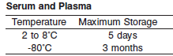

Specimens may be frozen once.

**NOTE:** Stored specimens must be inspected for particulates. If present, mix and centrifuge the specimen to remove particulates prior to testing.

**Materials and Equipment Required**

**TEST INSTRUMENT**: Abbott ARCHITECT System

**MATERIALS PROVIDED**

1E31-20 MULTIGENT Direct LDL Reagent Kit

**MATERIALS REQUIRED BUT NOT PROVIDED**

• 5P56-01 Lipid Multiconstituent Calibrator

• Control Material

• Saline (0.85% to 0.90% NaCl) for specimens that require dilution

**Reagent Handling and Storage:**

***CAUTION*:**

1. For in vitro diagnostic use.

2. Do not use components beyond the expiration date.

3. Do not mix materials from different kit lot numbers.

• Protect reagents from direct sunlight.

• Do not freeze reagents.

**CAUTION:** This product requires the handling of human specimens.

It is recommended that all human sourced materials be considered

potentially infectious and be handled in accordance with the OSHA

Standard on Bloodborne Pathogens. Biosafety Level 2 or other appropriate biosafety practices should be used for materials that contain or are suspected of containing infectious agents.

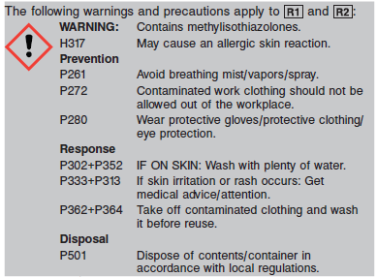

**Reagent Handling**

• Remove air bubbles, if present in the reagent cartridge, with a new applicator stick. Alternatively, allow the reagent to sit at the appropriate storage temperature to allow the bubbles to dissipate.

To minimize volume depletion, do not use a transfer pipette to remove the bubbles.

**CAUTION:** Reagent bubbles may interfere with proper detection of reagent level in the cartridge, causing insufficient reagent aspiration that could impact results.

**Reagent Storage**

• Reagent stability is 28 (672 hours) days if the reagent is uncapped and onboard.

• Unopened reagents are stable until the expiration date when stored at 2 to 8°C.

Reagent Preparation:

1E31-20 MULTIGENT Direct LDL is supplied as a liquid, ready‑to‑use, two-reagent kit which contains: **R1 & R2**

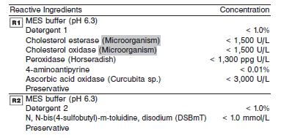

**Calibrator:** 5P56-01 Lipid Multiconstituent Calibrator

**Quality Control:** Minimum 2 levels of ChemistryControl (Normal and Abnormal)

**Calibration**

**Frequency:**

Calibration is stable for 28 days (672 hours) for any one lot. Calibration is required with each change in reagent lot number.

**A new calibration is required:**

1. If quality control results do not meet acceptance criteria defined by your laboratory, patient values may be suspect. Follow the established quality control procedures for your laboratory. Recalibration may be necessary.
2. Review quality control results and acceptance criteria following a change of reagent or calibrator lot.

**Calibrator Required:** 5P56-01 Lipid Multiconstituent Calibrator

**Reagents:**

Lipid MC Cal is prepared from human serum. Preservatives are also present.

**Calibrator Preparation:**

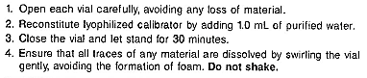

**Calibration Procedure:**

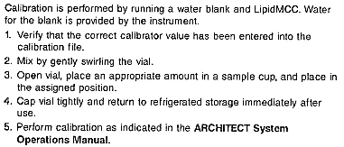

**Troubleshooting and Overall Acceptance Criteria Failure**

See ARCHITECT Operations Manual for further calibration troubleshooting.

**Quality Control:**

Abbott recommends, refer to your laboratory standard operating procedure(s) and/or quality assurance plan for additional quality control requirements and potential corrective actions:

• Two levels of controls (normal and abnormal) are to be run every 24 hours.

• If more frequent control monitoring is required, follow the established quality control procedures for your laboratory.

• If quality control results do not meet the acceptance criteria defined by your laboratory, patient values may be suspect. Follow the established quality control procedures for your laboratory.

Recalibration may be necessary.

• Review quality control results and acceptance criteria following a change of reagent or calibrator lot.

**Procedure**

For a detailed description of how to run an assay, refer to *Section 5* of the **ARCHITECT System Operations Manual**.

**Calculations**

Refer to *Appendix C* of the **ARCHITECT System Operations Manual** for information on results calculations.

**Reporting Results**

The result unit for the MULTIGENT Direct LDL assay can be reported as mg/dL.

**Specific Performance Characteristics**

**Reference Ranges**

It is recommended that each laboratory determine its own reference range based upon its particular locale and population characteristics.

**Serum/Plasma**

The following National Cholesterol Education Program (NCEP) cutpoints for patient classification are used for the prevention and management of coronary heart disease.

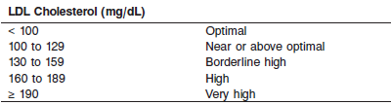

**Serum/Plasma: 0-100 mg/dL**

**Critical Values: None**

**Performance Characteristics**

**Reportable Range**

The reportable range of the MULTIGENT Direct LDL assay is from 1 to 800 mg/dL (0.03 to 20.69 mmol/L)

**Limit of Blank (LOB)**

The LOB for MULTIGENT Direct LDL is ≤ 10 mg/dL (0.259 mmol/L).

**Dilution:**

**Serum and Plasma:** The following specimens should be diluted by following the Manual Dilution Procedure:

• Specimens with levels of interfering substances (other than triglyceride) higher than the upper limit stated in the Interfering Substances section.

• Specimens with LDL cholesterol values exceeding 800 mg/dL (20.69 mmol/L).

**Manual Dilution Procedure**

Manual dilutions should be performed as follows:

• Use saline (0.85% to 0.90% NaCl) to dilute the sample.

• The operator must enter the manual dilution factor in the patient or control order screen. The system uses this dilution factor to automatically correct the concentration by multiplying the result by the entered factor.

• If the operator does not enter the dilution factor, the result must be multiplied by the appropriate dilution factor before reporting the result.



**NOTE:** If a diluted sample result is flagged indicating it is less than the linear low limit, do not report the result. Rerun using an appropriate dilution.

For detailed information on ordering dilutions, refer to *Section 5* of the **ARCHITECT System Operations Manual**.

**Precision:**

The precision of the MULTIGENT Direct LDL assay is < 4% CV

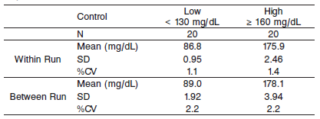

#### Limitations of Procedure

**N/A**

**Interfering Substances**

Potential interference in the MULTIGENT Direct LDL assay from ascorbic acid, bilirubin, gamma globulins, and hemoglobin is less than 10% at the levels indicated below. Varying amounts of potential interferents were added to serum pools with known quantities of cholesterol. No significant interference was detected in the MULTIGENT Direct LDL assay up to and including the concentrations stated below:

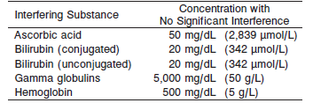

Samples with triglyceride concentrations > 1,293 mg/dL (14.61 mmol/L) should not be used for the determination of LDL cholesterol.

**References:**

1. ABBOTT ARCHITECT Direct LDL package insert

Abbott Laboratories

Diagnostics Division

Abbott Park, IL 60064

July 2016 307008/ R11

1. ABBOTT ARCHITECT Lipid Multiconstituent Calibrator package insert

Abbott Laboratories

Diagnostics Division

Abbott Park, IL 60064

1. Abbott ARCHITECT Operator’s Guide

**Related Documents:**

**Attachments:**