RUSH logo for emails

**CARBON DIOXIDE**

**SERUM OR PLASMA**

**ABBOTT ARCHITECT**

**Intended Use**

The Carbon Dioxide assay is used for the quantitation of carbon dioxide in human serum or plasma.

**Clinical Significance**

The determination of serum carbon dioxide total (CO2) in conjunction with other clinical and laboratory information is necessary for the evaluation of acid-base status. A high CO2 content may be observed in compensated respiratory acidosis and metabolic alkalosis. A low CO2 content may be observed in compensated respiratory alkalosis and metabolic acidosis. Additional laboratory determinations will permit differentiation between metabolic and respiratory conditions.

**Principle**

Carbon dioxide, as bicarbonate (HCO3–), and phosphor (enol) pyruvate (PEP) are converted to oxalacetate and phosphate in the reaction catalyzed by phosphor (enol) pyruvate carboxylase (PEPC). Malate dehydrogenase (MDH) catalyzes the reduction of oxalacetate to malate with the concomitant oxidation of reduced nicotinamide adenine dinucleotide (NADH) analog. The resulting decrease in absorbance at 404 nm is proportional to the CO2 content in the sample.

**Methodology:** PEP Carboxylase

**Specimen Collection and Handling**

**Suitable Specimens**

Serum and plasma are acceptable specimens.

• **Serum:** Use serum collected by standard venipuncture techniques into glass or plastic tubes with or without gel barriers. Ensure complete clot formation has taken place prior to centrifugation.

Centrifuge according to tube manufacturer’s instructions to ensure proper separation of serum from blood cells. Some specimens, especially those from patients receiving anticoagulant or thrombolytic therapy, may take longer to complete their clotting processes. Fibrin clots may subsequently form in these sera and the clots could cause erroneous test results.

• **Plasma:** Use plasma collected by standard venipuncture techniques into glass or plastic tubes. Acceptable anticoagulants are lithium heparin (with or without gel barrier) and sodium heparin. Ensure centrifugation is adequate to remove platelets. Centrifuge according to tube manufacturer’s instructions to ensure proper separation of plasma from blood cells.

**Specimen Storage**

**Serum and Plasma:** Keep tube tightly capped for storage. A consequent decrease in the CO2 value of up to 6 mEq/L can occur in the course of an hour once the specimen has been exposed to ambient air.

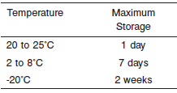

**NOTE:** Stored specimens must be inspected for particulates. If present, mix and centrifuge the specimen to remove particulates prior to testing.

**Materials and Equipment Required**

**TEST INSTRUMENT**: Abbott ARCHITECT System

**MATERIALS PROVIDED**

3L80 Carbon Dioxide Reagent Kit

**MATERIALS REQUIRED BUT NOT PROVIDED**

• 1E64 Carbon Dioxide Calibrator

• Control Material

• Saline (0.85% to 0.90% NaCl) for specimens that require dilution

**Reagent Handling and Storage:**

***CAUTION*:**

1. For in vitro diagnostic use.

2. Do not use components beyond the expiration date.

3. Do not mix materials from different kit lot numbers.

**CAUTION:** This product requires the handling of human specimens.

It is recommended that all human sourced materials be considered

potentially infectious and be handled in accordance with the OSHA

Standard on Bloodborne Pathogens. Biosafety Level 2 or other appropriate biosafety practices should be used for materials that contain or are suspected of containing infectious agents.

• The following warning and precaution apply to R1:

Contains sodium azide.

EUH032 Contact with acids liberates very toxic gas.

These materials and their containers must be disposed of in a safe way.

**Reagent Handling**

• R1 Ready for use.

• R2 Ready for use.

• Remove air bubbles, if present in the reagent cartridge, with a new applicator stick. Alternatively, allow the reagent to sit at the appropriate storage temperature to allow the bubbles to dissipate.

To minimize volume depletion, do not use a transfer pipette to remove the bubbles.

**CAUTION:** Reagent bubbles may interfere with proper detection of reagent level in the cartridge, causing insufficient reagent aspiration that could impact results.

**Reagent Storage**

• Reagent stability is 14 days if the reagent is uncapped and onboard.

• Unopened reagents are stable until the expiration date when stored at 2 to 8°C.

Reagent Preparation:

Carbon Dioxide is supplied as a liquid, ready-to-use, single reagent kit which contains: **R1**

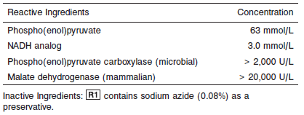

**Calibrator:** 1E64 Carbon Dioxide Calibrator

**Quality Control:** Minimum 2 levels of ChemistryControl (Normal and Abnormal)

**Calibration**

**Frequency:**

Calibration is stable for 7 days (168 hours) for any one lot.

**A new calibration is required:**

1. If quality control results do not meet acceptance criteria defined by your laboratory, patient values may be suspect. Follow the established quality control procedures for your laboratory. Recalibration may be necessary.
2. Review quality control results and acceptance criteria following a change of reagent or calibrator lot.

**Calibrator Required:** 1E64 Carbon Dioxide Calibrator

**Reagents:**

1E64-02 Carbon Dioxide Calibrator is prepared in an aqueous solution. Sodium azide is present as a preservative.

**Calibrator Preparation:**

Carbon Dioxide Calibrator requires no preparation prior to use.

**Calibration Procedure:**

Calibration is performed by running a water blank and Carbon Dioxide Calibrator set. Water for the blank is provided by the instrument.

1. Verify that the correct calibrator values have been entered into the calibration file.

2. Gently invert each bottle.

3. Open bottle, place an appropriate amount of each calibrator in a separate sample cup, and place in the assigned positions.

4. Cap bottle tightly and store at 2 to 8°C immediately after use.

5. Perform calibration as indicated in the **ARCHITECT System Operations Manual**.

**Troubleshooting and Overall Acceptance Criteria Failure**

See ARCHITECT Operations Manual for further calibration troubleshooting.

**Quality Control:**

Abbott recommends, refer to your laboratory standard operating procedure(s) and/or quality assurance plan for additional quality control requirements and potential corrective actions:

• Two levels of controls (normal and abnormal) are to be run every 24 hours.

• If more frequent control monitoring is required, follow the established quality control procedures for your laboratory.

• If quality control results do not meet the acceptance criteria defined by your laboratory, patient values may be suspect. Follow the established quality control procedures for your laboratory.

Recalibration may be necessary.

• Review quality control results and acceptance criteria following a change of reagent or calibrator lot.

**Procedure**

For a detailed description of how to run an assay, refer to *Section 5* of the **ARCHITECT System Operations Manual**.

**Calculations**

Refer to *Appendix C* of the **ARCHITECT System Operations Manual** for information on results calculations.

**Reporting Results**

The result unit for the ARCHITECT C02 assay can be reported as mEq/L or mmol/L.

**Specific Performance Characteristics**

**Reference Ranges**

It is recommended that each laboratory determine its own reference range based upon its particular locale and population characteristics.

**Serum/Plasma:**

0-2 months: 13-22 mmol/L

>2 months-12 months: 20-28 mmol/L

Adult: 22-31 mmol/L

**Critical Values: N/A**

**Performance Characteristics**

**Linearity**

Carbon Dioxide is linear from 5 mEq/L (5 mmol/L) to 50 mEq/L (50 mmol/L).

**Limit of Detection (LOD)**

The LOD for Carbon Dioxide is 2 mEq/L (2 mmol/L).

**Limit of Quantitation (LOQ)**

The LOQ for Carbon Dioxide in serum and plasma specimens is 4 mEq/L (4 mmol/L).

**Dilution:**

**Serum and Plasma:** Specimens with carbon dioxide values exceeding 50 mEq/L are flagged and may be diluted by following either the Automated Dilution Protocol or the Manual Dilution Procedure.

**Automated Dilution Protocol**

If using the Automated Dilution Protocol, the system performs a 1:2 dilution of the specimen and automatically corrects the concentration by multiplying the result by the appropriate dilution factor. To set up the automatic dilution feature, refer to *Section 2* of the **ARCHITECT System** **Operations Manual** for additional information.

**Manual Dilution Procedure**

Manual dilutions should be performed as follows:

• Use saline (0.85% to 0.90% NaCl) to dilute the sample.

• The operator must enter the dilution factor in the patient or control order screen. The system uses this dilution factor to automatically correct the concentration by multiplying the result by the entered factor.

• If the operator does not enter the dilution factor, the result must be multiplied by the appropriate dilution factor before reporting the result.

**NOTE:** If a diluted sample result is flagged indicating it is less than the linear low limit, do not report the result. Rerun using an appropriate dilution.

For detailed information on ordering dilutions, refer to *Section 5* of the **ARCHITECT System Operations Manual**.

**Precision:**

The imprecision of the Carbon Dioxide assay is ≤ 5.5% Total CV or total SD ≤ 1 mEq/L, whichever is greater.

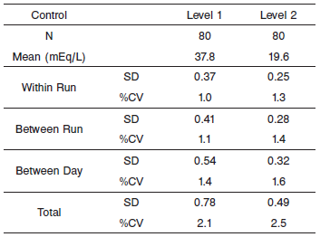

#### Limitations of Procedure

N/A

**Interfering Substances**

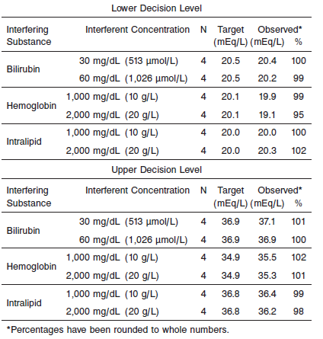.

**References:**

1. ABBOTT ARCHITECT C02 package insert

Abbott Laboratories

Diagnostics Division

Abbott Park, IL 60064

Dec 2012 305168/R03

1. ABBOTT ARCHITECT C02 Calibrator package insert

Abbott Laboratories

Diagnostics Division

Abbott Park, IL 60064

1. Abbott ARCHITECT Operator’s Guide

**Related Documents:**

**Attachments:**