RUSH logo for emails

**CREATINE KINASE**

**SERUM OR PLASMA**

**ABBOTT ARCHITECT**

**Intended Use**

The Creatine Kinase assay is used for the quantitation of creatine kinase in human serum or plasma.

**Clinical Significance**

Measurements of creatine kinase are used in the diagnosis and treatment of diseases associated with skeletal muscle, heart, central nervous system, and thyroid.

**Principle**

Creatine kinase (CK), present in the sample, catalyzes the transfer of a high energy phosphate group from creatine phosphate to ADP. The ATP produced in this reaction is subsequently used to phosphorylate glucose to produce glucose-6-phosphate (G-6-P) in the presence of hexokinase. G-6-P is then oxidized by glucose-6-phosphate dehydrogenase (G-6-PDH) with the concomitant reduction of nicotinamide adenine dinucleotide phosphate (NADP) to nicotinamide adenine dinucleotide phosphate reduced (NADPH). The rate of formation of NADPH is monitored at 340 nm and is proportional to the activity of CK in the sample. These reactions occur in the presence of *N*-acetyl-*L*-cysteine (NAC) which is present as an enzyme reactivator.

**Methodology:** NAC (*N*-acetyl-*L*-cysteine)

**Specimen Collection and Handling**

**Suitable Specimens**

Serum and plasma are acceptable specimens.

• **Serum:** Use serum collected by standard venipuncture techniques into glass or plastic tubes with or without gel barriers. Ensure complete clot formation has taken place prior to centrifugation.

Centrifuge according to tube manufacturer’s instructions to ensure proper separation of serum from blood cells. Some specimens, especially those from patients receiving anticoagulant or thrombolytic therapy, may take longer to complete their clotting processes. Fibrin clots may subsequently form in these sera and the clots could cause erroneous test results.

• **Plasma:** Use plasma collected by standard venipuncture techniques into glass or plastic tubes. Acceptable anticoagulants are lithium heparin (with or without gel barrier) and sodium heparin. Ensure centrifugation is adequate to remove platelets. Centrifuge according to tube manufacturer’s instructions to ensure proper separation of plasma from blood cells. To ensure accurate results, the plasma specimen tube should be filled with the prescribed minimum volume for an appropriate anticoagulant to specimen ratio.

**NOTE:** Moderate or severely hemolyzed specimens can liberate adenylate kinase, ATP, and G-6-P which may affect the lag phase and side reactions of the CK assay system.

**Specimen Storage**

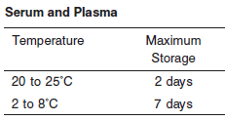

**NOTE:** Stored specimens must be inspected for particulates. If present, mix and centrifuge the specimen to remove particulates prior to testing.

**Materials and Equipment Required**

**TEST INSTRUMENT**: Abbott ARCHITECT System

**MATERIALS PROVIDED**

7D63 Creatine Kinase Reagent Kit

**MATERIALS REQUIRED BUT NOT PROVIDED**

• Control Material

• Saline (0.85% to 0.90% NaCl) for specimens that require dilution

**Reagent Handling and Storage:**

***CAUTION*:**

1. For in vitro diagnostic use.

2. Do not use components beyond the expiration date.

3. 4. Do not mix reagents prepared at different times.

**CAUTION:** This product requires the handling of human specimens.

It is recommended that all human sourced materials be considered potentially infectious and be handled in accordance with the OSHA Standard on Bloodborne Pathogens. Biosafety Level 2 or other appropriate biosafety practices should be used for materials that contain or are suspected of containing infectious agents.

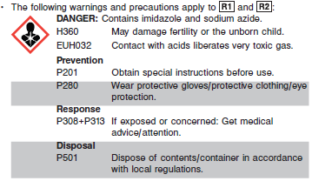

**Reagent Handling**

Remove air bubbles, if present in the reagent cartridge, with a new applicator stick. Alternatively, allow the reagent to sit at the appropriate storage temperature to allow the bubbles to dissipate. To minimize volume depletion, do not use a transfer pipette to remove the bubbles.

**CAUTION:** Reagent bubbles may interfere with proper detection of reagent level in the cartridge, causing insufficient reagent aspiration which could impact results.

**Reagent Storage**

Unopened reagents are stable until the expiration date when stored at 2 to 8°C.

Reagent stability is 30 days if the reagent is uncapped and onboard.

Reagent Preparation:

CK is supplied as a liquid, ready-to-use, reagent kit which contains: R1 & R2

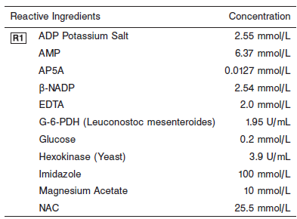

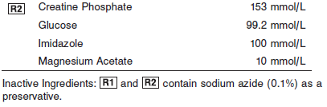

**Quality Control:** Minimum 2 levels of ChemistryControl (Normal and Abnormal)

**Calibration**

**Frequency:**

Calibration is stable for 30 days (720 hours) for any one lot.

**A new calibration is required:**

1. If quality control results do not meet acceptance criteria defined by your laboratory, patient values may be suspect. Follow the established quality control procedures for your laboratory. Recalibration may be necessary.
2. Review quality control results and acceptance criteria following a change of reagent or calibrator lot.

**Calibration Procedure:**

A calibration factor (9081) must be entered on the **Configure assay parameters** window, **Calibration** view.

**Troubleshooting and Overall Acceptance Criteria Failure**

See ARCHITECT Operations Manual for further calibration troubleshooting.

**Quality Control:**

Abbott recommends, refer to your laboratory standard operating procedure(s) and/or quality assurance plan for additional quality control requirements and potential corrective actions:

• Two levels of controls (normal and abnormal) are to be run every 24 hours.

Some controls may require addition of Liquid Stabilizer.

• If more frequent control monitoring is required, follow the established quality control procedures for your laboratory.

• If quality control results do not meet the acceptance criteria defined by your laboratory, patient values may be suspect. Follow the established quality control procedures for your laboratory.

Recalibration may be necessary.

• Review quality control results and acceptance criteria following a change of reagent or calibrator lot.

**Procedure**

For a detailed description of how to run an assay, refer to *Section 5* of the **ARCHITECT System Operations Manual**.

**Calculations**

Refer to *Appendix C* of the **ARCHITECT System Operations Manual** for information on results calculations.

**Reporting Results**

The result unit for the CK assay can be reported as U/L

**Specific Performance Characteristics**

**Reference Ranges**

It is recommended that each laboratory determine its own reference range based upon its particular locale and population characteristics.

**Serum/Plasma:**

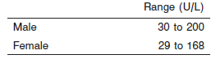

**Critical Values: N/A**

**Performance Characteristics**

**Linearity**

Creatine Kinase is linear up to 4,267 U/L.

**Dilution:**

**Serum and Plasma:** Specimens with creatine kinase values exceeding 4,267 U/L are flagged and may be diluted by following either the Automated Dilution Protocol or the Manual Dilution Procedure.

**Automated Dilution Protocol**

If using the Automated Dilution Protocol, the system performs a 1:2 or 1:10 dilution of the specimen and automatically corrects the enzyme activity value by multiplying the result by the appropriate dilution factor.

**Manual Dilution Procedure**

Manual dilutions should be performed as follows:

• Use saline (0.85% to 0.90% NaCl) to dilute the sample.

• The operator must enter the dilution factor in the patient or control order screen. The system uses this dilution factor to automatically correct the enzyme activity value by multiplying the result by the entered factor.

• If the operator does not enter the dilution factor, the result must be multiplied by the appropriate dilution factor before reporting the result.

**NOTE:** If a diluted sample result is flagged indicating it is less than the linear low limit, do not report the result. Rerun using an appropriate dilution.

For detailed information on ordering dilutions, refer to *Section 5* of the **ARCHITECT System Operations Manual**.

**Limit of Quantitation (LOQ):** The LOQ for Creatine Kinase is 6.6 U/L.

**Limit of Detection (LOD):** The LOD for Creatine Kinase is 5 U/L.

**Limitation of Procedure:**

N/A

**Precision:**

The imprecision of the Creatine Kinase assay is ≤ 6.5% Total CV.

Serum/Plasma:

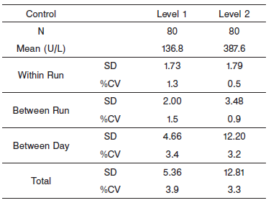

#### Interfering Substances:

**Interfering Substances**

Interference studies were conducted using CLSI protocol NCCLS EP7-P. Interference effects were assessed by Dose Response and Paired Difference methods, at the medical decision level of the analyte.

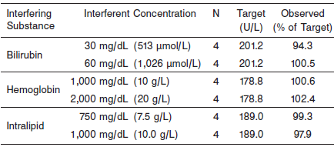

**References:**

1. ABBOTT ARCHITECT CK package insert

Abbott Laboratories

Diagnostics Division

Abbott Park, IL 60064

Nov 2015 306760/R04

1. Abbott ARCHITECT Operator’s Guide

**Related Documents:**

**Attachments:**

**Each Procedure should include:**

**Document #**

**Revision #**

**Department**

**Approval Routing**

**Effective Date**

**Revision Date**

**Next Review Date**

**Supercedes and Date (retain this procedure for 2 years)**

*Only applicable headings need to be included, if a specific heading is not applicable to a procedure, do not include it.*