RUSH logo for emails

**CRP VARIO**

**SERUM OR PLASMA**

**ABBOTT ARCHITECT**

**Intended Use**

The MULTIGENT CRP Vario assay [CRPVa] is intended for the quantitative immunoturbidimetric determination of C-reactive protein in human serum or plasma with variable assay ranges [CRP16, CRP32, CRP48] using the ARCHITECT *c* Systems.

**Clinical Significance**

C-reactive protein (CRP) is an acute phase protein whose concentration rises non-specifically in response to inflammation. CRP is seen to increase as a result of the inflammatory process, most notably in response to pneumococcal (bacterial) infection, histolytic disease, and a variety of other disease states. Intraindividual variation is a major limitation of the assay when the assay is used for directing therapies. Intraindividual variations of the CRP levels are from 30% to 60%. Serial measurement may be required to estimate true mean of CRP depending on the intended use in any specific individual. CRP is used as a marker or general diagnostic indicator of infections and inflammation, in addition to serving as a monitor of patient response to pharmacological therapy and surgery.

**Principle**

MULTIGENT CRP Vario is a latex immunoassay developed to accurately and reproducibly measure blood CRP levels in serum and plasma. When an antigen-antibody reaction occurs between CRP in a sample and anti‑CRP antibody, which has been adsorbed to latex particles, agglutination results. This agglutination is detected as an absorbance change (572 nm), with the rate of change being proportional to the quantity of CRP in the sample. Three different methods (High Sensitivity [CRP16], Standard [CRP32], and Wide Range [CRP48]) are available to cover a wide analytical measurement range.

**Methodology:** Turbidimetric/Immunoturbidimetric.

**Specimen Collection and Handling**

**Suitable Specimens**

• **Serum:** Use serum collected by standard venipuncture techniques into plastic tubes with or without gel barriers. Ensure complete clot formation has taken place prior to centrifugation. Centrifuge according to tube manufacturer’s instructions to ensure proper separation of serum from blood cells.

Some specimens, especially those from patients receiving anticoagulant or thrombolytic therapy, may take longer to complete their clotting processes. Fibrin clots may subsequently form in these sera and the clots could cause erroneous test results.

• **Plasma:** Use plasma collected by standard venipuncture techniques into plastic tubes. Acceptable anticoagulants are lithium heparin (with or without gel barrier), sodium heparin, and EDTA. Ensure centrifugation is adequate to remove platelets. Centrifuge according to tube manufacturer’s instructions to ensure proper separation of plasma from blood cells.

**NOTE:** Glass tubes were not tested

**Specimen Storage**

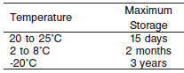

**NOTE:** Stored specimens must be inspected for particulates. If present, mix and centrifuge the specimen to remove particulates prior to testing.

**Materials and Equipment Required**

**TEST INSTRUMENT**: Abbott ARCHITECT System

**MATERIALS PROVIDED**

6K26-30 MULTIGENT CRP Vario Kit

6K26-41 MULTIGENT CRP Vario Kit

**MATERIALS REQUIRED BUT NOT PROVIDED**

• 6K26-10 MULTIGENT CRP Calibrator Set

• 6K26-14 MULTIGENT CRP Calibrator HS

• 6K26-12 MULTIGENT CRP Calibrator WR

• 6K26-21 MULTIGENT CRP Control HS

• 6K32-20 Immuno Control 1 (Not available in the US)

• 6K32-21 Immuno Control 2 (Not available in the US)

• Saline (0.85% to 0.90% NaCl) for specimens that require dilution

**Reagent Handling and Storage:**

***CAUTION*:**

1. For in vitro diagnostic use.

2. Do not use components beyond the expiration date.

3. Do not mix materials from different kit lot numbers.

**CAUTION:** This product requires the handling of human specimens.

It is recommended that all human sourced materials be considered

potentially infectious and be handled in accordance with the OSHA

Standard on Bloodborne Pathogens. Biosafety Level 2 or other appropriate biosafety practices should be used for materials that contain or are suspected of containing infectious agents.

• The following warning and precaution apply to R1 and R2:

Contains sodium azide.

EUH032 Contact with acids liberates very toxic gas.

These materials and their containers must be disposed of in a safe way.

**Reagent Handling**

R1 Ready for Use.

R2 Ready for Use.

• Remove air bubbles, if present in the reagent cartridge, with a new applicator stick. Alternatively, allow the reagent to sit at the appropriate storage temperature to allow the bubbles to dissipate.

To minimize volume depletion, do not use a transfer pipette to remove the bubbles.

**CAUTION:** Reagent bubbles may interfere with proper detection of reagent level in the cartridge, causing insufficient reagent aspiration that could impact results.

**Reagent Storage**

• Reagent stability is 60 days if the reagent is uncapped and onboard.

• Unopened reagents are stable until the expiration date when stored at 2 to 8°C.

Reagent Preparation:

MULTIGENT CRP Vario is supplied as a two-reagent kit which contains: **R1 & R2**

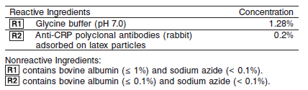

**Calibrator:**

• 6K26-10 MULTIGENT CRP Calibrator Set

**Quality Control:** Chemistry Controls

**Calibration**

**NOTE:** The MULTIGENT CRP Vario assay must be calibrated using the individual levels listed in the ASSAY PARAMETERS. Refer to the parameters for the High Sensitivity [CRP16], Standard [CRP32], and Wide Range [CRP48] methods and the MULTIGENT CRP Calibrator package insert specific for the method used in your laboratory.

**Frequency:**

Calibration is stable for 15 days for any one lot. Recalibration is required with each new reagent lot number.

**A new calibration is required:**

1. If quality control results do not meet acceptance criteria defined by your laboratory, patient values may be suspect. Follow the established quality control procedures for your laboratory. Recalibration may be necessary.
2. Review quality control results and acceptance criteria following a change of reagent or calibrator lot.

**Calibrator Required:**

• 6K26-10 MULTIGENT CRP Calibrator Set

**Reagents:**

6K26-10 MULTIGENT CRP Calibrator Set contains the following calibration levels, prepared by diluting CRP with human serum and stabilized by adding sodium azide (< 0.1%).

The values assigned and the color of the caps corresponding to each level are indicated in the table below.

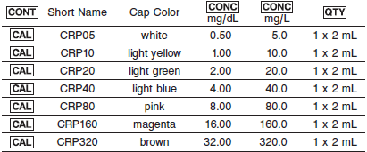

**Calibrator Preparation:**

Calibrator Sets require no preparation prior to use.

**Calibration Procedure:**

1. Enter the calibrator values provided in the following table for the Standard method. For the High Sensitivity and Wide Range methods, refer to the tables below.

2. Mix bottles several times by gentle inversion to ensure homogeneity of the solution.

3. Open the bottles, place an appropriate amount of each calibrator in a separate sample cup, and place in the assigned positions.

4. Cap bottles tightly and return to refrigerated storage immediately after use. Always return each cap to its original bottle.

5. Perform calibration as indicated in *Section 6* of the **ARCHITECT System Operations Manual**.

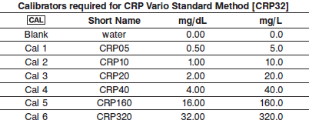

**Troubleshooting and Overall Acceptance Criteria Failure**

See ARCHITECT Operations Manual for further calibration troubleshooting.

**Quality Control:**

Abbott recommends, refer to your laboratory standard operating procedure(s) and/or quality assurance plan for additional quality control requirements and potential corrective actions:

• Analyze at least 2 levels of controls in 24 hours.

• If more frequent control monitoring is required, follow the established quality control procedures for your laboratory.

• If quality control results do not meet the acceptance criteria defined by your laboratory, patient values may be suspect. Follow the established quality control procedures for your laboratory.

Recalibration may be necessary.

• Review quality control results and acceptance criteria following a change of reagent or calibrator lot.

**Procedure**

For a detailed description of how to run an assay, refer to *Section 5* of the **ARCHITECT System Operations Manual**.

**Calculations**

Refer to *Appendix C* of the **ARCHITECT System Operations Manual** for information on results calculations.

**Reporting Results**

The result unit for the CRP Vario assay can be reported in mg/dL or mg/L

**Specific Performance Characteristics**

**Reference Ranges**

It is recommended that each laboratory determine its own reference range based upon its particular locale and population characteristics.

**Serum/Plasma:** 0-5.0 mg/L

CRP is an acute phase protein whose concentration rises non‑specifically in response to inflammation. CRP values should not be interpreted without a complete clinical evaluation. Follow-up testing of patients with elevated values is recommended in order to help rule out a recent response to undetected infection or tissue injury

**Critical Values: N/A**

**Performance Characteristics**

**Reportable Range**

The reportable range for MULTIGENT CRP Vario is:

* Standard Method 0.02 to 32.00 mg/dL (0.2 to 320 mg/L)

All methods were tested for prozone up to a CRP concentration of 100 mg/dL (1,000 mg/L). No prozone effect was observed within the linear range of the assay. At 100 mg/dL (1,000 mg/L) the observed result was correctly flagged as above the linearity of the assay.

**Limit of Quantitation (LOQ)**

The LOQ is the analyte concentration at which the CV = 20%. The limit of quantification for MULTIGENT CRP Vario is:

* Standard 0.02 mg/dL (0.2 mg/L)

**Dilution:**

**Serum and Plasma:** Specimens with CRP values exceeding the linearity are flagged and may be diluted by following either the Automated Dilution Protocol or the Manual Dilution Procedure.

***Automated Dilution Protocol***

If using the Automated Dilution Protocol, the system performs a dilution of the specimen and automatically corrects the concentration by multiplying the result by the appropriate dilution factor. The dilution for each method is listed below.

Method Dilution

Standard 1:5

***Manual Dilution Procedure***

• Use saline (0.85% to 0.90% NaCl) to dilute the sample.

• The operator must enter the dilution factor in the patient or control order screen. The system uses this dilution factor to automatically correct the concentration by multiplying the result by the entered factor.

• If the operator does not enter the dilution factor, the result must be multiplied by the appropriate dilution factor before reporting the result.

**NOTE:** If a diluted sample result is flagged indicating it is less than the linear low limit, do not report the result. Rerun using an appropriate dilution.

For detailed information on ordering dilutions, refer to *Section 5* of the **ARCHITECT System Operations Manual**.

**Precision:**

The precision of the MULTIGENT CRP Vario assay is ≤ 6% Total CV

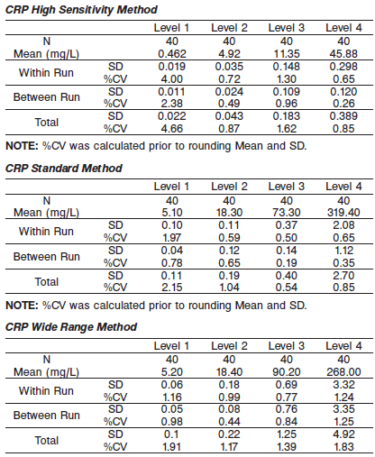

#### Limitations of Procedure

The following are limitations on the use of the High Sensitivity CRP per CDC/AHA recommendations.

• Screening the entire adult population is not recommended.

• CRP is not a substitute for traditional cardiovascular risk factors.

• Acute coronary syndrome management should not depend on CRP measurements.

• Patients with persistently unexplained CRP levels above 1.0 mg/dL (10 mg/L) should be evaluated for noncardiovascular etiologies.

• Secondary prevention measures should not depend on CRP.

• Serial measurements of CRP should not be used to monitor treatment.

• The average of two CRP results, repeated optimally two weeks apart, should be used on metabolically stable patients. In very rare cases gammopathy, particularly of the monoclonal IgM type (e.g., Waldenstrom macroglobulinemia), may cause unreliable results.

**Interfering Substances**

Interference studies were conducted using an acceptance criteria of+/- 5% or 0.05 mg/dL deviation, whichever is greater, from the target value. No interference was observed at the concentrations below.

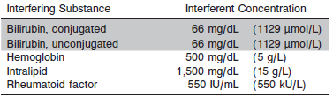

**References:**

1. ABBOTT ARCHITECT CRP Vario package insert

Abbott Laboratories

Diagnostics Division

Abbott Park, IL 60064

Aug 2015 306731/R04

1. ABBOTT ARCHITECT CRP Vario Calibrators package insert

Abbott Laboratories

Diagnostics Division

Abbott Park, IL 60064

1. Abbott ARCHITECT Operator’s Guide

**Related Documents:**

**Attachments:**