RUSH logo for emails

**CALCIUM**

**SERUM, PLASMA OR URINE**

**ABBOTT ARCHITECT**

**Intended Use**

The Calcium assay is used for the quantitation of calcium in human serum, plasma, or urine.

**Clinical Significance**

The majority of calcium in the body is present in bones. The remainder of the calcium is in serum and has various functions. For example, calcium ions decrease neuromuscular excitability, participate in blood coagulation, and activate some enzymes. Hypercalcemia can result from hyperparathyroidism, hypervitaminosis D, multiple myeloma, and some neoplastic diseases of bone. Long-term lithium therapy has been reported to cause hyperparathyroidism in some individuals, with resulting hypercalcemia. Hypocalcemia can result from hypoparathyroidism, hypoalbuminemia, renal insufficiency, and pancreatitis.

Calcium has traditionally been difficult to measure accurately and precisely, and a large variety of methods have been developed. Among these are flame photometry, oxalate precipitation with titration, atomic absorption spectrophotometry, EDTA chelation, and more recently calcium dye complexes which are measured spectrophotometrically. Examples of calcium dyes are o-cresolphthalein complexone and Arsenazo III, the latter being the dye used for calcium determination in this method.

**Principle**

Arsenazo-III dye reacts with calcium in an acid solution to form a blue‑purple complex. The color developed is measured at 660 nm and is proportional to the calcium concentration in the sample.

**Methodology:** Arsenazo III

**Specimen Collection and Handling**

**Suitable Specimens**

Serum, plasma, and urine are acceptable specimens.

• **Serum:** Use serum collected by standard venipuncture techniques into glass or plastic tubes with or without gel barriers. Ensure complete clot formation has taken place prior to centrifugation.

Centrifuge according to tube manufacturer’s instructions to ensure proper separation of serum from blood cells.

Some specimens, especially those from patients receiving anticoagulant or thrombolytic therapy, may take longer to complete their clotting processes. Fibrin clots may subsequently form in these sera and the clots could cause erroneous test results.

• **Plasma:** Use plasma collected by standard venipuncture techniques into glass or plastic tubes. Acceptable anticoagulants are lithium heparin (with or without gel barrier) and sodium heparin. Ensure centrifugation is adequate to remove platelets. Centrifuge according to tube manufacturer’s instructions to ensure proper separation of plasma from blood cells.

• **Urine:** Collect 24 hour specimens in a bottle containing 20 to 30 mL of 6 mol/L HCl (1 to 2 mL for a random specimen) in order to prevent calcium salt precipitation

**Specimen Storage**

Analyze fresh specimens if possible.

Avoid repeated freeze/thaw cycles

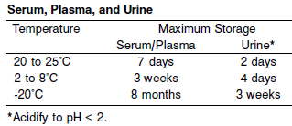

A tolerance of +/- 10% (+/- 2°C) is assumed not to change the stability of the specimen. (W. Guder, personal communication, August 6, 2001).

Each laboratory may establish a range around -20°C from either the freezer manufacturer’s specifications or your laboratory standard operating procedure(s) for specimen storage.

Frozen specimens must be completely thawed before mixing.

Mix thawed specimens thoroughly.

Visually inspect thawed specimens. If layering or stratification is observed, mix until specimens are visibly homogeneous. If specimens are not mixed thoroughly, inconsistent results may be obtained.

**NOTE:** Stored specimens must be inspected for particulates. If present, mix and centrifuge the specimen to remove particulates prior to testing.

**Materials and Equipment Required**

**TEST INSTRUMENT**: Abbott ARCHITECT System

**MATERIALS PROVIDED**

3L79 Calcium Reagent Kit

**MATERIALS REQUIRED BUT NOT PROVIDED**

• 1E65 Multiconstituent Calibrator

• Control Material

• Saline (0.85% to 0.90% NaCl) for specimens that require dilution

**Reagent Handling and Storage:**

***CAUTION*:**

For in vitro diagnostic use.

**•** Do not use reagents beyond the expiration date.

**•** Do not pool reagents within a kit or between kits.

**•** Do not use components from one lot with components from another lot.

**CAUTION:** This product requires the handling of human specimens.

It is recommended that all human sourced materials be considered potentially infectious and be handled in accordance with the OSHA Standard on Bloodborne Pathogens. Biosafety Level 2 or other appropriate biosafety practices should be used for materials that contain or are suspected of containing infectious agents.

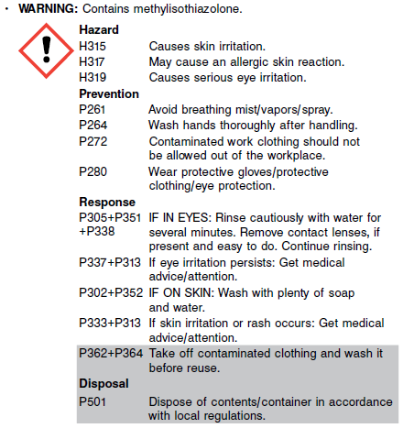

**Reagent Handling**

**NOTE:** Do not invert reagent cartridges prior to use. Reagents are susceptible to the formation of foam and bubbles.

Remove air bubbles, if present in the reagent cartridge, with a new applicator stick. Alternatively, allow the reagent to sit at the appropriate storage temperature to allow the bubbles to dissipate. To minimize volume depletion, do not use a transfer pipette to remove the bubbles.

**CAUTION:** Reagent bubbles may interfere with proper detection of reagent level in the cartridge, causing insufficient reagent aspiration which could impact results.

**Reagent Storage**

Unopened reagents are stable until the expiration date when stored at 15 to 30°C.

Reagent stability is 30 days if the reagent is uncapped and onboard.

Reagent Preparation:

Calcium is supplied as a liquid, ready-to-use, single reagent kit which contains: R1

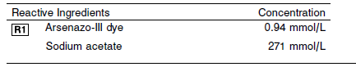

**Calibrator:** 1E65 Multiconstituent Calibrator

**Quality Control:** Minimum 2 levels of ChemistryControl (Normal and Abnormal), Urine controls

**Calibration**

**Frequency:**

Calibration is stable for 30 days (720 hours) for any one lot.

**A new calibration is required:**

1. If quality control results do not meet acceptance criteria defined by your laboratory, patient values may be suspect. Follow the established quality control procedures for your laboratory. Recalibration may be necessary.
2. Review quality control results and acceptance criteria following a change of reagent or calibrator lot.

**Calibration Procedure:**

Calibration is performed by running a water blank and the Multiconstituent Calibrator set. Water for the blank is provided by the instrument.

1. Verify that the correct calibrator values have been entered into the calibration file.

2. Allow calibrator to come to room temperature.

3. Mix bottle five times by gentle inversion.

4. Open bottle, place an appropriate amount of each calibrator in a separate sample cup, and place in the assigned positions.

5. Cap bottle tightly and return to refrigerated storage immediately after use.

6. Perform calibration as indicated in the **ARCHITECT System Operations Manual**.

**Troubleshooting and Overall Acceptance Criteria Failure**

See ARCHITECT Operations Manual for further calibration troubleshooting.

**Quality Control:**

Abbott recommends, refer to your laboratory standard operating procedure(s) and/or quality assurance plan for additional quality control requirements and potential corrective actions:

• Two levels of controls (normal and abnormal) are to be run every 24 hours.

Some controls may require addition of Liquid Stabilizer.

• If more frequent control monitoring is required, follow the established quality control procedures for your laboratory.

• If quality control results do not meet the acceptance criteria defined by your laboratory, patient values may be suspect. Follow the established quality control procedures for your laboratory.

Recalibration may be necessary.

• Review quality control results and acceptance criteria following a change of reagent or calibrator lot.

**Procedure**

For a detailed description of how to run an assay, refer to *Section 5* of the **ARCHITECT System Operations Manual**.

The Calcium assay file must be installed on the ARCHITECT cSystem prior to performing the assay.

For detailed information on assay file installation and viewing and editing assay parameters, refer to the ARCHITECT System Operations Manual, Section 2.

For information on printing assay parameters or for a detailed description of system procedures, refer to the ARCHITECT System

Operations Manual, Section 5.

**Calculations**

Refer to *Appendix C* of the **ARCHITECT System Operations Manual** for information on results calculations.

**Reporting Results**

The Conventional result unit for the Calcium assay is mg/dL. The corresponding SI result unit is mmol/L. To convert mg/dL to mmol/L, multiply mg/dL by 0.25. To convert mmol/L to mg/dL, divide mmol/L by 0.25.

The result unit for the Urine Calcium assay can be reported as mg/day or mmol/day

**Specific Performance Characteristics**

**Reference Ranges**

It is recommended that each laboratory determine its own reference range based upon its particular locale and population characteristics.

**Serum/Plasma:**

0-10 days: 7.6-10.4 mg/dL

10 days – 24 months: 9.0-11.0 mg/dL

Child: 2 years -12 years: 8.8-10.8 mg/dL

Adult: 8.4-10.2 mg/dL

Male >60 years: 8.8-10.0 mg/dL

**Critical Values:**

0-10 days: <7.0 and >13 mg/dL

10 days – 24 months: <7.0 and >13 mg/dL

Child: 2 years -12 years: <6.0 and >12 mg/dL

Adult: <6.0 and >12 mg/dL

Male >60 years: <6.0 and >12 mg/dL

**Performance Characteristics**

**Linearity**

The linearity of Calcium serum and urine is 2.0 to 24.0 mg/dL (0.50 to 6.00 mmol/L). Calcium is linear within ± 5% or ± 0.2 mg/dL, whichever is greater from 2.0 to 18.0 mg/dL (0.50 to 4.50 mmol/L) and within ± 10% from > 18.0 to 24.0 mg/dL (> 4.50 to 6.00 mmol/L) with 95% confidence.

**Dilution:**

**Serum and Plasma:** Specimens with calcium values exceeding 24.0 mg/dL (6.00 mmol/L) are flagged and may be diluted by following either the Automated Dilution Protocol or the Manual Dilution Procedure.

**Urine:** Specimens with calcium values exceeding 24.0 mg/dL (6.00 mmol/L) are flagged and may be diluted by following either the Automated Dilution Protocol or the Manual Dilution Procedure.

**Automated Dilution Protocol**

If using the Automated Dilution Protocol, the system performs a dilution of the specimen and automatically corrects the concentration by multiplying the result by the appropriate dilution factor. To set up the automated dilution feature, refer to *Section 2* of the **ARCHITECT System** **Operations Manual** for additional information.

**Manual Dilution Procedure**

Manual dilutions should be performed as follows:

• Use saline (0.85% to 0.90% NaCl) to dilute the sample.

• The operator must enter the dilution factor in the patient or control order screen. The system uses this dilution factor to automatically correct the concentration by multiplying the result by the entered factor.

• If the operator does not enter the dilution factor, the result must be multiplied by the appropriate dilution factor before reporting the result.

**NOTE:** If a diluted sample result is flagged indicating it is less than the linear low limit, do not report the result. Rerun using an appropriate dilution.

For detailed information on ordering dilutions, refer to *Section 5* of the **ARCHITECT System Operations Manual**.

**Limit of Quantitation (LOQ):** The LOQ for Calcium serum and urine is 1.0 mg/dL (0.25 mmol/L).

**Limit of Detection (LOD):** The LOD for Calcium serum and urine is 0.5 mg/dL (0.125 mmol/L).

**Limitation of Procedure:**

N/A

**Precision:**

The imprecision of the Calcium assay is ≤ 3% Total CV.

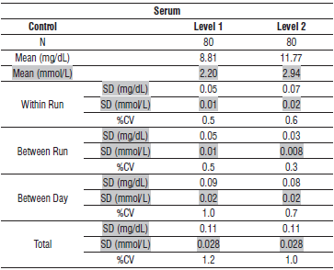

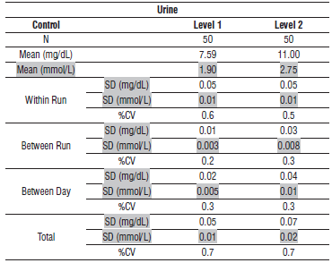

#### Interfering Substances:

**Interfering Substances**

Interference effects were assessed by Dose Response and Paired Difference methods, at the medical decision level of the analyte.

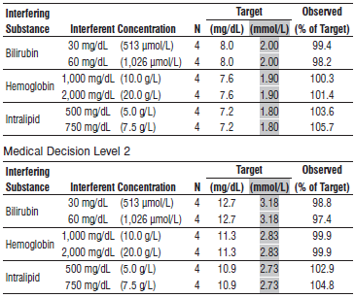

**References:**

1. ABBOTT ARCHITECT Calcium package insert

Abbott Laboratories

Diagnostics Division

Abbott Park, IL 60064

Jan 2016 306781 / R06

1. ABBOTT Multiconstituent Calibrator

Abbott Laboratories

Diagnostics Division

Abbott Park, IL 60064

June 2013 306297/R04

1. Abbott ARCHITECT Operator’s Guide

**Related Documents:**

**Attachments:**