RUSH logo for emails

**ASPARTATE AMINOTRANSFERASE**

**SERUM OR PLASMA**

**ABBOTT ARCHITECT**

**Intended Use**

The Aspartate Aminotransferase (AST) assay is used for the quantitation of aspartate aminotransferase in human serum or plasma.

**Clinical Significance**

Aspartate aminotransferase (AST), also referred to as glutamate oxaloacetate transaminase (GOT), is one of a group of enzymes which catalyzes the interconversion of amino acids and α-keto acids by transfer of amino groups. Both AST and alanine aminotransferase (ALT) are normally found in most body fluids, but not in urine except in instances of kidney lesions. The greatest concentrations of AST are found in heart, liver, muscle, and kidney tissues. Damage to these tissues can greatly elevate serum AST levels. Following myocardial infarction, AST in serum begins to increase within 6 to 8 hours of onset of pain, reaching a peak within 18 to 24 hours and falling to normal by the fourth or fifth day. Serum values may increase to 10 to 15 times normal levels and the increase is roughly proportional to the degree of tissue damage.

**Principle**

AST present in the sample catalyzes the transfer of the amino group from *L*-aspartate to α-ketoglutarate, forming oxaloacetate and *L*-glutamate. Oxaloacetate in the presence of NADH and malate dehydrogenase (MDH) is reduced to *L*-malate. In this reaction, NADH is oxidized to NAD. The reaction is monitored by measuring the rate of decrease in absorbance at 340 nm due to the oxidation of NADH to NAD.

**Methodology:** NADH (without P-5'-P)

**Specimen Collection and Handling**

**Suitable Specimens**

Serum and plasma are acceptable specimens.

• **Serum:** Use serum collected by standard venipuncture techniques into glass or plastic tubes with or without gel barriers. Ensure complete clot formation has taken place prior to centrifugation.

When processing samples, separate serum from blood cells or gel according to the specimen collection tube manufacturer’s instructions.

Some specimens, especially those from patients receiving anticoagulant or thrombolytic therapy, may take longer to complete their clotting processes. Fibrin clots may subsequently form in these sera and the clots could cause erroneous test results.

• **Plasma:** Use plasma collected by standard venipuncture techniques into glass or plastic tubes. Acceptable anticoagulants are lithium heparin (with or without gel barrier) and sodium heparin. Do not use ammonium heparin. Ensure centrifugation is adequate to remove platelets. When processing samples, separate plasma from blood cells or gel according to the specimen collection tube manufacturer’s instructions.

**Specimen Storage**

**Serum and Plasma:**

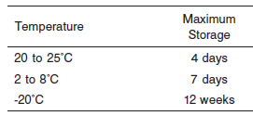

**NOTE:** Stored specimens must be inspected for particulates. If present, mix and centrifuge the specimen to remove particulates prior to testing.

**Materials and Equipment Required**

**TEST INSTRUMENT**: Abbott ARCHITECT System

**MATERIALS PROVIDED**

7D81 AST Reagent Kit

**MATERIALS REQUIRED BUT NOT PROVIDED**

• Control Material

• Saline (0.85% to 0.90% NaCl) for specimens that require dilution

**Reagent Handling and Storage:**

***CAUTION*:**

1. For in vitro diagnostic use.

2. Do not use components beyond the expiration date.

3. 4. Do not mix reagents prepared at different times.

**CAUTION:** This product requires the handling of human specimens.

It is recommended that all human sourced materials be considered potentially infectious and be handled in accordance with the OSHA Standard on Bloodborne Pathogens. Biosafety Level 2 or other appropriate biosafety practices should be used for materials that contain or are suspected of containing infectious agents.

**Reagent Handling**

Remove air bubbles, if present in the reagent cartridge, with a new applicator stick. Alternatively, allow the reagent to sit at the appropriate storage temperature to allow the bubbles to dissipate. To minimize volume depletion, do not use a transfer pipette to remove the bubbles.

**CAUTION:** Reagent bubbles may interfere with proper detection of reagent level in the cartridge, causing insufficient reagent aspiration which could impact results.

**Reagent Storage**

Unopened reagents are stable until the expiration date when stored at 2 to 8°C.

Reagent stability is 30 days if the reagent is uncapped and onboard.

Reagent Preparation:

7D81-21 AST is supplied as a liquid, ready-to-use, two-reagent kit which contains: R1 & R2

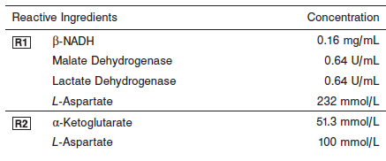

**Quality Control:** Minimum 2 levels of ChemistryControl (Normal and Abnormal)

**Calibration**

**Frequency:**

Calibration is stable for 30 days (720 hours) for any one lot.

**A new calibration is required:**

1. If quality control results do not meet acceptance criteria defined by your laboratory, patient values may be suspect. Follow the established quality control procedures for your laboratory. Recalibration may be necessary.
2. Review quality control results and acceptance criteria following a change of reagent or calibrator lot.

**Calibration Procedure:**

A calibration factor must be entered on the **Configure assay parameters** window, **Calibration** view. Refer to the ASSAY PARAMETERS section ofthe package insert for the specific factor.

• ARCHITECT *c* Systems—**Configure assay parameters** window, **Calibration** view

**Troubleshooting and Overall Acceptance Criteria Failure**

See ARCHITECT Operations Manual for further calibration troubleshooting.

**Quality Control:**

Abbott recommends, refer to your laboratory standard operating procedure(s) and/or quality assurance plan for additional quality control requirements and potential corrective actions:

• Two levels of controls (normal and abnormal) are to be run every 24 hours.

Some controls may require addition of Liquid Stabilizer.

• If more frequent control monitoring is required, follow the established quality control procedures for your laboratory.

• If quality control results do not meet the acceptance criteria defined by your laboratory, patient values may be suspect. Follow the established quality control procedures for your laboratory.

Recalibration may be necessary.

• Review quality control results and acceptance criteria following a change of reagent or calibrator lot.

**Procedure**

For a detailed description of how to run an assay, refer to *Section 5* of the **ARCHITECT System Operations Manual**.

**Calculations**

Refer to *Appendix C* of the **ARCHITECT System Operations Manual** for information on results calculations.

**Reporting Results**

The result unit for the AST assay can be reported as U/L

**Specific Performance Characteristics**

**Reference Ranges**

It is recommended that each laboratory determine its own reference range based upon its particular locale and population characteristics.

**Serum/Plasma:**



**Critical Values: N/A**

**Performance Characteristics**

**Linearity**

AST is linear up to 913 U/L.

Flex Rate Linearity is 4,202 U/L. To use Flex Rate Linearity, the operator must edit the linear high value to 4,202 on the **Configure assay** **parameters** window, **Results** view.

**Dilution:**

**Serum and Plasma:** Specimens with AST values exceeding 913 U/L (4,202 U/L for Flex Rate Linearity) are flagged and may be diluted using the Automated Dilution Protocol or the Manual Dilution Procedure.

**Automated Dilution Protocol**

If using the Automated Dilution Protocol, the system performs a dilution of the specimen and automatically corrects the enzyme activity value by multiplying the result by the appropriate dilution factor. To set up the automatic dilution feature, refer to *Section 2* of the instrument-specific operations manual for additional information.

**Manual Dilution Procedure**

Manual dilutions should be performed as follows:

• Use saline (0.85% to 0.90% NaCl) to dilute the sample.

• The operator must enter the dilution factor in the patient or control order screen. The system uses this dilution factor to automatically correct the enzyme activity value by multiplying the result by the entered factor.

• If the operator does not enter the dilution factor, the result must be multiplied by the appropriate dilution factor before reporting the result.

**NOTE:** If a diluted sample result is flagged indicating it is less than the linear low limit, do not report the result. Rerun using an appropriate dilution.

**Limit of Quantitation (LOQ):** The LOQ for AST is 2.2 U/L.

**Limit of Detection (LOD):** The LOD for AST is 2.0 U/L.

**Limitation of Procedure:**

N/A

**Precision:**

The imprecision of the AST assay is ≤ 4.6% Total CV.

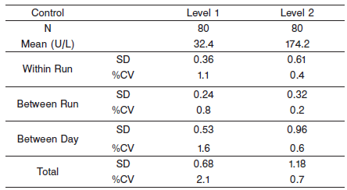

#### Interfering Substances:

**Interfering Substances**

Interference studies were conducted using CLSI protocol NCCLS EP7-P. Interference effects were assessed by Dose Response and Paired Difference methods, at the medical decision level of the analyte.

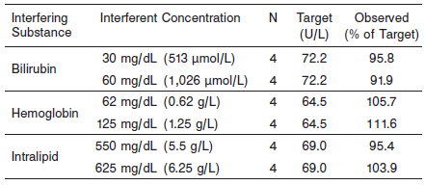

**References:**

1. ABBOTT ARCHITECT AST package insert

Abbott Laboratories

Diagnostics Division

Abbott Park, IL 60064

Oct 2012 304801/R02

1. Abbott ARCHITECT Operator’s Guide

**Related Documents:**

**Attachments:**