RUSH logo for emails

**LIPASE**

**SERUM OR PLASMA**

**ABBOTT ARCHITECT**

**Intended Use**

The Lipase assay is used for the quantitation of lipase in human serum or plasma.

**Clinical Significance**

Pancreatic lipase in serum and plasma is closely associated with pancreatic diseases. The activity of this enzyme has been measured as an important marker for diagnosing pancreatic diseases and the associated monitoring of therapeutic effects. Pancreatic lipase test kits currently available include a turbidimetric method using triglyceride as substrate and a colorimetric method using synthetic substrates. These

methods, however: 1) lack precision near the normal level; 2) exhibit poor reproducibility; and 3) are affected by other enzymes such as esterases.

The enzymatic color rate assay uses a clear substrate solution of 1,2‑diglyceride, which is a ‘natural’ substrate. The assay is highly sensitive and specific for pancreatic lipase, using colipase and deoxycholate as activators.

**Principle**

Lipase acts on a natural substrate, 1,2-diglyceride, to liberate 2‑monoglyceride. This is hydrolyzed by monoglyceride lipase into glycerol and free fatty acid. Glycerol kinase acts on glycerol to form glycerol‑3‑phosphate which is in turn acted on by glycerol-3-phosphate oxidase to generate hydrogen peroxide. Peroxidase converts the hydrogen peroxide, 4‑aminoantipyrine, and *N*-ethyl-*N*-(2-hydroxy- 3-sulfopropyl)-m-toluidine (TOOS) into a quinone dye. The rate of formation of the dye, measured as an increase in absorbance at 548 nm, is proportional to the lipase concentration in the sample.

**Methodology:** Quinone Dye.

**Specimen Collection and Handling**

Serum and plasma are acceptable specimens.

• **Serum:** Use serum collected by standard venipuncture techniques into glass or plastic tubes with or without gel barriers. Ensure complete clot formation has taken place prior to centrifugation.

Centrifuge according to tube manufacturer’s instructions to ensure proper separation of serum from blood cells.

Some specimens, especially those from patients receiving anticoagulant or thrombolytic therapy, may take longer to complete their clotting processes. Fibrin clots may subsequently form in these sera and the clots could cause erroneous test results.

• **Plasma:** Use plasma collected by standard venipuncture techniques into glass or plastic tubes. Acceptable anticoagulants are lithium heparin (with or without gel barrier) and sodium heparin. Ensure centrifugation is adequate to remove platelets. Centrifuge according to tube manufacturer’s instructions to ensure proper separation of plasma from blood cells.

**Specimen Storage**

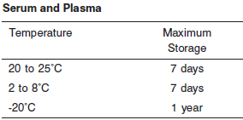

**NOTE:** Stored specimens must be inspected for particulates. If present, mix and centrifuge the specimen to remove particulates prior to testing.

**Materials and Equipment Required**

**TEST INSTRUMENT**: Abbott ARCHITECT System

**MATERIALS PROVIDED**

7D80 Lipase Reagent Kit

**MATERIALS REQUIRED BUT NOT PROVIDED**

• 3E16 Lipase Calibrator

• Control Material

• 2J94 Detergent B

• Saline (0.85% to 0.90% NaCl) for specimens that require dilution

**Reagent Handling and Storage:**

***CAUTION*:**

1. For in vitro diagnostic use.

2. Do not use components beyond the expiration date.

3. Do not mix materials from different kit lot numbers.

Do not mix reagents prepared at different times.

• Do not reuse the reagent containers, bottles, caps, or plugs due to the risk of contamination and the potential to compromise reagent performance.

**CAUTION:** This product requires the handling of human specimens.

It is recommended that all human sourced materials be considered

potentially infectious and be handled in accordance with the OSHA

Standard on Bloodborne Pathogens. Biosafety Level 2 or other appropriate biosafety practices should be used for materials that contain or are suspected of containing infectious agents.

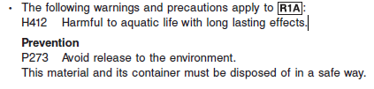

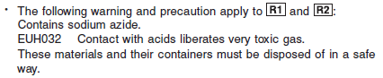

**Reagent Handling**

•R1 Ready for use.

• R2 Ready for use. Invert to mix well before first use. Avoid the formation of foam.

• Remove air bubbles, if present in the reagent cartridge, with a new applicator stick. Alternatively, allow the reagent to sit at the appropriate storage temperature to allow the bubbles to dissipate.

To minimize volume depletion, do not use a transfer pipette to remove the bubbles.

**CAUTION:** Reagent bubbles may interfere with proper detection of reagent level in the cartridge, causing insufficient reagent aspiration that could impact results.

**Reagent Storage**

• Reagent stability is 11 days if the reagent is uncapped and onboard.

• Unopened reagents are stable until the expiration date when stored at 2 to 8°C.

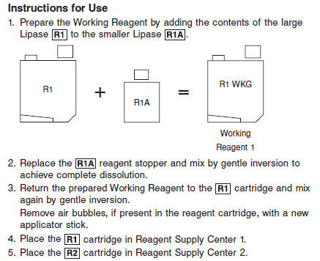

Reagent Preparation:

7D80-31 Lipase is supplied as a two-reagent kit which contains: **R1, R1A & R2**

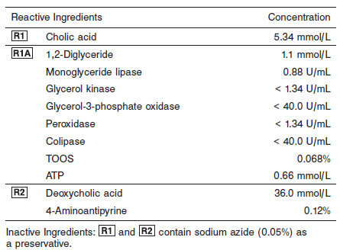

**Calibrator:** 3E16 Lipase Calibrator

**Quality Control:** Minimum 2 levels of ChemistryControl (Normal and Abnormal)

**Calibration**

**Frequency:**

Calibration is stable for 11 days for any one lot. Calibration is required with each change in reagent lot number.

**A new calibration is required:**

1. If quality control results do not meet acceptance criteria defined by your laboratory, patient values may be suspect. Follow the established quality control procedures for your laboratory. Recalibration may be necessary.
2. Review quality control results and acceptance criteria following a change of reagent or calibrator lot.

**Calibrator Required:** 3E16 Lipase Calibrator

**Reagents:**

Lipase Calibrator (lyophilized) is prepared from purified human pancreatic lipase. Preservatives are also present.

**Calibrator Preparation:**

Reconstitute the lyophilized calibrator by adding 3 mL of distilled or deionized water. Dissolve completely before use.

**Calibrator Procedure:**

Calibration is performed by running a water blank and Lipase Calibrator.

Water for the blank is provided by the instrument.

1. Verify that the correct calibrator value has been entered into the calibration file.

2. Mix bottle several times by gentle inversion.

3. Open bottle, place an appropriate amount in a sample cup, and place in the assigned position.

4. Cap bottle tightly and return to refrigerated storage immediately after use.

5. Perform calibration as indicated in the **ARCHITECT System Operations Manual**.

**Troubleshooting and Overall Acceptance Criteria Failure**

See ARCHITECT Operations Manual for further calibration troubleshooting.

**Quality Control:**

Abbott recommends, refer to your laboratory standard operating procedure(s) and/or quality assurance plan for additional quality control requirements and potential corrective actions:

• Two levels of controls (normal and abnormal) are to be run every 24 hours.

• If more frequent control monitoring is required, follow the established quality control procedures for your laboratory.

• If quality control results do not meet the acceptance criteria defined by your laboratory, patient values may be suspect. Follow the established quality control procedures for your laboratory.

Recalibration may be necessary.

• Review quality control results and acceptance criteria following a change of reagent or calibrator lot.

**Procedure**

For a detailed description of how to run an assay, refer to *Section 5* of the **ARCHITECT System Operations Manual**.

**Calculations**

Refer to *Appendix C* of the **ARCHITECT System Operations Manual** for information on results calculations.

**Reporting Results**

Results are expressed in U/L

**Specific Performance Characteristics**

**Reference Ranges**

It is recommended that each laboratory determine its own reference range based upon its particular locale and population characteristics.

**Serum/Plasma:**



**Critical Values: N/A**

**Performance Characteristics**

**Linearity**

Lipase is linear up to 1,200 U/L.

**Limit of Detection**

The LOD for Lipase is 1.6 U/L.

**Limit of Quantitation (LOQ)**

The LOQ for Lipase is 3.1 U/L.

**Dilution:**

**Serum and Plasma:** Specimens with lipase values exceeding 1,200 U/L are flagged and may be diluted by following either the Automated Dilution Protocol or the Manual Dilution Procedure.

**Automated Dilution Protocol**

If using the Automated Dilution Protocol, the system performs a dilution of the specimen and automatically corrects the enzyme activity value by multiplying the result by the appropriate dilution factor. To set up the automatic dilution feature, refer to *Section 2* of the **ARCHITECT System**

**Operations Manual** for additional information.

**Manual Dilution Procedure**

Manual dilutions should be performed as follows:

• Use saline (0.85% to 0.90% NaCl) to dilute the sample.

• The operator must enter the dilution factor in the patient or control order screen. The system uses this dilution factor to automatically correct the enzyme activity value by multiplying the result by the entered factor.

• If the operator does not enter the dilution factor, the result must be multiplied by the appropriate dilution factor before reporting the result.

**NOTE:** If a diluted sample result is flagged indicating it is less than the linear low limit, do not report the result. Rerun using an appropriate dilution.

For detailed information on ordering dilutions, refer to *Section 5* of the **ARCHITECT System Operations Manual**.

**Precision:**

The imprecision of the Lipase assay is ≤ 7.5% Total CV.

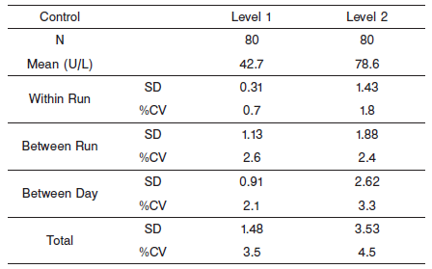

#### Limitations of Procedure

ARCHITECT c Systems are designed to mitigate reagent carryover, and testing is performed during assay development to determine needed SmartWash settings. However, system conditions may occur that allow Lipase contamination from other lipase-containing reagents. Lipase is found in Clinical Chemistry Cholesterol 7D62, Triglyceride 7D74, Direct LDL 1E31, and Ultra HDL 3K33 reagents.

To minimize the potential for Lipase contamination:

1. Always complete the cuvette wash cycle in its entirety. If necessary, Pause (do not stop) the system to ensure the cuvette wash occurs as scheduled.

2. Ensure instrument maintenance activities are complete.

3. Verify all SmartWash parameters are configured correctly.

4. Perform reagent carryover testing for non-Abbott assays before implementing them in the laboratory. Refer to Reagent carryover evaluation in the Architect c System Assay Applications Guide. For additional information, refer to Reagent carryover corrective action procedures in *Section 10* of the **ARCHITECT System Operations** **Manual.**

Should elevated or erratic Lipase results continue to occur, you may choose to configure the following SmartWash settings on the ARCHITECT c 4000 and c 8000 instruments (refer to *Section 2*, in the

**ARCHITECT System Operations Manual**):

Add the following SmartWash for all assays:

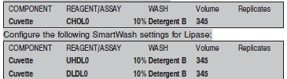

On the ARCHITECT c 16000 instrument, line-separate the Lipase reagent from the Cholesterol, Triglyceride, Ultra HDL, and Direct LDL reagents.

**Interfering Substances**

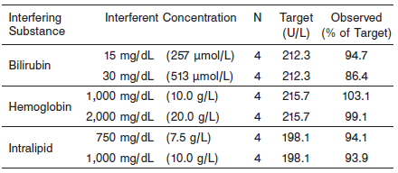

**References:**

1. ABBOTT ARCHITECT Lipase package insert

Abbott Laboratories

Diagnostics Division

Abbott Park, IL 60064

June 2016 306943/R04

1. ABBOTT ARCHITECT Lipase Calibrator package insert

Abbott Laboratories

Diagnostics Division

Abbott Park, IL 60064

1. Abbott ARCHITECT Operator’s Guide

**Related Documents:**

**Attachments:**