RUSH logo for emails

**ICT (Na+, K+, Cl-)**

**SERUM, PLASMA OR URINE**

**ABBOTT ARCHITECT**

**Intended Use**

The ARCHITECT *c* Systems ICT (Integrated Chip Technology) is used for the quantitation of sodium, potassium, and chloride in human serum, plasma, or urine.

**Clinical Significance**

Sodium is the major cation of extracellular fluid; it plays an essential role in the normal distribution of water and in the maintenance of osmotic pressure in extracellular fluid compartments. Decreased levels of sodium may be caused by an excessive use of diuretics, prolonged vomiting, a decrease in the intake of sodium in the diet, and metabolic acidosis. Increased levels of sodium may be found in Cushing’s syndrome, severe dehydration, or in high levels of salt intake without an adequate supply of water.

Potassium is the major intracellular cation. The concentration of potassium in the erythrocytes is approximately 23 times the concentration in plasma. For this reason, only unhemolyzed samples must be used. Decreased levels of extracellular potassium are characterized by weakness in the muscles, irritability, paralysis, accelerated heartbeat, and eventually cardiac arrest, and may be caused by a poor intake of potassium in the diet, by a redistribution of extracellular potassium, and by an increased loss of body fluids rich in potassium. Abnormally elevated levels of extracellular potassium produce mental confusion, general weakness, numbness, flaccid paralysis in the extremities, a slowed heart rate, and eventually collapse of the peripheral vascular system and cardiac arrest. Causes of increased potassium levels may be linked to inappropriate intravenous therapy, dehydration, shock, diabetic ketoacidosis, and severe burns.

Chloride is the major extracellular anion. The majority of ingested chloride is absorbed, and the excess is excreted along with other ions into the urine. Low levels of chloride are observed in the case of prolonged vomiting accompanied by the loss of hydrochloric acid (HCl), in some cases of metabolic acidosis in which there is an increased accumulation of organic anions, in critical cases of Addison’s disease, and in kidney disease resulting in loss of salt. Elevated levels of chloride are observed in metabolic acidosis associated with prolonged diarrhea and with loss of sodium bicarbonate (NaHCO3), and in the case of renal tubular diseases in which there is a decreased excretion of hydrogen ion (H+), which causes in turn a decrease in the reabsorption of bicarbonate ion (HCO3–). Elevated levels of serum chloride are also implicated in certain cases of hyperparathyroidism.

**Principle**

Ion-selective electrodes for sodium, potassium, and chloride utilize membranes selective to each of these ions. An electrical potential (voltage) is developed across the membranes between the reference and measuring electrodes in accordance with the Nernst equation. The voltage is compared to previously determined calibrator voltages and converted into ion concentration.

**Methodology:** Ion-selective electrode diluted (Indirect)

**Specimen Collection and Handling**

Serum, plasma, and urine are acceptable specimens.

• **Serum:** Use serum collected by standard venipuncture techniques into glass or plastic tubes with or without gel barriers. Ensure complete clot formation has taken place prior to centrifugation.

Centrifuge according to tube manufacturer’s instructions to ensure proper separation of serum from blood cells.

Some specimens, especially those from patients receiving anticoagulant or thrombolytic therapy, may take longer to complete their clotting processes. Fibrin clots may subsequently form in these sera and the clots could cause erroneous test results.

For Potassium, hemolyzed specimens must not be used.

• **Plasma:** Use plasma collected by standard venipuncture techniques into glass or plastic tubes. Acceptable anticoagulants are lithium heparin (with or without gel barrier) and sodium heparin (full draw).

Ensure centrifugation is adequate to remove platelets. Centrifuge according to tube manufacturer’s instructions to ensure proper separation of plasma from blood cells.

**NOTE:** Multiple myeloma and lipid samples are known to give low results on diluted ISE systems due to the high level of proteins/lipids present in the sample.

• **Urine:** Collect random or 24-hour urine specimens without the addition of preservatives.

The sample volume for the ICT assays is 15 μL. This volume is mixed with 69 μL of ICT Sample Diluent and 276 μL of system water.

**Specimen Storage**

**Serum and Plasma:**

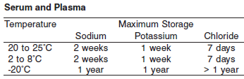

*A tolerance of +/- 10% (+/- 2°C) is assumed not to change the stability of the specimen. (W. Guder, personal communication, August 6, 2001).

**Urine**:

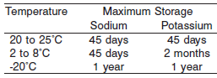

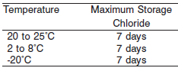

**NOTE:** Stored specimens must be inspected for particulates. If present, mix and centrifuge the specimen to remove particulates prior to testing.

**Materials and Equipment Required**

**TEST INSTRUMENT**: Abbott ARCHITECT System

**MATERIALS PROVIDED**

2P32 ICT Sample Diluent (ICTD5) Kit

**MATERIALS REQUIRED BUT NOT PROVIDED**

• 9D28 ICT Module

• 1E49 ICT Reference Solution

• 1E50 ICT Cleaning Fluid

• 1E46 ICT Serum Calibrator

• 1E47 ICT Urine Calibrator

• Control Material

• Disposable Pipette

**Reagent Handling and Storage:**

***CAUTION*:**

1. For in vitro diagnostic use.

2. Do not use components beyond the expiration date.

3. Do not mix materials from different kit lot numbers.

**CAUTION:** This product requires the handling of human specimens.

It is recommended that all human sourced materials be considered

potentially infectious and be handled in accordance with the OSHA

Standard on Bloodborne Pathogens. Biosafety Level 2 or other appropriate biosafety practices should be used for materials that contain or are suspected of containing infectious agents.

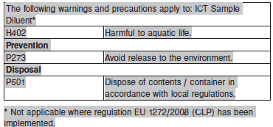

**Reagent Handling**

Remove air bubbles, if present in the reagent cartridge, with a new applicator stick. Alternatively, allow the reagent to sit at the appropriate storage temperature to allow the bubbles to dissipate.

To minimize volume depletion, do not use a transfer pipette to remove the bubbles.

**CAUTION:** Reagent bubbles may interfere with proper detection of reagent level in the cartridge, causing insufficient reagent aspiration that could impact results.

.

**Reagent Storage**

• Reagent stability is 30 days if the reagent is uncapped and onboard.

• Unopened reagents are stable until the expiration date when stored at 15 to 30°C.

Reagent Preparation:

ICT Sample Diluent (ICTD5) is supplied as a liquid, ready-to-use single reagent kit which contains:





**Quality Control:** Chemistry Controls

**Calibration**

Calibration is stable up to 24 hours and calibration is required with each change in diluent lot number. The laboratory may choose any calibration interval up to 24 hours. The use of a particular calibration time interval is dependent on individual laboratory policy or preference.

**Troubleshooting and Overall Acceptance Criteria Failure**

See ARCHITECT Operations Manual for further calibration troubleshooting.

**Quality Control:**

Abbott recommends, refer to your laboratory standard operating procedure(s) and/or quality assurance plan for additional quality control requirements and potential corrective actions:

• Two levels of controls (normal and abnormal) are to be run every 8 hours and following calibration.

• If more frequent control monitoring is required, follow the established quality control procedures for your laboratory.

• If quality control results do not meet the acceptance criteria defined by your laboratory, patient values may be suspect. Follow the established quality control procedures for your laboratory.

Recalibration may be necessary.

• Review quality control results and acceptance criteria following a change of reagent or calibrator lot.

**Procedure**

For a detailed description of how to run an assay, refer to *Section 5* of the **ARCHITECT System Operations Manual**.

The Sodium, Potassium, and Chloride assay files must be installed on the ARCHITECT cSystem prior to performing the assay.

For detailed information on assay file installation and viewing and editing assay parameters, refer to the ARCHITECT System Operations Manual, Section 2.

For information on printing assay parameters or for a detailed description of system procedures, refer to the ARCHITECT System Operations Manual, Section 5.

**Calculations**

Refer to *Appendix C* of the **ARCHITECT System Operations Manual** for information on results calculations.

**Reporting Results**

The Conventional result units for the Sodium, Potassium, and Chloride assays are mmol/L. The corresponding SI result units are mmol/L.

**Specific Performance Characteristics**

**Reference Ranges**

It is recommended that each laboratory determine its own reference range based upon its particular locale and population characteristics.

**Serum/Plasma:**

**Sodium:**

<1 year: 133 – 146 mmol/L

Adult: 136 – 145 mmol/L

**Potassium:**

<2 months: 3.7 - 5.9 mmol/L

2-12 months: 4.1 - 5.3 mmol/L

Adult: 3.4 - 5.1 mmol/L

**Chloride:**

<30 days: 98 – 113 mmol/L

Adult: 98 – 107 mmol/L

**Urine:**

**Sodium:** Adult 10 – 220 mmol/L

**Potassium:** Adult 25 – 125 mmol/L

**Chloride:** Adult: 110 – 250 mmol/L

**Critical Values:**

**Serum/Plasma:**

**Sodium:** < 2 months: <124 and >161 mmol/L

< 150 years: <119 and >161 mmol/L

**Potassium:** < 2 months: <3 and >7 mmol/L

< 150 years: <3 and >6 mmol/L

**Chloride: N/A**

**Urine: N/A**

**Performance Characteristics**

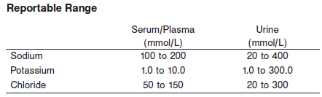.

**Linearity**

Sodium serum is linear up to 200 mmol/L. Sodium urine is linear up to 400 mmol/L.

Potassium serum is linear up to 10 mmol/L. Potassium urine is linear up to 300 mmol/L.

Chloride serum is linear up to 150 mmol/L. Chloride urine is linear up to 300 mmol/L.

**Dilution:**

N/A

**Precision:**

**Serum**

The imprecision of the ICT assays for serum samples are as follows: Sodium ≤ 1.5%, Potassium ≤ 2.7%, Chloride ≤ 2.0%.

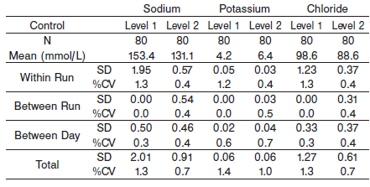

**Urine**

The imprecision of the ICT assays for urine samples are as follows:

Sodium ≤ 3.0%, Potassium ≤ 3%, Chloride ≤ 1.8%.

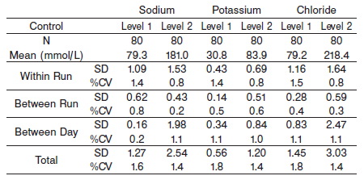

#### Limitations of Procedure

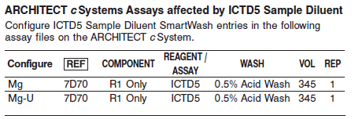

**Interfering Substances**

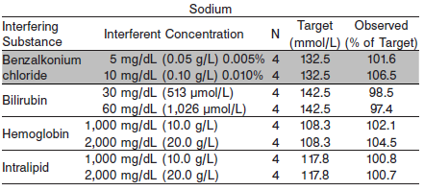

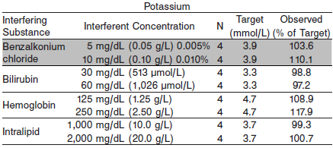

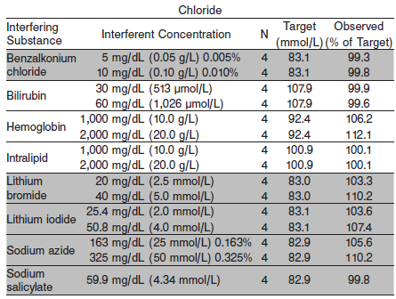

**References:**

1. ABBOTT ARCHITECT ICT package insert

Abbott Laboratories

Diagnostics Division

Abbott Park, IL 60064

May 2016 306954/R04

1. Abbott ARCHITECT Operator’s Guide

**Related Documents:**

**Attachments:**