RUSH logo for emails

**TOTAL PROTEIN**

**SERUM OR PLASMA**

**ABBOTT ARCHITECT**

**Intended Use**

The Total Protein assay is used for the quantitation of total protein in human serum or plasma.

**Clinical Significance**

Plasma proteins derive primarily from synthesis in the liver, plasma cells, lymph nodes, spleen, and bone marrow. In disease states both the total plasma protein level and the ratio of the individual fractions may be dramatically altered from their normal values. Hypoproteinemia may be caused by such conditions as nephrotic syndrome, extensive bleeding, sprue (deficient protein absorption), severe burns, salt retention syndromes, and Kwashiorkor (acute protein starvation). Hyperproteinemia may be observed in cases of severe dehydration and disease states such as multiple myeloma. Changes in the proportions of the plasma proteins may occur in one or several of the protein fractions and often without alterations in the quantity of the total protein. The A/G ratio has commonly been used as an index of the distribution between the albumin and globulin fractions. This ratio can be significantly altered in such conditions as cirrhosis of the liver, glomerulonephritis, nephrotic syndrome, acute hepatitis, lupus erythematosis, and in some acute and chronic infections.

**Principle**

Polypeptides containing at least two peptide bonds react with biuret reagent. In alkaline solution, cupric ion forms a coordination complex with protein nitrogen with very little difference between albumin and globulin on a protein‑nitrogen basis.

**Methodology:** Biuret

**Specimen Collection and Handling**

Serum and plasma are acceptable specimens.

• **Serum:** Use serum collected by standard venipuncture techniques into glass or plastic tubes with or without gel barriers. Ensure complete clot formation has taken place prior to centrifugation.

When processing samples, separate serum from blood cells or gel according to the specimen collection tube manufacturer’s instructions.

Some specimens, especially those from patients receiving anticoagulant or thrombolytic therapy, may take longer to complete their clotting processes. Fibrin clots may subsequently form in these sera and the clots could cause erroneous test results.

• **Plasma:** Use plasma collected by standard venipuncture techniques into glass or plastic tubes. Acceptable anticoagulants are lithium heparin (with or without gel barrier) and sodium heparin. Ensure centrifugation is adequate to remove platelets. When processing samples, separate plasma from blood cells or gel according to the specimen collection tube manufacturer’s instructions.

**Specimen Storage**

**Serum and Plasma:** Total protein is stable in serum and plasma for 1 week at room temperature, for at least 1 month when refrigerated, and for up to 2 months at -20°C.5 An in-house study confirmed total protein is stable in serum for 34 days at 2 to 8°C.

**NOTE:** Stored specimens must be inspected for particulates. If present, mix and centrifuge the specimen to remove particulates prior to testing.

**Materials and Equipment Required**

**TEST INSTRUMENT**: Abbott ARCHITECT System

**MATERIALS PROVIDED**

7D73 Total Protein Reagent Kit

**MATERIALS REQUIRED BUT NOT PROVIDED**

• 1E65 Multiconstituent Calibrator

• Control Material

• Saline (0.85% to 0.90% NaCl) for specimens that require dilution

**Reagent Handling and Storage:**

***CAUTION*:**

1. For in vitro diagnostic use.

2. Do not use components beyond the expiration date.

3. Do not mix reagents prepared at different times.

4. **CAUTION:** This product requires the handling of human specimens.

It is recommended that all human sourced materials be considered potentially infectious and be handled in accordance with the OSHA Standard on Bloodborne Pathogens. Biosafety Level 2 or other appropriate biosafety practices should be used for materials that contain or are suspected of containing infectious agents.

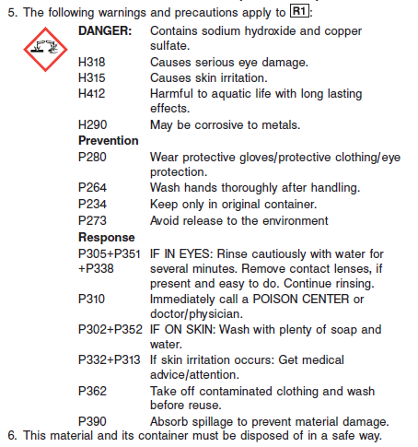

**Reagent Handling**

Remove air bubbles, if present in the reagent cartridge, with a new applicator stick. Alternatively, allow the reagent to sit at the appropriate storage temperature to allow the bubbles to dissipate. To minimize volume depletion, do not use a transfer pipette to remove the bubbles.

**CAUTION:** Reagent bubbles may interfere with proper detection of reagent level in the cartridge, causing insufficient reagent aspiration which could impact results.

**Reagent Storage**

Unopened reagents are stable until the expiration date when stored at 15 to 30°C.

Reagent stability is 23 days if the reagent is uncapped and onboard.

The R2 reagent may be colorless, yellow, green, or blue in appearance.

Reagent Preparation:

Total Protein is supplied as a liquid, ready-to-use, single reagent kit which contains: R1

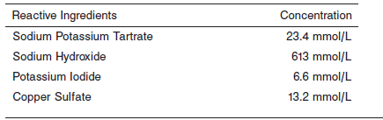

**Calibrator:** 1E65 Multiconstituent Calibrator

**Quality Control:** Minimum 2 levels of ChemistryControl (Normal and Abnormal)

**Calibration**

**Frequency:**

Calibration is stable for 23 days (552 hours) for any one lot.

**A new calibration is required:**

1. If quality control results do not meet acceptance criteria defined by your laboratory, patient values may be suspect. Follow the established quality control procedures for your laboratory. Recalibration may be necessary.
2. Review quality control results and acceptance criteria following a change of reagent or calibrator lot.

**Calibration Procedure:**

Calibration is performed by running a water blank and the Multiconstituent Calibrator set. Water for the blank is provided by the instrument.

1. Verify that the correct calibrator values have been entered into the calibration file.

2. Allow calibrator to come to room temperature.

3. Mix bottle five times by gentle inversion.

4. Open bottle, place an appropriate amount of each calibrator in a separate sample cup, and place in the assigned positions.

5. Cap bottle tightly and return to refrigerated storage immediately after use.

6. Perform calibration as indicated in the **ARCHITECT System Operations Manual**.

**Troubleshooting and Overall Acceptance Criteria Failure**

See ARCHITECT Operations Manual for further calibration troubleshooting.

**Quality Control:**

Abbott recommends, refer to your laboratory standard operating procedure(s) and/or quality assurance plan for additional quality control requirements and potential corrective actions:

• Two levels of controls (normal and abnormal) are to be run every 24 hours.

Some controls may require addition of Liquid Stabilizer.

• If more frequent control monitoring is required, follow the established quality control procedures for your laboratory.

• If quality control results do not meet the acceptance criteria defined by your laboratory, patient values may be suspect. Follow the established quality control procedures for your laboratory.

Recalibration may be necessary.

• Review quality control results and acceptance criteria following a change of reagent or calibrator lot.

**Procedure**

For a detailed description of how to run an assay, refer to *Section 5* of the **ARCHITECT System Operations Manual**.

**Calculations**

Refer to *Appendix C* of the **ARCHITECT System Operations Manual** for information on results calculations.

**Reporting Results**

The ARCHITECT Total Protein assay unit is g/dL or g/L

**Specific Performance Characteristics**

**Reference Ranges**

It is recommended that each laboratory determine its own reference range based upon its particular locale and population characteristics.

**Serum/Plasma:**

<2 months: 4.6 – 7.0 g/dL

<1 year: 5.1 – 7.3 g/dL

<2 years: 5.6 – 7.5 g/dL

Adult: 6.4 – 8.3 g/dL

**Critical Values: N/A**

**Performance Characteristics**

**Linearity**

Total Protein is linear up to 18.4 g/dL (184 g/L).

**Dilution:**

**Serum and Plasma:** Specimens with total protein values exceeding 18.4 g/dL (184 g/L) are flagged and may be diluted using the Automated Dilution Protocol or the Manual Dilution Procedure.

**Automated Dilution Protocol**

If using the Automated Dilution Protocol, the system performs a dilution of the specimen and automatically corrects the concentration by multiplying the result by the appropriate dilution factor. To set up the automatic dilution feature, refer to *Section 2* of the instrument-specific operations manual for additional information.

**Manual Dilution Procedure**

Manual dilutions should be performed as follows:

• Use saline (0.85% to 0.90% NaCl) to dilute the sample.

• The operator must enter the dilution factor in the patient or control order screen. The system uses this dilution factor to automatically correct the concentration by multiplying the result by the entered factor.

• If the operator does not enter the dilution factor, the result must be multiplied by the appropriate dilution factor before reporting the result.

**NOTE:** If a diluted sample result is flagged indicating it is less than the linear low limit, do not report the result. Rerun using an appropriate dilution.

**Limit of Detection (LOD):** The LOD for Total Protein is 0.5 g/dL (5.0 g/L).

**Limit of Quantitation (LOQ):** The LOQ for Total Protein is 0.76 g/dL (7.6 g/L).

**Limitation of Procedure:**

N/A

**Precision:**

The imprecision of the Total Protein assay is ≤ 3% Total CV.

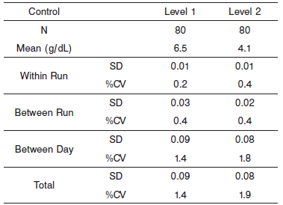

#### Interfering Substances:

**Interfering Substances**

Interference studies were conducted using CLSI protocol NCCLS EP7‑P. Interference effects were assessed by Dose Response and Paired Difference methods, at the medical decision level of the analyte.

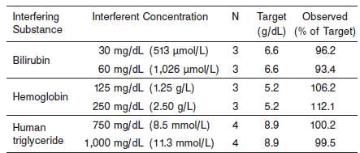

**References:**

1. ABBOTT ARCHITECT Total Protein package insert

Abbott Laboratories

Diagnostics Division

Abbott Park, IL 60064

Oct 2009 304326/R1

1. ABBOTT Multiconstituent Calibrator

Abbott Laboratories

Diagnostics Division

Abbott Park, IL 60064

June 2013 306297/R04

1. Abbott ARCHITECT Operator’s Guide

**Related Documents:**

**Attachments:**