RUSH logo for emails

**ULTRA HDL**

**SERUM OR PLASMA**

**ABBOTT ARCHITECT**

**Intended Use**

The Ultra HDL (UHDL) assay is used for the quantitation of high-density lipoprotein (HDL) cholesterol in human serum or plasma.

**Clinical Significance**

Plasma lipoproteins are spherical particles containing varying amounts of cholesterol, triglycerides, phospholipids, and proteins. Phospholipids, free cholesterol, and proteins constitute the outer surface of the lipoprotein particle, while the inner core contains mostly esterified cholesterol and triglyceride. These particles serve to solubilize and transport cholesterol and triglyceride in the bloodstream.

The relative proportions of protein and lipid determine the density of these lipoproteins and provide a basis on which to begin their classification. The classes are: chylomicron, very-low-density lipoprotein (VLDL), low-density lipoprotein (LDL), and high-density lipoprotein (HDL). Numerous clinical studies have shown that the different lipoprotein classes have very distinct and varied effects on coronary heart disease risk. The principle role of HDL cholesterol in lipid metabolism is the uptake and transport of cholesterol from peripheral tissues to the liver through a process known as reverse cholesterol transport (a proposed cardioprotective mechanism). Low HDL cholesterol levels are strongly associated with an increased risk of coronary heart disease. Hence, the determination of serum HDL cholesterol is a useful tool in identifying high-risk patients. The Adult Treatment Panel of the National Cholesterol Education Program (NCEP) recommends that in all adults 20 years of age and over, a fasting lipoprotein profile (total cholesterol, LDL cholesterol, HDL cholesterol, and triglyceride) should be obtained once every five years to screen for coronary heart disease risk.

**Principle**

The Ultra HDL assay is a homogeneous method for directly measuring HDL cholesterol concentrations in serum or plasma without the need for off‑line pretreatment or centrifugation steps. The method uses a two-reagent format and depends on the properties of a unique detergent. This method is based on accelerating the reaction of cholesterol oxidase (CO) with non-HDL unesterified cholesterol and dissolving HDL cholesterol selectively using a specific detergent. In the first reagent, non-HDL unesterified cholesterol is subject to an enzyme reaction and the peroxide generated is consumed

by a peroxidase reaction with DSBmT yielding a colorless product. The second reagent consists of a detergent (capable of solubilizing HDL cholesterol), cholesterol esterase (CE), and chromagenic coupler to develop color for the quantitative determination of HDL cholesterol.

**Methodology:** Accelerator Selective Detergent

**Specimen Collection and Handling**

Serum and plasma are acceptable specimens. The National Cholesterol Education Program (NCEP) recommends using fasting specimens for a lipoprotein profile. If the specimen is nonfasting, only the values for total cholesterol and HDL cholesterol are usable.

• **Serum:** Use serum collected by standard venipuncture techniques into glass or plastic tubes with or without gel barriers. Ensure complete clot formation has taken place prior to centrifugation. Centrifuge according to tube manufacturer’s instructions to ensure proper separation of serum from blood cells.

Some specimens, especially those from patients receiving anticoagulant or thrombolytic therapy, may take longer to complete their clotting processes. Fibrin clots may subsequently form in these sera and the clots could cause erroneous test results.

• **Plasma:** Use plasma collected by standard venipuncture techniques into glass or plastic tubes. Acceptable anticoagulants are sodium heparin, lithium heparin (with or without gel barrier), and spray‑dried EDTA.* Ensure centrifugation is adequate to remove platelets. Centrifuge according to tube manufacturer’s instructions to ensure proper separation of plasma from blood cells.

\***NOTE:** Lower HDL cholesterol results obtained from EDTA plasma have been attributed to an osmotic dilution effect. The NCEP has suggested multiplying EDTA plasma results by a factor of 1.03 to correct the EDTA result to a serum equivalent value

**Specimen Storage**

.

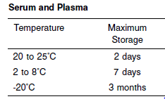

**NOTE:** Stored specimens must be inspected for particulates. If present, mix and centrifuge the specimen to remove particulates prior to testing.

**Materials and Equipment Required**

**TEST INSTRUMENT**: Abbott ARCHITECT System

**MATERIALS PROVIDED**

3K33-21 Ultra HDL Reagent Kit

**MATERIALS REQUIRED BUT NOT PROVIDED**

• 5P56-01 Lipid Multiconstituent Calibrator

• Control Material

• Saline (0.85% to 0.90% NaCl) for specimens that require dilution

**Reagent Handling and Storage:**

***CAUTION*:**

1. For in vitro diagnostic use.

2. Do not use components beyond the expiration date.

3. Do not mix materials from different kit lot numbers.

**CAUTION:** This product requires the handling of human specimens.

It is recommended that all human sourced materials be considered

potentially infectious and be handled in accordance with the OSHA

Standard on Bloodborne Pathogens. Biosafety Level 2 or other appropriate biosafety practices should be used for materials that contain or are suspected of containing infectious agents.

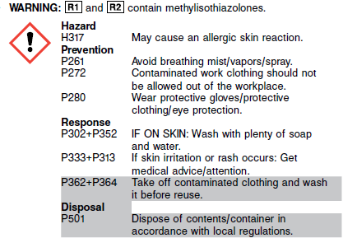

**Reagent Handling**

• Remove air bubbles, if present in the reagent cartridge, with a new applicator stick. Alternatively, allow the reagent to sit at the appropriate storage temperature to allow the bubbles to dissipate.

To minimize volume depletion, do not use a transfer pipette to remove the bubbles.

**CAUTION:** Reagent bubbles may interfere with proper detection of reagent level in the cartridge, causing insufficient reagent aspiration that could impact results.

**Reagent Storage**

• Reagent stability is 28 (672 hours) days if the reagent is uncapped and onboard.

• Unopened reagents are stable until the expiration date when stored at 2 to 8°C.

• DO NOT FREEZE.

• Protect reagents from direct sunlight.

Reagent Preparation:

3K33-21 Ultra HDL is supplied as a liquid, ready-to-use, two‑reagent kit which contains: **R1 & R2**

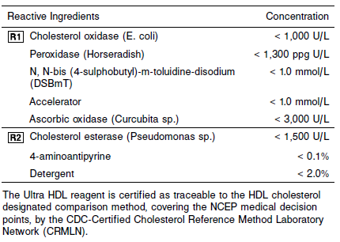

**Calibrator:** 5P56-01 Lipid Multiconstituent Calibrator

**Quality Control:** Minimum 2 levels of ChemistryControl (Normal and Abnormal)

**Calibration**

**Frequency:**

Calibration is stable for 28 days (672 hours) for any one lot. Calibration is required with each change in reagent lot number.

**A new calibration is required:**

1. If quality control results do not meet acceptance criteria defined by your laboratory, patient values may be suspect. Follow the established quality control procedures for your laboratory. Recalibration may be necessary.
2. Review quality control results and acceptance criteria following a change of reagent or calibrator lot.

**Calibrator Required:** 5P56-01 Lipid Multiconstituent Calibrator

**Reagents:**

Lipid MC Cal is prepared from human serum. Preservatives are also present.

**Calibrator Preparation:**

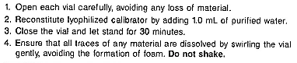

**Calibration Procedure:**

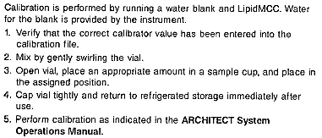

**Troubleshooting and Overall Acceptance Criteria Failure**

See ARCHITECT Operations Manual for further calibration troubleshooting.

**Quality Control:**

Abbott recommends, refer to your laboratory standard operating procedure(s) and/or quality assurance plan for additional quality control requirements and potential corrective actions:

• Two levels of controls (normal and abnormal) are to be run every 24 hours.

• If more frequent control monitoring is required, follow the established quality control procedures for your laboratory.

• If quality control results do not meet the acceptance criteria defined by your laboratory, patient values may be suspect. Follow the established quality control procedures for your laboratory.

Recalibration may be necessary.

• Review quality control results and acceptance criteria following a change of reagent or calibrator lot.

**Procedure**

For a detailed description of how to run an assay, refer to *Section 5* of the **ARCHITECT System Operations Manual**.

**Calculations**

Refer to *Appendix C* of the **ARCHITECT System Operations Manual** for information on results calculations.

**Reporting Results**

The result unit for the MULTIGENT Ultra HDL assay can be reported as mg/dL or mmol/L.

**Specific Performance Characteristics**

**Reference Ranges**

It is recommended that each laboratory determine its own reference range based upon its particular locale and population characteristics.

**Serum/Plasma:**

Major risk factor for heart disease <40 mg/dL

Negative risk factor for heart disease >60 mg/dL

**Critical Values: N/A**

**Performance Characteristics**

**Linearity**

Ultra HDL is linear up to 180 mg/dL (4.66 mmol/L), with recovery within 10% of the predicted value with 95% confidence.

**Limit of Detection and Quantitation**

The limit of quantitation (LOQ) for Ultra HDL is 5.0 mg/dL (0.13 mmol/L), and the limit of detection (LOD) is 2.5 mg/dL (0.06 mmol/L).

**Dilution:**

**Serum and Plasma:** Specimens with HDL cholesterol values exceeding 180 mg/dL (4.66 mmol/L) are flagged and may be diluted by following either the Automated Dilution Protocol or the Manual Dilution Procedure.

**Automated Dilution Protocol**

If using the Automated Dilution Protocol, the system performs a dilution of the specimen and automatically corrects the concentration by multiplying the result by the appropriate dilution factor. To set up the automatic dilution feature, refer to *Section 2* of the **ARCHITECT System** **Operations Manual** for additional information.

**Manual Dilution Procedure**

Manual dilutions should be performed as follows:

• Use saline (0.85% to 0.90% NaCl) to dilute the sample.

• The operator must enter the dilution factor in the patient or control order screen. The system uses this dilution factor to automatically correct the concentration by multiplying the result by the entered factor.

• If the operator does not enter the dilution factor, the result must be multiplied by the appropriate dilution factor before reporting the result.

**NOTE:** If a diluted sample result is flagged indicating it is less than the linear low limit, do not report the result. Rerun using an appropriate dilution.

For detailed information on ordering dilutions, refer to *Section 5* of the **ARCHITECT System Operations Manual**.

**Precision:**

The imprecision of the Ultra HDL assay is total SD ≤ 1.7 mg/dL or total CV ≤ 4%, whichever is greater.

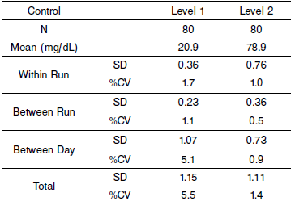

#### Limitations of Procedure

Using three homogenous HDL assays, Camps, et al. have reported artificially low HDL results in patients with liver cirrhosis. Published studies are not available that define the severity of liver disease necessary to affect lipoprotein and HDL metabolism, or establish other possible patterns of interference with HDL results. When an HDL result is diagnostically critical with concomitant clinically relevant liver disease, use a recognized precipitation or ultracentrifugation HDL‑reference method for confirmation. Artificially decreased or increased HDL values in the presence of dyslipidemias have been reported.

**Interfering Substances**

Interference studies were conducted using an acceptance criteria of 5% of the target value. Interference effects were assessed by Dose Response method, at the medical decision levels of the analyte.

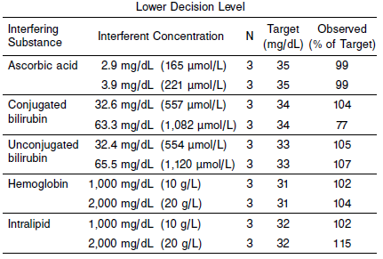

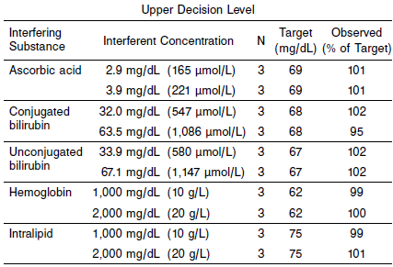

**References:**

1. ABBOTT ARCHITECT Ultra HDL package insert

Abbott Laboratories

Diagnostics Division

Abbott Park, IL 60064

Dec 2014 306571/R03

1. ABBOTT ARCHITECT Lipid Multiconstituent Calibrator package insert

Abbott Laboratories

Diagnostics Division

Abbott Park, IL 60064

1. Abbott ARCHITECT Operator’s Guide

**Related Documents:**

**Attachments:**