RUSH logo for emails

**GLUCOSE**

**SERUM, PLASMA, OR CSF**

**ABBOTT ARCHITECT**

**Intended Use**

The Glucose assay is used for the quantitation of glucose in human serum, plasma, urine, or cerebrospinal fluid (CSF).

**Clinical Significance**

Blood glucose determinations are the most frequently performed clinical chemistry laboratory procedures, commonly used as an aid in the diagnosis and treatment of diabetes. Elevated glucose levels (hyperglycemia) may also occur with pancreatic neoplasm, hyperthyroidism, and adrenal cortical hyperfunction as well as other disorders. Decreased glucose levels (hypoglycemia) may result from excessive insulin therapy or various liver diseases.

**Principle**

Glucose is phosphorylated by hexokinase (HK) in the presence of adenosine triphosphate (ATP) and magnesium ions to produce glucose-6-phosphate (G-6-P) and adenosine diphosphate (ADP). Glucose-6-phosphate dehydrogenase (G-6-PDH) specifically oxidizes G-6-P to 6-phosphogluconate with the concurrent reduction of nicotinamide adenine dinucleotide (NAD) to nicotinamide adenine dinucleotide reduced (NADH). One micromole of NADH is produced for each micromole of glucose consumed. The NADH produced absorbs light at 340 nm and can be detected spectrophotometrically as an increased absorbance.

**Methodology:** Hexokinase/G-6-PDH

**Specimen Collection and Handling**

**Suitable Specimens**

Serum, plasma, and CSF are acceptable specimens.

• **Serum:** Use serum collected by standard venipuncture techniques into glass or plastic tubes with or without gel barriers. Ensure complete clot formation has taken place prior to centrifugation.

Centrifuge according to tube manufacturer’s instructions to ensure proper separation of serum from blood cells.

Some specimens, especially those from patients receiving anticoagulant or thrombolytic therapy, may take longer to complete their clotting processes. Fibrin clots may subsequently form in these sera and the clots could cause erroneous test results.

• **Plasma:** Use plasma collected by standard venipuncture techniques into glass or plastic tubes. Acceptable anticoagulants are lithium heparin (with or without gel barrier), sodium heparin, sodium fluoride/ potassium oxalate, and EDTA. Ensure centrifugation is adequate to remove platelets. Centrifuge according to tube manufacturer’s instructions to ensure proper separation of plasma from blood cells.

• **CSF:** Process immediately to avoid falsely low results

**Specimen Storage**

Glucose in whole blood stored at room temperature is metabolized at a rate of approximately 5% per hour

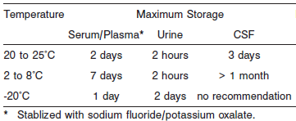

**NOTE:** Stored specimens must be inspected for particulates. If present, mix and centrifuge the specimen to remove particulates prior to testing.

**Materials and Equipment Required**

**TEST INSTRUMENT**: Abbott ARCHITECT System

**MATERIALS PROVIDED**

3L82 Glucose Reagent Kit

**MATERIALS REQUIRED BUT NOT PROVIDED**

• 1E65 Multiconstituent Calibrator

• Control Material

• Saline (0.85% to 0.90% NaCl) for specimens that require dilution

**Reagent Handling and Storage:**

***CAUTION*:**

1. For in vitro diagnostic use.

2. Do not use components beyond the expiration date.

3. Do not mix reagents prepared at different times.

**CAUTION:** This product requires the handling of human specimens.

It is recommended that all human sourced materials be considered potentially infectious and be handled in accordance with the OSHA Standard on Bloodborne Pathogens. Biosafety Level 2 or other appropriate biosafety practices should be used for materials that contain or are suspected of containing infectious agents.

• The following warning and precaution apply to R1:

Contains sodium azide.

EUH032 Contact with acids liberates very toxic gas.

This material and its container must be disposed of in a safe way.

**Reagent Handling**

Remove air bubbles, if present in the reagent cartridge, with a new applicator stick. Alternatively, allow the reagent to sit at the appropriate storage temperature to allow the bubbles to dissipate. To minimize volume depletion, do not use a transfer pipette to remove the bubbles.

**CAUTION:** Reagent bubbles may interfere with proper detection of reagent level in the cartridge, causing insufficient reagent aspiration which could impact results.

**Reagent Storage**

Unopened reagents are stable until the expiration date when stored at 2 to 8°C.

Reagent stability is 30 days if the reagent is uncapped and onboard.

Reagent Preparation:

Glucose is supplied as a liquid, ready-to-use, single reagent kit which Contains: R1

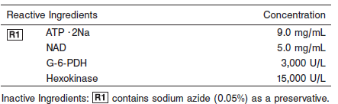

**Calibrator:** 1E65 Multiconstituent Calibrator

**Quality Control:** Minimum 2 levels of ChemistryControl (Normal and Abnormal), Urine & CSF controls

**Calibration**

**Frequency:**

Calibration is stable for 30 days (720 hours) for any one lot.

**A new calibration is required:**

1. If quality control results do not meet acceptance criteria defined by your laboratory, patient values may be suspect. Follow the established quality control procedures for your laboratory. Recalibration may be necessary.
2. Review quality control results and acceptance criteria following a change of reagent or calibrator lot.

**Calibration Procedure:**

Calibration is performed by running a water blank and the Multiconstituent Calibrator set. Water for the blank is provided by the instrument.

1. Verify that the correct calibrator values have been entered into the calibration file.

2. Allow calibrator to come to room temperature.

3. Mix bottle five times by gentle inversion.

4. Open bottle, place an appropriate amount of each calibrator in a separate sample cup, and place in the assigned positions.

5. Cap bottle tightly and return to refrigerated storage immediately after use.

6. Perform calibration as indicated in the **ARCHITECT System Operations Manual**.

**Troubleshooting and Overall Acceptance Criteria Failure**

See ARCHITECT Operations Manual for further calibration troubleshooting.

**Quality Control:**

Abbott recommends, refer to your laboratory standard operating procedure(s) and/or quality assurance plan for additional quality control requirements and potential corrective actions:

• Two levels of controls (normal and abnormal) are to be run every 24 hours.

Some controls may require addition of Liquid Stabilizer.

• If more frequent control monitoring is required, follow the established quality control procedures for your laboratory.

• If quality control results do not meet the acceptance criteria defined by your laboratory, patient values may be suspect. Follow the established quality control procedures for your laboratory.

Recalibration may be necessary.

• Review quality control results and acceptance criteria following a change of reagent or calibrator lot.

**Procedure**

For a detailed description of how to run an assay, refer to *Section 5* of the **ARCHITECT System Operations Manual**.

**Calculations**

Refer to *Appendix C* of the **ARCHITECT System Operations Manual** for information on results calculations.

**Reporting Results**

The ARCHITECT Glucose assay can be reported in mg/dL or mmol/L

**Specific Performance Characteristics**

**Reference Ranges**

It is recommended that each laboratory determine its own reference range based upon its particular locale and population characteristics.

The American Diabetes Association recommends use of a fasting glucose concentration of 99 mg/dL (5.5 mmol/L) as the upper limit of “normal”. Population reference ranges in various texts and publications may differ.

**Serum/Plasma:**

<2 years: 40 – 80 mg/dL

< 12 years: 60 – 100 mg/dL

Adult: 70 – 100 mg/dL

**CSF:**

< 12 years: 60 – 80 mg/dL

Adult: 40 – 70 mg/dL

**Critical Values:**

**Serum/Plasma:** <39.0 and >500

**CSF: N/A**

**Performance Characteristics**

**Linearity**

Glucose serum is linear from 5 to 800 mg/dL (0.28 to 44.40 mmol/L).

Glucose urine/CSF is linear from 1 to 800 mg/dL (0.06 to 44.40 mmol/L).

**Dilution:**

**Serum and Plasma:** Specimens with glucose values exceeding 800 mg/dL (44 mmol/L) are flagged and may be diluted by following either the Automated Dilution Protocol or the Manual Dilution Procedure.

**Urine and CSF:** Specimens with glucose values exceeding 800 mg/dL (44 mmol/L) are flagged and may be diluted by following the Manual Dilution Procedure, or an automatic dilution may be configured. Refer to *Section 2* of the **ARCHITECT System Operations Manual** for additional information.

**Serum/Plasma Automated Dilution Protocol**

If using the Automated Dilution Protocol, the system performs a 1:5 dilution of the specimen and automatically corrects the concentration by multiplying the result by the appropriate dilution factor.

**Manual Dilution Procedure**

Manual dilutions should be performed as follows:

• Use saline (0.85% to 0.90% NaCl) to dilute the sample.

• The operator must enter the dilution factor in the patient or control order screen. The system uses this dilution factor to automatically correct the concentration by multiplying the result by the entered factor.

• If the operator does not enter the dilution factor, the result must be multiplied by the appropriate dilution factor before reporting the result.

**NOTE:** If a diluted sample result is flagged indicating it is less than the linear low limit, do not report the result. Rerun using an appropriate dilution.

For detailed information on ordering dilutions, refer to *Section 5* of the **ARCHITECT System Operations Manual**.

**Limit of Quantitation (LOQ):** The LOQ for Glucose in serum and plasma specimens is

5.0 mg/dL (0.278 mmol/L). The LOQ for Glucose in urine/CSF specimens is 1.0 mg/dL (0.056 mmol/L).

**Limit of Detection (LOD):** The LOD for Glucose serum is 2.5 mg/dL (0.139 mmol/L). The LOD

for Glucose urine/CSF is 1.0 mg/dL (0.056 mmol/L).

**Limitation of Procedure:**

N/A

**Precision:**

The imprecision of the Glucose assay is ≤ 5% Total CV for serum and CSF and ≤ 6% Total CV for urine.

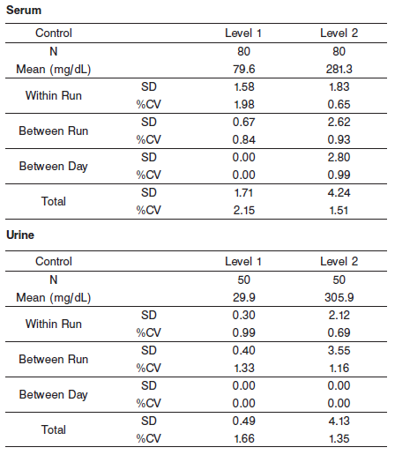

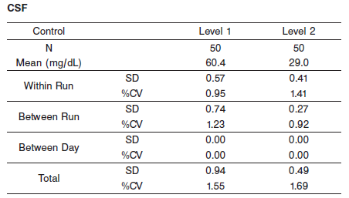

#### Interfering Substances:

**Interfering Substances**

Interference effects were assessed by Dose Response and Paired Difference methods, at the medical decision level of the analyte.

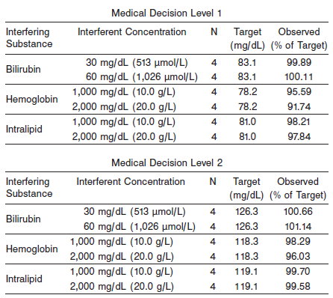

**References:**

1. ABBOTT ARCHITECT Glucose package insert

Abbott Laboratories

Diagnostics Division

Abbott Park, IL 60064

Oct 2012 304772/R02

1. ABBOTT Multiconstituent Calibrator

Abbott Laboratories

Diagnostics Division

Abbott Park, IL 60064

June 2013 306297/R04

1. Abbott ARCHITECT Operator’s Guide

**Related Documents:**

**Attachments:**