RUSH logo for emails

**GAMMA-GLUTAMYL TRANSFERASE (GGT)**

**SERUM OR PLASMA**

**ABBOTT ARCHITECT**

**Intended Use**

The Gamma-Glutamyl Transferase (GGT) assay is used for the quantitation of gamma-glutamyl transferase in human serum or plasma.

**Clinical Significance**

Gamma-glutamyl transferase was first identified in kidney tissue. Even though renal tissue has the highest level of GGT, the enzyme present in serum appears to originate primarily from the hepatobiliary system, and GGT is elevated in many forms of liver disease. Elevations in

GGT levels are seen earlier and are more pronounced than those with other liver enzymes in cases of obstructive jaundice and metastatic neoplasms. It may reach 5 to 30 times normal levels in intra- or post-hepatic biliary obstruction. Only moderate elevations in the enzyme level (2 to 5 times normal) are observed with infectious hepatitis: therefore, GGT measurements are less useful diagnostically than transaminase determinations with this condition.

**Principle**

GGT catalyzes the transfer of the gamma-glutamyl group from the donor substrate (*L*-gamma-glutamyl-3-carboxy-4-nitroanilide) to the glycylglycine acceptor to yield 3-carboxy-4-nitroaniline. The rate of the absorbance increase at 412 nm (416 nm for *c* 4000 and *c* 16000) is directly proportional to the GGT in the sample. The GGT procedure is a modification of the method described by Theodorsen et al.

**Methodology:** *L-*Gamma-glutamyl-3-carboxy-4-nitroanilide Substrate

**Specimen Collection and Handling**

**Suitable Specimens**

**Suitable Specimens**

Serum and plasma are acceptable specimens.

• **Serum:** Use serum collected by standard venipuncture techniques into glass or plastic tubes with or without gel barriers. Ensure complete clot formation has taken place prior to centrifugation.

Centrifuge according to tube manufacturer’s instructions to ensure proper separation of serum from blood cells.

Some specimens, especially those from patients receiving anticoagulant or thrombolytic therapy, may take longer to complete their clotting processes. Fibrin clots may subsequently form in these sera and the clots could cause erroneous test results.

• **Plasma:** Use plasma collected by standard venipuncture techniques into glass or plastic tubes. Acceptable anticoagulants are lithium heparin (with or without gel barrier) and sodium heparin. Ensure centrifugation is adequate to remove platelets. Centrifuge according to tube manufacturer’s instructions to ensure proper separation of plasma from blood cells.

**Specimen Storage**

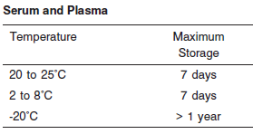

**NOTE:** Stored specimens must be inspected for particulates. If present, mix and centrifuge the specimen to remove particulates prior to testing.

**Materials and Equipment Required**

**TEST INSTRUMENT**: Abbott ARCHITECT System

**MATERIALS PROVIDED**

7D65 Gamma-Glutamyl Transferase Reagent Kit

**MATERIALS REQUIRED BUT NOT PROVIDED**

• Control Material

• Saline (0.85% to 0.90% NaCl) for specimens that require dilution

**Reagent Handling and Storage:**

***CAUTION*:**

1. For in vitro diagnostic use.

2. Do not use components beyond the expiration date.

3. 4. Do not mix reagents prepared at different times.

**CAUTION:** This product requires the handling of human specimens.

It is recommended that all human sourced materials be considered potentially infectious and be handled in accordance with the OSHA Standard on Bloodborne Pathogens. Biosafety Level 2 or other appropriate biosafety practices should be used for materials that contain or are suspected of containing infectious agents.

• The following warning and precaution apply to R1 and R2:

Contains sodium azide.

EUH032 Contact with acids liberates very toxic gas.

These materials and their containers must be disposed of in a safe

way.

**Reagent Handling**

Remove air bubbles, if present in the reagent cartridge, with a new applicator stick. Alternatively, allow the reagent to sit at the appropriate storage temperature to allow the bubbles to dissipate. To minimize volume depletion, do not use a transfer pipette to remove the bubbles.

**CAUTION:** Reagent bubbles may interfere with proper detection of reagent level in the cartridge, causing insufficient reagent aspiration which could impact results.

**Reagent Storage**

Unopened reagents are stable until the expiration date when stored at 2 to 8°C.

Reagent stability is 27 days if the reagent is uncapped and onboard.

Reagent Preparation:

GGT is supplied as a liquid, ready-to-use, reagent kit which contains: R1 & R2

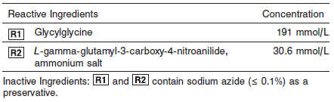

**Quality Control:** Minimum 2 levels of ChemistryControl (Normal and Abnormal)

**Calibration**

**Frequency:**

Calibration is stable for 27 days (648 hours) for any one lot.

**A new calibration is required:**

1. If quality control results do not meet acceptance criteria defined by your laboratory, patient values may be suspect. Follow the established quality control procedures for your laboratory. Recalibration may be necessary.
2. Review quality control results and acceptance criteria following a change of reagent or calibrator lot.

**Calibration Procedure:**

A calibration factor must be entered in the **Configure assay parameters** window, **Calibration** view.

**Troubleshooting and Overall Acceptance Criteria Failure**

See ARCHITECT Operations Manual for further calibration troubleshooting.

**Quality Control:**

Abbott recommends, refer to your laboratory standard operating procedure(s) and/or quality assurance plan for additional quality control requirements and potential corrective actions:

• Two levels of controls (normal and abnormal) are to be run every 24 hours.

Some controls may require addition of Liquid Stabilizer.

• If more frequent control monitoring is required, follow the established quality control procedures for your laboratory.

• If quality control results do not meet the acceptance criteria defined by your laboratory, patient values may be suspect. Follow the established quality control procedures for your laboratory.

Recalibration may be necessary.

• Review quality control results and acceptance criteria following a change of reagent or calibrator lot.

**Procedure**

For a detailed description of how to run an assay, refer to *Section 5* of the **ARCHITECT System Operations Manual**.

**Calculations**

Refer to *Appendix C* of the **ARCHITECT System Operations Manual** for information on results calculations.

**Reporting Results**

The result unit for the GGT assay can be reported as U/L

**Specific Performance Characteristics**

**Reference Ranges**

It is recommended that each laboratory determine its own reference range based upon its particular locale and population characteristics.

**Serum/Plasma**

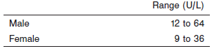

**Critical Values: N/A**

**Performance Characteristics**

**Linearity**

GGT is linear up to 1,543 U/L (1,417 U/L using IFCC factor).

Flex Rate Linearity is 9,256 U/L (8,500 U/L using IFCC factor). To use Flex Rate Linearity, the operator must edit the linear high value to 9,256 on the **Configure assay parameters** window, **Results** view.

**Dilution:**

**Serum and Plasma:** Specimens with GGT values exceeding 1,543 U/L (9,256 U/L for Flex Rate Linearity) are flagged and may be diluted by following either the Automated Dilution Protocol or the Manual Dilution Procedure.

**Automated Dilution Protocol**

If using the Automated Dilution Protocol, the system performs a dilution of the specimen and automatically corrects the enzyme activity value by multiplying the result by the appropriate dilution factor. To set up the automatic dilution feature, refer to *Section 2* of the **ARCHITECT System**

**Operations Manual** for additional information.

**Manual Dilution Procedure**

Manual dilutions should be performed as follows:

• Use saline (0.85% to 0.90% NaCl) to dilute the sample.

• The operator must enter the dilution factor in the patient or control order screen. The system uses this dilution factor to automatically correct the enzyme activity value by multiplying the result by the entered factor.

• If the operator does not enter the dilution factor, the result must be multiplied by the appropriate dilution factor before reporting the result.

**NOTE:** If a diluted sample result is flagged indicating it is less than the linear low limit, do not report the result. Rerun using an appropriate dilution.

For detailed information on ordering dilutions, refer to *Section 5* of the **ARCHITECT System Operations Manual**.

**Limit of Quantitation (LOQ):** The LOQ for GGT is 3.3 U/L.

**Limit of Detection (LOD):** The LOD for GGT is 2.5 U/L.

**Limitation of Procedure:**

N/A

**Precision:**

The imprecision of the GGT assay is ≤ 4.8% Total CV.

Serum/Plasma:

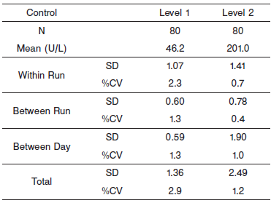

#### Interfering Substances:

**Interfering Substances**

Interference studies were conducted using CLSI protocol NCCLS EP7-P. Interference effects were assessed by Dose Response and Paired Difference methods, at the medical decision level of the analyte.

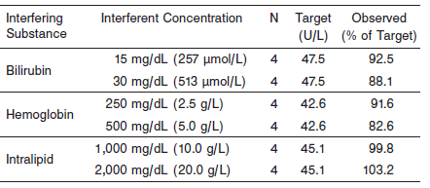

**References:**

1. ABBOTT ARCHITECT GGT package insert

Abbott Laboratories

Diagnostics Division

Abbott Park, IL 60064

Dec 2012 305249/R04

1. Abbott ARCHITECT Operator’s Guide

**Related Documents:**

**Attachments:**