RUSH logo for emails

**IRON**

**SERUM OR PLASMA**

**ABBOTT ARCHITECT**

**Intended Use**

The MULTIGENT Iron assay is intended for the direct colorimetric determination of iron without deproteinization in human serum or plasma on the ARCHITECT *c* Systems

**Clinical Significance**

Iron exists in biological fluids as a component of hemoglobin and myoglobin and is bound in serum and plasma to transferrin, which acts as a carrier protein. Increased iron concentrations are seen in hemolytic anemias, hemochromatosis, and acute liver disease. Decreased iron concentrations are seen in iron deficiency and anemia of chronic disease. Major causes of iron deficiency include gastrointestinal and menstrual bleeding. For the assessment of the body’s iron status, the measurement of transferrin and ferritin can provide more accurate information.

**Principle**

At a pH of 4.8, iron is released from transferrin to which it is bound, and then quantitatively reduced to a ferrous state. The iron forms with Ferene-S*, a stable colored complex of which the color intensity is proportional to the amount of iron in the sample. Particular reaction conditions and a specific masking agent almost entirely eliminate the interference from copper.

* Ferene-S = 3-(2-pyridyl)-5,6-bis-[2-(5-furylsulfonic acid)]-1,2,4-triazine

**Methodology:** Ferene

**Specimen Collection and Handling**

**Suitable Specimens**

• **Serum:** Use nonhemolyzed serum collected by standard venipuncture techniques into plastic tubes with or without gel barriers. Ensure complete clot formation has taken place prior to centrifugation.

Centrifuge according to tube manufacturer’s instructions to ensure proper separation of serum from blood cells. Glass tubes were not tested.

Some specimens, especially those from patients receiving anticoagulant or thrombolytic therapy, may take longer to complete their clotting processes. Fibrin clots may subsequently form in these sera and the clots could cause erroneous test results.

• **Plasma:** Use nonhemolyzed plasma collected by standard venipuncture techniques. Acceptable anticoagulants are lithium heparin with or without gel barrier and sodium heparin. Ensure centrifugation is adequate to remove platelets. Centrifuge according to tube manufacturer’s instructions to ensure proper separation of plasma from blood cells. Glass tubes were not tested. For total sample volume requirements, refer to the ASSAY PARAMETERS section of this package insert and *Section 5* of the **ARCHITECT** **System Operations Manual**.

**Specimen Storage**

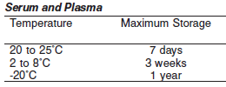

**NOTE:** Stored specimens must be inspected for particulates. If present, mix and centrifuge the specimen to remove particulates prior to testing.

**Materials and Equipment Required**

**TEST INSTRUMENT**: Abbott ARCHITECT System

**MATERIALS PROVIDED**

6K95 MULTIGENT Iron Kit

**MATERIALS REQUIRED BUT NOT PROVIDED**

• 1E65 Multiconstituent Calibrator

• Control Material

• Saline (0.85% to 0.90% NaCl) for specimens that require dilution

**Reagent Handling and Storage:**

***CAUTION*:**

1. For in vitro diagnostic use.

2. Do not use components beyond the expiration date.

3. Do not mix reagents prepared at different times.

**CAUTION:** This product requires the handling of human specimens.

It is recommended that all human sourced materials be considered potentially infectious and be handled in accordance with the OSHA Standard on Bloodborne Pathogens. Biosafety Level 2 or other appropriate biosafety practices should be used for materials that contain or are suspected of containing infectious agents.

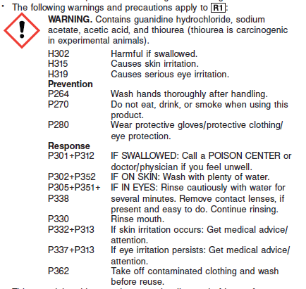

**Reagent Handling**



Remove air bubbles, if present in the reagent cartridge, with a new applicator stick. Alternatively, allow the reagent to sit at the appropriate storage temperature to allow the bubbles to dissipate. To minimize volume depletion, do not use a transfer pipette to remove the bubbles.

**CAUTION:** Reagent bubbles may interfere with proper detection of reagent level in the cartridge, causing insufficient reagent aspiration which could impact results.

**Reagent Storage**

Unopened reagents are stable until the expiration date when stored at 2 to 8°C.

Reagent stability is 60 days if the reagent is uncapped and onboard.

Reagent Preparation:

MULTIGENT Iron is supplied as a liquid ready-to-use, two‑component kit which contains: R1 & R2

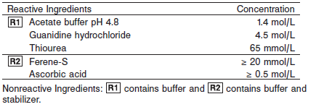

**Calibrator:** 1E65 Multiconstituent Calibrator

**Quality Control:** Minimum 2 levels of ChemistryControl (Normal and Abnormal)

**Calibration**

**Frequency:**

Calibration is stable for 14 days (336 hours) for any one lot.

**A new calibration is required:**

1. If quality control results do not meet acceptance criteria defined by your laboratory, patient values may be suspect. Follow the established quality control procedures for your laboratory. Recalibration may be necessary.
2. Review quality control results and acceptance criteria following a change of reagent or calibrator lot.

**Calibration Procedure:**

Calibration is performed by running a water blank and the Multiconstituent Calibrator set. Water for the blank is provided by the instrument.

1. Verify that the correct calibrator values have been entered into the calibration file.

2. Allow calibrator to come to room temperature.

3. Mix bottle five times by gentle inversion.

4. Open bottle, place an appropriate amount of each calibrator in a separate sample cup, and place in the assigned positions.

5. Cap bottle tightly and return to refrigerated storage immediately after use.

6. Perform calibration as indicated in the **ARCHITECT System Operations Manual**.

**Troubleshooting and Overall Acceptance Criteria Failure**

See ARCHITECT Operations Manual for further calibration troubleshooting.

**Quality Control:**

Abbott recommends, refer to your laboratory standard operating procedure(s) and/or quality assurance plan for additional quality control requirements and potential corrective actions:

• Two levels of controls (normal and abnormal) are to be run every 24 hours.

Some controls may require addition of Liquid Stabilizer.

• If more frequent control monitoring is required, follow the established quality control procedures for your laboratory.

• If quality control results do not meet the acceptance criteria defined by your laboratory, patient values may be suspect. Follow the established quality control procedures for your laboratory.

Recalibration may be necessary.

• Review quality control results and acceptance criteria following a change of reagent or calibrator lot.

**Procedure**

For a detailed description of how to run an assay, refer to *Section 5* of the **ARCHITECT System Operations Manual**.

**Calculations**

Refer to *Appendix C* of the **ARCHITECT System Operations Manual** for information on results calculations.

**Reporting Results**

The MULTIGENT Iron assay can be reported in ug/dL or umol/L

**Specific Performance Characteristics**

**Reference Ranges**

It is recommended that each laboratory determine its own reference range based upon its particular locale and population characteristics.

**Serum/Plasma:**

Female: 50 – 170 μg/dL

Male: 65 – 175 μg/dL

**Critical Values: N/A**

**Performance Characteristics**

**Reportable Range**

The reportable range (analytical measurement range) for MULTIGENT Iron is 5 to 1,000 μg/dL (0.9 to 179.0 μmol/L).

**Dilution:**

**Serum and Plasma:** Specimens with iron values exceeding 1,000 μg/dL (179.0 μmol/L) are flagged and may be diluted by following either the Automated Dilution Protocol or the Manual Dilution Procedure.

***Automated Dilution Protocol***

If using the Automated Dilution Protocol, the system performs a 1:6.55 dilution of the specimen and automatically corrects the concentration by multiplying the result by the appropriate dilution factor.

***Manual Dilution Procedure***

• Use saline (0.85% to 0.90% NaCl) to dilute the sample.

• The operator must enter the dilution factor in the patient or control order screen. The system uses this dilution factor to automatically correct the concentration by multiplying the result by the entered factor.

• If the operator does not enter the dilution factor, the result must be multiplied by the appropriate dilution factor before reporting the result.

**NOTE:** If a diluted sample result is flagged indicating it is less than the linear low limit, do not report the result. Rerun using an appropriate dilution. For detailed information on ordering dilutions, refer to *Section 5* of the **ARCHITECT System Operations Manual.**

**Limit of Detection (LOD):** The LOD for MULTIGENT Iron is 5 μg/dL (0.9 μmol/L).

**Limitation of Procedure:**

N/A

**Precision:**

The precision of MULTIGENT Iron assay is ≤ 5% Total CV.

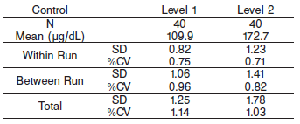

#### Interfering Substances:

**Interfering Substances**

Interference studies were conducted using acceptance criteria of +/- 10% or +/- 17.5 μg/dL deviation, whichever is greater, from the target value. MULTIGENT Iron assay is not affected by the presence of the following interferents up to the concentrations indicated below.

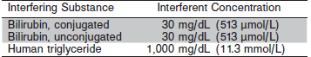

**References:**

1. ABBOTT ARCHITECT Iron package insert

Abbott Laboratories

Diagnostics Division

Abbott Park, IL 60064

May 2015 306710/R04

1. ABBOTT Multiconstituent Calibrator

Abbott Laboratories

Diagnostics Division

Abbott Park, IL 60064

June 2013 306297/R04

1. Abbott ARCHITECT Operator’s Guide

**Related Documents:**

**Attachments:**