RUSH logo for emails

**LACTATE DEHYDROGENASE (LDH)**

**SERUM OR PLASMA**

**ABBOTT ARCHITECT**

**Intended Use**

The Lactate Dehydrogenase (LDH) assay is used for the quantitation of lactate dehydrogenase in human serum or plasma.

**Clinical Significance**

LDH is an enzyme found in the cells of many body tissues, including the heart, liver, kidneys, skeletal muscle, brain, red blood cells, and lungs. It is responsible for converting muscle lactate into pyruvate, an essential step in producing cellular energy. It is composed of four peptide chains of two subunits (M form and H form) which results in up to five different isoenzymes which can be separated and quantitated by electrophoresis. Measurement of the total LDH activity in serum or plasma is non‑specific and cannot differentiate the tissues of origin of the component isoenzymes.

LDH is used in the differential diagnosis of hemolytic anemia and as a tumor marker in some malignancies, such as germ cell tumors. LDH is elevated in hepatitis, glomerular nephritis, pulmonary embolism, muscle disease, and many leukemias and lymphomas. As LDH is a non-specific marker, it is used in combination with other markers in diagnosis and patient management.

**Principle**

Lactate dehydrogenase is a hydrogen transfer enzyme that catalyzes the oxidation of *L*-lactate to pyruvate with the mediation of NAD+ as a hydrogen acceptor.



**Methodology:** This method uses the IFCC recommended forward reaction - Lactate to Pyruvate.

**Specimen Collection and Handling**

**Suitable Specimens**

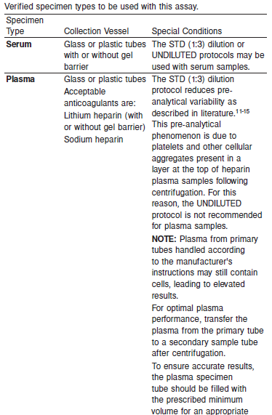



**Specimen Storage**

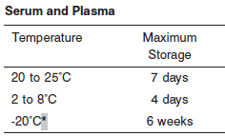

*A temperature variation of +/- 10% at -20°C (+/- 2°C) is assumed not to change the stability of the specimen (W. Guder, personal communication, August 6, 2001).

Each laboratory may establish a range around -20°C from either the freezer manufacturer’s specifications or your laboratory standard operating procedure(s) for specimen storage.

**NOTE:** The various LDH isoenzymes differ in stability at different temperatures. LDH-4 and LDH-5 are most susceptible to refrigeration or freezing.

**NOTE:** Stored specimens must be inspected for particulates. If present, mix and centrifuge the specimen to remove particulates prior to testing.

**Materials and Equipment Required**

**TEST INSTRUMENT**: Abbott ARCHITECT System

**MATERIALS PROVIDED**

2P56 Lactate Dehydrogenase Reagent Kit

**MATERIALS REQUIRED BUT NOT PROVIDED**

• Control Material

• Saline (0.85% to 0.90% NaCl) for specimens that require dilution

**Reagent Handling and Storage:**

***CAUTION*:**

1. For in vitro diagnostic use.

2. Do not use components beyond the expiration date.

3. Do not mix reagents prepared at different times.

4. Do not pool reagents within a kit or between kits.

• Hemolyzed specimens must not be used.

• Plasma samples may exhibit pre-analytical variability. Refer to the SPECIMEN COLLECTION AND HANDLING, Plasma section of the package insert

**CAUTION:** This product requires the handling of human specimens.

It is recommended that all human sourced materials be considered potentially infectious and be handled in accordance with the OSHA Standard on Bloodborne Pathogens. Biosafety Level 2 or other appropriate biosafety practices should be used for materials that contain or are suspected of containing infectious agents.

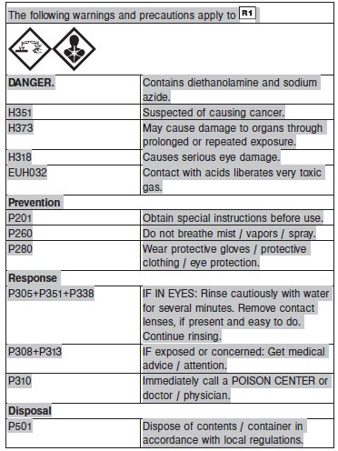

**Reagent Handling**

Remove air bubbles, if present in the reagent cartridge, with a new applicator stick. Alternatively, allow the reagent to sit at the appropriate storage temperature to allow the bubbles to dissipate. To minimize volume depletion, do not use a transfer pipette to remove the bubbles.

**CAUTION:** Reagent bubbles may interfere with proper detection of reagent level in the cartridge, causing insufficient reagent aspiration which could impact results.

**Reagent Storage**

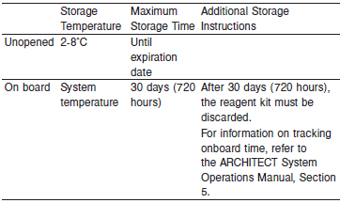

Reagents may be stored on or off the ARCHITECT cSystem.

If reagents are removed from the system, store at 2-8°C (with replacement caps) in their original boxes. When reagent is placed back on the system, run controls and if appropriate criteria are not met, recalibration may be required. For information on unloading reagents, refer to the ARCHITECT System Operations Manual, Section 5.

Reagent Preparation:

LDH is supplied as a liquid, ready-to-use, reagent kit which contains: R1 & R2

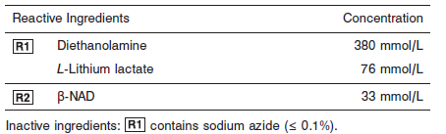

**Quality Control:** Minimum 2 levels of ChemistryControl (Normal and Abnormal)

**Calibration**

**Frequency:**

Calibration is stable for 30 days (720 hours) for any one lot.

**A new calibration is required:**

1. If quality control results do not meet acceptance criteria defined by your laboratory, patient values may be suspect. Follow the established quality control procedures for your laboratory. Recalibration may be necessary.
2. Review quality control results and acceptance criteria following a change of reagent or calibrator lot.

**Calibration Procedure:**

The calibration factor was established based on the IFCC methodology.

**Troubleshooting and Overall Acceptance Criteria Failure**

See ARCHITECT Operations Manual for further calibration troubleshooting.

**Quality Control:**

Abbott recommends, refer to your laboratory standard operating procedure(s) and/or quality assurance plan for additional quality control requirements and potential corrective actions:

• Two levels of controls (normal and abnormal) are to be run every 24 hours.

Some controls may require addition of Liquid Stabilizer.

• If more frequent control monitoring is required, follow the established quality control procedures for your laboratory.

• If quality control results do not meet the acceptance criteria defined by your laboratory, patient values may be suspect. Follow the established quality control procedures for your laboratory.

Recalibration may be necessary.

• Review quality control results and acceptance criteria following a change of reagent or calibrator lot.

**Procedure**

For a detailed description of how to run an assay, refer to *Section 5* of the **ARCHITECT System Operations Manual**.

The Lactate Dehydrogenase assay file must be installed on the ARCHITECT cSystem prior to performing the assay. For detailed information on assay file installation and viewing

and editing assay parameters, refer to the ARCHITECT System Operations Manual, Section 2.

For information on printing assay parameters or for a detailed description of system procedures, refer to the ARCHITECT System Operations Manual, Section 5.

**Calculations**

Refer to *Appendix C* of the **ARCHITECT System Operations Manual** for information on results calculations.

**Reporting Results**

The Conventional result units for the LDH assay is U/L. The corresponding SI result unit is U/L.

**Specific Performance Characteristics**

**Reference Ranges**

It is recommended that each laboratory determine its own reference range based upon its particular locale and population characteristics.

**Serum/Plasma:**

**1-30 days 135-750**

**31days – 11 months 180-435**

**1-3 years 160-370**

**4-6 years 145-345**

**7-9 years 143-290**

**10-12 years 120-293**

**13-15 years 110-283**

**16-17 years 105-233**

**Adult 125-220**

**Critical Values: N/A**

**Performance Characteristics**

**Measuring Interval**

The measuring interval of Lactate Dehydrogenase STD (1:3) dilution protocol is 30 to 2,000 U/L and the UNDILUTED protocol is 10 to 2,000 U/L (10 to 4,500 U/L if Flex Rate is used).

**Linearity**

Lactate Dehydrogenase is linear up to 2,000 U/L within } 9.0% or 20 U/L, whichever is greater with 95% confidence.

Flex Rate Linearity is 4,500 U/L (UNDILUTED protocol only).

**Dilution:**

Specimens with LDH values exceeding 2,000 U/L (4,500 U/L for Flex Rate Linearity) are flagged and may be diluted by following either the Automated Dilution Protocol (1:5) or the Manual Dilution Procedure.

**Automated Dilution Protocol**

If using the Automated Dilution Protocol, the system performs a dilution of the specimen and automatically corrects the enzyme activity value by multiplying the result by the appropriate dilution factor.

**Manual Dilution Procedure**

Manual dilutions should be performed as follows:

• Use saline (0.85% to 0.90% NaCl) to dilute the sample.

• The operator must enter the dilution factor in the patient or control order screen. The system uses this dilution factor to automatically correct the enzyme activity value by multiplying the result by the entered factor.

• If the operator does not enter the dilution factor, the result must be multiplied by the appropriate dilution factor before reporting the result.

**NOTE:** If a diluted sample result is flagged indicating it is less than the linear low limit, do not report the result. Rerun using an appropriate dilution.

For detailed information on ordering dilutions, refer to *Section 5* of the **ARCHITECT System Operations Manual**.

**Limit of Quantitation (LOQ), Limit of Detection (LOD), Limit of Blank, (LOB)**

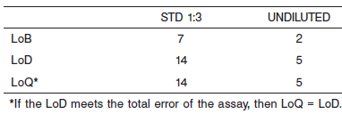

**Limitation of Procedure:**

N/A

**Precision:**

The imprecision of the LDH assay is ≤ 4.7% Total CV.

Serum/Plasma:

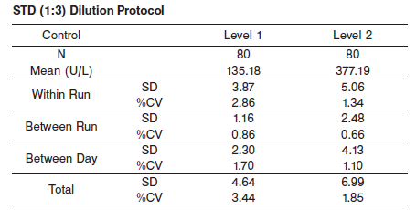

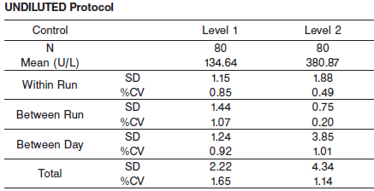

#### Interfering Substances:

**Interfering Substances**

Interference studies were conducted using an acceptance criteria of ≤ 9.0% of the target value. Interference studies were conducted using CLSI protocol NCCLS EP7-P. Interference effects were assessed by Dose Response and Paired Difference methods, at the medical decision level of the analyte.

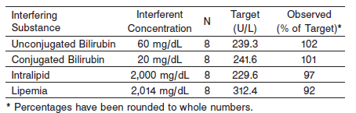

**NOTE:** Hemolyzed specimens must not be used because erythrocytes contain approximately 150 times more LDH activity.

**References:**

1. ABBOTT ARCHITECT LDH package insert

Abbott Laboratories

Diagnostics Division

Abbott Park, IL 60064

Nov 2015 306788 / R05

1. Abbott ARCHITECT Operator’s Guide

**Related Documents:**

**Attachments:**