RUSH logo for emails

**TOTAL BhCG**

**SERUM OR PLASMA**

**ABBOTT ARCHITECT**

**Intended Use**

The ARCHITECT Total β‑hCG assay is a Chemiluminescent Microparticle Immunoassay (CMIA) for the quantitative and qualitative determination of beta human chorionic gonadotropin (β‑hCG) in human serum and plasma for the early detection of pregnancy.

**Clinical Significance**

Human chorionic gonadotropin (hCG) is a sialoglycoprotein with a molecular weight of approximately 46,000 daltons. HCG is initially secreted by the trophoblastic cells of the placenta shortly after implantation of the fertilized ovum into the uterine wall. The rapid rise in hCG serum levels after conception makes it an excellent marker for early confirmation and monitoring of pregnancy.

Physiologically, hCG appears to maintain the corpus luteum, thereby allowing synthesis of progesterone and estrogens that support the endometrium. As uncomplicated pregnancies progress, the placenta assumes the production of these hormones. The serum hCG levels increase to a peak concentration, then decrease and plateau. HCG circulates as the intact molecule in the serum of normal women who have an uncomplicated pregnancy. The subunits are cleaved rapidly and cleared by the kidney. The placental hormone, hCG, is similar to luteinizing hormone (LH), follicle stimulating hormone (FSH), and thyroid stimulating hormone (TSH). All are glycoproteins consisting of two noncovalently bound dissimilar subunits, designated alpha and beta, with attached carbohydrate sidechains. The alpha subunits of these glycoproteins are very similar. In contrast, the beta subunit portions determine the biological and immunochemical specificities. The beta subunits of hCG and LH exhibit considerable homology in amino acid content. Amino acid residues specific for the beta subunit of hCG confer the immunochemical specificity.

With the availability of sensitive quantitative assays for the measurement of serum β‑hCG, it has been shown that hCG levels can be useful in prediction of spontaneous abortions, aiding in the detection of ectopic pregnancy and multiple gestation.

**Principle**

The ARCHITECT Total β‑hCG assay is a two-step immunoassay to determine the presence of β‑hCG in human serum and plasma using Chemiluminescent Microparticle Immunoassay (CMIA) technology with flexible assay protocols, referred to as Chemiflex.

In the first step, sample, and anti-β‑hCG coated paramagnetic microparticles are combined. β‑hCG present in the sample binds to the anti-β‑hCG coated microparticles. After washing, anti-β‑hCG acridinium-labeled conjugate is added in the second step. Pre-Trigger and Trigger Solutions are then added to the reaction mixture; the resulting chemiluminescent reaction is measured as relative light units (RLUs). A direct relationship exists between the amount of β‑hCG in the sample and the RLUs detected by the ARCHITECT *i* optical system.

For additional information on system and assay technology, refer to the ARCHITECT System Operations Manual, Section 3.

**Specimen Collection and Handling**

**Suitable Specimens**

Human serum (including serum collected in serum separator tubes) or plasma collected in lithium heparin, sodium heparin, or potassium EDTA may be used in the ARCHITECT Total β‑hCG assay. Other anticoagulants have not been validated for use with the ARCHITECT Total β‑hCG assay. Follow the tube manufacturer’s processing instructions for serum or plasma collection tubes.

Abbott Laboratories recommends the use of plasma for STAT testing. Since plasma does not require the clotting time of serum, it has a decreased likelihood of the presence of fibrin or other particulates.

For optimal results, serum and plasma specimens should be free of fibrin, red blood cells or other particulate matter.

**Storage**

If testing will be delayed more than 24 hours, remove serum or plasma from the clot, serum separator or red blood cells. Specimens may be stored for up to 7 days at 2-8°C prior to being tested. If testing will be delayed more than 7 days, specimens should be frozen at -10°C or colder. Specimens stored frozen at -10°C or colder for 12 months showed no performance difference.

**•** Multiple freeze-thaw cycles of specimens should be avoided.

**NOTE:** Stored specimens must be inspected for particulates. If present, mix and centrifuge the specimen to remove particulates prior to testing.

**Materials and Equipment Required**

**TEST INSTRUMENT**: Abbott ARCHITECT System

**MATERIALS PROVIDED**

7K78 ARCHITECT Total β‑hCG Reagent Kit

**MATERIALS REQUIRED BUT NOT PROVIDED**

**•** ARCHITECT *i* System with *STAT* protocol

**•** ARCHITECT Total β‑hCG Assay file, may be obtained from:

**•** ARCHITECT *i* System e-Assay CD-ROM found on www.abbottdiagnostics.com

**•** ARCHITECT *i* System Assay CD-ROM

**•** 7K78-01 ARCHITECT Total β‑hCG Calibrators

**•** 7K78-10 ARCHITECT Total β‑hCG Controls

**•** 7D82-50 ARCHITECT *i* Multi-Assay Manual Diluent

**•** ARCHITECT *i* Pretrigger

**•** ARCHITECT *i* Trigger

**•** ARCHITECT *i i* Wash Buffer

**•** ARCHITECT *i* Reaction Vessels

**•** ARCHITECT *i* Sample Cups

**•** ARCHITECT *i* Septums

**•** ARCHITECT *i* Replacement Caps

**•** Pipettes or pipette tips (optional) to deliver the specified volumes.

**Reagent Handling and Storage:**

***CAUTION*:**

* For in vitro diagnostic use.

**CAUTION:** This product requires the handling of human specimens.

It is recommended that all human sourced materials be considered potentially infectious and be handled in accordance with the OSHA Standard on Bloodborne Pathogens. Biosafety Level 2 or other appropriate biosafety practices should be used for materials that contain or are suspected of containing infectious agents.

**Reagent Handling**

* Do not use reagent kits beyond the expiration date.
* **Do not pool reagents within a kit or between reagent kits.**
* Before loading the ARCHITECT Reagent Kit on the system for the first time, the microparticle bottle requires mixing to resuspend microparticles that have settled during shipment.
* **Septums MUST be used to prevent reagent evaporation and contamination and to ensure reagent integrity. Reliability of assay results cannot be guaranteed if septums are not used according to the instructions in the package insert.**
* To avoid contamination, wear clean gloves when placing a septum on an uncapped reagent bottle.
* Once a septum has been placed on the reagent bottle, **do not invert the bottle** as this will result in reagent leakage and maycompromise assay results.
* Over time, residual liquids may dry on the septum surface. These are typically dried salts and have no effect on assay efficacy.
* For a detailed discussion of handling precautions during system operation, refer to the ARCHITECT System Operations Manual, Section 7.

**Reagent Storage**

* The ARCHITECT BhCG Reagent Kit must be stored at 2-8°C and may be used immediately after removal from 2‑8°C storage.
* When stored and handled as directed, reagents are stable until the expiration date.
* The ARCHITECT BhCG Reagent Kit may be stored on-board the ARCHITECT *i* System for a maximum of 30 days. After 30 days, the reagent kit must be discarded. For information on tracking on‑board time, refer to the ARCHITECT System Operations Manual, Section 5.
* Reagents may be stored on or off the ARCHITECT *i* System. If reagents are removed from the system, store them at 2-8°C (with septums and replacement caps) in an upright position. For reagents stored off the system, it is recommended that they be stored in their original trays and boxes to ensure they remain upright.
* For information on unloading reagents, refer to the ARCHITECT System Operations Manual, Section 5.

Reagents

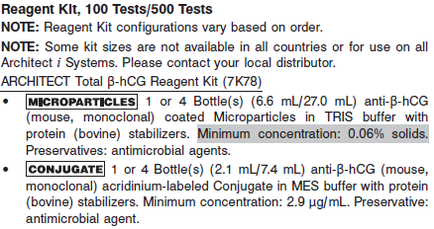

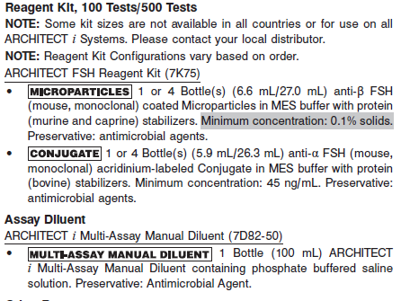

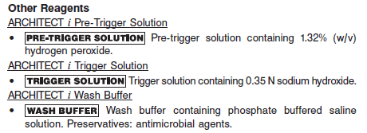

**Calibrator:** 7K78-01 ARCHITECT Total β‑hCG Calibrators

**Quality Control:** 7K78-10 ARCHITECT Total β‑hCG Controls

**Calibration**

**Frequency:**

Recalibration is required with each new reagent lot number.

**A new calibration is required:**

1. If quality control results do not meet acceptance criteria defined by your laboratory, patient values may be suspect. Follow the established quality control procedures for your laboratory. Recalibration may be necessary.
2. Review quality control results and acceptance criteria following a change of reagent or calibrator lot.

**Calibrator Required:** 7K78-01 ARCHITECT Total β‑hCG Calibrators

**Reagents:**

6 Bottles (4 mL each) of ARCHITECT Total b-hCG Calibrators prepared in human serum. Preservative: Sodium Azide.

**Calibrator Preparation:**

Ready to use.

**Calibration Procedure:**

To perform an ARCHITECT Total β‑hCG calibration, test Calibrators A, B, C, D, E, and F in duplicate. A single sample of all levels of Total β‑hCG controls must be tested to evaluate the assay calibration. Ensure that assay control values are within the concentration ranges specified in the package insert. Calibrators should be priority loaded.

**•** Calibrator Range: 0.00 - 15,000.00 mIU/mL.

**•** Routine and STAT protocols require separate calibrations but require only one reagent kit.

**Troubleshooting and Overall Acceptance Criteria Failure**

See ARCHITECT Operations Manual for further calibration troubleshooting.

**Quality Control:**

Abbott recommends, refer to your laboratory standard operating procedure(s) and/or quality assurance plan for additional quality control requirements and potential corrective actions:

• At a minimum a single level of quality control are to be run every 24 hours

• If more frequent control monitoring is required, follow the established quality control procedures for your laboratory.

• If quality control results do not meet the acceptance criteria defined by your laboratory, patient values may be suspect. Follow the established quality control procedures for your laboratory.

Recalibration may be necessary.

• Review quality control results and acceptance criteria following a change of reagent or calibrator lot.

Due to variation in analyte composition and/or matrices, external quality control materials and proficiency survey samples, may not elicit identical results across all hCG assays. Non-Abbott Quality Control and proficiency testing material may contain high levels of free beta-subunit hCG molecules. Non-Abbott Quality Control and proficiency testing material may generate different results when comparing a whole molecule hCG assay to a total β‑hCG assay. Each laboratory needs to determine the suitability of each control material for specific immunoassays and validate the material prior to use.

**Instrument Procedure**

* The ARCHITECT Total β‑hCG Routine protocol (assay number 651) must be installed on the ARCHITECT *i*2000 from the ARCHITECT *i* System Assay CD-ROM prior to performing the assay. The ARCHITECT Total β‑hCG Routine protocol (assay number 651) and / or STAT protocol (assay number 030) assay files must be installed on the ARCHITECT *i* System with STAT protocol capability from the ARCHITECT *i* System Assay CD-ROM prior to performing the assay. For detailed instructions on the assay file installation, refer to the ARCHITECT System Operations Manual, Section 2.
* The ARCHITECT Total β‑hCG Routine protocol (two-step 18-4) is available for use on ARCHITECT *i* Systems. The ARCHITECT Total β‑hCG STAT protocol (two step 4-4) is available for use on the ARCHITECT *i* System with STAT protocol capability.
* For detailed information on assay file installation and viewing and editing assay parameters, refer to the ARCHITECT System Operations Manual, Section 2.
* For information on printing assay parameters, refer to the ARCHITECT System Operations Manual, Section 5.
* For a detailed description of system procedures, refer to the ARCHITECT System Operations Manual.

**Assay Procedure**

For a detailed description of how to run an assay, refer to *Section 5* of the **ARCHITECT System Operations Manual**.

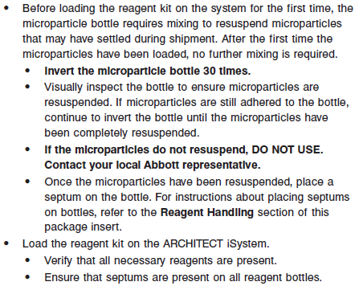

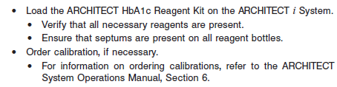

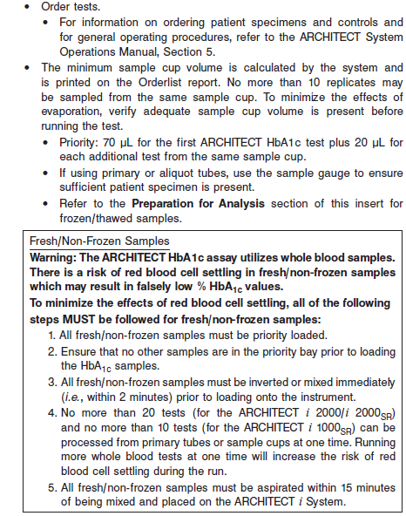

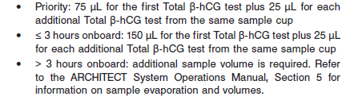

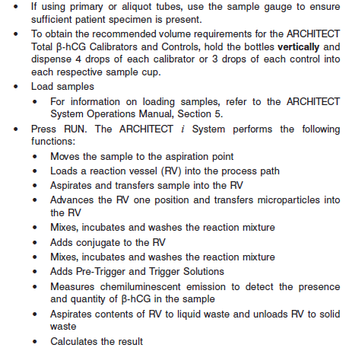

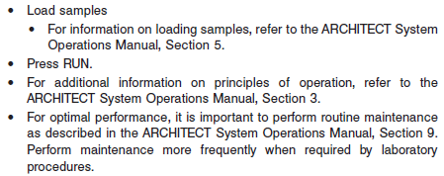

**Results**

The default result unit for the ARCHITECT Total β‑hCG assay is mIU/mL. An alternative unit, IU/L, may be selected for reporting results by editing assay parameter “Result concentration units”, to IU/L. The conversion factor used by the system is 1.

**Interpretation of Results**

For qualitative interpretation of the ARCHITECT Total β‑hCG test results, specimens with β‑hCG levels less than or equal to 5.00 mIU/mL will be reported in the INTERPRETATION field on the test results screen or printout as “NEGATIVE”. Specimens with β‑hCG levels greater than or equal to 25.00 mIU/mL will be reported as “POSITIVE”. Specimens with β‑hCG levels greater than 5.00 mIU/mL and less than 25.00 mIU/mL will be reported with concentrations only. No interpretation will be reported for these results.

**Flags**

Some results may contain information in the Flags field. For a description of the flags that may appear in this field, refer to the ARCHITECT System Operations Manual, Section 5.

**Specific Performance Characteristics**

**Expected Values**

It is recommended that each laboratory determine its own reference range based upon its particular locale and population characteristics.

**Serum/Plasma:**

0 – 5 Negative

5 – 25 Indeterminate

>25 Positive

**Critical Values: N/A**

**Performance Characteristics**

**Sensitivity**

The ARCHITECT Total β‑hCG assay is designed to have an analytical sensitivity of ≤ 1.2 mIU/mL.

**Linearity**

The data support a linear range of 1.2 to 15000 mIU/mL.

**Dilution:**

Specimens with a Total β‑hCG value exceeding 15,000.00 mIU/mL are flagged with the code “>15,000.00” and may be diluted with either the Automated Dilution Protocol or the Manual Dilution Procedure.

**•** If using the Automated Dilution Protocol, the system performs a 1:15 dilution of the specimen and automatically calculates the concentration of the diluted specimen and reports the result.

**•** Manual dilutions should be performed as follows:

**•** The suggested dilution for Total β‑hCG is 1:15. It is recommended dilutions not exceed 1:75.

**•** For a 1:15 dilution, add 20 μL of the patient specimen to 280 μL of

ARCHITECT *i* Multi-Assay Manual Diluent (7D82-50).

**•** The operator must enter the dilution factor in the patient or control order screen. The system will use this dilution factor to automatically calculate the concentration of the sample before dilution. This will be the reported result. The result (before dilution factor is applied) should be greater than 467.00 mIU/mL.

**•** If the operator does not enter the dilution factor, the reported result will be that of the diluted sample. This result (before dilution factor is applied) should be greater than 467.00 mIU/mL.

**• NOTE:** A printed or displayed result of < 7000.00 mIU/mL (1:15 Automated Dilution Protocol) indicates the need to retest the sample at a lower dilution or undiluted. The result and interpretation should not be reported.

**•** For detailed information on ordering dilutions, refer to the ARCHITECT System Operations Manual, Section 5.

**Precision:**

The ARCHITECT Total β‑hCG assay is designed to have a precision of < 10% (total CV).

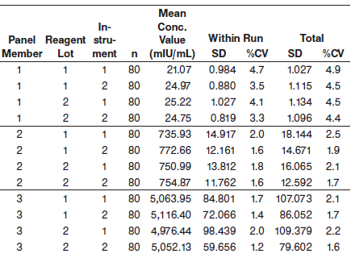

#### Limitations of Procedure

* Specimens from patients who have received preparations of mouse monoclonal antibodies for diagnosis or therapy may contain human anti-mouse antibodies (HAMA). Specimens containing HAMA may produce anomalous values when tested with assay kits that employ mouse monoclonal antibodies.
* Heterophilic antibodies in human serum can react with reagent immunoglobulins, interfering with *in vitro* immunoassays. Patients routinely exposed to animals or to animal serum products can be prone to this interference and anomalous results may be observed. Additional information may be required for diagnosis. Immunoassays are nonspecific and cross react with metabolites.
* This assay is capable of detecting whole molecule (intact) hCG as well as free β‑hCG subunits.
* For diagnostic purposes, hCG results should always be used in conjunction with other data; e.g., patient’s medical history, symptoms, results of other tests, clinical impressions, etc. Ectopic pregnancy cannot be distinguished from normal pregnancy by hCG measurements alone. The results from this or any other diagnostic kit should be used and interpreted only in the context of the overall clinical picture.
* If the hCG level is inconsistent with, or unsupported by, clinical evidence, results should be confirmed by an alternate hCG method. This may include the qualitative testing of urine. The absence of urinary hCG may suggest a falsely elevated serum result. Results may also be confirmed by performing serial dilutions of the sample. Usually, but not always, samples that contain interfering substances exhibit nonlinear results when diluted.
* The ARCHITECT Total β‑hCG assay is cleared for use in the early detection of pregnancy **only**. It is not approved for any other uses such as tumor marker screening, tumor marker monitoring, etc. and it should not be performed for any other uses.
* Infrequently, hCG levels may appear consistently elevated and could be due to, but not limited to, the presence of the following:

- heterophilic antibodies

- nonspecific protein binding

- hCG-like substances

- trophoblastic or nontrophoblastic neoplasms

* As with any immunochemical reaction, unknown interferences from medications or endogenous substances may affect results.
* Elevated hCG levels have been associated with some pathological conditions (e.g., trophoblastic and nontrophoblastic neoplasms) and the results of this test should not be used in the diagnosis of these abnormal states. There have been reports of people receiving unnecessary medical treatment and surgery, including chemotherapy and hysterectomy, when hCG results were used in the diagnosis of abnormal conditions.
* Interfering substances (such as heterophilic antibodies, non-specific proteins, or hCG-like substances) may falsely depress or falsely elevate results. These interfering substances may cause false results over the entire range of the assay, not just at low levels, and may indicate the presence of hCG when there is none.
* Detection of very low levels of hCG does not rule out pregnancy. Low levels of hCG can occur in apparently healthy, nonpregnant subjects. Because hCG values double approximately every 48 hours in a normal pregnancy, patients with very low levels of hCG should be resampled and retested after 48 hours.
* Post-menopausal specimens may elicit weak positive results due to low hCG levels unrelated to pregnancy. With a weak positive result, it is good laboratory practice to resample and retest after 48 hours, or to test with an alternate hCG method.
* Because of the high degree of sensitivity of the assay, specimens tested as positive during initial days after conception may later be negative due to natural termination of the pregnancy. Natural termination occurs in 22% of clinically unrecognized pregnancies and 31% of pregnancies overall.26 It is good laboratory practice to resample and retest weak positive results after an additional 48 hours.

**Specificity**

The ARCHITECT Total β‑hCG assay is designed to have a mean analytical specificity of < 10% cross reactivity with FSH, LH, and TSH. Aliquots of human serum containing β‑hCG were supplemented with 150 mIU/mL FSH, 250 mIU/mL LH, and 100 μIU/mL TSH and assayed for β‑hCG. The cross reactivity was calculated as a percent interference and was shown to be less than 10% for each cross reactant.

**Carryover**

Carryover from a sample containing 1,000,000 mIU/mL β‑hCG to an adjacent 0 mIU/mL β‑hCG sample was less than 7.5 mIU/mL β‑hCG.

**NOTE:** Please be aware that individual samples may exhibit elevated concentration due to build up of proteins on the sample pipettor probe. For further troubleshooting information, refer to the ARCHITECT System Operations Manual, Section 10.

**Interference**

The ARCHITECT Total β‑hCG assay is designed to have a potential interference from hemoglobin, bilirubin, triglycerides and protein of < 10% at the levels indicated below.

**•** Hemoglobin - < 10% at 500 mg/dL

**•** Bilirubin - < 10% at 20 mg/dL

**•** Triglycerides - < 10% at 3000 mg/dL

**•** Protein - < 10% at 2 g/dL and 12 g/dL

**References:**

1. ABBOTT ARCHITECT Total BhCG package insert

Abbott Laboratories

Diagnostics Division

Abbott Park, IL 60064

March 2014 G4-7603/R13

1. ABBOTT ARCHITECT Total BhCG Calibrator package insert

Abbott Laboratories

Diagnostics Division

Abbott Park, IL 60064

1. Abbott ARCHITECT Operator’s Guide

**Related Documents:**

**Attachments:**