RUSH logo for emails

**STAT CK-MB**

**SERUM OR PLASMA**

**ABBOTT ARCHITECT**

**Intended Use**

ARCHITECT STAT CK-MB is a Chemiluminescent Microparticle Immunoassay (CMIA) for the quantitative determination of the MB isoenzyme of creatine kinase (CK-MB) in human serum and plasma on the ARCHITECT iSystem with STAT protocol capability. CK-MB values are used to assist in the diagnosis of myocardial infarction (MI).

**Clinical Significance**

CK-MB is an 84,000 molecular weight enzyme that represents a significant fraction of the creatine kinase present in myocardial tissue. CK-MB is also present in a variety of other tissues, although at much lower levels. The appearance of CK-MB in serum, in the absence of major muscle trauma, may be indicative of cardiac damage and thus, myocardial infarction (MI). MI is defined as myocardial cell death due to prolonged ischemia. The magnitude and temporal course of CK-MB elevation and decline may clarify the timing of the myocardial insult, allow an estimate of infarct size, and contribute to the non-invasive assessment of reperfusion.

**Principle**

The ARCHITECT STAT CK-MB assay is a two-step assay to determine the presence of the MB isoenzyme of creatine kinase (CK-MB) in human serum and plasma using CMIA technology with flexible assay protocols, referred to as Chemiflex.

1. Sample and anti-CK-MB coated paramagnetic microparticles are combined. The CK-MB present in the sample binds to the anti- CK-MB coated microparticles.

2. After incubation and washing, anti-CK-MB acridinium-labeled conjugate is added to create a reaction mixture.

3. After further incubation and washing, Pre-Trigger and Trigger Solutions are added to the reaction mixture.

4. The resulting chemiluminescent reaction is measured as relative light units (RLUs). There is a direct relationship between the amount of CK-MB in the sample and the RLUs detected by the ARCHITECT iSystem optics.

For additional information on system and assay technology, refer to the ARCHITECT System Operations Manual, Section 3.

**Specimen Collection and Handling**

**Suitable Specimens**

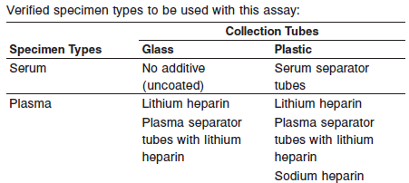

**NOTE:** Evaluation of serum samples may result in up to a -18% bias compared with plasma samples.

When serial specimens are being evaluated, the same type of specimen should be used throughout the study.

**•** Other specimen collection tube types have not been tested with this assay.

**•** Performance has not been established using cadaver specimens or body fluids other than human serum or plasma.

Do not use specimens with the following conditions:

**•** heat-inactivated

**•** obvious microbial contamination

**Specimen Storage**

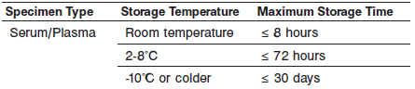

If testing will be delayed more than 8 hours, remove plasma or serum from the red blood cells, clot or separator gel. Specimens removed from the red blood cells, clot or separator gel may be stored up to 72 hours at 2-8°C.

Specimens can be stored up to 30 days frozen at -10°C or colder. All samples (patient specimens, controls, and calibrators) should be tested within 3 hours of being placed on board the ARCHITECT iSystem.

Avoid multiple freeze/thaw cycles.

**NOTE:** Stored specimens must be inspected for particulates. If present, mix and centrifuge the specimen to remove particulates prior to testing.

**Materials and Equipment Required**

**TEST INSTRUMENT**: Abbott ARCHITECT System

**MATERIALS PROVIDED**

2K42 ARCHITECT STAT CK-MB Reagent Kit

**MATERIALS REQUIRED BUT NOT PROVIDED**

**•** ARCHITECT *i* System with *STAT* protocol

**•** ARCHITECT STAT CK-MB Assay file, may be obtained from:

**•** ARCHITECT *i* System e-Assay CD-ROM found on www.abbottdiagnostics.com

**•** ARCHITECT *i* System Assay CD-ROM

**•** 2K42-01 ARCHITECT STAT CK-MB Calibrators

**•** 2K42-10 ARCHITECT STAT CK-MB Controls

**•** ARCHITECT *i* Pretrigger

**•** ARCHITECT *i* Trigger

**•** ARCHITECT *i i* Wash Buffer

**•** ARCHITECT *i* Reaction Vessels

**•** ARCHITECT *i* Sample Cups

**•** ARCHITECT *i* Septums

**•** ARCHITECT *i* Replacement Caps

**•** Pipettes or pipette tips (optional) to deliver the specified volumes.

**Reagent Handling and Storage:**

***CAUTION*:**

* For in vitro diagnostic use.

**CAUTION:** This product requires the handling of human specimens.

It is recommended that all human sourced materials be considered

potentially infectious and be handled in accordance with the OSHA

Standard on Bloodborne Pathogens. Biosafety Level 2 or other appropriate biosafety practices should be used for materials that contain or are suspected of containing infectious agents.

**Reagent Handling**

* Do not use reagent kits beyond the expiration date.
* **Do not pool reagents within a kit or between reagent kits.**
* Before loading the ARCHITECT Reagent Kit on the system for the first time, the microparticle bottle requires mixing to resuspend microparticles that have settled during shipment.
* **Septums MUST be used to prevent reagent evaporation and contamination and to ensure reagent integrity. Reliability of assay results cannot be guaranteed if septums are not used according to the instructions in the package insert.**
* To avoid contamination, wear clean gloves when placing a septum on an uncapped reagent bottle.
* Once a septum has been placed on the reagent bottle, **do not invert the bottle** as this will result in reagent leakage and maycompromise assay results.
* Over time, residual liquids may dry on the septum surface. These are typically dried salts and have no effect on assay efficacy.
* For a detailed discussion of handling precautions during system operation, refer to the ARCHITECT System Operations Manual, Section 7.

**Reagent Storage**

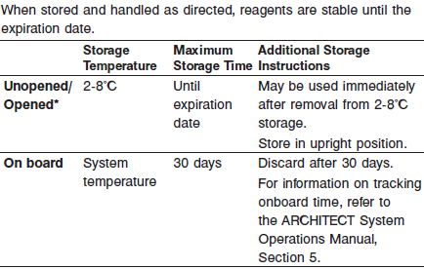

* Reagents may be stored on or off the ARCHITECT *i* System. If reagents are removed from the system, store them at 2-8°C (with septums and replacement caps) in an upright position. For reagents stored off the system, it is recommended that they be stored in their original trays and boxes to ensure they remain upright. **If the microparticle bottle does** **not remain upright (with a septum installed) while in refrigerated** **storage off the system, the reagent kit must be discarded.** For information on unloading reagents, refer to the ARCHITECT System Operations Manual, Section 5.

Reagents

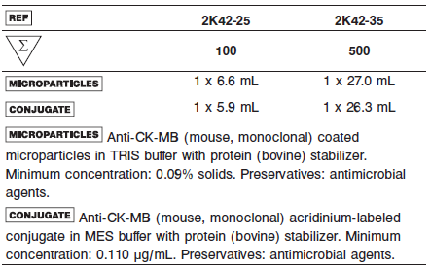

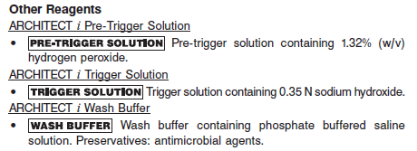

**Calibrator:** 2K42-01 ARCHITECT STAT CK-MB Calibrators

**Quality Control:** 2K42-10 ARCHITECT STAT CK-MB Controls

**Calibration**

**Frequency:**

Recalibration is required with each new reagent lot number.

**A new calibration is required:**

1. If quality control results do not meet acceptance criteria defined by your laboratory, patient values may be suspect. Follow the established quality control procedures for your laboratory. Recalibration may be necessary.
2. Review quality control results and acceptance criteria following a change of reagent or calibrator lot.

**Calibrator Required:**

2K42-01 ARCHITECT STAT CK-MB Calibrators

**Reagents:**

6 Bottles (3.0 mL each) of ARCHITECT *STAT* CK-MB Calibrators. Calibrator A contains MOPS buffer with protein (bovine) stabilizer. Calibrators B-F contain recombinant CK-MB in MOPS buffer with protein (bovine) stabilizer. Preservative: antimicrobial agents.

**Calibrator Preparation:**

Self-defrosting freezers are not suitable for storage.

**•** Thaw completely at room temperature (15-30°C) for 45-60 minutes. Prior to use, mix THOROUGHLY by inversion 5-10 times. After each use, immediately return the thawed calibrators to refrigerated storage (2-8°C) for up to 90 days after thaw.

**Calibration Procedure:**

Test Calibrators A-F in duplicate. The calibrators should be priority loaded.

A single sample of each control level must be tested to evaluate the assay calibration. Ensure that assay control values are within the ranges specified in the respective control package insert.

**•** Calibration Range: 0.0 – 300.0 ng/mL.

**Troubleshooting and Overall Acceptance Criteria Failure**

See ARCHITECT Operations Manual for further calibration troubleshooting.

**Quality Control:**

Abbott recommends, refer to your laboratory standard operating procedure(s) and/or quality assurance plan for additional quality control requirements and potential corrective actions:

• At a minimum a single level of quality control are to be run every 24 hours

• If more frequent control monitoring is required, follow the established quality control procedures for your laboratory.

• If quality control results do not meet the acceptance criteria defined by your laboratory, patient values may be suspect. Follow the established quality control procedures for your laboratory.

Recalibration may be necessary.

• Review quality control results and acceptance criteria following a change of reagent or calibrator lot.

**Instrument Procedure**

* The ARCHITECT STAT CK-MB assay is designed for use on the ARCHITECT *i* System with STAT protocol capability which must be installed on the system prior to running the assay.
* The ARCHITECT STAT CK-MB assay file must be installed on the ARCHITECT *i* System from an ARCHITECT *i* System Assay CD-ROM prior to performing the assay. For detailed information on assay file installation and on viewing and editing assay parameters, refer to the ARCHITECT System Operations Manual, Section 2.
* For detailed information on assay file installation and viewing and editing assay parameters, refer to the ARCHITECT System Operations Manual, Section 2.
* For information on printing assay parameters, refer to the ARCHITECT System Operations Manual, Section 5.
* For a detailed description of system procedures, refer to the ARCHITECT System Operations Manual.

**Assay Procedure**

For a detailed description of how to run an assay, refer to *Section 5* of the **ARCHITECT System Operations Manual**.

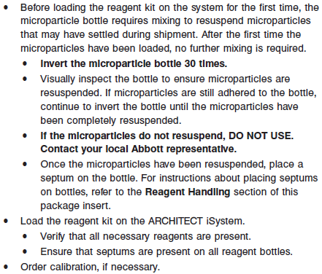

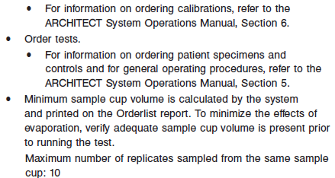

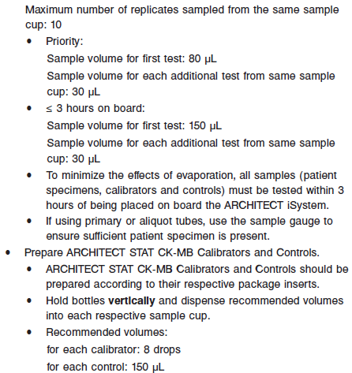

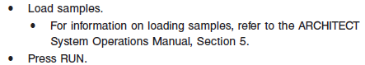

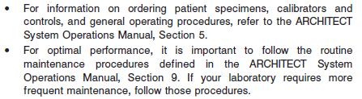

**Results**



**Flags**

Some results may contain information in the Flags field. For a description of the flags that may appear in this field, refer to the ARCHITECT System Operations Manual, Section 5.

**Specific Performance Characteristics**

**Expected Values**

It is recommended that each laboratory determine its own reference range based upon its particular locale and population characteristics.

**Serum/Plasma (Abbott Package Insert)**

Since CK-MB is released from damaged myocardium, CK-MB levels in normal individuals are often low or undetectable. A reference range study was conducted based on guidance from National Committee for Clinical Laboratory Standards (NCCLS) Protocol C28-A2. Plasma samples from apparently healthy individuals were evaluated in replicates of one using the ARCHITECT STAT CK-MB assay. The observed values are summarized in the following table.

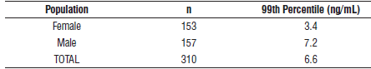

The concentration of CK-MB in serum rises rapidly subsequent to myocardial infarction. It is recommended that serial samples be drawn at intervals subsequent to initial symptoms for most accurate results. Correlation with other clinical findings (e.g., ECG, symptoms, etc.) should be sought in evaluating the determined CK-MB levels. Values for CK-MB generally peak at 10-24 hours subsequent to the initial symptom of chest pain and decline to normal range within 72-96 hours.20 CK-MB values which increase rapidly or which show an early time to peak may be indicative of reperfusion.

Since low levels of CK-MB are present in other tissues, a rise in CK-MB and total CK is not always indicative of MI or reperfusion. It has also been shown to be elevated following long distance running or vigorous exercise due to CK-MB present in skeletal muscle. Additionally, patients with acute skeletal muscle trauma, dermatomyositis, polymyositis and muscular dystrophy may exhibit elevated CK-MB and total CK levels. Renal failure, tissue damage following surgery and cardiac contusion may also cause an elevation of CK-MB. In these cases, the relative percent (%) index of CK-MB may be helpful in differentiating MI from non-MI specimens. The relative percent index of CK-MB is calculated by the following equation.



Due to differences in total CK methods and CK-MB levels in hospital populations, the normal range for the relative % index must be established at each laboratory. Use of relative % index may not be appropriate for all samples.

**Serum/Plasma:**Female: <3.4 ng/mL

Male: <7.2 ng/mL

**Critical Values: N/A**

**Performance Characteristics**

**Analytical Sensitivity**

The ARCHITECT STAT CK-MB analytical sensitivity is ≤ 0.1 ng/mL at the 95% level of confidence.

**Dilution:**

Specimens with a CK-MB value exceeding 300.0 ng/mL are flagged with the code “> 300.0” and may be diluted using either the Automated Dilution Protocol or the Manual Dilution Procedure.

**Automated Dilution Protocol**

The system performs a 1:2 dilution of the specimen and automatically calculates the concentration of the specimen before dilution and reports the result.

Specimens with a CK-MB value exceeding 600.0 ng/mL are flagged with the code “> 600.0” when run using the Automated Dilution Protocol. These specimens may be diluted with the Manual Dilution Procedure.

**Manual Dilution Procedure**

Suggested dilution: 1:10

1. Add 15 drops of ARCHITECT STAT CK-MB Calibrator A into a clean test tube for use in the next step.

2. Transfer 180 μL of ARCHITECT STAT CK-MB Calibrator A from the test tube prepared in the prior step into another clean test tube and add 20 μL of the patient specimen.

3. The operator must enter the dilution factor in the Patient or Control order screen. The system will use this dilution factor to automatically calculate the concentration of the sample before dilution and report the result. The result should be > 3.0 ng/mL before the dilution factor is applied.

For detailed information on ordering dilutions, refer to the ARCHITECT System Operations Manual, Section 5.

**Precision:**

The ARCHITECT STAT CK-MB assay precision is ≤ 10% total CV for samples ≥ 3 ng/mL. See package insert for more information.

#### Limitations of Procedure

* Specimens from patients who have received preparations of mouse monoclonal antibodies for diagnosis or therapy may contain human anti-mouse antibodies (HAMA). Specimens containing HAMA may produce anomalous values when tested with assay kits that employ mouse monoclonal antibodies.
* Heterophilic antibodies in human serum can react with reagent immunoglobulins, interfering with *in vitro* immunoassays. Patients routinely exposed to animals or to animal serum products can be prone to this interference and anomalous results may be observed. Additional information may be required for diagnosis.
* ARCHITECT STAT CK-MB is not intended to be used on an ARCHITECT iSystem without STAT protocol capability.

**Interference**

Potential interference from elevated levels of bilirubin, hemoglobin, triglycerides, and total protein in the ARCHITECT STAT CK-MB assay is ≤ 15% at the levels indicated in the following table.

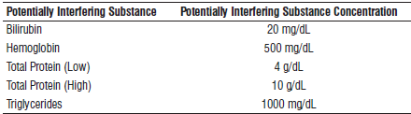

Evaluation of Potentially Interfering Clinical Conditions

The ARCHITECT STAT CK-MB assay was evaluated by testing specimens with HAMA and rheumatoid factor (RF) to further assess clinical specificity.



**Analytical Specificity**

The ARCHITECT STAT CK-MB assay analytical specificity is ≤ 0.01% cross-reactivity with CK-MM and CK-BB.

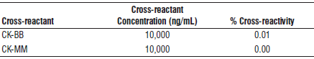

**References:**

1. ABBOTT ARCHITECT STAT CK-MB package insert

Abbott Laboratories

Diagnostics Division

Abbott Park, IL 60064

Oct 2015 G1-0450/ R05

1. ABBOTT ARCHITECT STAT CK-MB Calibrator package insert

Abbott Laboratories

Diagnostics Division

Abbott Park, IL 60064

1. Abbott ARCHITECT Operator’s Guide

**Related Documents:**

**Attachments:**