RUSH logo for emails

**BNP**

**PLASMA**

**ABBOTT ARCHITECT**

**Intended Use**

The ARCHITECT BNP assay is a chemiluminescent microparticle immunoassay (CMIA) for the quantitative determination of human B-type natriuretic peptide (BNP) in human EDTA plasma on the ARCHITECT *i* System. BNP values are used as an aid in the diagnosis and assessment of severity of heart failure.

**Clinical Significance**

Heart failure is a syndrome caused by a variety of conditions such as coronary artery disease, hypertension, valve disease, myocarditis and others. Common symptoms of heart failure include shortness of breath, coughing under exertion, swelling of appendages, and dizziness. Heart failure is better defined as the progressive inability of the heart ventricles to pump blood out to the lungs and/or the extremities. Heart failure is either systolic or diastolic or a combination of both. Severity is usually classified into four classes defined by the New York Heart Association (NYHA class I-IV).

BNP is one member of the family of natriuretic peptides that were initially discovered by de Bold, *et al.* Although BNP was first isolated from porcine brain tissue (originally named brain natriuretic peptide), the heart has been determined to be the major source. BNP is synthesized and released into the blood in response to volume overload or conditions that cause ventricular stretch, to control fluid and electrolyte homeostasis by interaction with the renin-angiotensin-aldosterone system (RAAS). PreproBNP (134 amino acids) is synthesized in the cardiac myocytes and is processed to a proBNP (108 amino acids) precursor molecule. The proBNP is subsequently cleaved into physiologically active BNP (32 amino acids), and a degradation fragment NT-proBNP (76 amino acids). BNP, NT-proBNP, and a higher molecular weight form have been detected in peripheral blood. BNP is cleared from the circulation, with a half-life (*t½*) of approximately 23 minutes, by specific cellular receptors and neutral endopeptidases. Numerous studies have indicated that BNP can be used for patient diagnosis, prognosis and therapy monitoring. Levels of BNP have been shown to be elevated in patients with cardiac dysfunction. Plasma

BNP levels provide clinically useful information concerning the diagnosis and management of left ventricular dysfunction and heart failure, which complements other diagnostic testing procedures (e.g., electrocardiograms, chest x-rays, and echocardiograms). BNP levels can be used to assess the severity of heart failure, as demonstrated by the correlation with New York Heart Association classifications. Plasma BNP levels also increase with decreasing physiological functional capacities, as measured by left ventricular ejection fraction (LVEF) or exercise-based evaluations.

The European Society of Cardiology has included the use of natriuretic peptides (e.g., BNP) testing in their guidelines for the diagnosis or rule out of heart failure.

Others have suggested that BNP has utility in the stratification of patients with heart failure and acute coronary syndrome (ACS). Elevated levels of BNP in heart failure patients predict disease progression and increased morbidity and mortality. Studies also suggest ACS patients with increased BNP levels have a higher rate of cardiac complications and higher mortality post myocardial infarction. Preliminary studies have reported the use of BNP measurements to optimize patient treatment / management for heart failure. Nesiritide (Natrecor), recombinant BNP has been used for treatment in patients with acute, decompensated heart failure. The efficacy of BNP monitoring, pre- and post-treatment with Natrecor, has been studied. Measurements of BNP two hours or more post-treatment detect only the endogenous levels of BNP.

**Principle**

The ARCHITECT BNP assay is a two-step immunoassay for the quantitative determination of human B-type natriuretic peptide (BNP) in human EDTA plasma using CMIA technology with flexible assay protocols, referred to as Chemiflex. In the first step, sample and anti-BNP coated paramagnetic

microparticles are combined. BNP present in the sample binds to the anti‑BNP coated microparticles. After washing, anti-BNP acridinium‑labeled conjugate is added to create a reaction mixture in the second step. Following another wash cycle, pre-trigger and trigger solutions are added to the reaction mixture. The resulting chemiluminescent reaction is measured as relative light units (RLUs). A direct relationship exists between the amount of BNP in the sample and the RLUs detected by the ARCHITECT *i* System optics.

For additional information on system and assay technology, refer to the ARCHITECT System Operations Manual, Section 3.

**Specimen Collection and Handling**

**Suitable Specimens**

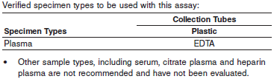

**•** Samples should be collected in **plastic collection tubes,** because the BNP molecule has been shown to be unstable in glass containers. Follow the manufacturer’s processing instructions for plasma collection tubes.

The ARCHITECT *i* System does not provide the capability to verify specimen type. It is the responsibility of the operator to verify that the correct specimen types are used in the assay.

Do not use specimens with the following conditions:

* Specimens containing red cells or particulate matter
* grossly hemolyzed

**Specimen Storage**

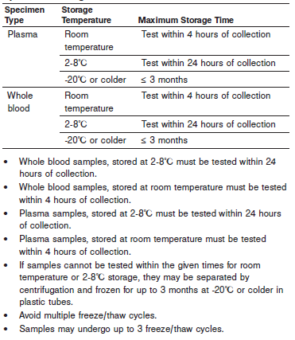

**•** Whole blood samples, stored at 2-8°C must be tested within 24 hours of collection.

**•** Whole blood samples, stored at room temperature must be tested within 4 hours of collection.

**•** Plasma samples, stored at 2-8°C must be tested within 24 hours of collection.

**•** Plasma samples, stored at room temperature must be tested within 4 hours of collection.

**•** If samples cannot be tested within the given times for room temperature or 2-8°C storage, they may be separated by centrifugation and frozen for up to 3 months at -20°C or colder in plastic tubes.

**•** Avoid multiple freeze/thaw cycles.

**•** Samples may undergo up to 3 freeze/thaw cycles

**NOTE:** Stored specimens must be inspected for particulates. If present, mix and centrifuge the specimen to remove particulates prior to testing.

**Materials and Equipment Required**

**TEST INSTRUMENT**: Abbott ARCHITECT System

**MATERIALS PROVIDED**

8K28 ARCHITECT BNP Reagent Kit

**MATERIALS REQUIRED BUT NOT PROVIDED**

**•** ARCHITECT BNP Assay file obtained from the ARCHITECT iSystem e-Assay CD-ROM found on www.abbottdiagnostics.com.

**•** 8K28-02 ARCHITECT BNP Calibrators

**•** 8K28-11 ARCHITECT BNP Controls

**•** ARCHITECT Pre-Trigger Solution

**•** ARCHITECT Trigger Solution

**•** ARCHITECT Wash Buffer

**•** ARCHITECT Reaction Vessels

**•** ARCHITECT Sample Cups

**•** ARCHITECT Septum

**•** ARCHITECT Replacement Caps

**•** Pipettes or pipette tips (optional) to deliver the volumes specified

on the patient or control order screen.

**Reagent Handling and Storage:**

***CAUTION*:**

* For in vitro diagnostic use.

**CAUTION:** This product requires the handling of human specimens.

It is recommended that all human sourced materials be considered

potentially infectious and be handled in accordance with the OSHA

Standard on Bloodborne Pathogens. Biosafety Level 2 or other appropriate biosafety practices should be used for materials that contain or are suspected of containing infectious agents.

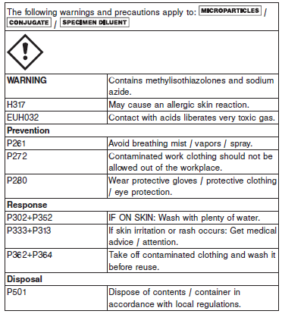

**Reagent Handling**

* Do not use reagent kits beyond the expiration date.
* **Do not pool reagents within a kit or between reagent kits.**
* Before loading the ARCHITECT reagent kit on the system for the first time, the microparticle bottle requires mixing to resuspend microparticles that may have settled during shipment. For microparticle mixing instructions, refer to the **PROCEDURE, Assay Procedure** section of the package insert.
* **Septums MUST be used to prevent reagent evaporation and contamination and to ensure reagent integrity. Reliability of assay results cannot be guaranteed if septums are not used according to the instructions in the package insert.**
* To avoid contamination, wear clean gloves when placing a septum on an uncapped reagent bottle.
* Once a septum has been placed on the reagent bottle, **do not invert the bottle** as this will result in reagent leakage and maycompromise assay results.
* Over time, residual liquids may dry on the septum surface. These are typically dried salts and have no effect on assay efficacy.
* For a detailed discussion of handling precautions during system operation, refer to the ARCHITECT System Operations Manual, Section 7.

**Reagent Storage**

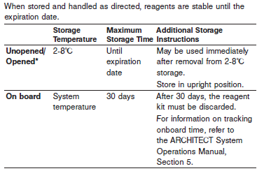

* Reagents may be stored on or off the ARCHITECT *i* System. If reagents are removed from the system, store them at 2-8°C (with septums and replacement caps) in an upright position. For reagents stored off the system, it is recommended that they be stored in their original trays and boxes to ensure they remain upright. **If the microparticle bottle does** **not remain upright (with a septum installed) while in refrigerated** **storage off the system, the reagent kit must be discarded.** For information on unloading reagents, refer to the ARCHITECT System Operations Manual, Section 5.

Reagents

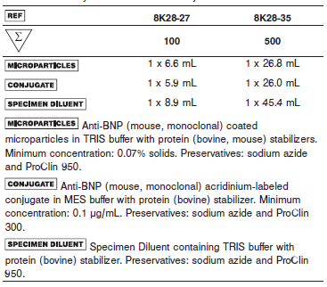

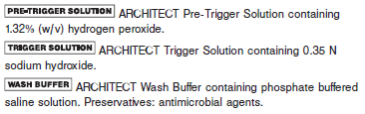

**Calibrator:** 8K28-02 ARCHITECT BNP Calibrators

**Quality Control:** 8K28-11 ARCHITECT BNP Controls or other control material

**Calibration**

**Frequency:**

Recalibration is required with each new reagent lot number.

**A new calibration is required:**

1. If quality control results do not meet acceptance criteria defined by your laboratory, patient values may be suspect. Follow the established quality control procedures for your laboratory. Recalibration may be necessary.
2. Review quality control results and acceptance criteria following a change of reagent or calibrator lot.

**Calibrator Required:** 8K28-02 ARCHITECT BNP Calibrators

**Reagents:**

6 Bottles (4 mL each) of ARCHITECT BNP Calibrators. Calibrator A is acetate buffer with protein (bovine) stabilizer. Calibrators B – F contain BNP in acetate buffer with protein (bovine) stabilizer.

**Calibrator Preparation:**

**•** Calibrators may be used immediately after removal from 2-8°C storage.

**•** Prior to use, mix by gentle inversion (5-10 times).

**•** After each use, tightly close the caps and return the calibrators to 2-8°C storage.

**Calibration Procedure:**

**•** To perform an ARCHITECT BNP calibration, test calibrators A, B, C, D, E and F in duplicate. A single sample of each BNP control must be tested to evaluate the assay calibration. Ensure that assay control values are within the concentration ranges specified in the control package insert. Calibrators should be priority loaded.

**•** Calibrator Range: 0 – 5000 pg/mL.

**Troubleshooting and Overall Acceptance Criteria Failure**

See ARCHITECT Operations Manual for further calibration troubleshooting.

**Quality Control:**

Abbott recommends, refer to your laboratory standard operating procedure(s) and/or quality assurance plan for additional quality control requirements and potential corrective actions:

• At a minimum a single level of all quality control are to be run every 24 hours

• If more frequent control monitoring is required, follow the established quality control procedures for your laboratory.

• If quality control results do not meet the acceptance criteria defined by your laboratory, patient values may be suspect. Follow the established quality control procedures for your laboratory.

Recalibration may be necessary.

• Review quality control results and acceptance criteria following a change of reagent or calibrator lot.

**Instrument Procedure**

* The ARCHITECT BNP assay is designed for use on the ARCHITECT *i* System.
* The ARCHITECT BNP assay file must be installed on the ARCHITECT *i* System with *STAT* capabilities before performing the assay.
* For detailed information on assay file installation and viewing and editing assay parameters, refer to the ARCHITECT System Operations Manual, Section 2.
* For information on printing assay parameters, refer to the ARCHITECT System Operations Manual, Section 5.
* For a detailed description of system procedures, refer to the ARCHITECT System Operations Manual.

**Assay Procedure**

For a detailed description of how to run an assay, refer to *Section 5* of the **ARCHITECT System Operations Manual**.

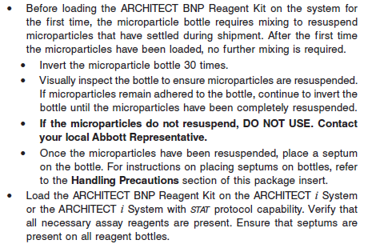

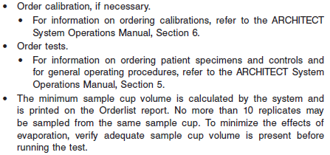

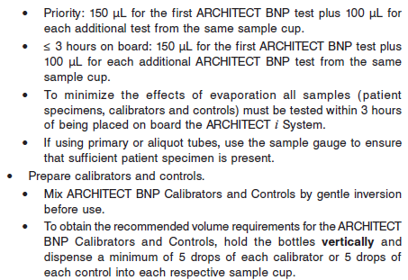

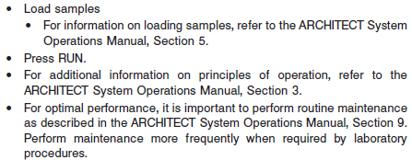

**Results**

The default result unit for the ARCHITECT BNP assay is pg/mL. The alternative unit is pmol/L

**Flags**

Some results may contain information in the Flags field. For a description of the flags that may appear in this field, refer to the ARCHITECT System Operations Manual, Section 5.

**Specific Performance Characteristics**

**Expected Values**

It is recommended that each laboratory determine its own reference range based upon its particular locale and population characteristics.

**Serum/Plasma:** < 100 pg/mL

< 100 pg/mL = Heart failure unlikely

100 – 400 pg/mL = Indeterminant; heart failure risk depends on clinical history

> 400 pg/mL = Heart failure likely

**Critical Values: N/A**

**Performance Characteristics**

**Measurement Range (Reportable Range)**

The measurement range for the ARCHITECT BNP assay is 10 pg/mL to 5000 pg/mL.

**Analytical Sensitivity**

The ARCHITECT BNP assay is designed to have an analytical sensitivity of ≤ 10 pg/mL.

**Dilution:**

Specimens with a BNP assay value exceeding 5000.0 pg/mL are flagged with the code “>5000.0” and may be diluted using the Automated Dilution Protocol. Retest of samples must be performed within assay specimen handling limits to ensure optimal BNP recovery (refer to the **SPECIMEN**

**COLLECTION AND PREPARATION FOR ANALYSIS** section of the package insert).

The Manual Dilution Feature of the Assay Parameter is set to ON primarily for use when performing dilution linearity studies.

NOTE: The Automated Dilution Protocol is preferred when diluting specimens due to the known instability of the BNP analyte. If performing manual dilutions, the specimen handling guidelines must be followed (refer to the **SPECIMEN COLLECTION AND PREPARATION FOR ANALYSIS** section of the package insert).

**•** If using the Automated Dilution Protocol, the system performs a 1:5 dilution of the specimen and automatically calculates the concentration of the sample before dilution and reports the result.

**•** For detailed information on ordering dilutions, refer to the ARCHITECT System Operations Manual, Section 5.

**Precision:**

The ARCHITECT BNP assay is designed to have an upper 95% Confidence Interval (CI) imprecision of ≤ 12% total CV.

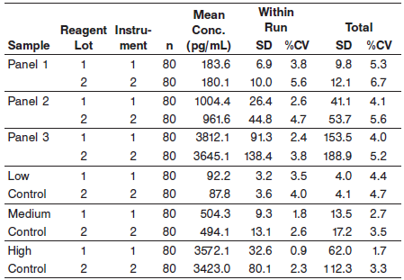

#### Limitations of Procedure

**•** EDTA plasma, collected in plastic tubes, should be used for this assay. The use of glass collection tubes, or other sample types, such as serum or plasma with other anticoagulants, is not

recommended.

**•** For diagnostic purposes, the ARCHITECT BNP results should be used in conjunction with other clinical data; e.g., symptoms, medical history, etc. If BNP results are not consistent with other

clinical observations, additional information may be required for diagnosis.

**•** Specimens from patients who have received preparations of mouse monoclonal antibodies for diagnosis or therapy may contain human anti-mouse antibodies (HAMA). Such specimens may show either falsely elevated or depressed values when tested with assay kits which employ mouse monoclonal antibodies.

ARCHITECT BNP reagents contain a component that reduces the effect of HAMA reactive specimens. Additional clinical or diagnosis information may be required to determine patient status.

**•** Heterophilic antibodies in human plasma can react with reagent immunoglobulins, interfering with *in vitro* immunoassays. The presence of heterophilic antibodies in a patient may cause anomalous values to be observed.

**•** ARCHITECT BNP results should not be used interchangeably with other manufacturers’ methods for BNP or NT-proBNP determinations.

**•** Measurements of BNP should occur prior to Nesiritide (Natrecor), recombinant BNP treatment and 2 hours post-treatment.

**Interfering Substances**

Potential interference in the ARCHITECT BNP assay from the following compounds is designed to be ≤ 10%.

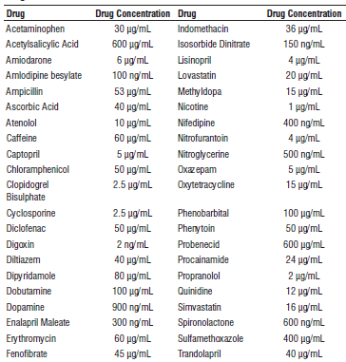

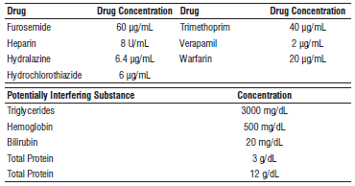

**Analytical Specificity**

The specificity of the ARCHITECT BNP assay is designed to be ≤ 10 pg/mL of measured BNP when tested with human ANP, Angiotensin I, II and III, CNP, and NT-proBNP at the following concentrations. Each potential cross-reactant was added to protease-inhibitor treated plasma and then assayed. Data from this study are summarized in the following table.*.

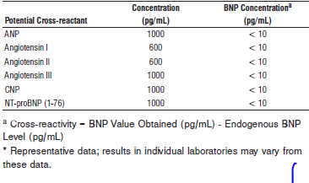

**References:**

1. ABBOTT ARCHITECT BNP package insert

Abbott Laboratories

Diagnostics Division

Abbott Park, IL 60064

Nov 2015 608-033 10/15/ R05

1. ABBOTT ARCHITECT BNP Calibrator package insert

Abbott Laboratories

Diagnostics Division

Abbott Park, IL 60064

1. Abbott ARCHITECT Operator’s Guide

**Related Documents:**

**Attachments:**