RUSH logo for emails

***STAT* TROPONIN-I**

**SERUM OR PLASMA**

**ABBOTT ARCHITECT**

**Intended Use**

ARCHITECT *STAT* Troponin-I is a chemiluminescent microparticle immunoassay (CMIA) for the quantitative determination of cardiac troponin‑I in human serum and plasma on the ARCHITECT *i* System with *STAT* protocol capability. Troponin-I values are used to assist in the diagnosis of myocardial infarction (MI).

**Clinical Significance**

Troponin-I (TnI) is a regulatory subunit of the troponin complex associated with the actin thin filament within muscle cells. TnI, in conjunction with troponin-C and troponin-T, plays an integral role in the regulation of muscle contraction. Three distinct tissue specific isoforms of TnI have been identified from skeletal and cardiac muscles. The cardiac isoform exhibits only 60% similarity with the skeletal muscle isoform and contains additional amino acids at the N-terminus; cardiac troponin-I (cTnI) has a molecular weight of approximately 24,000 daltons. Clinical studies have demonstrated the release of cTnI into the blood stream within hours following myocardial infarction (MI) or ischemic damage. Elevated levels of cTnI (above the values established for non-MI specimens) are detectable in serum within 4 to 6 hours after the onset of chest pain, reach peak concentrations in approximately 8 to 28 hours, and remain elevated for 3 to 10 days following MI. Cardiac troponin is the preferred biomarker for the detection of myocardial injury based on improved sensitivity and superior tissue-specificity compared to other available biomarkers of necrosis, including CK-MB, myoglobin, lactate dehydrogenase, and others. The high specificity of cTnI measurements is beneficial in identifying cardiac injury for clinical conditions involving skeletal muscle injury resulting from surgery, trauma, extensive exercise, or muscular disease. High tissue specificity of cardiac troponin, however, should not be confused with the specificity for the mechanism of injury (e.g., MI vs. myocarditis). When an increased value for cardiac troponin is encountered (e.g., exceeding the 99th percentile of a reference control population) in the absence of evidence of myocardial ischemia, a careful search of other possible etiologies for cardiac damage should be taken. The World Health Organization (WHO) criteria for defining MI are the presence of two of the following three elements: ECG changes, serum cardiac enzyme changes, and prolonged chest pain. More recently, a Global Task Force with joint leadership among the European Society of Cardiology (ESC), the American College of Cardiology Foundation (ACCF), the American Heart Association (AHA), and the World Heart Federation (WHF) refined past criteria with a universal definition of myocardial infarction that also supports use of cTnI as a preferred biomarker for myocardial injury. Their universal definition of MI is a typical rise and gradual fall of cardiac biomarkers (preferably troponin) with at least one value above the 99th percentile of the upper reference limit (URL) together with evidence of myocardial ischemia with at least one of the following: ischemic symptoms, pathological Q waves on electrocardiogram (ECG), ischemic ECG changes, or imaging evidence of new loss of viable myocardium or new regional wall motion abnormality. The recommended criteria are based on the principle that any reliable detectable amount of myocardial necrosis, if caused by myocardial ischemia, constitutes an MI. An elevated troponin value alone is not sufficient to make the diagnosis of myocardial infarction. Serial sampling is recommended to detect the temporal rise and fall of troponin levels characteristic of MI. In addition, other markers such as CK-MB can be used in conjunction with troponin-I results in aiding the diagnosis of MI.

Several major studies have shown that cTnI is also useful as a predictor of cardiac risk in patients with unstable angina. Previous studies showed that during a 30-day follow-up, patients with acute coronary syndromes (including unstable angina) were at greater risk of progressing to MI if cTnI is elevated. Results from the PRISM trial showed that elevated cTnI levels could help to identify patients with unstable angina who had additional cardiac risk (especially within the first 72 hours after onset of symptoms) and who could benefit from treatment with a glycoprotein IIb/IIIa-receptor antagonist. Thus, cTnI can play an important role in identifying patients with acute coronary syndromes who are at greater risk for cardiac events. The ACCF, AHA, and the National Academy of Clinical Biochemistry (NACB) also recommend using troponin results when making treatment decisions regarding unstable angina and non-ST segment elevation MI (NSTEMI).

**PRINCIPLE**

The ARCHITECT *STAT* Troponin-I assay is a two-step immunoassay to determine the presence of cTnI in human serum and plasma using CMIA technology with flexible assay protocols, referred to as Chemiflex.

In the first step, sample, assay diluent and anti-troponin-I antibody-coated paramagnetic microparticles are combined. Troponin-I present in the sample binds to the anti-troponin-I coated microparticles. After incubation and wash, anti-troponin-I acridinium-labeled conjugate is added in the second step.

Following another incubation and wash, pre-trigger and trigger solutions are then added to the reaction mixture. The resulting chemiluminescent reaction is measured as relative light units (RLUs). A direct relationship exists between the amount of troponin-I in the sample and the RLUs detected by the ARCHITECT *i*\* System optics. The concentration of troponin-I is read relative to a standard curve established with calibrators of known troponin-I concentrations.

For additional information on system and assay technology, refer to the ARCHITECT System Operations Manual, Section 3.

* *i* = immunoassay

**Specimen Collection and Handling**

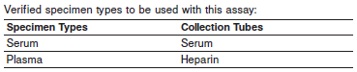

**•** For serum specimens, ensure that complete clot formation has taken place prior to centrifugation. Some specimens, especially those from patients receiving anticoagulant or thrombolytic therapy, may exhibit increased clotting times. If the specimen is centrifuged before complete clot formation, the presence of fibrin may cause erroneous results.



**•** When serial specimens are being evaluated, use the same specimen type throughout the evaluation.

Do not use:

**•** heat-inactivated specimens.

**•** samples with obvious microbial contamination.

**•** cadaver specimens or body fluids other than human heparinized plasma or serum.

For optimal results, serum and plasma specimens should be free of fibrin, red blood cells or other particulate matter.

**Storage**

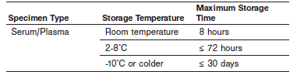

Test all samples (patient specimens, controls, and calibrators) within 3 hours of being placed on board the ARCHITECT *i* System. Refer to the ARCHITECT System Operations Manual, Section 5, for a more detailed discussion of on-board sample storage constraints.

**•** If testing will be delayed more than 8 hours, remove the plasma or serum from the cells, clot, or gel. Specimens removed from the cells, clot, or gel may be stored up to 72 hours at 2-8°C or stored frozen

(-10°C or colder) prior to being tested.

**•** Specimens can be stored up to 30 days frozen at -10°C or colder.

**Materials and Equipment Required**

**TEST INSTRUMENT**: Abbott ARCHITECT System

**MATERIALS PROVIDED**

2K41 ARCHITECT *STAT* Troponin-I Reagent Kit

**MATERIALS REQUIRED BUT NOT PROVIDED**

**•** ARCHITECT STAT Troponin-I Assay file obtained from the ARCHITECT iSystem e-Assay CD-ROM found on [www.abbottdiagnostics.com](http://www.abbottdiagnostics.com).

**•** 2K41-01 ARCHITECT *STAT* Troponin-I Calibrators

**•** 2K41-10 ARCHITECT *STAT* Troponin-I Controls

**•** ARCHITECT *i* Pretrigger

**•** ARCHITECT *i* Trigger

**•** ARCHITECT *i* Wash Buffer

**•** ARCHITECT *i* Reaction Vessels

**•** ARCHITECT *i* Sample Cups

**•** ARCHITECT *i* Septums

**•** ARCHITECT *i* Replacement Caps

**•** Pipettes or pipette tips (optional) to deliver the specified volumes.

**Reagent Handling and Storage:**

***CAUTION*:**

* For in vitro diagnostic use.

**CAUTION:** This product requires the handling of human specimens.

It is recommended that all human sourced materials be considered potentially infectious and be handled in accordance with the OSHA Standard on Bloodborne Pathogens. Biosafety Level 2 or other appropriate biosafety practices should be used for materials that contain or are suspected of containing infectious agents.

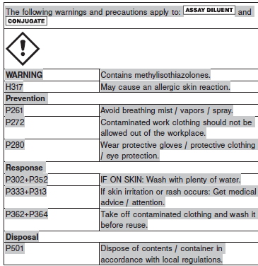

**Reagent Handling**

* Do not use reagent kits beyond the expiration date.
* **Do not pool reagents within a kit or between reagent kits.**
* Before loading the ARCHITECT Reagent Kit on the system for the first time, the microparticle bottle requires mixing to resuspend microparticles that have settled during shipment.
* **Septums MUST be used to prevent reagent evaporation and contamination and to ensure reagent integrity. Reliability of assay results cannot be guaranteed if septums are not used according to the instructions in the package insert.**
* To avoid contamination, wear clean gloves when placing a septum on an uncapped reagent bottle.
* Once a septum has been placed on the reagent bottle, **do not invert the bottle** as this will result in reagent leakage and maycompromise assay results.
* Over time, residual liquids may dry on the septum surface. These are typically dried salts and have no effect on assay efficacy.
* For a detailed discussion of handling precautions during system operation, refer to the ARCHITECT System Operations Manual, Section 7.

**Reagent Storage**

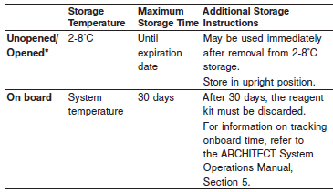

* The ARCHITECT *STAT* Troponin-I Reagent Kit may be stored on-board the ARCHITECT *i* System for a maximum of 30 days. After 30 days, the reagent kit must be discarded. For information on tracking on-board time, refer to the ARCHITECT System Operations Manual, Section 5.
* Reagents may be stored on or off the ARCHITECT *i* System. If reagents are removed from the system, store them at 2-8°C (with septums and replacement caps) in an upright position. For reagents stored off the system, it is recommended that they be stored in their original trays and boxes to ensure they remain upright.
* For information on unloading reagents, refer to the ARCHITECT System Operations Manual, Section 5.

Reagents

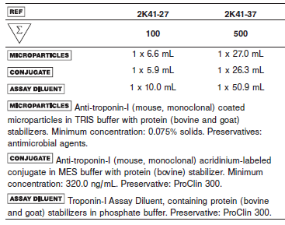

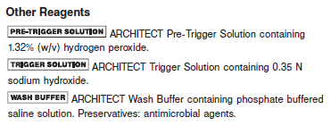

**Calibrator:** 2K41-01 ARCHITECT *STAT* Troponin-I Calibrators

**Quality Control:** 2K41-10 ARCHITECT *STAT* Troponin-I Controls

**Calibration**

**Frequency:**

Recalibration is required with each new reagent lot number.

**A new calibration is required:**

1. If quality control results do not meet acceptance criteria defined by your laboratory, patient values may be suspect. Follow the established quality control procedures for your laboratory. Recalibration may be necessary.
2. Review quality control results and acceptance criteria following a change of reagent or calibrator lot.

**Calibrator Required:** 2K41-01 ARCHITECT *STAT* Troponin-I Calibrators

**Reagents:**

6 Bottles (4.0 mL each) of ARCHITECT *STAT* Troponin-I Calibrators. Calibrator A contains human serum. Preservative: sodium azide. Calibrators B through F contain a recombinant human cardiac troponin IC complex in phosphate buffer with protein (bovine) stabilizer. Preservative: ProClin 300.

**Calibrator Preparation:**

Calibrators may be used immediately after removal from 2-8°C storage.

**•** Prior to each use, mix by gentle inversion, 5-10 times. After each use, tightly close the caps and return the calibrators to 2-8°C storage.

**Calibration Procedure:**

To perform an ARCHITECT *STAT* Troponin-I calibration, test the

Calibrators A, B, C, D, E, and F in duplicate. A single sample of each

ARCHITECT *STAT* Troponin-I Control level must be tested to evaluate

the assay calibration. Ensure that assay control values are within the

concentration ranges specified in the control package insert. Calibrators

should be priority loaded.

**•** Calibration Range: 0.00 - 50.00 ng/mL (0.00 - 50.00 μg/L).

**Troubleshooting and Overall Acceptance Criteria Failure**

See ARCHITECT Operations Manual for further calibration troubleshooting.

**Quality Control:**

Abbott recommends, refer to your laboratory standard operating procedure(s) and/or quality assurance plan for additional quality control requirements and potential corrective actions:

• At a minimum a single level of each quality control are to be run every 24 hours

• If more frequent control monitoring is required, follow the established quality control procedures for your laboratory.

• If quality control results do not meet the acceptance criteria defined by your laboratory, patient values may be suspect. Follow the established quality control procedures for your laboratory.

Recalibration may be necessary.

• Review quality control results and acceptance criteria following a change of reagent or calibrator lot.

**Instrument Procedure**

* The ARCHITECT *STAT* Troponin-I assay file must be installed on the ARCHITECT *i* System with *STAT* protocol capability from an ARCHITECT *i* System Assay CD-ROM prior to performing the assay. For detailed information on assay file installation and on viewing and editing assay parameters, refer to the ARCHITECT System Operations Manual, Section 2.
* For detailed information on assay file installation and viewing and editing assay parameters, refer to the ARCHITECT System Operations Manual, Section 2.
* For information on printing assay parameters, refer to the ARCHITECT System Operations Manual, Section 5.
* For a detailed description of system procedures, refer to the ARCHITECT System Operations Manual.

**Assay Procedure**

For a detailed description of how to run an assay, refer to *Section 5* of the **ARCHITECT System Operations Manual**.

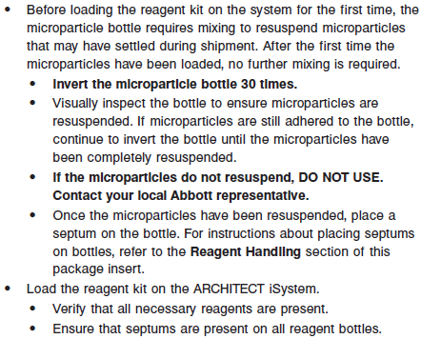

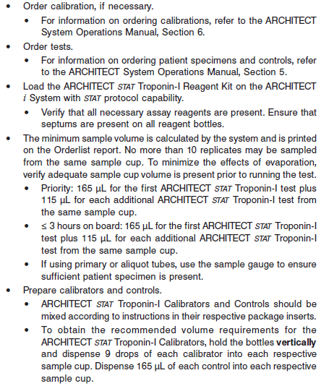

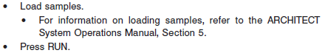

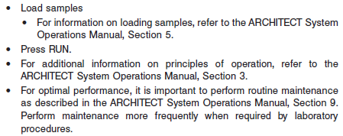

**Results**

The default result unit for the ARCHITECT STAT Troponin-I assay is ng/mL.

Edit assay parameter "Result concentration units" to select an alternate unit.

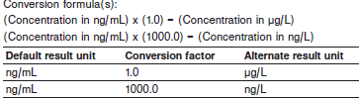

**Flags**

Some results may contain information in the Flags field. For a description of the flags that may appear in this field, refer to the ARCHITECT System Operations Manual, Section 5.

**Specific Performance Characteristics**

**Expected Values**

It is recommended that each laboratory determine its own reference range based upon its particular locale and population characteristics.

**Serum/Plasma**

Any condition resulting in myocardial cell damage can potentially increase cardiac troponin-I levels. Published studies have documented that these conditions include, but are not limited to, angina, unstable angina, congestive heart failure, myocarditis, cardiac surgery, or invasive testing and noncardiac related causes such as pulmonary embolism, renal failure, and sepsis.

**Serial sampling is recommended to detect the temporal rise and fall of troponin levels characteristic of MI.**

**The ARCHITECT *STAT* Troponin-I assay diagnostic cutoff is 0.30 ng/mL (0.30 μg/L).**

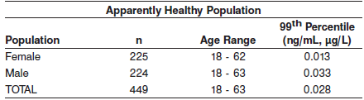

See the EXPECTED VALUES section of the reagent package insert for more information.

**Serum/Plasma:** <0.03 combined healthy population 99th percentile

**Critical Values: N/A**

**Performance Characteristics**

**Sensitivity**

The ARCHITECT *STAT* Troponin-I assay analytical sensitivity is ≤ 0.01 ng/mL (≤ 0.01 μg/L) at the 95% level of confidence

**Linearity**

The ARCHITECT *STAT* Troponin-I assay is designed to be linear across the measurement range of 0.01 to 50 ng/mL. See information in the **SPECIFIC PERFORMANCE CHARACTERISTICS** section of the package insert.

**Dilution:**

Specimens with a troponin-I value exceeding 50.00 ng/mL (50.00 μg/L) are flagged with the code “>50.00” and may be diluted with the Automated Dilution Procedure or the Manual Dilution Procedure.

Automated Dilution Protocol

**•** If using the Automated Dilution Protocol, the system performs a 1:9 dilution of the specimen and automatically calculates the concentration of the specimen before dilution and reports the result.

**•** Specimens with a troponin-I value exceeding 440.00 ng/mL (440.00 μg/L) are flagged with the code “>440.00” when run using the Automated Dilution Protocol. These specimens may be diluted by the following Manual Dilution Procedure.

Manual Dilution Procedure

**•** Manual dilutions should be performed as follows:

**•** The suggested dilution for a troponin-I test is 1:20.

**•** Prior to diluting the specimen, dispense several drops of ARCHITECT *STAT* Troponin-I Calibrator A into a clean test tube for use in the next step.

**•** Add 10 μL of the patient specimen to 190 μL of ARCHITECT *STAT* Troponin-I Calibrator A.

**•** The operator must enter the dilution factor in the Patient or Control order screen. The system will use this dilution factor to automatically calculate the concentration of the sample before dilution. This will be the reported result. The concentration of the specimen diluted (before dilution factor is applied) should be 2.5 ng/mL (2.5 μg/L) or greater.

**•** For detailed information on ordering dilutions, refer to the ARCHITECT System Operations Manual, Section 5.

**Precision:**

The ARCHITECT *STAT* Troponin-I assay concentration at 10% CV is ≤ 0.10 ng/mL (≤ 0.10 μg/L).

See information in the **SPECIFIC PERFORMANCE CHARACTERISTICS** section of the package insert.

#### Limitations of Procedure

* Specimens from patients who have received preparations of mouse monoclonal antibodies for diagnosis or therapy may contain human anti-mouse antibodies (HAMA). Specimens containing HAMA may produce anomalous values when tested with assay kits that employ mouse monoclonal antibodies.
* Heterophilic antibodies in human serum can react with reagent immunoglobulins, interfering with *in vitro* immunoassays. Patients routinely exposed to animals or to animal serum products can be prone to this interference and anomalous results may be observed. Additional information may be required for diagnosis. Immunoassays are nonspecific and cross react with metabolites.
* Cardiac troponin-I levels can be increased in any condition resulting in cardiac cell damage. For MI diagnostic purposes, the ARCHITECT *STAT* Troponin-I results should be used in conjunction with other information such as cardiac marker results (e.g., CK-MB and/or myoglobin), ECG, clinical observations and symptoms, etc.
* A single negative troponin-I result is not sufficient to declare that a patient has not had a heart attack or cardiac damage. Serial negative blood draws over time are recommended before patients are classified as negative for a heart attack
* *In vitro* studies suggest the measured level of cardiac troponin-I in serum and plasma specimens may be decreased in the presence of streptokinase or tissue-type plasminogen activator.

**Specificity**

The ARCHITECT *STAT* Troponin-I assay analytical specificity is ≤ 0.1% crossreactivity with skeletal troponin-I and ≤ 1% with cardiac troponin-C and cardiac troponin-T.

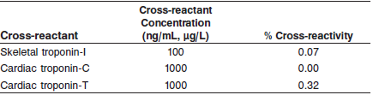

**Interference**

Potential interference from various drugs and elevated levels of bilirubin, hemoglobin, triglycerides, and total protein in the ARCHITECT *STAT* Troponin-I assay is ≤ 15% at the levels indicated.

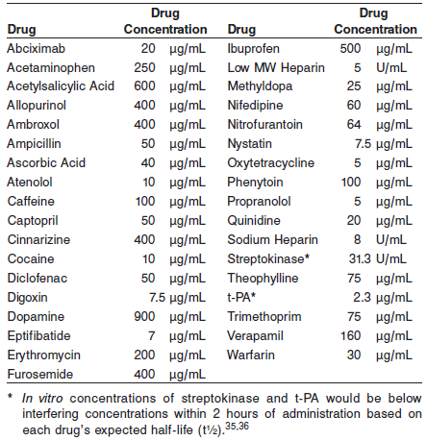

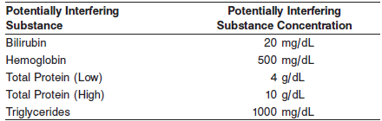

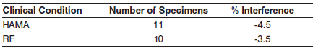

**References:**

1. ABBOTT ARCHITECT *STAT* Troponin-I package insert

Abbott Laboratories

Diagnostics Division

Abbott Park, IL 60064

June 2015 G1-0467/ R11

1. ABBOTT ARCHITECT *STAT* Troponin-I Calibrator package insert

Abbott Laboratories

Diagnostics Division

Abbott Park, IL 60064

1. Abbott ARCHITECT Operator’s Guide

**Related Documents:**

**Attachments:**