RUSH logo for emails

**TSH**

**SERUM OR PLASMA**

**ABBOTT ARCHITECT**

**Intended Use**

The ARCHITECT TSH assay is a Chemiluminescent Microparticle Immunoassay (CMIA) for the quantitative determination of human Thyroid Stimulating Hormone (TSH) in human serum and plasma.

**Clinical Significance**

Human Thyroid Stimulating Hormone (TSH) or thyrotropin is a glycoprotein with a molecular weight of approximately 28,000 daltons, synthesized by the basophilic cells (thyrotropes) of the anterior pituitary. TSH is composed of two non-covalently linked subunits designated alpha and beta. Although the alpha subunit of TSH is common to the luteinizing hormone (LH), follicle stimulating hormone (FSH) and human chorionic gonadotropin (hCG), the beta subunits of these glycoproteins are hormone specific and confer biological as well as immunological specificity. Both alpha and beta subunits are required for biological activity. TSH stimulates the production and secretion of the metabolically active thyroid hormones, thyroxine (T4) and triiodothyronine (T3), by interacting with a specific receptor on the thyroid cell surface. T3 and T4 are responsible for regulating diverse biochemical processes throughout the body which are essential for normal development and metabolic and neural activity.

The synthesis and secretion of TSH is stimulated by thyrotropin releasing hormone (TRH), the hypothalamic tripeptide, in response to low levels of circulating thyroid hormones. Elevated levels of T3 and T4 suppress the production of TSH via a classic negative feedback mechanism. Other evidence also indicates that somatostatin and dopamine exert inhibitory control over TSH release, suggesting that the hypothalamus may provide both inhibitory and stimulatory influence on pituitary TSH production. Failure at any level of regulation of the hypothalamic-pituitary-thyroid axis will result in either underproduction (hypothyroidism) or overproduction (hyperthyroidism) of T4 and/or T3. In cases of primary hypothyroidism, T3 and T4 levels are low and TSH levels are significantly elevated. In the case of pituitary dysfunction, either due to intrinsic hypothalamic or pituitary disease; i.e., central hypothyroidism, normal or marginally elevated basal TSH levels are often seen despite significant reduction in T4 and/or T3 levels. These inappropriate TSH values are due to a reduction in TSH bioactivity which is frequently observed in such cases. Routine TRH stimulation is advised to confirm the diagnosis in such cases. Secondary hypothyroidism typically results in an impaired TSH response to TRH, while in tertiary hypothyroidism the TSH response to TRH may be normal, prolonged or exaggerated. Primary hyperthyroidism (e.g., Grave’s Disease, nodular goiter) is associated with high levels of thyroid hormones and depressed or undetectable levels of TSH. The TRH stimulation test has been used in diagnosis of hyperthyroidism. Hyperthyroid patients show a subnormal response to the TRH test. In addition, large doses of glucocorticoids, somatostatin, dopamine and replacement doses of thyroid hormones reduce or totally blunt the TSH response to TRH. Earlier assays for serum TSH lacked the sensitivity to be used as a primary test of thyroid function. Sensitive TSH assays now available, with increased ability to clearly distinguish between euthyroid and hyperthyroid populations, are changing thyroid function testing. Analytical sensitivity, as a means of assessing low concentration accuracy, is being replaced by functional sensitivity. The American Thyroid Association has formally recommended the use of functional sensitivity as the means to quantify the sensitivity of TSH assays, although analytical sensitivity is still widely used. Third generation TSH assays exhibit 20% interassay

CVs at < 0.02 μIU/mL and are useful in the discrimination of patients with true hyperthyroidism from those with TSH suppression seen in subclinical hyperthyroidism and some non-thyroidal illnesses. Other thyroid tests (Free T4 estimate, Total T4, T-Uptake, and Total T3) combined with the ability to accurately measure low levels of TSH, improve the efficiency of thyroid diagnosis.

The ARCHITECT TSH assay is used as an aid in the assessment of thyroid status, diagnosis of thyroid disease, and treatment of thyroid disease.

**Principle**

The ARCHITECT TSH assay is a two-step immunoassay to determine the presence of Thyroid Stimulating Hormone (TSH) in human serum and plasma using Chemiluminescent Microparticle Immunoassay (CMIA) technology with flexible assay protocols, referred to as Chemiflex. In the first step, sample, anti-β TSH antibody coated paramagnetic microparticles and TSH Assay Diluent are combined. TSH present in the sample binds to the anti-TSH antibody coated microparticles. After washing, anti-α TSH acridinium labeled conjugate is added in the second step. Pre-Trigger and Trigger Solutions are then added to the reaction mixture; the resulting chemiluminescent reaction is measured as relative light units (RLUs). A direct relationship exists between the amount of TSH in the sample and the RLUs detected by the ARCHITECT *i* optical system.

For additional information on system and assay technology, refer to the ARCHITECT System Operations Manual, Section 3.

**Specimen Collection and Handling**

**Suitable Specimens**

* Human serum (including serum collected in serum separator tubes) or plasma collected in lithium heparin, sodium heparin, or potassium EDTA anticoagulant tubes may be used in the ARCHITECT TSH assay. Other anticoagulants have not been validated for use with the ARCHITECT TSH assay.
* **Ensure that complete clot formation in serum specimens has taken place prior to centrifugation. Some specimens, especially those from patients receiving anticoagulant or thrombolytic therapy may exhibit increased clotting time. If specimens are centrifuged before a complete clot forms, the presence of fibrin or particulate matter may cause erroneous results. Centrifuge specimens containing fibrin, red blood cells, or particulate matter. Note that interfering levels of fibrin may be present in samples that do not have obvious or visible particulate matter.**
* **If proper specimen collection and preparation cannot be verified, or if samples have been disrupted due to transportation or sample handling, an additional centrifugation step is recommended. Centrifugation conditions should be sufficient to remove particulate matter. Aliquots poured versus pipetted from specimen tube types that do not include serum separators are at higher risk of including particulates and generating depressed results.**
* **Failure to follow these instructions may result in depressed specimen results.**.

Do not use specimens with the following conditions:

**•** heat inactivated

**Storage**

If testing will be delayed more than 24 hours, remove serum or plasma from the clot, serum separator or red blood cells. Specimens may be stored for up to 7 days at 2-8°C prior to being tested. If testing will be delayed more than 7 days, specimens should be frozen at -10°C or colder. Specimens stored frozen at -10°C or colder for 6 months showed no performance difference

* Multiple freeze-thaw cycles of specimens should be avoided..

**NOTE:** Stored specimens must be inspected for particulates. If present, mix and centrifuge the specimen to remove particulates prior to testing.

**Materials and Equipment Required**

**TEST INSTRUMENT**: Abbott ARCHITECT System

**MATERIALS PROVIDED**

7K62 ARCHITECT TSH Reagent Kit

**MATERIALS REQUIRED BUT NOT PROVIDED**

**•** ARCHITECT *i* System with *STAT* protocol

**•** ARCHITECT TSH Assay file, may be obtained from:

**•** ARCHITECT *i* System e-Assay CD-ROM found on www.abbottdiagnostics.com

**•** ARCHITECT *i* System Assay CD-ROM

**•** 7K62-01 ARCHITECT TSH Calibrators

**•** 7K62-10 ARCHITECT TSH Controls

**•** 7D82-50 ARCHITECT *i* Multi-Assay Manual Diluent

**•** ARCHITECT *i* Pretrigger

**•** ARCHITECT *i* Trigger

**•** ARCHITECT *i i* Wash Buffer

**•** ARCHITECT *i* Reaction Vessels

**•** ARCHITECT *i* Sample Cups

**•** ARCHITECT *i* Septums

**•** ARCHITECT *i* Replacement Caps

**•** Pipettes or pipette tips (optional) to deliver the specified volumes.

**Reagent Handling and Storage:**

***CAUTION*:**

* For in vitro diagnostic use.

**CAUTION:** This product requires the handling of human specimens.

It is recommended that all human sourced materials be considered

potentially infectious and be handled in accordance with the OSHA

Standard on Bloodborne Pathogens. Biosafety Level 2 or other appropriate biosafety practices should be used for materials that contain or are suspected of containing infectious agents.

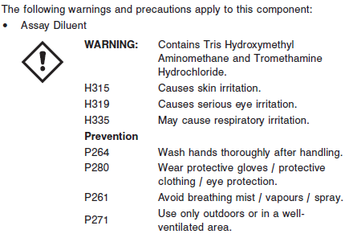

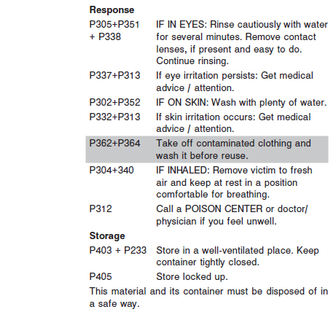

**Reagent Handling**

* Do not use reagent kits beyond the expiration date.
* **Do not pool reagents within a kit or between reagent kits.**
* Before loading the ARCHITECT Reagent Kit on the system for the first time, the microparticle bottle requires mixing to resuspend microparticles that have settled during shipment.
* **Septums MUST be used to prevent reagent evaporation and contamination and to ensure reagent integrity. Reliability of assay results cannot be guaranteed if septums are not used according to the instructions in the package insert.**
* To avoid contamination, wear clean gloves when placing a septum on an uncapped reagent bottle.
* Once a septum has been placed on the reagent bottle, **do not invert the bottle** as this will result in reagent leakage and maycompromise assay results.
* Over time, residual liquids may dry on the septum surface. These are typically dried salts and have no effect on assay efficacy.
* For a detailed discussion of handling precautions during system operation, refer to the ARCHITECT System Operations Manual, Section 7.

**Reagent Storage**

* The ARCHITECT TSH Reagent Kit must be stored at 2-8°C and may be used immediately after removal from 2‑8°C storage.
* When stored and handled as directed, reagents are stable until the expiration date.
* The ARCHITECT TSH Reagent Kit may be stored on-board the ARCHITECT *i* System for a maximum of 30 days. After 30 days, the reagent kit must be discarded. For information on tracking on‑board time, refer to the ARCHITECT System Operations Manual, Section 5.
* Reagents may be stored on or off the ARCHITECT *i* System. If reagents are removed from the system, store them at 2-8°C (with septums and replacement caps) in an upright position. For reagents stored off the system, it is recommended that they be stored in their original trays and boxes to ensure they remain upright.
* For information on unloading reagents, refer to the ARCHITECT System Operations Manual, Section 5.

Reagents

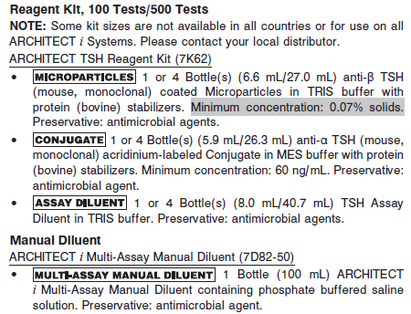

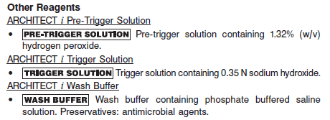

**Calibrator:** 7K62-01 ARCHITECT TSH Calibrators

**Quality Control:** 7K62-10 ARCHITECT TSH Controls

**Calibration**

**Frequency:**

Recalibration is required with each new reagent lot number.

**A new calibration is required:**

1. If quality control results do not meet acceptance criteria defined by your laboratory, patient values may be suspect. Follow the established quality control procedures for your laboratory. Recalibration may be necessary.
2. Review quality control results and acceptance criteria following a change of reagent or calibrator lot.

**Calibrator Required:**

7K62-01 ARCHITECT TSH Calibrators

**Reagents:**

2 Bottles (4 mL each) of ARCHITECT TSH Calibrators. Calibrator 1 contains TRIS buffer with protein (bovine) stabilizers; Calibrator 2 contains TSH (recombinant) in TRIS buffer with protein (bovine) stabilizers. Preservative: sodium azide.

**Calibrator Preparation:**

Ready to use.

**Calibration Procedure:**

To perform an ARCHITECT TSH calibration, test Calibrators 1 and 2 in duplicate. A single sample of all levels of TSH controls must be tested to evaluate the assay calibration. Ensure that assay control values are within the concentration ranges specified in the package insert. Calibrators should be priority loaded.

**•** Calibrator Range: 0.0000 - 100.0000 μIU/mL.

**Troubleshooting and Overall Acceptance Criteria Failure**

See ARCHITECT Operations Manual for further calibration troubleshooting.

**Quality Control:**

Abbott recommends, refer to your laboratory standard operating procedure(s) and/or quality assurance plan for additional quality control requirements and potential corrective actions:

• At a minimum a single level of quality control are to be run every 24 hours

• If more frequent control monitoring is required, follow the established quality control procedures for your laboratory.

• If quality control results do not meet the acceptance criteria defined by your laboratory, patient values may be suspect. Follow the established quality control procedures for your laboratory.

Recalibration may be necessary.

• Review quality control results and acceptance criteria following a change of reagent or calibrator lot.

**Instrument Procedure**

* The ARCHITECT TSH assay is designed for use on the ARCHITECT *i* System
* The ARCHITECT TSH assay file must be installed on the ARCHITECT *i* System with *STAT* protocol from an ARCHITECT *i* System Assay CD-ROM prior to performing the assay. For detailed information on assay file installation and on viewing and editing assay parameters, refer to the ARCHITECT System Operations Manual, Section 2.
* For detailed information on assay file installation and viewing and editing assay parameters, refer to the ARCHITECT System Operations Manual, Section 2.
* For information on printing assay parameters, refer to the ARCHITECT System Operations Manual, Section 5.
* For a detailed description of system procedures, refer to the ARCHITECT System Operations Manual.

**Assay Procedure**

For a detailed description of how to run an assay, refer to *Section 5* of the **ARCHITECT System Operations Manual**.

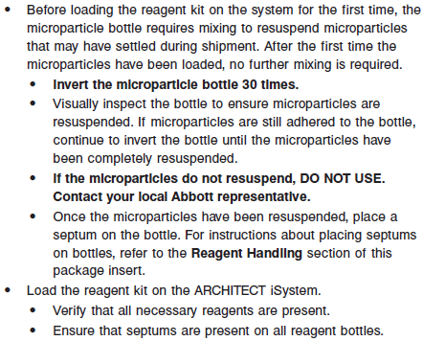

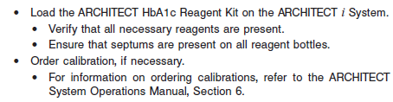

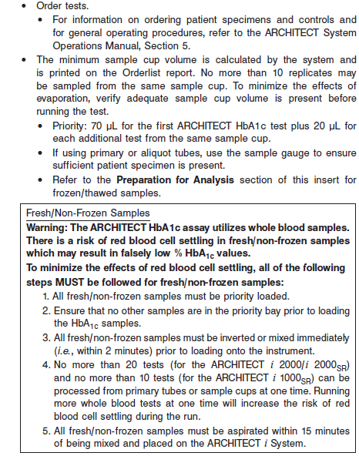

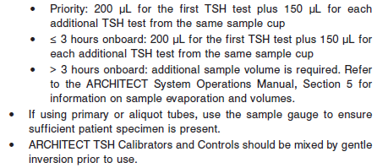

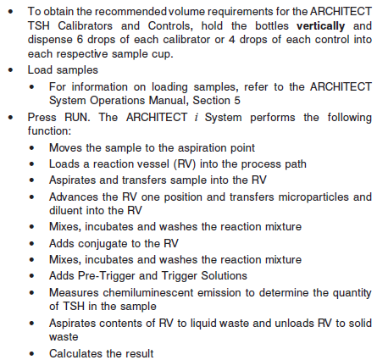

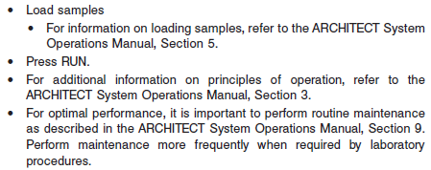

**Results**

The default result unit for the ARCHITECT TSH assay is μIU/ mL. An alternate result unit, mIU/L, may be selected for reporting results by editing assay parameter “Result concentration units”, to mIU/L. The conversion factor used by the system is 1.

**Flags**

Some results may contain information in the Flags field. For a description of the flags that may appear in this field, refer to the ARCHITECT System Operations Manual, Section 5.

**Specific Performance Characteristics**

**Expected Values**

It is recommended that each laboratory determine its own reference range based upon its particular locale and population characteristics.

**Serum/Plasma:** 0.35 – 4.94 μlU/mL

**Critical Values:** >40 μlU/mL

**Performance Characteristics**

**Sensitivity**

The ARCHITECT TSH assay is designed to have a functional sensitivity of ≤ 0.01 μlU/mL, which meets the requirements of a third generation TSH assay.

The ARCHITECT TSH assay is designed to have an analytical sensitivity of ≤ 0.0025 μIU/mL.

**Linearity**

The assay is linear from 0.0025 to 100 μIU/mL

**Dilution:**

Specimens with a TSH value exceeding 100.0000 μIU/mL, are flagged with the code “>100.0000” and may be diluted with either the Automated Dilution Protocol or the Manual Dilution Procedure.

**•** If using the Automated Dilution Protocol, the system performs a 1:5 dilution of the specimen and automatically calculates the concentration of the diluted specimen and reports the result.

**•** Manual dilutions should be performed as follows:

**•** The suggested dilution for TSH is 1:10. It is recommended dilutions not exceed 1:10.

**•** For example, to perform a 1:10 dilution, add 30 μL of the patient specimen to 270 μL of ARCHITECT *i* Multi-Assay Manual Diluent (7D82-50).

**•** The operator must enter the dilution factor in the patient or control order screen. The system will use this dilution factor to automatically calculate the concentration of the sample before dilution. This will be the reported result. The result (before dilution factor is applied) should be greater than 0.0100 μIU/mL.

**•** If the operator does not enter the dilution factor, the reported result will be that of the diluted sample. This result (before dilution factor is applied) should be greater than 0.0100 μIU/mL.

**•** For detailed information on ordering dilutions, refer to the ARCHITECT System Operations Manual, Section 5.

**Precision:**

The ARCHITECT TSH assay is designed to have a precision of ≤ 10% (total CV).

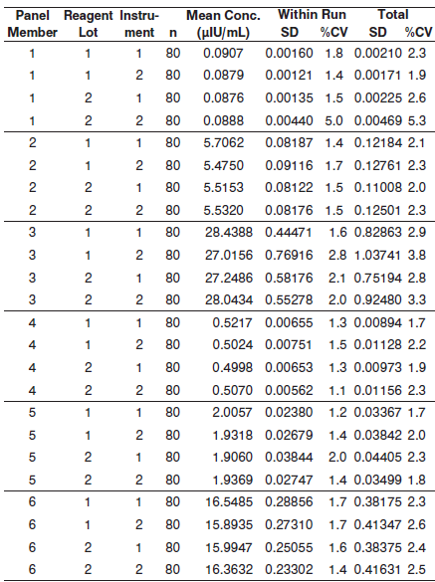

#### Limitations of Procedure

**•** Specimens from patients who have received preparations of mouse monoclonal antibodies for diagnosis or therapy may contain human anti-mouse antibodies (HAMA). Such specimens may show either falsely elevated or depressed values when tested with assay kits which employ mouse monoclonal antibodies. Additional information may be required for diagnosis.

**•** Heterophilic antibodies in human serum can react with reagent immunoglobulins, interfering with *in vitro* immunoassays. Patients routinely exposed to animals or animal serum products can be prone to this interference and anomalous values may be observed. Additional information may be required for diagnosis.

**•** Suspected hyperthyroidism based on low or undetectable TSH levels should be confirmed with additional thyroid function testing along with other clinical information.

**Specificity**

The ARCHITECT TSH assay is designed to have an analytical specificity of < 10% cross reactivity with the following substances, at the concentration levels listed, in human serum samples containing TSH in the normal range.

**•** FSH - ≤ 500 mIU/mL

**•** LH - ≤500 mIU/mL

**•** hCG - ≤ 200,000 mIU/mL.

**Interference**

The ARCHITECT TSH assay is designed to have a potential interference from hemoglobin, bilirubin, triglycerides and protein of ≤ 10% at the levels indicated below.

**•** Hemoglobin - ≤ 500 mg/dL

**•** Bilirubin - ≤ 20 mg/dL

**•** Triglycerides - ≤ 3000 mg/dL

**•** Protein - ≤ 2 g/dL and 12 g/dL

**References:**

1. ABBOTT ARCHITECT TSH package insert

Abbott Laboratories

Diagnostics Division

Abbott Park, IL 60064

Jan 2014 G4-5947/R05

1. ABBOTT ARCHITECT TSH Calibrator package insert

Abbott Laboratories

Diagnostics Division

Abbott Park, IL 60064

1. Abbott ARCHITECT Operator’s Guide

**Related Documents:**

**Attachments:**