RUSH logo for emails

**B12**

**SERUM OR PLASMA**

**ABBOTT ARCHITECT**

**Intended Use**

The ARCHITECT B12 assay is a Chemiluminescent Microparticle Intrinsic Factor assay for the quantitative determination of vitamin B12 in human serum and plasma on the ARCHITECT *i* System.

**Clinical Significance**

Vitamin B12 (B12), a member of the corrin family, is a cofactor for the conversion of methylmalonyl Coenzyme-A (CoA) to succinoyl CoA. In addition, B12 is a cofactor in the synthesis of methionine from homocysteine, is implicated in the formation of myelin, and, along with folate, is required for DNA synthesis.

B12 is absorbed from food after binding to a protein called intrinsic factor which is produced by the stomach. Causes of vitamin B12 deficiency can be divided into three classes: nutritional deficiency, malabsorption syndromes, and other gastrointestinal causes. B12 deficiency can cause megaloblastic anemia (MA), nerve damage and degeneration of the spinal cord. Lack of B12, even mild deficiencies, damages the myelin sheath that surrounds and protects nerves, which may lead to peripheral neuropathy.

The nerve damage caused by a lack of B12 may become permanently debilitating, if the underlying condition is not treated. People with intrinsic factor defects who do not get treatment eventually develop a MA called pernicious anemia (PA).

The relationship between B12 levels and MA is not always clear in that some patients with MA will have normal B12 levels; conversely, many individuals with B12 deficiency are not afflicted with MA. Despite these complications, however, in the presence of MA (e.g., elevated mean corpuscular volume

(MCV)) there is usually serum B12 or folate deficiency.

The true prevalence of B12 deficiency in the general population is unknown but increases with age. In one study, fifteen percent of adults older than 65 years old had laboratory evidence of vitamin B12 deficiency.

A serum B12 level below the normal expected range may indicate that tissue B12 levels are becoming depleted. However, a B12 level in the low normal range does not ensure that B12 levels are healthy and symptomatic patients should be further evaluated with tests for holotranscobalamin, homocysteine and methylmalonic acid. There are a number of conditions that are associated with low serum B12 levels, including iron deficiency, normal near-term pregnancy, vegetarianism, partial gastrectomy/ileal damage, celiac disease, use of oral contraception, parasitic competition, pancreatic deficiency, treated epilepsy, and advancing age. Disorders associated with elevated serum B12 levels include renal failure, liver disease, and myeloproliferative diseases.

**Principle**

The ARCHITECT B12 assay is a two-step assay with an automated sample pretreatment, for determining the presence of B12 in human serum and plasma using Chemiluminescent Microparticle Immunoassay (CMIA) technology with flexible assay protocols, referred to as Chemiflex. Sample and Pre-Treatment Reagent 1, Pre-Treatment Reagent 2, and Pre Treatment Reagent 3 are combined. An aliquot of the pre-treated sample is aspirated and transferred into a new Reaction Vessel (RV). The pre-treated sample, assay diluent, and intrinsic factor coated paramagnetic microparticles are combined. B12 present in the sample binds to the intrinsic factor coated microparticles. After washing, B12 acridinium labeled conjugate is added in the second step. Pre-Trigger and Trigger Solutions are then added to the reaction mixture; the resulting chemiluminescent reaction is measured as relative light units (RLUs). An inverse relationship exists between the amount of B12 in the sample and the RLUs detected by the ARCHITECT *i* optical system.

For additional information on system and assay technology, refer to the ARCHITECT System Operations Manual, Section 3.

**Specimen Collection and Handling**

**Suitable Specimens**

Verified for use:

**•** Human serum and human plasma collected in lithium heparin plasma separator tubes have been verified for use with the ARCHITECT B12 assay.

**•** The ARCHITECT *i* System does not provide the capability to verify specimen type. It is the responsibility of the operator to verify the correct specimen type is used in the ARCHITECT B12 assay.

Performance has not been established for cadaveric specimens or for the use of body fluids other than human serum.

The ARCHITECT *i* System does not provide the capability to verify specimen type. It is the responsibility of the operator to verify that the correct specimen types are used in the ARCHITECT B12 assay.

Do not use specimens with the following conditions:

* heat-inactivated
* pooled
* grossly hemolyzed
* obvious microbial contamination
* Do not use hemolyzed samples. Hemolyzed samples will cause erroneous results.

**Specimen Storage**

**•** Specimens may be stored on or off the clot, red blood cells, or separator gel for

**•** up to 3 days at room temperature or

**•** up to 7 days at 2-8°C.

**•** If testing will be delayed more than 3 days for specimens stored at room temperature or more than 7 days for specimens stored at 2-8°C, remove serum or plasma from the clot, red blood cells, or separator gel and store at -20°C or colder.

**•** Avoid more than three freeze/thaw cycles.

**NOTE:** Stored specimens must be inspected for particulates. If present, mix and centrifuge the specimen to remove particulates prior to testing.

**Materials and Equipment Required**

**TEST INSTRUMENT**: Abbott ARCHITECT System

**MATERIALS PROVIDED**

7K61 ARCHITECT B12 Reagent Kit

**MATERIALS REQUIRED BUT NOT PROVIDED**

**•** ARCHITECT *i* System

**•** ARCHITECT B12 Assay file, may be obtained from:

**•** ARCHITECT *i* System e-Assay CD-ROM found on www.abbottdiagnostics.com

**•** ARCHITECT *i* System Assay CD-ROM

**•** 7K61-02 ARCHITECT B12 Calibrators

**•** 7K61-12 ARCHITECT B12 Controls

**•** 7D82-50 ARCHITECT *i* Multi-Assay Manual Diluent

**•** ARCHITECT *i* Pretrigger

**•** ARCHITECT *i* Trigger

**•** ARCHITECT *i i* Wash Buffer

**•** ARCHITECT *i* Reaction Vessels

**•** ARCHITECT *i* Sample Cups

**•** ARCHITECT *i* Septums

**•** ARCHITECT *i* Replacement Caps

**•** Pipettes or pipette tips (optional) to deliver the specified volumes.

**Reagent Handling and Storage:**

***CAUTION*:**

* For in vitro diagnostic use.

**CAUTION:** This product requires the handling of human specimens.

It is recommended that all human sourced materials be considered

potentially infectious and be handled in accordance with the OSHA

Standard on Bloodborne Pathogens. Biosafety Level 2 or other appropriate biosafety practices should be used for materials that contain or are suspected of containing infectious agents.

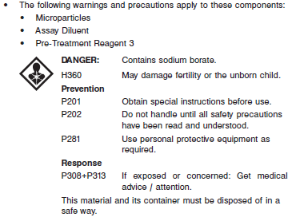

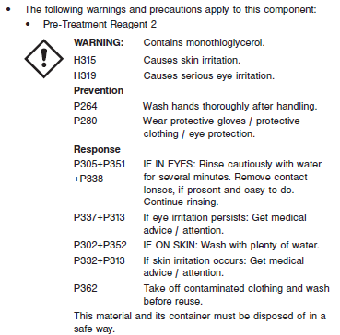

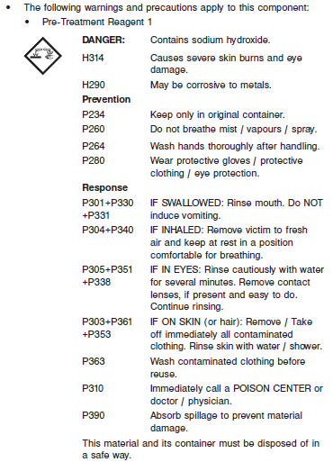

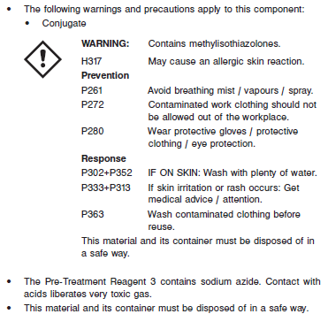

**Reagent Handling**

* Do not use reagent kits beyond the expiration date.
* **Do not pool reagents within a kit or between reagent kits.**
* Before loading the ARCHITECT reagent kit on the system for the first time, the microparticle bottle requires mixing to resuspend microparticles that may have settled during shipment. For microparticle mixing instructions, refer to the **PROCEDURE, Assay Procedure** section of the package insert.
* **Septums MUST be used to prevent reagent evaporation and contamination and to ensure reagent integrity. Reliability of assay results cannot be guaranteed if septums are not used according to the instructions in the package insert.**
* To avoid contamination, wear clean gloves when placing a septum on an uncapped reagent bottle.
* Once a septum has been placed on the reagent bottle, **do not invert the bottle** as this will result in reagent leakage and maycompromise assay results.
* Over time, residual liquids may dry on the septum surface. These are typically dried salts and have no effect on assay efficacy.
* For a detailed discussion of handling precautions during system operation, refer to the ARCHITECT System Operations Manual, Section 7.

**Reagent Storage**

* The ARCHITECT B12 Reagent Kit must be stored at 2-8°C in an upright position and may be used immediately after removal from 2-8°C storage.
* When stored and handled as directed, the reagents are stable until the expiration date.
* The ARCHITECT B12 Reagent Kit may be stored on board the ARCHITECT *i* System for a maximum of 26 days. After 26 days, the reagent kit must be discarded. For information on tracking onboard time, refer to the ARCHITECT System Operations Manual, Section 5.
* Reagents may be stored on or off the ARCHITECT *i* System. If reagents are removed from the system, store them at 2-8°C (with septums and replacement caps) in an upright position. For reagents stored off the system, it is recommended that they be stored in their original trays and boxes to ensure they remain upright. **If the microparticle bottle does** **not remain upright (with a septum installed) while in refrigerated** **storage off the system, the reagent kit must be discarded.** For information on unloading reagents, refer to the ARCHITECT System Operations Manual, Section 5.

Reagents

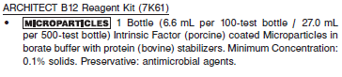

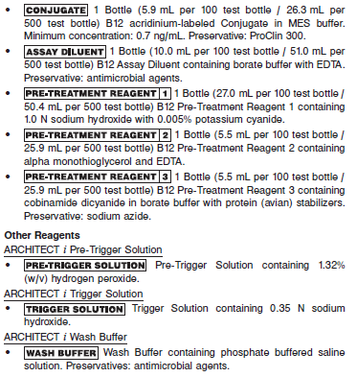

**Calibrator:** 7K61-02 ARCHITECT B12 Calibrators

**Quality Control:** 7K61-12 ARCHITECT B12 Controls or other control material

**Calibration**

**Frequency:**

Recalibration is required with each new reagent lot number.

**A new calibration is required:**

1. If quality control results do not meet acceptance criteria defined by your laboratory, patient values may be suspect. Follow the established quality control procedures for your laboratory. Recalibration may be necessary.
2. Review quality control results and acceptance criteria following a change of reagent or calibrator lot.

**Calibrator Required:** 7K61-02 ARCHITECT B12 Calibrators

**Reagents:**

6 Bottles (4 mL each) of ARCHITECT B12 Calibrators. Calibrator A contains borate buffer with protein (human albumin) stabilizer. Calibrators B through F contain gravimetrically prepared cyanocobalamin in borate buffer with protein (human albumin) stabilizer. Preservative: sodium azide.

**Calibrator Preparation:**

**•** ARCHITECT B12 Calibrators must be mixed by gentle inversion before use.

**•** To perform a calibration, test ARCHITECT B12 Calibrators A through F in duplicate. The calibrators should be priority loaded.

**•** To obtain the recommended volume requirements for the ARCHITECT B12 Calibrators, hold the bottles **vertically** and dispense 3 drops into each respective sample cup.

**Calibration Procedure:**

**•** To perform an ARCHITECT B12 calibration, test Calibrators A through F in duplicate. Calibrators should be priority loaded.

**•** Calibration Range: 0-2000 pg/mL (0-1476 pmol/L).

**Troubleshooting and Overall Acceptance Criteria Failure**

See ARCHITECT Operations Manual for further calibration troubleshooting.

**Quality Control:**

Abbott recommends, refer to your laboratory standard operating procedure(s) and/or quality assurance plan for additional quality control requirements and potential corrective actions:

• At a minimum a single level of all quality control are to be run every 24 hours

• If more frequent control monitoring is required, follow the established quality control procedures for your laboratory.

• If quality control results do not meet the acceptance criteria defined by your laboratory, patient values may be suspect. Follow the established quality control procedures for your laboratory.

Recalibration may be necessary.

• Review quality control results and acceptance criteria following a change of reagent or calibrator lot.

**Instrument Procedure**

* The ARCHITECT B12 assay is designed for use on the ARCHITECT *i* System.
* The ARCHITECT B12 assay file must be installed on the ARCHITECT *i* System before performing the assay.
* For detailed information on assay file installation and viewing and editing assay parameters, refer to the ARCHITECT System Operations Manual, Section 2.
* For information on printing assay parameters, refer to the ARCHITECT System Operations Manual, Section 5.
* For a detailed description of system procedures, refer to the ARCHITECT System Operations Manual.

**Assay Procedure**

For a detailed description of how to run an assay, refer to *Section 5* of the **ARCHITECT System Operations Manual**.

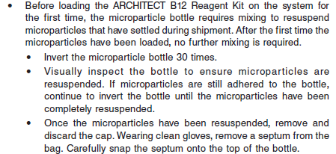

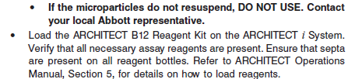

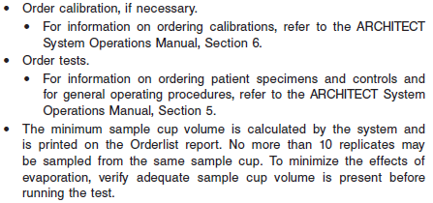

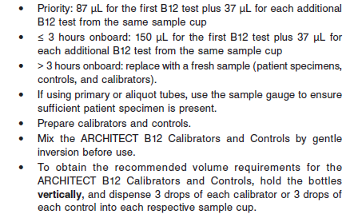

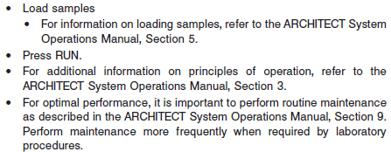

**Results**

The default result unit for the ARCHITECT B12 assay is pg/mL. When the alternate result unit, pmol/L, is selected, the conversion factor used by the system is 0.7378.

**Flags**

Some results may contain information in the Flags field. For a description of the flags that may appear in this field, refer to the ARCHITECT System Operations Manual, Section 5.

**Specific Performance Characteristics**

**Expected Values**

It is recommended that each laboratory determine its own reference range based upon its particular locale and population characteristics.

**Serum/Plasma:**



**B12 Indeterminates**

Levels above 300 or 400 pg/mL (221 or 295 pmol/L) are rarely associated with B12 deficiency induced hematological or neurological disease, respectively. Further testing is suggested for symptomatic patients with B12 levels between 100 and 300 pg/mL (74 and 221 pmol/L) (hematological abnormalities), and between 100 and 400 pg/mL (74 and 295 pmol/L) (neurological abnormalities).

See Data in the **EXPECTED VALUES** section of the package insert

**Critical Values: N/A**

**Performance Characteristics**

**Measuring Interval (Reportable Range)**

Measuring interval is defined as the range of values in pg/mL which meets the acceptable performance for both imprecision and bias for an undiluted sample. For the studies described in this package insert, the range was 146 pg/mL (Limit of Quantitation - LoQ) to 2000 pg/mL.

**Limit of Detection (LOD), Limit of Blank (LOB) and Limit of Quantitation (LOQ)**

The LoQ for the ARCHITECT B12 assay was 146 pg/mL, where the LoQ is defined as the lowest amount of analyte in a sample that can be accurately quantitated with an observed

absolute bias ≤ 10% and an observed imprecision ≤ 10%. The Limit of Blank (LoB) and Limit of Detection (LoD) were determined. The LoB was 66 pg/mL and the LoD was 88 pg/mL.

**Linearity**

The ARCHITECT B12 assay was evaluated for linearity by mixing a high (> 2000 pg/mL) serum specimen pool in specific ratios with low samples to create 16 mixed sample pools. All pools were tested by the ARCHITECT B12 assay. Based on guidance from CLSI document EP6-A, the study

demonstrated linearity from 109 to 2,000 pg/mL with an absolute deviation from linearity ≤ 10%.

**Precision:**

The ARCHITECT B12 assay is designed to have a Total CV of ≤ 11% for concentrations in the range of the low, medium, and high controls. See reagent package insert for tables.

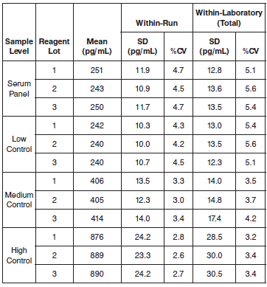

#### Limitations of Procedure

**•** For diagnostic purposes, results should be used in conjunction with other data; e.g., symptoms, results of other tests, clinical impressions, etc.

**•** The diagnosis of B12 deficiency cannot be solely based on serum or plasma B12 levels. Further testing for folic acid, intrinsic factor blocking antibodies, holotranscobalamin,5 homocysteine, and/ or methylmalonic acid is suggested for symptomatic patients with hematological or neurological abnormalities.

**•** If the B12 results are inconsistent with clinical evidence, additional testing is suggested to confirm the result.

**•** Hemolysis has been demonstrated to exhibit negative interference in this B12 assay. Hemolyzed specimens should not be analyzed.

**•** Specimens containing above normal protein concentrations may generate repeated (2 or more) “3350 Unable to process test-aspiration error for (Sample Pipettor) at (RV 24)” errors. These specimens are

unable to be tested using the ARCHITECT B12 assay.

**•** Heterophilic antibodies and rheumatoid factor (RF) in human serum can react with reagent immunoglobulins, interfering with *in vitro* immunoassays. Patients routinely exposed to animals or to animal serum products can be prone to this interference and anomalous values may be observed. Additional information may be required for diagnosis.

**•** The assay is designed to test human serum and lithium heparin plasma. Specimens tested in other matrices may not give accurate results.

**Interfering Substances**

Potential interference in the ARCHITECT B12 assay from bilirubin (conjugated and unconjugated), total protein, and triglycerides was demonstrated in a study based on guidance from the CLSI document

EP7-A2. The endogenous substances listed below were spiked into samples with different levels of B12 (150 - 250 pg/mL and > 500 pg/mL).

The samples were assayed, and the B12 concentrations of the spiked samples were compared to the reference samples and showed less than 10% interference at the following test concentrations.

**•** Bilirubin ≤ 20 mg/dL

**•** Total Protein ≤ 12 g/dL

**•** Triglycerides ≤ 3000 mg/dL

Hemolyzed specimens should not be analyzed

**Specificity**

The ARCHITECT B12 assay is designed to have an interference (difference) less than the LoD of the assay with cobinamide, a B12 analogue.

**References:**

1. ABBOTT ARCHITECT B12 package insert

Abbott Laboratories

Diagnostics Division

Abbott Park, IL 60064

Feb 2013 G3-0354/R04

1. ABBOTT ARCHITECT B12 Calibrator package insert

Abbott Laboratories

Diagnostics Division

Abbott Park, IL 60064

1. Abbott ARCHITECT Operator’s Guide

**Related Documents:**

**Attachments:**