RUSH logo for emails

**CA 15-3**

**SERUM OR PLASMA**

**ABBOTT ARCHITECT**

**Intended Use**

The ARCHITECT CA 15-3 assay is a chemiluminescent microparticle immunoassay (CMIA) for the quantitative determination of DF3 defined antigen in human serum and plasma on the ARCHITECT iSystem.

The ARCHITECT CA 15-3 assay is to be used as an aid in the management of Stage II and III breast cancer patients. Serial testing for patient CA 15-3 assay values should be used in conjunction with other clinical methods for monitoring breast cancer.

**Clinical Significance**

The ARCHITECT CA 15-3 assay values are defined by using the 115D8 and DF3 monoclonal antibodies. Monoclonal antibody 115D8, raised against human milk-fat globule membranes, and monoclonal antibody DF3, raised against a membrane enriched fraction of metastatic human breast carcinoma, react with epitopes expressed by a family of high molecular weight glycoproteins designated as polymorphic epithelial mucins (PEMs).

Research studies have indicated that CA 15-3 assay values are frequently elevated in patients with breast cancer. These studies have suggested that the CA 15-3 assay may be of clinical value for monitoring the response of patients undergoing therapy because increasing and decreasing values correlated with disease progression and regression, respectively. Additional published studies have suggested that increasing CA 15-3 assay values in patients at risk for breast cancer recurrence after primary therapy may be indicative of recurrent disease before it can be detected clinically. Elevations of CA 15-3 assay values have been reported in individuals with nonmalignant conditions such as cirrhosis, hepatitis, autoimmune disorders, and benign diseases of the ovary and breast. Non-mammary malignancies in which elevated CA 15-3 assay values have been reported include lung, colon, pancreatic, primary liver, ovarian, cervical, and endometrial. CA 15-3 assay values are not elevated in most normal individuals. The CA 15-3 assay is not recommended as a screening procedure to detect cancer in the general population; however, use of the CA 15-3 assay as an aid in the management of breast cancer patients has been reported.

**Principle**

The ARCHITECT CA 15-3 assay is a two-step immunoassay for the quantitative determination of DF3 defined antigens in human serum and plasma using CMIA technology with flexible assay protocols, referred to as Chemiflex.

1. Sample, wash buffer and 115D8 coated paramagnetic microparticles are combined. The DF3 defined antigen present in the sample binds to the 115D8 coated microparticles.

2. After washing, DF3 acridinium-labeled conjugate is added to create a reaction mixture.

3. Following another wash cycle, Pre-Trigger and Trigger Solutions are added to the reaction mixture.

4. The resulting chemiluminescent reaction is measured as relative light units (RLUs). There is a direct relationship between the amount of DF3 defined antigen in the sample and the RLUs detected by the ARCHITECT iSystem optics.

**This assay is unique in that the calibrators are supplied prediluted. The ARCHITECT System dilutes all controls and specimens by the same final dilution factor as the prediluted calibrators during the course of the assay.**

For additional information on system and assay technology, refer to the ARCHITECT System Operations Manual, Section 3.

**Specimen Collection and Handling**

**Suitable Specimens**

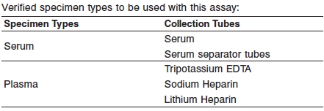

Do not use specimens with the following conditions:

**•** heat-inactivated

**•** grossly hemolyzed

**•** obvious microbial contamination

**•** Performance has not been established using body fluids other than human serum and plasma.

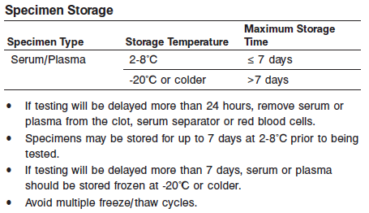

**NOTE:** Stored specimens must be inspected for particulates. If present, mix and centrifuge the specimen to remove particulates prior to testing.

**Materials and Equipment Required**

**TEST INSTRUMENT**: Abbott ARCHITECT System

**MATERIALS PROVIDED**

2K44 ARCHITECT CA 15-3 Reagent Kit

**MATERIALS REQUIRED BUT NOT PROVIDED**

**•** ARCHITECT CA 15-3 Assay file obtained from the ARCHITECT iSystem e-Assay CD-ROM found on www.abbottdiagnostics.com.

**•** 2K44-01 ARCHITECT CA 15-3 Calibrators

**•** 2K44-10 ARCHITECT CA 15-3 Controls

**•** 7D82-50 ARCHITECT Multi-Assay Manual Diluent

**•** ARCHITECT Pre-Trigger Solution

**•** ARCHITECT Trigger Solution

**•** ARCHITECT Wash Buffer

**•** ARCHITECT Reaction Vessels

**•** ARCHITECT Sample Cups

**•** ARCHITECT Septum

**•** ARCHITECT Replacement Caps

**•** Pipettes or pipette tips (optional) to deliver the specified volumes.

**Reagent Handling and Storage:**

***CAUTION*:**

* For in vitro diagnostic use.

**CAUTION:** This product requires the handling of human specimens.

It is recommended that all human sourced materials be considered

potentially infectious and be handled in accordance with the OSHA

Standard on Bloodborne Pathogens. Biosafety Level 2 or other appropriate biosafety practices should be used for materials that contain or are suspected of containing infectious agents.

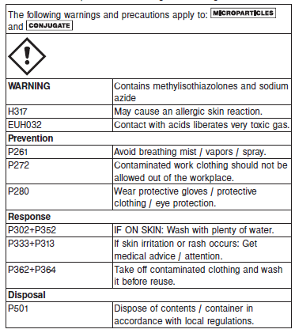

**Reagent Handling**

* Do not use reagent kits beyond the expiration date.
* **Do not pool reagents within a kit or between reagent kits.**
* Before loading the ARCHITECT reagent kit on the system for the first time, the microparticle bottle requires mixing to resuspend microparticles that may have settled during shipment. For microparticle mixing instructions, refer to the **PROCEDURE, Assay Procedure** section of the package insert.
* **Septums MUST be used to prevent reagent evaporation and contamination and to ensure reagent integrity. Reliability of assay results cannot be guaranteed if septums are not used according to the instructions in the package insert.**
* To avoid contamination, wear clean gloves when placing a septum on an uncapped reagent bottle.
* Once a septum has been placed on the reagent bottle, **do not invert the bottle** as this will result in reagent leakage and maycompromise assay results.
* Over time, residual liquids may dry on the septum surface. These are typically dried salts and have no effect on assay efficacy.
* For a detailed discussion of handling precautions during system operation, refer to the ARCHITECT System Operations Manual, Section 7.

**Reagent Storage**

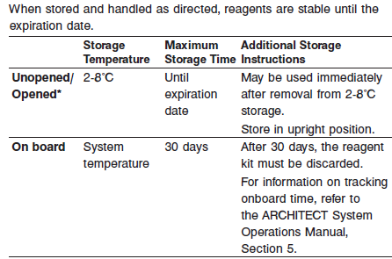

* Reagents may be stored on or off the ARCHITECT *i* System. If reagents are removed from the system, store them at 2-8°C (with septums and replacement caps) in an upright position. For reagents stored off the system, it is recommended that they be stored in their original trays and boxes to ensure they remain upright. **If the microparticle bottle does** **not remain upright (with a septum installed) while in refrigerated** **storage off the system, the reagent kit must be discarded.** For information on unloading reagents, refer to the ARCHITECT System Operations Manual, Section 5.

Reagents

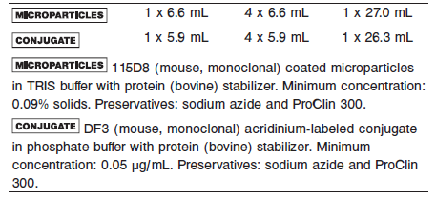

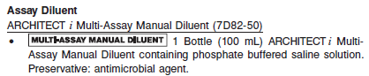

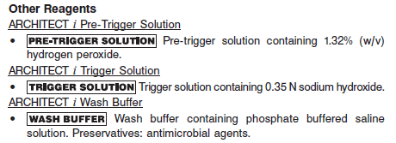

**Calibrator:** 2K44-01 ARCHITECT CA 15-3 Calibrators

**Quality Control:** 2K44-10 ARCHITECT CA 15-3 Controls or other control material

**Calibration**

**Frequency:**

Recalibration is required with each new reagent lot number.

**A new calibration is required:**

1. If quality control results do not meet acceptance criteria defined by your laboratory, patient values may be suspect. Follow the established quality control procedures for your laboratory. Recalibration may be necessary.
2. Review quality control results and acceptance criteria following a change of reagent or calibrator lot.

**Calibrator Required:** 2K44-01 ARCHITECT CA 15-3 Calibrators

**Reagents:**

6 Bottles (4 mL each) of ARCHITECT CA 15-3 Calibrators. Calibrator A contains TRIS buffer with protein (bovine) stabilizer. Calibrators B-F contain DF3 defined antigen (human) prepared in TRIS

buffer with protein (bovine) stabilizer. Preservatives: sodium azide and ProClin 300.

**Calibrator Preparation:**

**•** ARCHITECT CA 15-3 Calibrators may be used immediately after removal from 2-8°C storage.

**•** Prior to use, mix by gentle inversion (5-10 times).

**•** After each use, tightly close the caps and return the calibrators to 2-8°C storage.

**Calibration Procedure:**

**•** Test Calibrators A-F in duplicate. The calibrators should be priority loaded.

A single sample of each control level must be tested to evaluate the assay calibration. Ensure that assay control values are within the ranges specified in the respective control package insert.

**•** Calibration Range: 0 - 800 U/mL

**Troubleshooting and Overall Acceptance Criteria Failure**

See ARCHITECT Operations Manual for further calibration troubleshooting.

**Quality Control:**

Abbott recommends, refer to your laboratory standard operating procedure(s) and/or quality assurance plan for additional quality control requirements and potential corrective actions:

• At a minimum a single level of all quality control are to be run every 24 hours

• If more frequent control monitoring is required, follow the established quality control procedures for your laboratory.

• If quality control results do not meet the acceptance criteria defined by your laboratory, patient values may be suspect. Follow the established quality control procedures for your laboratory.

Recalibration may be necessary.

• Review quality control results and acceptance criteria following a change of reagent or calibrator lot.

**Instrument Procedure**

The ARCHITECT CA 15-3 assay file must be installed on the ARCHITECT iSystem prior to performing the assay.

For detailed information on assay file installation and viewing and editing assay parameters, refer to the ARCHITECT System Operations Manual, Section 2.

For information on printing assay parameters, refer to the ARCHITECT System Operations Manual, Section 5.

For a detailed description of system procedures, refer to the ARCHITECT System Operations Manual.

**Assay Procedure**

For a detailed description of how to run an assay, refer to *Section 5* of the **ARCHITECT System Operations Manual**.

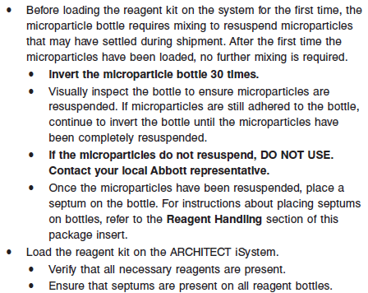

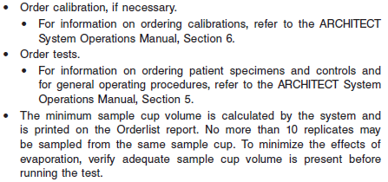

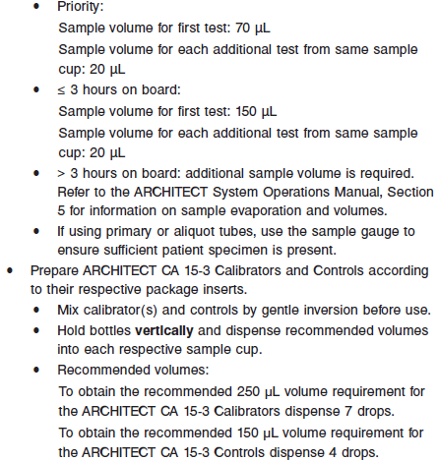

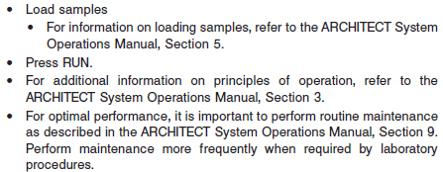

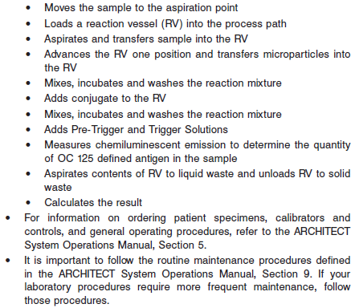

**Results**

The default result unit for the ARCHITECT Ca 15-3 assay is U/mL.

**Flags**

Some results may contain information in the Flags field. For a description of the flags that may appear in this field, refer to the ARCHITECT System Operations Manual, Section 5.

**Specific Performance Characteristics**

**Expected Values**

It is recommended that each laboratory determine its own reference range based upon its particular locale and population characteristics.

**Serum/Plasma:** < 31.3 IU/mL

**Critical Values: N/A**

**Performance Characteristics**

**Reportable Range:**

The measurement range for the ARCHITECT CA 15-3 assay is 0.5 U/mL to 800 U/mL.

**Analytical Sensitivity**

The sensitivity of the ARCHITECT CA 15-3 assay is ≤ 0.5 U/mL

**Dilution:**

Specimens with a CA 15-3 assay value exceeding 800 U/mL are flagged with the code “> 800.0” and may be diluted using either the Automated Dilution Protocol or the Manual Dilution Procedure.

**Automated Dilution Protocol**

The system performs a 1:5 dilution of the specimen and automatically calculates the concentration of the specimen before dilution and reports the result.

**Manual Dilution Procedure**

Suggested dilution: 1:5

1. For a 1:5 dilution, add 100 μL of the patient specimen to 400 μL of ARCHITECT iMulti-Assay Manual Diluent (7D82-50).

2. The operator must enter the dilution factor in the Patient or Control order screen. All assays selected for that order will be diluted. The system will use this dilution factor to automatically calculate the concentration of the sample before dilution and report the result. The dilution should be performed so that the diluted result reads > 30 U/mL.

For detailed information on ordering dilutions, refer to the ARCHITECT System Operations Manual, Section 5.

**Precision:**

The ARCHITECT CA 15-3 assay precision is ≤ 8% total CV

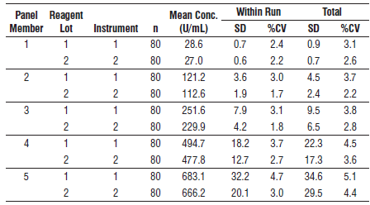

#### Limitations of Procedure

**•** Patients with confirmed breast carcinoma may have CA 15-3 assay values in the same range as healthy individuals. Elevations in circulating DF3 defined antigen may be observed in patients with nonmalignant disease. For these reasons, a CA 15-3 assay value, regardless of level, should not be interpreted as absolute evidence for the presence or absence of malignant disease.

The CA 15-3 assay value should be used in conjunction with information available from clinical evaluation and other diagnostic procedures. **The ARCHITECT CA 15-3 assay should not be** **used as a cancer screening test.**

**•** The ARCHITECT CA 15-3 Calibrators are supplied prediluted. A specialized protocol dilutes all controls and specimens by the same final dilution factor as the prediluted calibrators.

**•** Heterophilic antibodies in human serum can react with reagent immunoglobulins, interfering with *in vitro* immunoassays. Patients routinely exposed to animals or to animal serum products can be prone to this interference and anomalous results may be observed. Additional information may be required for diagnosis.

**•** Specimens from patients who have received preparations of mouse monoclonal antibodies for diagnosis or therapy may contain human anti-mouse antibodies (HAMA). Such specimens may show either falsely elevated or depressed values when tested with assay kits which employ mouse monoclonal antibodies. ARCHITECT BNP reagents contain a component that reduces the effect of HAMA reactive specimens. Additional clinical or diagnosis information may be required to determine patient status.

**Analytical Specificity**

The ARCHITECT CA 15-3 mean assay specificity is ≤ 12%.

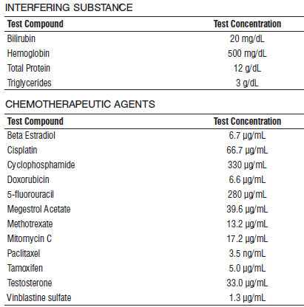

POTENTIALLY INTERFERING CLINICAL CONDITIONS

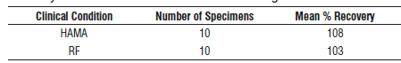

**References:**

1. ABBOTT ARCHITECT CA 15-3 package insert

Abbott Laboratories

Diagnostics Division

Abbott Park, IL 60064

Nov 2015 603-032 10/15 / R08

1. ABBOTT ARCHITECT CA 15-3 Calibrator package insert

Abbott Laboratories

Diagnostics Division

Abbott Park, IL 60064

1. Abbott ARCHITECT Operator’s Guide

**Related Documents:**

**Attachments:**