RUSH logo for emails

**CA 19-9**

**SERUM OR PLASMA**

**ABBOTT ARCHITECT**

**Intended Use**

The ARCHITECT CA 19-9*XR* assay is a chemiluminescent microparticle immunoassay (CMIA) for the quantitative determination of 1116-NS- 19-9 reactive determinants in human serum or plasma on the ARCHITECT *i* System. The ARCHITECT CA 19-9*XR* assay is to be used as an aid in the management of pancreatic cancer patients with detectable levels of CA 19-9 at some point in their disease process and in conjunction with other clinical methods.

**Clinical Significance**

The ARCHITECT CA 19-9*XR* assay detects a tumor-associated antigen, which occurs in tissue as a monosialoganglioside and in serum as a high molecular weight, carbohydrate-rich glycoprotein known as a mucin. The ARCHITECT CA 19‑9*XR* assay is based upon a monoclonal antibody, 1116-NS-19-9, which reacts with a carbohydrate antigenic determinant expressed on the circulating antigen. The role of CA 19-9 is to be used as an adjunct with other diagnostic information in the management of patients with pancreatic cancer. No data exist to support the use of CA 19-9 in screening for malignancies. Increased serum CA 19-9 assay values have also been observed in patients with nonmalignant conditions such as hepatitis, cirrhosis, pancreatitis, and other gastrointestinal disease. Elevated levels have also been seen in cystic fibrosis. It has been shown that a persistent elevation in CA 19-9 assay value following treatment may be indicative of occult metastatic and/or residual disease. A persistently rising

CA 19-9 assay value may be associated with progressive malignant disease and poor therapeutic response. A declining CA 19-9 assay value may be indicative of a favorable prognosis and a good response to treatment. Testing for 1116-NS-19-9 reactive determinants must not be used as a screening procedure for malignancy. 1116-NS-19-9 reactive determinants are present as a normal constituent in serum and plasma of individuals without pancreatic carcinomas or having certain aforementioned non‑cancer related conditions.

**Principle**

The ARCHITECT CA 19-9XR assay is a two-step immunoassay for the quantitative determination of 1116-NS-19-9 reactive determinants in human serum or plasma using CMIA technology with flexible assay protocols, referred to as Chemiflex.

1. Sample and 1116-NS-19-9 coated paramagnetic microparticles are combined. The 1116-NS-19-9 reactive determinants present in the sample bind to the 1116-NS-19-9 coated microparticles.

2. After washing, 1116-NS-19-9 acridinium-labeled conjugate is added to create a reaction mixture.

3. Following another wash cycle, Pre-Trigger and Trigger Solutions are added to the reaction mixture.

4. The resulting chemiluminescent reaction is measured as relative light units (RLUs). There is a direct relationship between the amount of 1116-NS-19-9 in the sample and the RLUs detected by the ARCHITECT iSystem optics.

For additional information on system and assay technology, refer to the ARCHITECT System Operations Manual, Section 3

**Specimen Collection and Handling**

**Suitable Specimens**

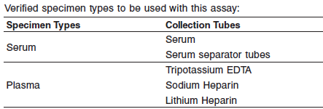

**•** Other specimen collection tube types have not been tested with this assay.

**•** When serial specimens are being evaluated, the same type of specimen should be used throughout the study.

Do not use specimens with the following conditions:

**•** grossly hemolyzed

**•** obvious microbial contamination

**Specimen Storage:**

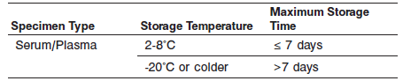

**•** If testing will be delayed more than 24 hours, remove serum or plasma from the clot, serum separator or red blood cells.

**•** Specimens may be stored for up to 7 days at 2-8°C prior to being tested.

**•** If testing will be delayed more than 7 days, serum or plasma should be stored frozen at -20°C or colder.

**•** Avoid multiple freeze/thaw cycles.

**NOTE:** Stored specimens must be inspected for particulates. If present, mix and centrifuge the specimen to remove particulates prior to testing.

**Materials and Equipment Required**

**TEST INSTRUMENT**: Abbott ARCHITECT System

**MATERIALS PROVIDED**

2K91 ARCHITECT CA 19-9*XR* Reagent Kit

**MATERIALS REQUIRED BUT NOT PROVIDED**

**•** ARCHITECT *i* System with *STAT* protocol

**•** ARCHITECT CA 19-9*XR* Assay file, may be obtained from:

**•** ARCHITECT *i* System e-Assay CD-ROM found on www.abbottdiagnostics.com

**•** ARCHITECT *i* System Assay CD-ROM

**•** 2K91 ARCHITECT CA 19-9*XR* Calibrators

**•** 2K91 ARCHITECT CA 19-9*XR* Controls

**•** 7D82-50 ARCHITECT *I*Multi-assay diluent

**•** ARCHITECT *i* Pretrigger

**•** ARCHITECT *i* Trigger

**•** ARCHITECT *i i* Wash Buffer

**•** ARCHITECT *i* Reaction Vessels

**•** ARCHITECT *i* Sample Cups

**•** ARCHITECT *i* Septums

**•** ARCHITECT *i* Replacement Caps

**•** Pipettes or pipette tips (optional) to deliver the specified volumes.

**Reagent Handling and Storage:**

***CAUTION*:**

* For in vitro diagnostic use.

**CAUTION:** This product requires the handling of human specimens.

It is recommended that all human sourced materials be considered

potentially infectious and be handled in accordance with the OSHA

Standard on Bloodborne Pathogens. Biosafety Level 2 or other appropriate biosafety practices should be used for materials that contain or are suspected of containing infectious agents.

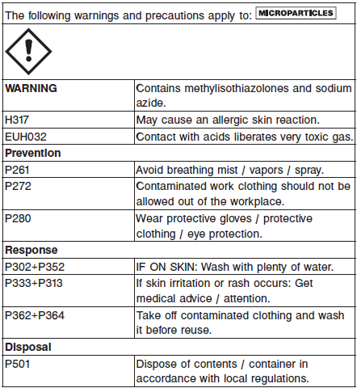

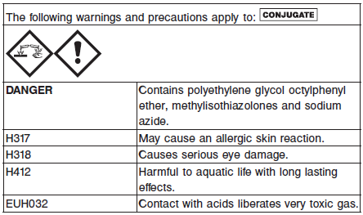

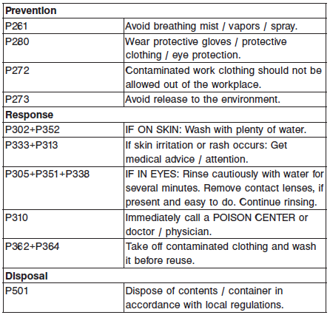

**Reagent Handling**

**• 1116-NS-19-9 reactive determinants are shed naturally in saliva and other body fluids.1 Contamination of the samples or the ARCHITECT *i* System disposables with saliva or aerosols (e.g., as a result of sneezing) may cause falsely elevated CA 19-9 assay values. It is recommended that all elevated values be reviewed and testing repeated as appropriate. Gloves should always be worn when handling samples, sample cups, reaction vessels, and septums. Face masks are also recommended.**

* Do not use reagent kits beyond the expiration date.
* **Do not pool reagents within a kit or between reagent kits.**
* Before loading the ARCHITECT reagent kit on the system for the first time, the microparticle bottle requires mixing to resuspend microparticles that may have settled during shipment. For microparticle mixing instructions, refer to the **PROCEDURE, Assay Procedure** section of the package insert.
* **Septums MUST be used to prevent reagent evaporation and contamination and to ensure reagent integrity. Reliability of assay results cannot be guaranteed if septums are not used according to the instructions in the package insert.**
* To avoid contamination, wear clean gloves when placing a septum on an uncapped reagent bottle.
* Once a septum has been placed on the reagent bottle, **do not invert the bottle** as this will result in reagent leakage and maycompromise assay results.
* Over time, residual liquids may dry on the septum surface. These are typically dried salts and have no effect on assay efficacy.
* For a detailed discussion of handling precautions during system operation, refer to the ARCHITECT System Operations Manual, Section 7.

**Reagent Storage**

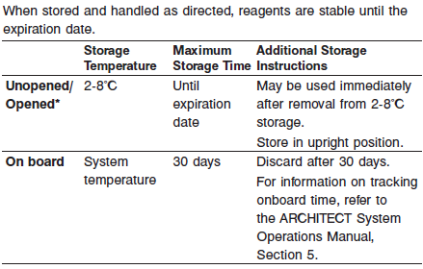

* Reagents may be stored on or off the ARCHITECT iSystem. If reagents are removed from the system, store them at 2-8°C (with septums and replacement caps) in an upright position. For reagents stored off the system, it is recommended that they be stored in their original trays and boxes to ensure they remain upright.

**If any reagent bottle does not remain upright (with a septum installed) while in refrigerated storage off the system, the reagent kit must be discarded.** For information on unloading reagents, referto the ARCHITECT System Operations Manual, Section 5.

Reagents

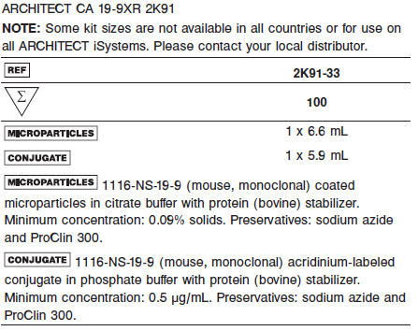

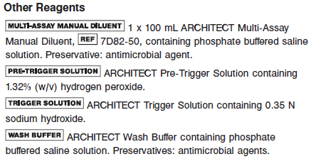

**Calibrator:** 2K91 ARCHITECT CA 19-9*XR* Calibrators

**Quality Control:** 2K91 ARCHITECT CA 19-9*XR* Controls or other control material

**Calibration**

**Frequency:**

Recalibration is required with each new reagent lot number.

**A new calibration is required:**

1. If quality control results do not meet acceptance criteria defined by your laboratory, patient values may be suspect. Follow the established quality control procedures for your laboratory. Recalibration may be necessary.
2. Review quality control results and acceptance criteria following a change of reagent or calibrator lot.

**Calibrator Required:** 2K91-01 ARCHITECT CA 19-9*XR* Calibrators

**Reagents:**

Bottles (4 mL each) of ARCHITECT CA 19-9*XR* Calibrators. Calibrator A contains TRIS buffer with protein (bovine) stabilizer. Calibrators B - F contain 1116-NS-19-9 reactive determinants (human)

prepared in TRIS buffer with protein (bovine) stabilizer. Preservatives: sodium azide and ProClin 300.

**Calibrator Preparation:**

ARCHITECT CA 19-9*XR* Calibrators may be used immediately after removal from 2-8°C storage. Prior to use, mix by gentle inversion (5-10 times).

**•** After each use, tightly close the caps and return the calibrators to 2-8°C storage.

**Calibration Procedure:**

**•** To perform an ARCHITECT CA 19-9*XR* calibration, test calibrators A, B, C, D, E, and F in duplicate. A single sample of each CA 19-9 control must be tested to evaluate the assay calibration. Ensure that assay control values are within the concentration ranges specified in the control package insert. Calibrators should be priority loaded.

**•** Calibrator Range: 0 - 1200 U/mL.

**Troubleshooting and Overall Acceptance Criteria Failure**

See ARCHITECT Operations Manual for further calibration troubleshooting.

**Quality Control:**

Abbott recommends, refer to your laboratory standard operating procedure(s) and/or quality assurance plan for additional quality control requirements and potential corrective actions:

• At a minimum a single level of all quality control are to be run every 24 hours

• If more frequent control monitoring is required, follow the established quality control procedures for your laboratory.

• If quality control results do not meet the acceptance criteria defined by your laboratory, patient values may be suspect. Follow the established quality control procedures for your laboratory.

Recalibration may be necessary.

• Review quality control results and acceptance criteria following a change of reagent or calibrator lot.

**Instrument Procedure**

* The ARCHITECT CA 19-9 assay is designed for use on the ARCHITECT *i* System.
* The ARCHITECT CA 19-9 assay file must be installed on the ARCHITECT *i* System with *STAT* capabilities before performing the assay.
* For detailed information on assay file installation and viewing and editing assay parameters, refer to the ARCHITECT System Operations Manual, Section 2.
* For information on printing assay parameters, refer to the ARCHITECT System Operations Manual, Section 5.
* For a detailed description of system procedures, refer to the ARCHITECT System Operations Manual.

**Assay Procedure**

For a detailed description of how to run an assay, refer to *Section 5* of the **ARCHITECT System Operations Manual**.

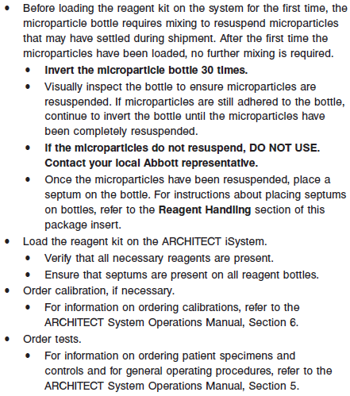

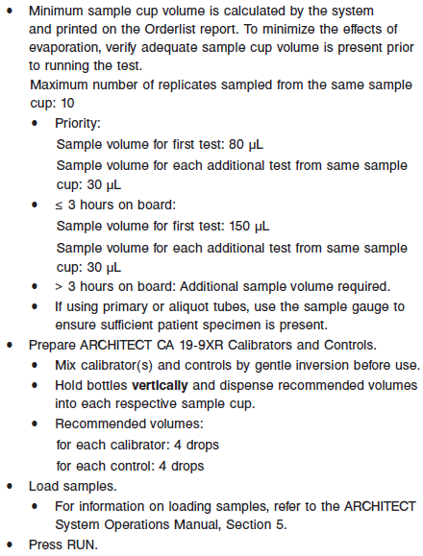

For additional information on principles of operation, refer to the ARCHITECT System Operations Manual, Section 3.

**Results**

The ARCHITECT CA 19-9XR assay utilizes a Linear Regression data reduction method to generate a calibration curve.

The default result unit for the ARCHITECT Ca 19-9 assay is U/mL.

**Flags**

Some results may contain information in the Flags field. For a description of the flags that may appear in this field, refer to the ARCHITECT System Operations Manual, Section 5.

**Specific Performance Characteristics**

**Expected Values**

It is recommended that each laboratory determine its own reference range based upon its particular locale and population characteristics.

**Serum/Plasma (Abbott Package Insert)**

See Data in the **EXPECTED VALUES** section of the package insert

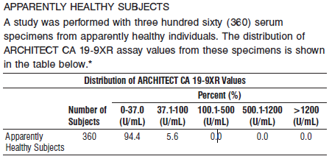

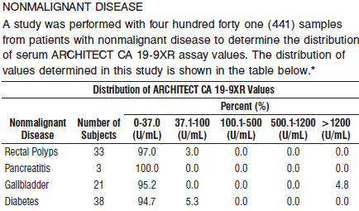

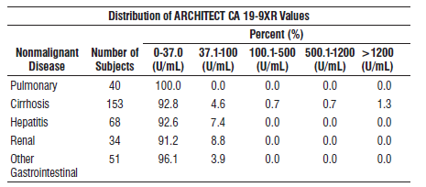

* Representative data; results in individual laboratories may vary from these data.

**Serum/Plasma:** < 37 IU/mL

**Critical Values: N/A**

**Performance Characteristics**

**Analytical Sensitivity**

The analytical sensitivity of the ARCHITECT CA 19-9*XR* assay was calculated to be better than 2.00 U/mL

**Dilution:**

Specimens with an ARCHITECT CA 19-9*XR* assay value exceeding 1200 U/mL are flagged with the code “>1200.00” and may be diluted using either the Automated Dilution Protocol or the Manual Dilution Procedure.

**•** If using the Automated Dilution Protocol, the system performs a 1:10 dilution of the specimen and automatically calculates the concentration of the sample before dilution and reports the result.

**•** Manual dilutions should be performed as follows:

**•** The suggested dilution for the ARCHITECT CA 19-9*XR* assay is 1:10. An additional 1:10 dilution may be made if needed.

**•** For a 1:10 dilution, add 50 μL of the patient specimen to 450 μL of ARCHITECT *i* Multi-Assay Manual Diluent (7D82).

**•** The operator must enter the dilution factor in the Patient or Control order screen. All assays selected for that order will be diluted. The system will use this dilution factor to automatically calculate the concentration of the sample before dilution and report the result.

The dilution should be performed so that the diluted result reads greater than 30 U/mL.

**•** For detailed information on ordering dilutions, refer to the ARCHITECT System Operations Manual, Section 5.

**Precision:**

The ARCHITECT CA 19-9*XR* assay is designed to have an assay precision of ≤10% total CV.

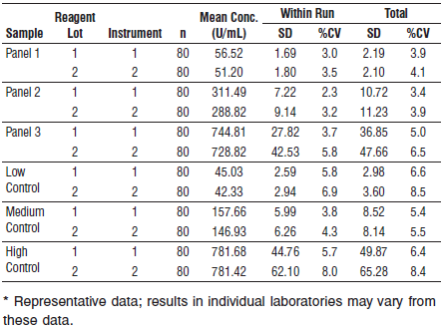

#### Limitations of Procedure

**•** The ARCHITECT CA 19-9XR assay value must be used in conjunction with information available from clinical evaluation and other diagnostic procedures.

**•** If the CA 19-9XR results are inconsistent with clinical evidence, additional testing is recommended.

**•** Heterophilic antibodies in human serum can react with reagent immunoglobulins, interfering with *in vitro* immunoassays. Patients routinely exposed to animals or to animal serum products can be prone to this interference and anomalous values may be observed.

**•** Specimens from patients who have received preparations of mouse monoclonal antibodies for diagnosis or therapy may contain human anti-mouse antibodies (HAMA). Specimens containing HAMA may produce anomalous values when tested with assay kits that employ mouse monoclonal antibodies.

ARCHITECT CA 19-9XR reagents contain a component that reduces the effect of HAMA reactive specimens. Additional clinical or diagnostic information may be required to determine patient status.

**•** Patients with confirmed carcinoma may have pretreatment CA 19-9 assay values in the same range as healthy individuals. Elevations in circulating 1116-NS-19-9 reactive determinants may be observed in patients with metastases and in nonmalignant conditions such as hepatitis, cirrhosis, pancreatitis, and other gastrointestinal disease. Elevated levels have also been seen in cystic fibrosis. For these reasons, a CA 19-9 assay value, regardless of level, should not be interpreted as absolute

evidence for the presence or absence of malignant disease. **The ARCHITECT CA 19-9XR assay must not be used as a cancer screening test.**

**•** Patients with the Le a-b- phenotype may not express the 1116- NS-19-9 reactive determinant.

**Interference**

The ARCHITECT CA 19-9*XR* assay is designed to have a mean recovery of 100 +/- 12% in the presence of the chemotherapeutic agents listed below and elevated levels of bilirubin, hemoglobin, triglycerides, and total protein at the levels indicated.

.

POTENTIALLY INTERFERING SUBSTANCES

The average recovery observed during the study ranged from 91% to 102%.*

Substance Concentration

Bilirubin 22 mg/dL

Hemoglobin 600 mg/dL

Total Protein 10 g/dL

Triglycerides 5100 mg/dL

CHEMOTHERAPEUTIC AGENTS

The average recovery observed during the study ranged from 95% to 104%.*

Substance Concentration

5-Fluorouracil 0.390 mg/mL

Cisplatin 0.057 mg/mL

Cyclophosphamide 0.375 mg/mL

Cytarabine 30 μg/mL

Doxorubicin 40 μg/mL

Gemcitabine 0.382 mg/mL

Leucovorin 0.114 mg/mL

Methotrexate 0.909 mg/mL

Paclitaxel 0.067 mg/mL

Streptozotocin 0.28 mg/mL

Tamoxifen 2.2 8 μg/dL

**\*** Representative data; results in individual laboratories may vary from these data.

EVALUATION OF POTENTIALLY INTERFERING CLINICAL CONDITIONS

The ARCHITECT CA 19-9XR assay is designed to have a mean recovery of 100 +/-12% in the presence of HAMA and rheumatoid factor (RF).

**References:**

1. ABBOTT ARCHITECT CA 19-9 package insert

Abbott Laboratories

Diagnostics Division

Abbott Park, IL 60064

Aug 2017 613-070 7/17/ R01

1. ABBOTT ARCHITECT CA 19-9 Calibrator package insert

Abbott Laboratories

Diagnostics Division

Abbott Park, IL 60064

1. Abbott ARCHITECT Operator’s Guide

**Related Documents:**

**Attachments:**