RUSH logo for emails

**CEA**

**SERUM OR PLASMA**

**ABBOTT ARCHITECT**

**Intended Use**

The ARCHITECT CEA assay is a Chemiluminescent Microparticle Immunoassay (CMIA) for the quantitative determination of Carcinoembryonic Antigen (CEA) in human serum and plasma. The

ARCHITECT CEA assay is to be used as an aid in the prognosis and management of cancer patients in whom changing concentrations of CEA are observed.

**Clinical Significance**

Carcinoembryonic antigen (CEA), first described in 1965 by Gold and Freedman, is a tumor associated antigen. CEA was characterized as a glycoprotein of approximately 200,000 molecular weight with a β-electrophoretic mobility. Subsequent development of a radioimmunoassay (RIA) by Thomson, *et al* made it possible to detect the very low concentrations of CEA in blood, other body fluids, and also in normal and diseased tissues. Two years later, Hansen, *et al* developed a modified RIA for CEA.

The result of clinical studies to date indicate that CEA, although originally thought to be specific for digestive tract cancers, may also be elevated in other malignancies and in some nonmalignant disorders.

CEA testing can have significant value in the monitoring of patients with diagnosed malignancies in whom changing concentrations of CEA are observed. A persistent elevation in circulating CEA following treatment is strongly indicative of occult metastatic and/or residual disease.

A persistently rising CEA value may be associated with progressive malignant disease and a poor therapeutic response. A declining CEA value is generally indicative of a favorable prognosis and a good response to treatment. Patients who have low pretherapy CEA levels may later show elevations in the CEA level as an indication of progressive disease.

Clinical relevance of the CEA assay has been shown in the follow-up management of patients with colorectal, gastric, breast, lung, prostatic, pancreatic, and ovarian carcinoma. Follow-up studies of patients with colorectal, breast, and lung carcinoma suggest that the preoperative CEA level has prognostic significance.

CEA testing is not recommended as a screening procedure to detect cancer in the general population; however, use of the CEA test as an adjunctive test in predicting prognosis and as an aid in the management of cancer patients has been widely accepted.

**Principle**

The ARCHITECT CEA assay is a two-step immunoassay to determine the presence of CEA in human serum and plasma, using Chemiluminescent Microparticle Immunoassay (CMIA) technology with flexible assay protocols, referred to as Chemiflex.

In the first step, sample and anti-CEA coated paramagnetic microparticles are combined. CEA present in the sample binds to the anti-CEA coated microparticles. After washing, anti-CEA acridinium-labeled conjugate is added in the second step. Pre-Trigger and Trigger Solutions are then added to the reaction mixture; the resulting chemiluminescent reaction is measured as relative light units (RLUs). A direct relationship exists between the amount of CEA in the sample and the RLUs detected by the

ARCHITECT *i*\* optical system. For additional information on system and assay technology refer to the

ARCHITECT System Operations Manual, Section 3.

* *i* = immunoassay

**Specimen Collection and Handling**

**Suitable Specimens**

Human serum and plasma collected in heparin (sodium and lithium) or potassium EDTA may be used in the ARCHITECT CEA assay. Follow the tube manufacturer’s processing instructions for serum and plasma collection tubes.

**•** Plasma specimens collected in lithium or sodium heparin have been shown to exhibit an average of 7% to 8% higher results compared to corresponding serum results.

**•** When serial specimens are being evaluated, the same type of specimen should be used throughout the study.

**•** The ARCHITECT *i* System does not provide the capability to verify the specimen type. It is the responsibility of the operator to verify the correct specimen types are used in the ARCHITECT CEA assay.

**•** Use caution when handling patient specimens to prevent cross contamination. Use of disposable pipettes or pipette tips is recommended.

**•** Do not use grossly hemolyzed specimens.

**Specimen Storage**

If testing will be delayed more than 24 hours, serum or plasma should be removed from the clot, serum separator, or red blood cells. Specimens may be stored for up to 7 days at 2-8°C prior to being tested. If testing will be delayed more than 7 days, specimens should be stored/frozen at - 20°C or colder.

**NOTE:** Stored specimens must be inspected for particulates. If present, mix and centrifuge the specimen to remove particulates prior to testing.

**Materials and Equipment Required**

**TEST INSTRUMENT**: Abbott ARCHITECT System

**MATERIALS PROVIDED**

7K68 ARCHITECT CEA Reagent Kit

**MATERIALS REQUIRED BUT NOT PROVIDED**

**•** ARCHITECT *i* System

**•** ARCHITECT CEA Assay file, may be obtained from:

**•** ARCHITECT *i* System e-Assay CD-ROM found on www.abbottdiagnostics.com

**•** ARCHITECT *i* System Assay CD-ROM

**•** 7K68-02 ARCHITECT CEA Calibrators

**•** 7K68-12 ARCHITECT CEA Controls or other commercial controls

**•** ARCHITECT *i* Pretrigger

**•** ARCHITECT *i* Trigger

**•** ARCHITECT *i i* Wash Buffer

**•** ARCHITECT *i* Reaction Vessels

**•** ARCHITECT *i* Sample Cups

**•** ARCHITECT *i* Septums

**•** ARCHITECT *i* Replacement Caps

**•** Pipettes or pipette tips (optional) to deliver the specified volumes.

**Reagent Handling and Storage:**

***CAUTION*:**

* For in vitro diagnostic use.

**CAUTION:** This product requires the handling of human specimens.

It is recommended that all human sourced materials be considered

potentially infectious and be handled in accordance with the OSHA

Standard on Bloodborne Pathogens. Biosafety Level 2 or other appropriate biosafety practices should be used for materials that contain or are suspected of containing infectious agents.

**Reagent Handling**

* Do not use reagent kits beyond the expiration date.
* **Do not pool reagents within a kit or between reagent kits.**
* Before loading the ARCHITECT Reagent Kit on the system for the first time, the microparticle bottle requires mixing to resuspend microparticles that have settled during shipment.
* **Septums MUST be used to prevent reagent evaporation and contamination and to ensure reagent integrity. Reliability of assay results cannot be guaranteed if septums are not used according to the instructions in the package insert.**
* To avoid contamination, wear clean gloves when placing a septum on an uncapped reagent bottle.
* Once a septum has been placed on the reagent bottle, **do not invert the bottle** as this will result in reagent leakage and maycompromise assay results.
* Over time, residual liquids may dry on the septum surface. These are typically dried salts and have no effect on assay efficacy.
* For a detailed discussion of handling precautions during system operation, refer to the ARCHITECT System Operations Manual, Section 7.

**Reagent Storage**

* The ARCHITECT CEA Reagent Kit must be stored at 2-8°C and may be used immediately after removal from 2-8°C storage.
* When stored and handled as directed, reagents are stable until the expiration date.
* The ARCHITECT CEA Reagent Kit may be stored on-board the ARCHITECT *i* System for a maximum of 30 days. After 30 days, the reagent kit must be discarded. For information on tracking on-board time, refer to the ARCHITECT System Operations Manual, Section 5.
* Reagents may be stored on or off the ARCHITECT *i* System. If reagents are removed from the system, store them at 2-8°C (with septums and replacement caps) in an upright position. For reagents stored off the system, it is recommended that they be stored in their original trays and boxes to ensure they remain upright. **If the microparticle bottle does** **not remain upright (with a septum installed) while in refrigerated** **storage off the system, the reagent kit must be discarded.** For information on unloading reagents, refer to the ARCHITECT System Operations Manual, Section 5.

Reagents

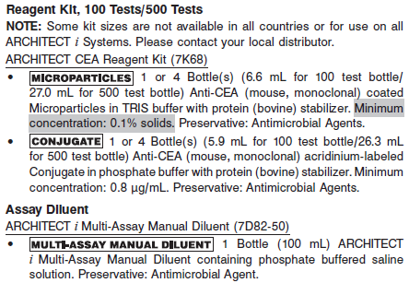

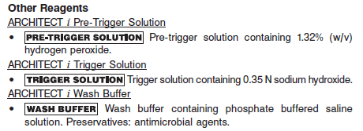

**Calibrator:** 7K68-02 ARCHITECT CEA Calibrators

**Quality Control:** 7K68-12 ARCHITECT CEA Controls or other commercial controls

**Calibration**

**Frequency:**

Recalibration is required with each new reagent lot number.

**A new calibration is required:**

1. If quality control results do not meet acceptance criteria defined by your laboratory, patient values may be suspect. Follow the established quality control procedures for your laboratory. Recalibration may be necessary.
2. Review quality control results and acceptance criteria following a change of reagent or calibrator lot.

**Calibrator Required:**

7K68-02 ARCHITECT CEA Calibrators

**Reagents:**

2 Bottles (4.0 mL each) of ARCHITECT CEA Calibrators. Calibrator 1 contains phosphate buffer with protein (bovine) stabilizer; Calibrator 2 contains CEA (human) prepared in phosphate buffer with protein (bovine) stabilizer. Preservative: Antimicrobial Agents.

**Calibrator Preparation:**

Ready for use.

**Calibration Procedure:**

To perform an ARCHITECT CEA calibration, test calibrators 1 and 2 in duplicate. A single sample of all levels of CEA controls must be tested to evaluate the assay calibration. Ensure that assay control values are within the concentration ranges specified in the control package insert. Calibrators should be priority loaded.

**•** Calibration range: 0 - 500 ng/mL.

**•** The assay protocol allows for the range to be extended to 1500 ng/mL.

**Troubleshooting and Overall Acceptance Criteria Failure**

See ARCHITECT Operations Manual for further calibration troubleshooting.

**Quality Control:**

Abbott recommends, refer to your laboratory standard operating procedure(s) and/or quality assurance plan for additional quality control requirements and potential corrective actions:

• At a minimum a single level of quality control are to be run every 24 hours

• If more frequent control monitoring is required, follow the established quality control procedures for your laboratory.

• If quality control results do not meet the acceptance criteria defined by your laboratory, patient values may be suspect. Follow the established quality control procedures for your laboratory.

Recalibration may be necessary.

• Review quality control results and acceptance criteria following a change of reagent or calibrator lot.

**Instrument Procedure**

* The ARCHITECT CEA assay is designed for use on the ARCHITECT *i* System
* The ARCHITECT CEA assay file must be installed on the ARCHITECT *i* System from an ARCHITECT *i* System Assay CD-ROM prior to performing the assay. For detailed information on assay file installation and on viewing and editing assay parameters, refer to the ARCHITECT System Operations Manual, Section 2.
* For detailed information on assay file installation and viewing and editing assay parameters, refer to the ARCHITECT System Operations Manual, Section 2.
* For information on printing assay parameters, refer to the ARCHITECT System Operations Manual, Section 5.
* For a detailed description of system procedures, refer to the ARCHITECT System Operations Manual.

**Assay Procedure**

For a detailed description of how to run an assay, refer to *Section 5* of the **ARCHITECT System Operations Manual**.

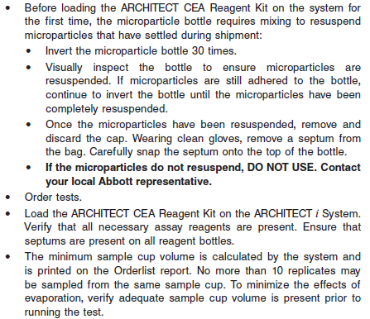

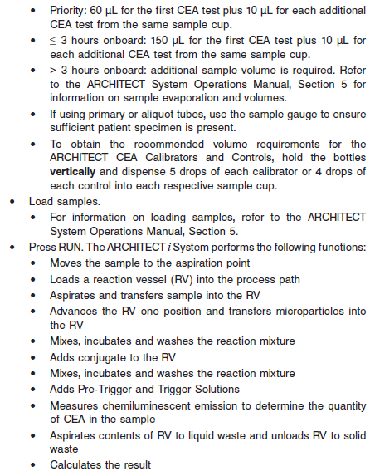

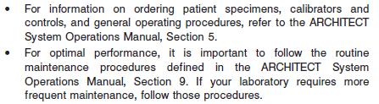

**Results**

The default result unit for the ARCHITECT CEA assay is ng/mL.

**Flags**

Some results may contain information in the Flags field. For a description of the flags that may appear in this field, refer to the ARCHITECT System Operations Manual, Section 5.

**Specific Performance Characteristics**

**Expected Values**

It is recommended that each laboratory determine its own reference range based upon its particular locale and population characteristics.

**Serum/Plasma (Abbott Package Insert)**

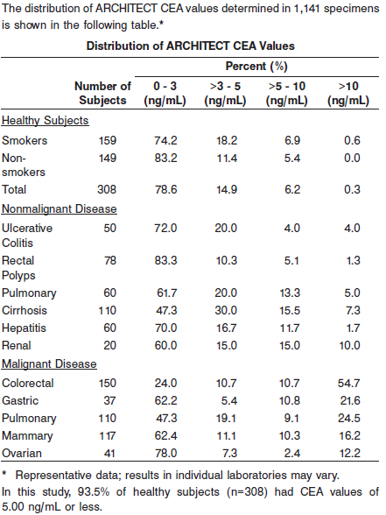

**Serum/Plasma:** < 5.0 ng/mL

**Critical Values: N/A**

**Performance Characteristics**

**Sensitivity**

The sensitivity of the ARCHITECT CEA assay was calculated to be better than 0.5 ng/mL at the 95% level of confidence (n = 18 runs).

**Dilution:**

Specimens with a CEA value exceeding 1500 ng/mL, are flagged with the code “>1500.00” and may be diluted using either the Automated Dilution Protocol or the Manual Dilution Procedure.

**•** If using the Automated Dilution Protocol, the system performs a 1:10 dilution of the specimen and automatically calculates the concentration of the sample before dilution and reports the result.

**•** Manual dilutions should be performed as follows:

**•** The suggested dilution for ARCHITECT CEA assay is 1:100. An additional 1:10 dilution may be made if needed. It is recommended that dilutions not exceed 1:1000.

**•** For a 1:100 dilution, add 20 μL of the patient specimen to 1980 μL of ARCHITECT *i* Multi-Assay Manual Diluent (7D82-50).

**•** The operator must enter the dilution factor in the Patient or Control order screen. All assays selected for that order will be diluted. The system will use this dilution factor to automatically calculate the concentration of the sample before dilution and report the result. The dilution should be performed so that the diluted result reads greater than 4 ng/mL.

**•** For detailed information on ordering dilutions, refer to the ARCHITECT System Operations Manual, Section 5.

**•** A comparison of the Automated Dilution Protocol to the Manual Dilution Procedure yielded recoveries between 86% and 97%.

**Precision:**

The Architect CEA assay precision is ≤ 8%.

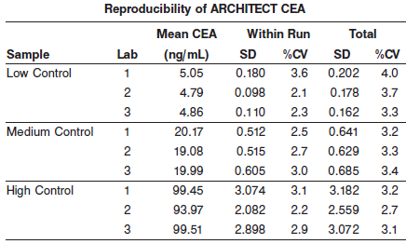

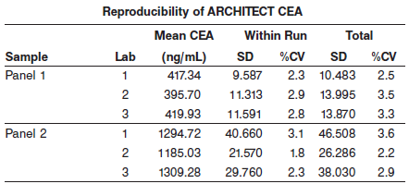

#### Limitations of Procedure

* Specimens from patients who have received preparations of mouse monoclonal antibodies for diagnosis or therapy may contain human anti-mouse antibodies (HAMA). Specimens containing HAMA may produce anomalous values when tested with assay kits that employ mouse monoclonal antibodies.
* Heterophilic antibodies in human serum can react with reagent immunoglobulins, interfering with *in vitro* immunoassays. Patients routinely exposed to animals or to animal serum products can be prone to this interference and anomalous results may be observed. Additional information may be required for diagnosis.

**WARNING:** The concentration of CEA in a given specimen, determined with assays from different manufacturers, can vary due to differences in assay methods and reagent specificity. The results reported by the laboratory to the physician must include the identity of the CEA assay used. Values obtained with different assay methods cannot be used interchangeably. If, in the course of monitoring a patient, the assay method used for determining CEA levels serially is changed, additional sequential testing should be carried out. Prior to changing assays, the laboratory MUST confirm baseline values for patients being serially monitored.

* The ARCHITECT CEA assay should not be used as a cancer screening test.
* Patients with confirmed carcinoma frequently have a pretreatment CEA level in the same range as healthy individuals. Elevations in circulating CEA levels may be observed in smokers as well as patients with nonmalignant disease. For these reasons, a serum or plasma CEA level, regardless of value, should not be interpreted as absolute evidence for the presence or absence of malignant disease. The CEA level should be used in conjunction with information available from clinical evaluation and other diagnostic procedures.

**Specificity**

The specificity of the ARCHITECT CEA assay was determined by testing sera containing the compounds listed below. These compounds showed less than 10% interference in the ARCHITECT CEA assay at the levels indicated.

Test Compound Test Concentration

Bilirubin 22 mg/dL

Hemoglobin 550 mg/dL

Total Protein 1.8 to 13.2 g/dL

Triglycerides 3300 mg/dL

**References:**

1. ABBOTT ARCHITECT CEA package insert

Abbott Laboratories

Diagnostics Division

Abbott Park, IL 60064

Aug 2013 G4-3208/R03

1. ABBOTT ARCHITECT CEA Calibrator package insert

Abbott Laboratories

Diagnostics Division

Abbott Park, IL 60064

1. Abbott ARCHITECT Operator’s Guide

**Related Documents:**

**Attachments:**