RUSH logo for emails

**CORTISOL**

**SERUM, PLASMA OR URINE**

**ABBOTT ARCHITECT**

**Intended Use**

ARCHITECT Cortisol is a chemiluminescent microparticle immunoassay (CMIA) for the quantitative determination of cortisol in human serum, plasma or urine on the ARCHITECT *i* System. The ARCHITECT Cortisol assay is intended for use as an aid in the diagnosis and treatment of adrenal disorders.

**Clinical Significance**

Cortisol is the major glucocorticoid hormone secreted by the adrenal cortex. Its physiological functions include regulation of carbohydrate metabolism and electrolyte and water distribution. Cortisol also has immunosuppressive and anti-inflammatory activity. In normal individuals, cortisol levels are regulated through a negative feedback loop in which the adrenal cortex responds to increased adrenocorticotropic hormone (ACTH) levels by increasing cortisol secretion, and the pituitary responds to elevated cortisol levels by down-regulation of ACTH production. Plasma cortisol levels are highest in the morning, and concentrations decrease by about half toward evening. Pregnancy or estrogen treatment markedly elevates cortisol levels. Other stimuli such as severe stress may also lead to increased cortisol production.

Cortisol measurements are used as a direct monitor of adrenal status and an indirect measure of pituitary hyper or hypofunction. Elevated cortisol levels are associated with adrenal tumors, pituitary tumors or ectopic ACTH-producing tumors. Subnormal cortisol concentrations may indicate generalized adrenal hypofunction or a defect in the metabolic pathway for cortisol biosynthesis. The majority of cortisol in plasma is bound to proteins and approximately 1% is excreted unchanged into the urine. Urinary cortisol is generally thought to reflect the level of unbound (free) plasma cortisol, which is biologically active. In cases of cortisol overproduction, cortisol-binding globulin becomes saturated, such that unbound plasma cortisol increases disproportionately, as does urinary excretion. The measurement of urinary cortisol is a sensitive means of determining adrenocortical hyperfunction such as Cushing’s syndrome. Urinary cortisol from 24-hour collections represent integration over a full day and are not affected by the diurnal variation evident in plasma cortisol levels.

Cortisol measurements are often performed in conjunction with certain “challenge” tests designed to measure whether regulation of the hypothalamic-pituitary-adrenal axis is intact. These include the dexamethasone suppression test (DST), ACTH stimulation test and insulin tolerance test. Such challenge tests aid in the differential diagnosis of Cushing’s syndrome (cortisol overproduction) and the assessment of Addison’s disease (cortisol underproduction).

**Principle**

The ARCHITECT Cortisol assay is a delayed one-step immunoassay for the quantitative determination of cortisol in human serum, plasma or urine using CMIA technology with flexible assay protocols, referred to as Chemiflex.

Sample and anti-cortisol coated paramagnetic microparticles are combined to create a reaction mixture. Cortisol present in the sample binds to the anti-cortisol coated microparticles. After incubation, cortisol acridinium-labeled conjugate is added to the reaction mixture. The cortisol acridinium-labeled conjugate competes for the available binding sites on the anti-cortisol coated microparticles. Following a second incubation, the microparticles are washed, and pre-trigger and trigger solutions are added to the reaction mixture. The resulting chemiluminescent reaction is measured as relative light units (RLUs). An inverse relationship exists between the amount of cortisol in the sample and the RLUs detected by the ARCHITECT *i* System optics.

For additional information on system and assay technology, refer to the ARCHITECT System Operations Manual, Section 3.

**Specimen Collection and Handling**

**Suitable Specimens**

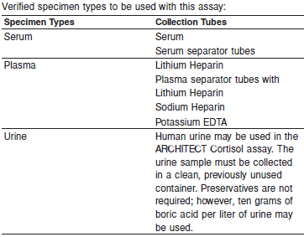

Do not use specimens with the following conditions:

**•** heat-inactivated

**•** obvious microbial contamination

**•** cadaver specimens or body fluids other than human serum, plasma or urine

Plasma and serum specimens should be free of fibrin, red blood cells or other particulate matter

**Specimen Storage**

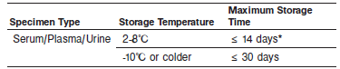

*If testing will be delayed for more than eight hours, remove plasma or serum from the serum or plasma separator, red blood cells or clot.

Specimens removed from the separator gel, cells or clot may be stored up to 14 days at 2-8°C.

Urine samples may be stored up to 14 days at 2-8°C.

Serum, plasma or urine specimens can be stored up to 30 days at -10°C or colder.

Avoid multiple freeze/thaw cycles.

**NOTE:** Stored specimens must be inspected for particulates. If present, mix and centrifuge the specimen to remove particulates prior to testing.

**Materials and Equipment Required**

**TEST INSTRUMENT**: Abbott ARCHITECT System

**MATERIALS PROVIDED**

8D15 ARCHITECT Cortisol Reagent Kit

**MATERIALS REQUIRED BUT NOT PROVIDED**

**•** ARCHITECT *i* System with *STAT* protocol

**•** ARCHITECT Cortisol Assay file, may be obtained from:

**•** ARCHITECT *i* System e-Assay CD-ROM found on www.abbottdiagnostics.com

**•** ARCHITECT *i* System Assay CD-ROM

**•** 8D15-02 ARCHITECT Cortisol Calibrators

**•** 6E20-10 Abbott Immunoassay Multi-Constituent Controls or other commercial controls

**•** ARCHITECT *i* Pretrigger

**•** ARCHITECT *i* Trigger

**•** ARCHITECT *i i* Wash Buffer

**•** ARCHITECT *i* Reaction Vessels

**•** ARCHITECT *i* Sample Cups

**•** ARCHITECT *i* Septums

**•** ARCHITECT *i* Replacement Caps

**•** Pipettes or pipette tips (optional) to deliver the specified volumes.

**Reagent Handling and Storage:**

***CAUTION*:**

* For in vitro diagnostic use.

**CAUTION:** This product requires the handling of human specimens.

It is recommended that all human sourced materials be considered

potentially infectious and be handled in accordance with the OSHA

Standard on Bloodborne Pathogens. Biosafety Level 2 or other appropriate biosafety practices should be used for materials that contain or are suspected of containing infectious agents.

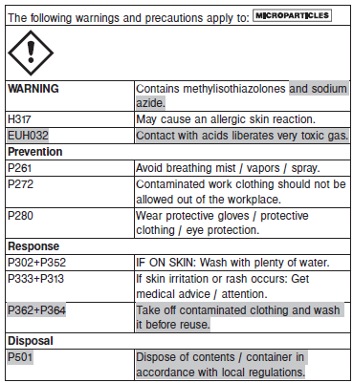

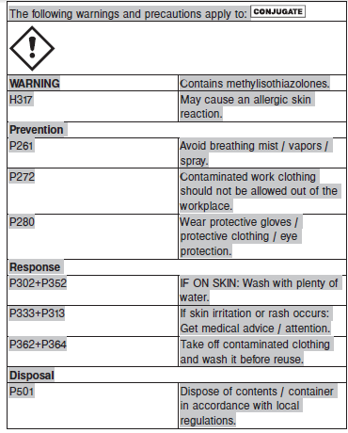

**Reagent Handling**

* Do not use reagent kits beyond the expiration date.
* **Do not pool reagents within a kit or between reagent kits.**
* Before loading the ARCHITECT Reagent Kit on the system for the first time, the microparticle bottle requires mixing to resuspend microparticles that have settled during shipment.
* **Septums MUST be used to prevent reagent evaporation and contamination and to ensure reagent integrity. Reliability of assay results cannot be guaranteed if septums are not used according to the instructions in the package insert.**
* To avoid contamination, wear clean gloves when placing a septum on an uncapped reagent bottle.
* Once a septum has been placed on the reagent bottle, **do not invert the bottle** as this will result in reagent leakage and maycompromise assay results.
* Over time, residual liquids may dry on the septum surface. These are typically dried salts and have no effect on assay efficacy.
* For a detailed discussion of handling precautions during system operation, refer to the ARCHITECT System Operations Manual, Section 7.

**Reagent Storage**

* 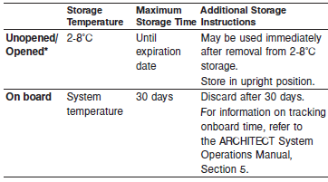Reagents may be stored on or off the ARCHITECT *i* System. If reagents are removed from the system, store them at 2-8°C (with septums and replacement caps) in an upright position. For reagents stored off the system, it is recommended that they be stored in their original trays and boxes to ensure they remain upright. **If the microparticle bottle does** **not remain upright (with a septum installed) while in refrigerated** **storage off the system, the reagent kit must be discarded.** For information on unloading reagents, refer to the ARCHITECT System Operations Manual, Section 5.

Reagents

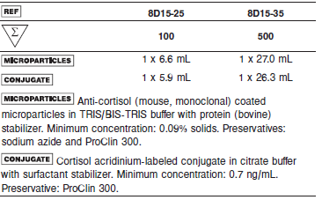

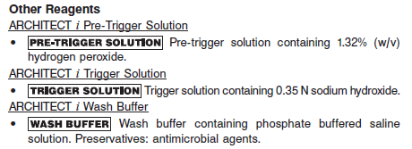

**Calibrator:** 8D15-02 ARCHITECT Cortisol Calibrators

**Quality Control:** 6E20-10 Abbott Immunoassay Multi-Constituent Controls or other commercial controls

**Calibration**

**Frequency:**

Recalibration is required with each new reagent lot number.

**A new calibration is required:**

1. If quality control results do not meet acceptance criteria defined by your laboratory, patient values may be suspect. Follow the established quality control procedures for your laboratory. Recalibration may be necessary.
2. Review quality control results and acceptance criteria following a change of reagent or calibrator lot.

**Calibrator Required:**

8D15-02 ARCHITECT Cortisol Calibrators

**Reagents:**

6 Bottles (4.0 mL each) of ARCHITECT Cortisol Calibrators. Calibrators ‑ contain human serum. Calibrators - contain purified cortisol. Preservatives: sodium azide and ProClin 950.

**Calibrator Preparation:**

Thaw completely at room temperature (15-30°C) for 45-60 minutes. Prior to use, mix THOROUGHLY by inversion 5-10 times. After each use, immediately return the thawed calibrators to refrigerated storage (2-8°C) for up to 90 days after thaw.

**Calibration Procedure:**

To perform an ARCHITECT Cortisol calibration, test Calibrators A, B, C, D, E, and F in duplicate. A single sample of each cortisol control level must be tested to evaluate the assay calibration. Ensure that assay control values are within established ranges. Calibrators should be priority loaded.

**•** Calibration Range: 0.0 - 59.8 μg/dL.

**Troubleshooting and Overall Acceptance Criteria Failure**

See ARCHITECT Operations Manual for further calibration troubleshooting.

**Quality Control:**

Abbott recommends, refer to your laboratory standard operating procedure(s) and/or quality assurance plan for additional quality control requirements and potential corrective actions:

• At a minimum a single level of quality control are to be run every 24 hours

• If more frequent control monitoring is required, follow the established quality control procedures for your laboratory.

• If quality control results do not meet the acceptance criteria defined by your laboratory, patient values may be suspect. Follow the established quality control procedures for your laboratory.

Recalibration may be necessary.

• Review quality control results and acceptance criteria following a change of reagent or calibrator lot.

**Instrument Procedure**

* The ARCHITECT Cortisol assay file must be installed on the ARCHITECT *i* System from an ARCHITECT *i* System Assay CD-ROM prior to performing the assay.
* The ARCHITECT Cortisol assay file must be installed on the ARCHITECT *i* System from an ARCHITECT *i* System Assay CD-ROM prior to performing the assay. For detailed information on assay file installation and on viewing and editing assay parameters, refer to the ARCHITECT System Operations Manual, Section 2.
* For detailed information on assay file installation and viewing and editing assay parameters, refer to the ARCHITECT System Operations Manual, Section 2.
* For information on printing assay parameters, refer to the ARCHITECT System Operations Manual, Section 5.
* For a detailed description of system procedures, refer to the ARCHITECT System Operations Manual.

**Assay Procedure**

For a detailed description of how to run an assay, refer to *Section 5* of the **ARCHITECT System Operations Manual**.

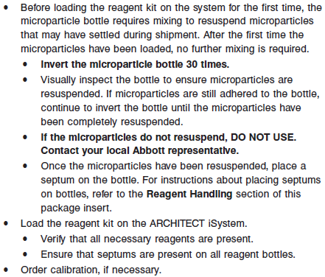

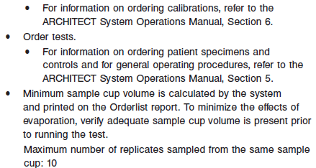

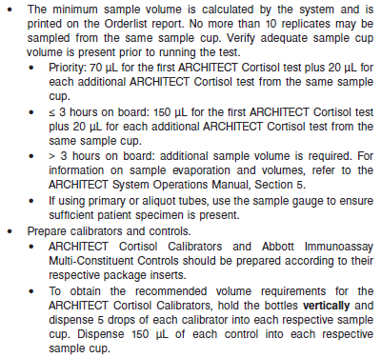

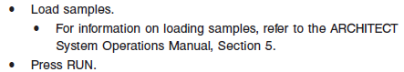

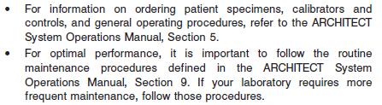

**Results**

The default result unit for the ARCHITECT Cortisol assay is μg/dL

**Flags**

Some results may contain information in the Flags field. For a description of the flags that may appear in this field, refer to the ARCHITECT System Operations Manual, Section 5.

**Specific Performance Characteristics**

**Expected Values**

It is recommended that each laboratory determine its own reference range based upon its particular locale and population characteristics.

**Serum/Plasma:**

AM: 3.7 – 19.4 ug/dL

PM: 2.9 – 17.3 ug/dL

**Urine:**  4.3 – 176 ug/24 hour

**Critical Values: N/A**

**Performance Characteristics**

**Functional Sensitivity**

The ARCHITECT Cortisol assay is designed to have a functional sensitivity of ≤ 1 μg/dL.

**Limit of Blank (LoB)/Limit of Detection (LoD):**

LoB = 0.23 μg/dL and LoD = 0.40 μg/dL

**Linearity**

The ARCHITECT Cortisol assay is linear between 1 and 59.8 μg/dL

**Dilution:**

Specimens with a cortisol value exceeding 59.8 μg/dL are flagged with the code “>59.8” and may be diluted with the Automated Dilution Protocol or the Manual Dilution Procedure.

Automated Dilution Protocol

**•** If using the Automated Dilution Protocol, the system performs a 1:2 dilution of the specimen and automatically calculates the concentration of the specimen before dilution and reports the result.

Specimens with a cortisol value exceeding 119.6 μg/dL are flagged with the code “>119.6” when run using the Automated Dilution Protocol. These specimens may be diluted by following the Manual Dilution Procedure.

Manual Dilution Procedure

**•** Manual dilutions should be performed as follows:

**•** The suggested dilution for a cortisol test is 1:4.

**•** Prior to diluting the specimen, dispense approximately 7 drops of ARCHITECT Cortisol Calibrator A into a clean test tube for use in the next step.

**•** Transfer 150 μL of ARCHITECT Cortisol Calibrator A from the test tube prepared in the prior step into another clean test tube and add 50 μL of the patient specimen.

**•** The operator must enter the dilution factor in the Patient or Control order screen. The system will use this dilution factor to automatically calculate the concentration of the sample before dilution. This will be the reported result. The dilution should be performed so that the diluted result (before the dilution factor is applied) reads greater than 3.0 μg/dL.

**•** For detailed information on ordering dilutions, refer to the ARCHITECT System Operations Manual, Section 5.

**Precision:**

The ARCHITECT Cortisol assay is designed to have an assay precision of ≤ 10% total CV for serum samples ≥ 3 to ≤ 35 μg/dL and ≤ 20% total CV for urine samples ≥ 3 to ≤ 35 μg/dL.

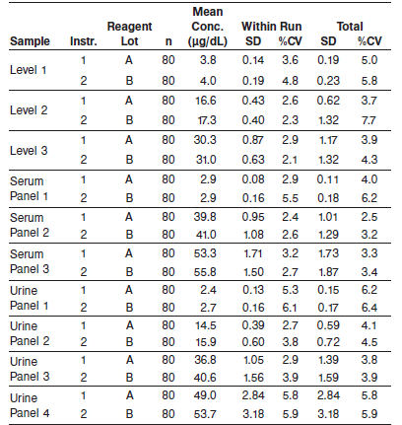

#### Limitations of Procedure

**•** Due to the diurnal variation of cortisol levels in normal subjects, all serum/plasma cortisol measurements should be referenced to the time of day of sample collection.

**•** Patients receiving fludrocortisone, prednisolone or prednisone (which is converted to prednisolone *in vivo*) may show artificially elevated cortisol values due to cross-reactivity. Cross-reactivity to

endogenous and synthetic steroids is reported in the **SPECIFIC PERFORMANCE CHARACTERISTICS, Specificity** section in thepackage insert.

**•** If the cortisol results are inconsistent with clinical evidence, additional testing is suggested to confirm the result.

**•** For diagnostic purposes, results should be used in conjunction with other data; e.g., symptoms, results of other tests, clinical impressions, etc.

**•** Specimens from patients who have received preparations of mouse monoclonal antibodies for diagnosis or therapy may contain human anti-mouse antibodies (HAMA). Such specimens may show either falsely elevated or depressed values when tested with assay kits that employ mouse monoclonal

antibodies. Assay results that are not consistent with other clinical observations may require additional information for diagnosis.

**•** Heterophilic antibodies in human serum can react with reagent immunoglobulins, interfering with *in vitro* immunoassays. The presence of heterophilic antibodies in a patient specimen may cause anomalous values to be observed. Additional information may be required for diagnosis.

**•** The concentration of cortisol in a given specimen, determined with assays from different manufacturers, can vary due to differences in assay methods, calibration, and reagent specificity.

**Interference**

The average amount of interference observed during the study ranged from -7.8% to 13.2%.

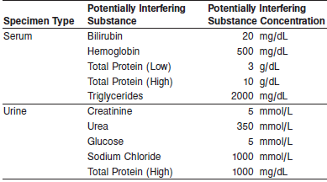

**Evaluation of Other Potential Interferents**

Potential interference in the ARCHITECT Cortisol assay from HAMA and rheumatoid factor (RF) is designed to be ≤ 15%

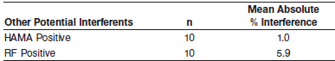

**Specificity**

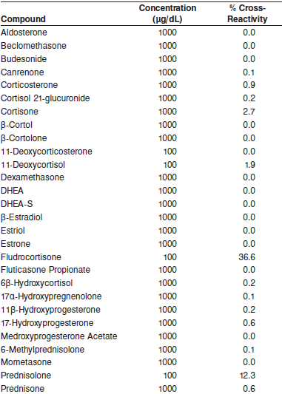

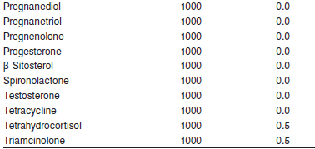

**References:**

1. ABBOTT ARCHITECT Cortisol package insert

Abbott Laboratories

Diagnostics Division

Abbott Park, IL 60064

Nov 2015 G1-0454/ R08

1. ABBOTT ARCHITECT Cortisol Calibrator package insert

Abbott Laboratories

Diagnostics Division

Abbott Park, IL 60064

1. Abbott ARCHITECT Operator’s Guide

**Related Documents:**

**Attachments:**