RUSH logo for emails

**FOLATE**

**SERUM OR PLASMA**

**ABBOTT ARCHITECT**

**Intended Use**

The ARCHITECT Folate assay is a chemiluminescent microparticle Folate Binding Protein assay for the quantitative determination of folate in human serum and plasma on the ARCHITECT *i* System. Folate measurements are used in the diagnosis and treatment of megaloblastic anemia.

**Clinical Significance**

Folates are a class of vitamin compounds related to pteroylglutamic acid (PGA), which serve as cofactors in the enzymatic transfer of single carbon units in a variety of metabolic pathways. Folate mediated one‑carbon metabolism represents one of the most important biochemical reactions that occur in cells. Folates are necessary for nucleic acid and mitochondrial protein synthesis, amino acid metabolism, and other cellular processes that involve single carbon transfers. Folates can serve as carbon donors or acceptors. Since different metabolic pathways require carbon groups with different levels of oxidation, cells contain numerous enzymes that change the oxidation state of carbon groups carried by folates resulting in different metabolically active forms of folate. The predominant form of circulating folate is 5-methyltetrahydrofolic acid (5‑mTHF). A methyl group is transferred from 5-mTHF to cobalamin in the pathway that links metabolism of folic acid and vitamin B12. Folate deficiency can be caused by low dietary intake, malabsorption due to gastrointestinal diseases, inadequate utilization due to enzyme deficiencies or folate antagonist therapy, drugs such as alcohol and oral contraceptives, and excessive folate demand, such as during pregnancy. Because deficiencies of both vitamin B12 and folate can lead to megaloblastic (macrocytic) anemia, appropriate treatment requires differential diagnosis of the deficiency; thus, both vitamin B12 and folate values are needed. Low serum folate levels reflect the first stage of negative folate balance, and precede tissue depletion.

**Principle**

The ARCHITECT Folate assay is a two-step assay for the quantitative determination of folate in human serum and plasma using Chemiluminescent Microparticle Immunoassay (CMIA) technology with flexible assay protocols, referred to as Chemiflex. Two pre‑treatment steps mediate the release of folate from endogenous folate binding protein. In Pre-Treatment Step 1, sample and Pre‑Treatment Reagent 2 (Dithiothreitol or DTT) are aspirated and dispensed into a reaction vessel (RV). In Pre‑Treatment Step 2, an aliquot of sample/Pre‑Treatment Reagent 2 mixture is aspirated and dispensed into a second RV. Pre-Treatment Reagent 1 (potassium hydroxide or KOH) is then added. An aliquot of the pre-treated sample is transferred into a third RV, followed by the addition of Folate Binding Protein (FBP) coated paramagnetic microparticles and assay specific diluent. Folate present in the sample binds to the FBP coated microparticles. After washing, pteroic acid-acridinium labeled conjugate is added and binds to unoccupied sites on the FBP-coated microparticles. Pre-Trigger and Trigger Solutions are then added to the reaction mixture; the resulting chemiluminescent reaction is measured as relative light units (RLUs). An inverse relationship exists between the amount of folate in the sample and the RLUs detected by the ARCHITECT *i* optical system.

For additional information on system and assay technology, refer to the ARCHITECT System Operations Manual, Section 3.

**Specimen Collection and Handling**

**Suitable Specimens**

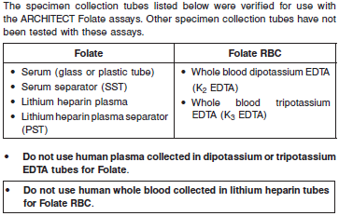

**•** Human serum or plasma specimens to be tested for folate should be protected from light.

**•** Serum or plasma specimens should be collected from fasting individuals. Recent food intake may appreciably increase the folate concentration.

**•** Do not use hemolyzed specimens. Serum or plasma specimens that are hemolyzed will give falsely elevated folate levels.

Do not use specimens with the following conditions:

**•** heat-inactivated

**•** pooled

**•** hemolyzed

**•** obvious microbial contamination

**•** Performance has not been established for the use of cadaveric specimens or body fluids other than human serum and plasma.

**Specimen Storage**

Serum or Plasma

**•** Human serum, plasma, or whole blood specimens to be tested for folate should be protected from light.

**•** Remove serum from clot or separator gel as soon as possible after complete clot formation. If testing will not be performed immediately, serum specimens may be stored either at 2-8°C for up to 7 days or frozen (-10°C or colder) for up to 30 days prior to being tested.

**•** Remove plasma from red blood cells as soon as possible upon receipt. If testing will not be performed immediately, plasma specimens may be stored either at 2-8°C for up to 7 days or frozen (-10°C or colder) for up to 30 days prior to being tested.

**•** Avoid more than 3 freeze/thaw cycles.

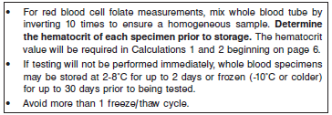

**NOTE:** Stored specimens must be inspected for particulates. If present, mix and centrifuge the specimen to remove particulates prior to testing.

**Materials and Equipment Required**

**TEST INSTRUMENT**: Abbott ARCHITECT System

**MATERIALS PROVIDED**

1P74 ARCHITECT Folate Reagent Kit

**MATERIALS REQUIRED BUT NOT PROVIDED**

**•** ARCHITECT *i* System

**•** ARCHITECT Folate Assay file, may be obtained from:

**•** ARCHITECT *i* System e-Assay CD-ROM found on www.abbottdiagnostics.com

**•** ARCHITECT *i* System Assay CD-ROM

**•** 1P74-02 ARCHITECT Folate Calibrators

**•** 1P74-12 ARCHITECT Folate Controls (or other commercially available control material)

**•** ARCHITECT *i* Pretrigger

**•** ARCHITECT *i* Trigger

**•** ARCHITECT *i i* Wash Buffer

**•** ARCHITECT *i* Reaction Vessels

**•** ARCHITECT *i* Sample Cups

**•** ARCHITECT *i* Septums

**•** ARCHITECT *i* Replacement Caps

**•** Pipettes or pipette tips (optional) to deliver the specified volumes.

**Reagent Handling and Storage:**

***CAUTION*:**

* For in vitro diagnostic use.

**CAUTION:** This product requires the handling of human specimens.

It is recommended that all human sourced materials be considered

potentially infectious and be handled in accordance with the OSHA

Standard on Bloodborne Pathogens. Biosafety Level 2 or other appropriate biosafety practices should be used for materials that contain or are suspected of containing infectious agents.

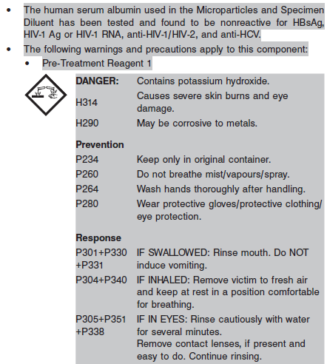

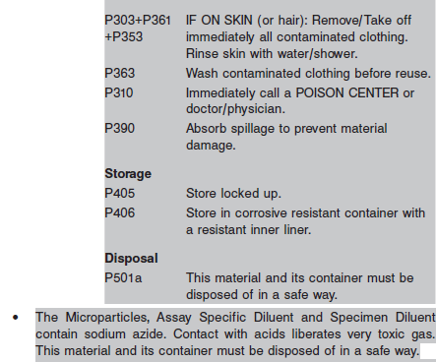

**Reagent Handling**

* Do not use reagent kits beyond the expiration date.
* **Do not pool reagents within a kit or between reagent kits.**
* **Septums MUST be used to prevent reagent evaporation and contamination and to ensure reagent integrity. Reliability of assay results cannot be guaranteed if septums are not used according to the instructions in the package insert.**
* To avoid contamination, wear clean gloves when placing a septum on an uncapped reagent bottle.
* Once a septum has been placed on the reagent bottle, **do not invert the bottle** as this will result in reagent leakage and maycompromise assay results.
* Over time, residual liquids may dry on the septum surface. These are typically dried salts and have no effect on assay efficacy.
* **Prolonged exposure of Folate Pre-Treatment Reagent 1 to air without septum in place may compromise performance.**
* For a detailed discussion of handling precautions during system operation, refer to the ARCHITECT System Operations Manual, Section 7.

**Reagent Storage**

* The ARCHITECT Folate Reagent Kit, Folate Manual Diluent, and the Controls must be stored at 2-8°C in an upright position and may be used immediately after removal from 2-8°C storage.
* When stored and handled as directed, reagents are stable until the expiration date.
* NOTE: The ARCHITECT Folate Reagent Kit is shipped cold and should be stored at 2‑8°C after receipt. Calibrators are shipped frozen and must be stored at ‑10°C or colder.
* Calibrators and Controls are sensitive to light. **Store bottles in carton to protect from light.**
* The ARCHITECT Folate Reagent Kit may be stored on board the ARCHITECT *i* System for a maximum of 30 days. After 30 days, the reagent kit must be discarded. For information on tracking onboard time, refer to the ARCHITECT System Operations Manual, Section 5.
* Reagents may be stored on or off the ARCHITECT *i* System. If reagents are removed from the system, store them at 2-8°C (with septums and replacement caps) in an upright position. For reagents stored off the system, it is recommended that they be stored in their original trays and boxes to ensure they remain upright. **If the microparticle bottle does** **not remain upright (with a septum installed) while in refrigerated** **storage off the system, the reagent kit must be discarded.** For information on unloading reagents, refer to the ARCHITECT System Operations Manual, Section 5.

Reagents

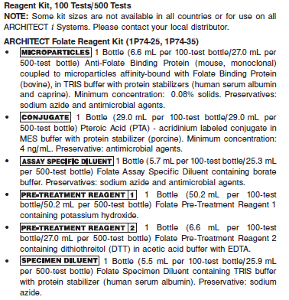

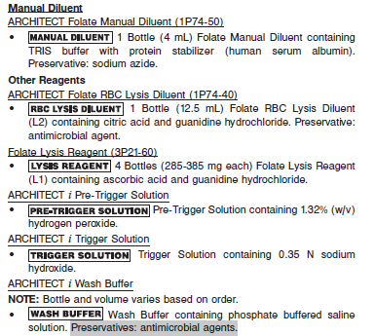

**Calibrator:** 1P74-02 ARCHITECT Folate Calibrators

**Quality Control:** 1P74-12 ARCHITECT Folate Controls or other control material

**Calibration**

**Frequency:**

Recalibration is required with each new reagent lot number.

**A new calibration is required:**

1. If quality control results do not meet acceptance criteria defined by your laboratory, patient values may be suspect. Follow the established quality control procedures for your laboratory. Recalibration may be necessary.
2. Review quality control results and acceptance criteria following a change of reagent or calibrator lot.

**Calibrator Required:** 1P74-02 ARCHITECT Folate Calibrators

**Reagents:**

6 Bottles (2 mL each) of ARCHITECT Folate Calibrators. Calibrator A, Calibrator B, Calibrator C Calibrator D, Calibrator E and Calibrator F are prepared in TRIS buffer with protein stabilizer (human serum albumin). Calibrators B through F contain pteroylglutamic acid (PGA). Preservative: sodium azide.

**Calibrator Preparation:**

Remove from carton and allow calibrators to stand at room temperature (15-30°C) until completely thawed (approximately 45 minutes). Mix by gentle inversion (3-5 times) prior to use. **Return calibrators to carton** **and store at -10°C or colder immediately after use.** It is suggested to record the thaw date on the carton or the bottles, as an aid in tracking the number of times the calibrators are thawed. Discard calibrators after three freeze-thaw cycles.

**Calibration Procedure:**

To perform a calibration, test ARCHITECT Calibrators A through F in duplicate. A single sample of all levels of ARCHITECT Folate Controls must be tested to evaluate the assay calibration. Ensure that assay control values are within the concentration ranges specified in the control package insert. Calibrators should be priority loaded.

**•** Calibration Range: 0.0 - 20.0 ng/mL.

**Troubleshooting and Overall Acceptance Criteria Failure**

See ARCHITECT Operations Manual for further calibration troubleshooting.

**Quality Control:**

Abbott recommends, refer to your laboratory standard operating procedure(s) and/or quality assurance plan for additional quality control requirements and potential corrective actions:

• At a minimum a single level of quality control are to be run every 24 hours

• If more frequent control monitoring is required, follow the established quality control procedures for your laboratory.

• If quality control results do not meet the acceptance criteria defined by your laboratory, patient values may be suspect. Follow the established quality control procedures for your laboratory.

Recalibration may be necessary.

• Review quality control results and acceptance criteria following a change of reagent or calibrator lot.

**Instrument Procedure**

**•** The ARCHITECT Folate (1P74) assay files are named “Folate II” and “FolateRBC”.

**•** The ARCHITECT Folate II (assay number 685) and/or FolateRBC (assay number 686) assay file(s) must be installed on the ARCHITECT *i* System before performing the assay. For detailed information on assay file installation and on viewing and editing assay parameters, refer to the ARCHITECT System Operations Manual, Section 2.

**•** ARCHITECT maintenance procedure *6041 Daily Maintenance* (version 5 or higher) must be installed on the ARCHITECT *i* System prior to performing the assay. For information on installing and deleting

maintenance procedures, refer to the ARCHITECT System Operations Manual, Section 2.

**•** ARCHITECT maintenance procedure *6041 Daily Maintenance* (version 5 or higher) must be run at a minimum once every 24 hours. For laboratories processing a higher volume of B12 (List 6C09) and Folate tests on a single module, this procedure must be run more than once in a 24-hour period.

**•** If B12 (List 6C09) and Folate are run on a single module and you run > 100 B12 (List 6C09) or > 100 Folate tests in 24 hours, perform the *6041 Daily Maintenance* procedure (version 5 or higher) after every

100 B12 (List 6C09) or 100 Folate tests run.

**•** Refer to **LIMITATIONS OF THE PROCEDURE** for additional information.

**•** If microbial contamination is suspected when running ARCHITECT Folate on the ARCHITECT *i* System due to shifts in results and/or the incidence of calibration failures with the following error codes:

**•** 1402 - Assay (Folate II/FolateRBC). Number (685/686) Calibration failure, calibrators incorrectly loaded

**•** 1206 - Assay (Folate II/FolateRBC). Number (685/686) Calibration failure, concentration too high for Cal A

**•** 1120 - Assay (Folate II/FolateRBC). Number (685/686) Calibration failure, fit response too low for Cal A

the following actions must be taken to protect the integrity of assay results:

**•** Contact your local customer support representative to schedule the local Abbott Service Representative to perform the *2180* *Internal Decontamination* procedure on your ARCHITECT *i* System.

If the instrument is connected to an Automatic Reconstitution Module (ARM), the *2182 ARM Decontamination* procedure must also be executed.

**•** It may be necessary to repeat the decontamination procedure if microbial contamination recurs.

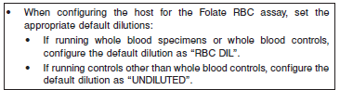

**•** For information on printing assay parameters, refer to the ARCHITECT System Operations Manual, Section 5.

**•** For a detailed description of system procedures, refer to the ARCHITECT System Operations Manual.

**Assay Procedure**

For a detailed description of how to run an assay, refer to *Section 5* of the **ARCHITECT System Operations Manual**.

**Assay Procedure Overview**

The Folate result is obtained using serum or plasma specimens. The Folate RBC result is obtained using a hemolysate prepared from whole blood. The Folate RBC result includes folate present in the RBCs and in the plasma. In order to obtain the folate concentration only in the RBCs, both specimens are required and a calculation is performed using results from both assays to obtain a Corrected RBC Folate result (if desired). The three paths are shown in the flowchart below based on the specimens provided.

NOTE: The ARCHITECT Folate (1P74) assay files are named “Folate II” and “FolateRBC”.

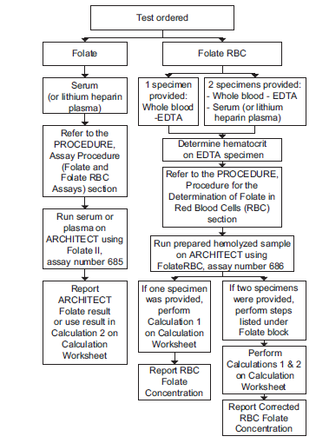

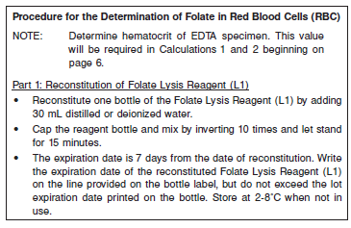

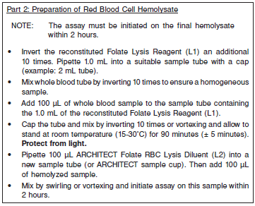

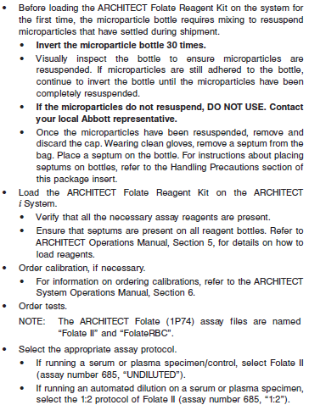

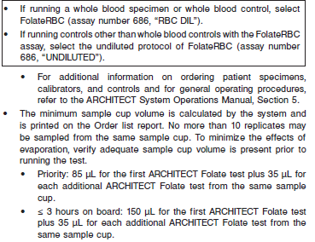

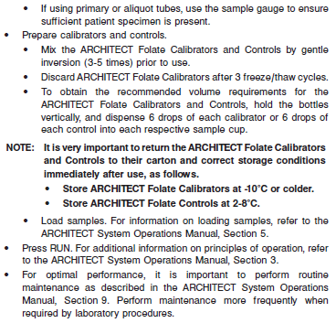

**Results**

The default result unit for the ARCHITECT Folate assay is ng/mL. An alternate result unit, nmol/L, may be selected for reporting results by editing assay parameter “Result concentration units”, to nmol/L. The

conversion factor used by the ARCHITECT *i* System is 2.265.

Formulas and examples indicate ng/mL as the result unit. If the chosen ARCHITECT Folate result is nmol/L, the final result would be in nmol/L.

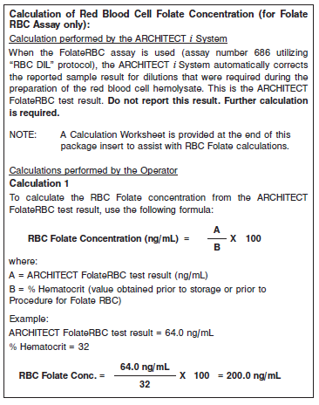

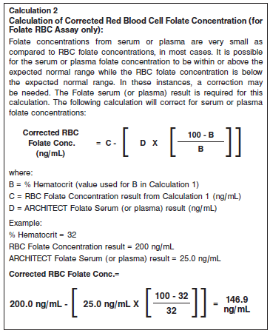

**Flags**

Some results may contain information in the Flags field. For a description of the flags that may appear in this field, refer to the ARCHITECT System Operations Manual, Section 5.

**Specific Performance Characteristics**

**Expected Values**

It is recommended that each laboratory determine its own reference range based upon its particular locale and population characteristics.

**Serum/Plasma:** 7.0 – 31.4 ng/mL

**Folate Deficients/Indeterminates**

**•** Folate deficiency is typically associated with serum levels less than 3.5 ng/mL or RBC levels less than 150 ng/mL.

**•** Patients with RBC folate levels ranging from 150 to 250 ng/mL have been associated with megaloblastic erythropoiesis, but folate values in patients with normal erythropoiesis can also fall within this range.

**•** Often, the diagnosis of folate deficiency cannot be based solely on serum or RBC folate levels, and further testing may be required.

**Critical Values: N/A**

**Performance Characteristics**

**Measuring Interval**

The measuring interval of the ARCHITECT Folate assay is 1.5 ng/mL to 20.0 ng/mL.

**Linearity**

The ARCHITECT Folate assay was evaluated for the study demonstrated linearity from 1.6 to 20 ng/mL.

**Sensitivity**

**(Limit of Blank, Limit of Detection, and Limit of Quantitation)**

The following values were determined in this study: LoB = 0.3 ng/mL (0.7 nmol/L), LoD = 0.5 ng/mL (1.1 nmol/L), and LoQ = 1.5 ng/mL (3.4 nmol/L).

**Dilution:**

**(for folate serum or plasma determinations only)**

Specimens with a folate serum or plasma value exceeding 20.0 ng/ mL are flagged with the code “ > 20.0” and may be diluted using either the Automated Dilution Procedure or the Manual Dilution Procedure. Automated Dilution Procedure

**•** If using the Automated Dilution Protocol (assay number 685, 1:2 Protocol), the system performs a 1:2 dilution. The system will use the dilution factor to automatically calculate the concentration of the sample before dilution. This will be the reported result.

Manual Dilution Procedure

**•** The suggested dilution for ARCHITECT Folate is 1:2. It is recommended dilutions not exceed 1:4.

**•** For a 1:2 dilution, add 100 μL of the patient specimen to 100 μL of ARCHITECT Folate Manual Diluent (1P74-50). For a 1:4 dilution, add 100 μL of the patient specimen to 300 μL of ARCHITECT Folate Manual Diluent (1P74-50).

**•** The operator must enter the dilution factor in the Patient or Control order screen. The system will use this dilution factor to automatically calculate the concentration of the sample before dilution. This will be the reported result.

**•** For detailed information on ordering dilutions, refer to the ARCHITECT System Operations Manual, Section 5.

**Precision:**

The ARCHITECT Folate assay is designed to have a within-laboratory imprecision of:

**•** ≤ 12% total CV for serum samples from 3.5 ng/mL to 20 ng/mL and ≤ 11% CV for RBC hemolysate between 150 ng/mL and 640 ng/mL.

**•** a Standard Deviation (SD) ≤ 0.42 for serum samples below 3.5 ng/ mL and SD ≤ 16.50 for RBC hemolysate samples below 150 ng/mL.

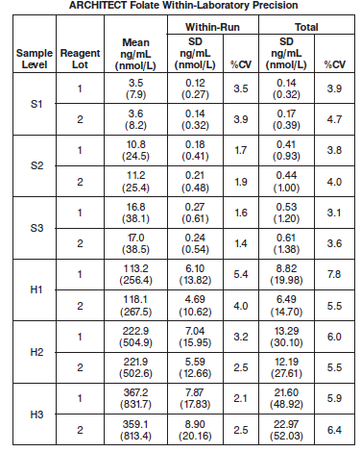

#### Limitations of Procedure

**•** For diagnostic purposes the ARCHITECT Folate assay result should be used in conjunction with other data, *e.g.*, other clinical testing, symptoms, clinical impressions, etc.

**•** If the folate level is inconsistent with clinical evidence, additional testing is suggested to confirm the result.

**•** Specimens from patients who have received preparations of mouse monoclonal antibodies for diagnosis or therapy may contain human anti-mouse antibodies (HAMA). Such specimens may show either falsely elevated or depressed values when tested with assay kits that employ mouse monoclonal antibodies.

**•** Heterophilic antibodies in human serum can react with reagent immunoglobulins, interfering with *in vitro* immunoassays. Patients routinely exposed to animals or to animal serum products can be

prone to this interference and anomalous values may be observed.

**•** Serum or plasma containing red blood cells may give falsely elevated folate levels. These samples should be centrifuged prior to use. Serum or plasma samples that are hemolyzed will give falsely elevated folate levels.

**•** Serum and plasma specimens from patients with renal impairment or failure (including dialysis patients) may exhibit varying degrees of falsely depressed folate values. Therefore, to evaluate folate

patients with renal impairment or failure, it is recommended that low ARCHITECT Folate values be confirmed by an alternate folate method such as the ARCHITECT Folate RBC assay.

**•** Methotrexate, aminopterin, and folinic acid (Leucovorin) are chemotherapeutic agents whose molecular structures are similar to folate. These agents cross react with folate binding protein in folate

assays.

**•** Samples to be tested for folate should be protected from light. Light accelerates the degradation of folate.

**•** Accumulation of denatured protein from the pre-treatment step in the sample probe may impact results of other assays on the ARCHITECT *i* System. ARCHITECT maintenance procedure *6041 Daily Maintenance* (version 5 or higher) must be run to eliminate this effect. Refer to the **INSTRUMENT PROCEDURE** section for instructions.

**Specificity**

The specificity of the ARCHITECT Folate assay was evaluated by testing cross-reactivity with aminopterin, folinic acid, and methotrexate in processed human serum containing endogenous folate. Therapeutic levels of these drugs can greatly exceed the levels tested in this study and are expected to interfere with the ARCHITECT Folate assay.

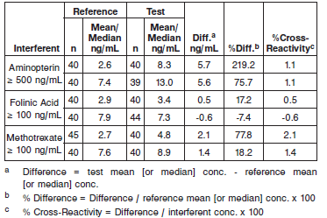

**Interfering Substances**

Potential interference in the ARCHITECT Folate assay from bilirubin, (conjugated and unconjugated), triglycerides, and protein was demonstrated in a study based on guidance from CLSI document EP7-A2. Hemoglobin was not tested due to the high folate content in red blood cells. Refer to the **LIMITATIONS OF THE PROCEDURE** section.

Data from this study are summarized in the following table.

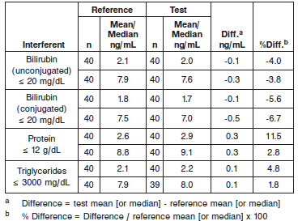

**References:**

1. ABBOTT ARCHITECT Folate package insert

Abbott Laboratories

Diagnostics Division

Abbott Park, IL 60064

June 2012 G2-7444/R04

1. ABBOTT ARCHITECT Folate Calibrator package insert

Abbott Laboratories

Diagnostics Division

Abbott Park, IL 60064

1. Abbott ARCHITECT Operator’s Guide

**Related Documents:**

**Attachments:**