RUSH logo for emails

**FREE T3**

**SERUM OR PLASMA**

**ABBOTT ARCHITECT**

**Intended Use**

The ARCHITECT Free T3 (FT3) assay is a Chemiluminescent Microparticle Immunoassay (CMIA) for the quantitative determination of free triiodothyronine (Free T3) in human serum and plasma.

**Clinical Significance**

3,5,3’ Triiodothyronine (T3) is a thyroid hormone with a molecular weight of 651 daltons and a half-life in serum of 1.5 days. T3 circulates in the blood as an equilibrium mixture of free and protein bound hormone. T3 is bound to thyroxine binding globulin (TBG), prealbumin, and albumin. The actual distribution of T3 among these binding proteins is controversial as estimates range from 38-80% for TBG, 9-27% for prealbumin, and 11-35% for albumin. The binding of these proteins is such that only 0.2-0.4% of the total T3 is present in solution as unbound or free T3. This free fraction represents the physiologically active thyroid hormone. Free T3 is typically elevated to a greater degree than free thyroxine (T4) in Graves’ disease. Occasionally, free T3 alone is elevated (T3 thyrotoxicosis) in about 5% of the hyperthyroid population. In contrast, levels of free T4 are elevated to a greater degree than free T3 in toxic multinodular goiter and excessive T4 therapy. Serum free T3 is useful in distinguishing these forms of hyperthyroidism. Free T3 may also be important in monitoring patients on anti-thyroid therapy where treatment is focused on reducing the T3 production and the T4 conversion to T3. Serum free T3 may also be useful in assessing the severity of the thyrotoxic state.

The ARCHITECT Free T3 assay is to be used as an aid in the assessment of thyroid status.

**Principle**

The ARCHITECT Free T3 assay is a two-step immunoassay to determine the presence of free (unbound) T3 in human serum and plasma using Chemiluminescent Microparticle Immunoassay (CMIA) technology with flexible assay protocols, referred to as Chemiflex. In the first step, sample and anti-T3 coated paramagnetic microparticles are combined. Free T3 (unbound) present in the sample binds to the anti‑T3 coated microparticles. After washing, T3 acridinium labeled conjugate is added in the second step. Pre-Trigger and Trigger Solutions are then added to the reaction mixture; the resulting chemiluminescent reaction is measured as relative light units (RLUs). An inverse relationship exists between the amount of Free T3 in the sample and the RLUs detected by the ARCHITECT *i* optical system.

For additional information on system and assay technology, refer to the ARCHITECT System Operations Manual, Section 3.

**Specimen Collection and Handling**

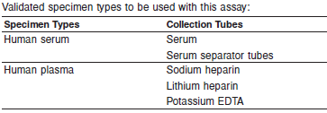

* When serial specimens are being evaluated, the same type of specimen should be used throughout the study.

Do not use specimens with the following conditions:

**•** heat inactivated

**Storage**



* If testing will be delayed more than 24 hours, remove serum or plasma from the clot, serum separator or red blood cells. Specimens may be stored for up to 6 days at 2-8°C prior to being tested. If testing will be delayed more than 6 days, specimens should be frozen at -10°C or colder. Specimens stored frozen at -10°C or colder for 6 days showed no performance difference.
* Multiple freeze-thaw cycles of specimens should be avoided.

**NOTE:** Stored specimens must be inspected for particulates. If present, mix and centrifuge the specimen to remove particulates prior to testing.

**Materials and Equipment Required**

**TEST INSTRUMENT**: Abbott ARCHITECT System

**MATERIALS PROVIDED**

7K63 ARCHITECT Free T3 Reagent Kit

**MATERIALS REQUIRED BUT NOT PROVIDED**

**•** ARCHITECT *i* System

**•** ARCHITECT Free T3 Assay file, may be obtained from:

**•** ARCHITECT *i* System e-Assay CD-ROM found on www.abbottdiagnostics.com

**•** ARCHITECT *i* System Assay CD-ROM

**•** 7K63-01 ARCHITECT Free T3 Calibrators

**•** 7K63-10 ARCHITECT Free T3 Controls

**•** ARCHITECT *i* Pretrigger

**•** ARCHITECT *i* Trigger

**•** ARCHITECT *i i* Wash Buffer

**•** ARCHITECT *i* Reaction Vessels

**•** ARCHITECT *i* Sample Cups

**•** ARCHITECT *i* Septums

**•** ARCHITECT *i* Replacement Caps

**•** Pipettes or pipette tips (optional) to deliver the specified volumes.

**Reagent Handling and Storage:**

***CAUTION*:**

* For in vitro diagnostic use.

**CAUTION:** This product requires the handling of human specimens.

It is recommended that all human sourced materials be considered

potentially infectious and be handled in accordance with the OSHA

Standard on Bloodborne Pathogens. Biosafety Level 2 or other appropriate biosafety practices should be used for materials that contain or are suspected of containing infectious agents.

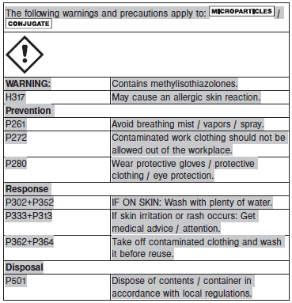

**Reagent Handling**

* Do not use reagent kits beyond the expiration date.
* **Do not pool reagents within a kit or between reagent kits.**
* Before loading the ARCHITECT Reagent Kit on the system for the first time, the microparticle bottle requires mixing to resuspend microparticles that have settled during shipment.
* **Septums MUST be used to prevent reagent evaporation and contamination and to ensure reagent integrity. Reliability of assay results cannot be guaranteed if septums are not used according to the instructions in the package insert.**
* To avoid contamination, wear clean gloves when placing a septum on an uncapped reagent bottle.
* Once a septum has been placed on the reagent bottle, **do not invert the bottle** as this will result in reagent leakage and maycompromise assay results.
* Over time, residual liquids may dry on the septum surface. These are typically dried salts and have no effect on assay efficacy.
* For a detailed discussion of handling precautions during system operation, refer to the ARCHITECT System Operations Manual, Section 7.

**Reagent Storage**

* The ARCHITECT Free T3 Reagent Kit must be stored at 2-8°C and may be used immediately after removal from 2‑8°C storage.
* When stored and handled as directed, reagents are stable until the expiration date.
* The ARCHITECT Free T3 Reagent Kit may be stored on-board the ARCHITECT *i* System for a maximum of 30 days. After 30 days, the reagent kit must be discarded. For information on tracking on‑board time, refer to the ARCHITECT System Operations Manual, Section 5.
* Reagents may be stored on or off the ARCHITECT *i* System. If reagents are removed from the system, store them at 2-8°C (with septums and replacement caps) in an upright position. For reagents stored off the system, it is recommended that they be stored in their original trays and boxes to ensure they remain upright.
* For information on unloading reagents, refer to the ARCHITECT System Operations Manual, Section 5.

Reagents

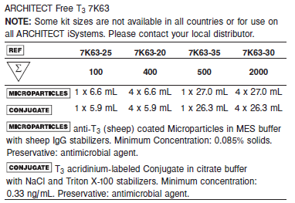

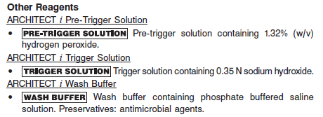

**Calibrator:** 7K63-01 ARCHITECT Free T3 Calibrators

**Quality Control:** 7K63-10 ARCHITECT Free T3 Controls or commercially available controls

**Calibration**

**Frequency:**

Recalibration is required with each new reagent lot number.

**A new calibration is required:**

1. If quality control results do not meet acceptance criteria defined by your laboratory, patient values may be suspect. Follow the established quality control procedures for your laboratory. Recalibration may be necessary.
2. Review quality control results and acceptance criteria following a change of reagent or calibrator lot.

**Calibrator Required:**

7K63-01 ARCHITECT Free T3 Calibrators

**Reagents:**

2 Bottles (4 mL each) of ARCHITECT Free T3 Calibrators prepared in human serum. Preservative: Sodium Azide.

**Calibrator Preparation:**

Ready to use.

**Calibration Procedure:**

To perform an ARCHITECT Free T3 calibration, test Calibrators 1 and 2 in duplicate. A single sample of all levels of Free T3 controls must be tested to evaluate the assay calibration. Ensure that assay control values are within the concentration ranges specified in the package insert. Calibrators should be priority loaded.

**•** Calibrator Range: 0.0 - 30.0 pg/mL.

**Troubleshooting and Overall Acceptance Criteria Failure**

See ARCHITECT Operations Manual for further calibration troubleshooting.

**Quality Control:**

Abbott recommends, refer to your laboratory standard operating procedure(s) and/or quality assurance plan for additional quality control requirements and potential corrective actions:

• At a minimum a single level of quality control are to be run every 24 hours

• If more frequent control monitoring is required, follow the established quality control procedures for your laboratory.

• If quality control results do not meet the acceptance criteria defined by your laboratory, patient values may be suspect. Follow the established quality control procedures for your laboratory.

Recalibration may be necessary.

• Review quality control results and acceptance criteria following a change of reagent or calibrator lot.

**Instrument Procedure**

* The ARCHITECT Free T3 assay is designed for use on the ARCHITECT *i* System
* The ARCHITECT Free T3 assay file must be installed on the ARCHITECT *i* System from an ARCHITECT *i* System Assay CD-ROM prior to performing the assay. For detailed information on assay file installation and on viewing and editing assay parameters, refer to the ARCHITECT System Operations Manual, Section 2.
* For detailed information on assay file installation and viewing and editing assay parameters, refer to the ARCHITECT System Operations Manual, Section 2.
* For information on printing assay parameters, refer to the ARCHITECT System Operations Manual, Section 5.
* For a detailed description of system procedures, refer to the ARCHITECT System Operations Manual.

**Assay Procedure**

For a detailed description of how to run an assay, refer to *Section 5* of the **ARCHITECT System Operations Manual**.

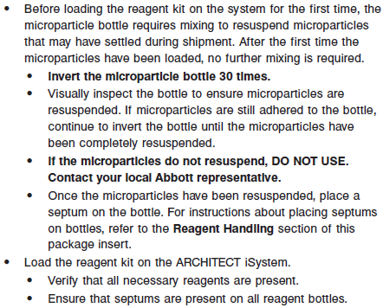

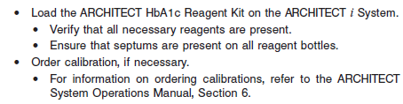

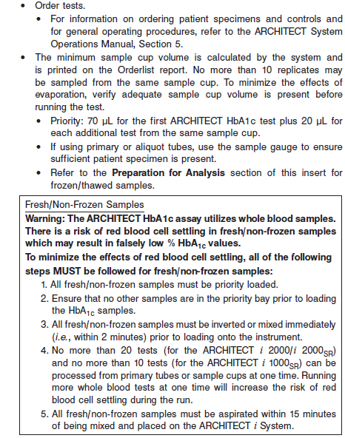

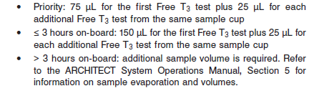

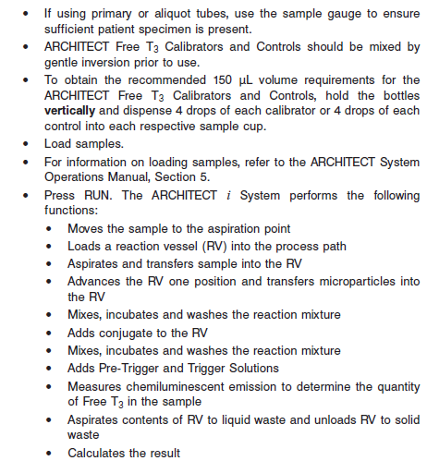

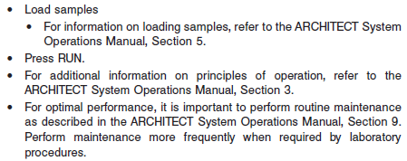

**Results**

The default result unit for the ARCHITECT Free T3 assay is pg/mL. An alternate result unit, pmol/L, may be selected for reporting results by editing assay parameter “Result concentration units” to pmol/L. The conversion factor used by the system is 1.536.

**Flags**

Some results may contain information in the Flags field. For a description of the flags that may appear in this field, refer to the ARCHITECT System Operations Manual, Section 5.

**Specific Performance Characteristics**

**Expected Values**

It is recommended that each laboratory determine its own reference range based upon its particular locale and population characteristics.

**Serum/Plasma:** 1.71 – 3.71 pg/mL

**Critical Values: N/A**

**Performance Characteristics**

**Sensitivity**

The ARCHITECT Free T3 assay is designed to have an analytical sensitivity of ≤ 1.0 pg/mL.

**Linearity**

The assay is linear from 1-30 pg/mL.

**Dilution:**

Specimens cannot be diluted for Free T3 determinations. Specimens which read > 30.00 pg/mL should be reported as such.

**Precision:**

The ARCHITECT Free T3 assay is designed to have a precision of ≤ 10% (total CV).

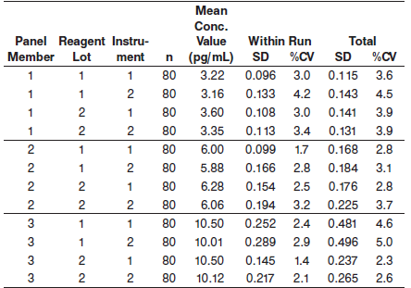

#### Limitations of Procedure

Performance of this test has not been established with neonatal specimens.

**Specificity**

The ARCHITECT Free T3 assay is designed to have a mean analytical specificity of ≤ 0.001% cross reactivity with thyroxine (T4) at a concentration of 1,000,000 pg/mL.

**Interference**

The ARCHITECT Free T3 assay is designed to have a mean potential interference from hemoglobin, bilirubin, triglycerides, and protein of < 10% at the levels indicated below.

**•** Hemoglobin - ≤ 500 mg/dL

**•** Bilirubin - ≤ 20 mg/dL

**•** Triglycerides - ≤ 2000 mg/dL

**•** Protein - ≤ 12 g/dL

**References:**

1. ABBOTT ARCHITECT Free T3 package insert

Abbott Laboratories

Diagnostics Division

Abbott Park, IL 60064

Sept 2015 G5-6683/ R07

1. ABBOTT ARCHITECT Free T3 Calibrator package insert

Abbott Laboratories

Diagnostics Division

Abbott Park, IL 60064

1. Abbott ARCHITECT Operator’s Guide

**Related Documents:**

**Attachments:**