RUSH logo for emails

**FREE T4**

**SERUM OR PLASMA**

**ABBOTT ARCHITECT**

**Intended Use**

The ARCHITECT Free T4 (FT4) assay is a Chemiluminescent Microparticle Immunoassay (CMIA) for the quantitative determination of free thyroxine (Free T4) in human serum and plasma.

**Clinical Significance**

Thyroxine (T4) circulates in the blood as an equilibrium mixture of free and serum protein bound hormone. Thyroxine binding globulin (TBG), albumin and pre-albumin bind approximately 75%, 10% and 15% of the total circulating T4 respectively. The binding of T4 by these proteins is such that less than 0.03% is present in the circulation as unbound, free T4. This small percentage of the total T4 represents the physiologically available hormone which is biologically active. Once the free T4 is absorbed by the target cells, the equilibrium reestablishes circulating free T4 levels. The equilibrium results in the maintenance of a constant level of free T4 when alterations occur in either the concentration or affinity of the serum binding proteins. Therefore, in a variety of normal (pregnancy) and abnormal (Familial Dysalbuminemic Hyperthyroxinemia, FDH) states, or as a result of the administration of certain drugs (e.g. furosemide and fenclofenac), the target tissues are assured of receiving the required amount of hormone. Free T4 values may, therefore, provide the best indication of thyroid dysfunction, since free T4 is less sensitive to changes in the serum binding proteins. Historically, the diagnosis of thyroid function has involved performing a total T4 assay in addition15 to a Thyroxine Uptake (TU) assay of the same sample. The mathematical combination of these two assays produces a

Free Thyroxine Index (FTI) which provides an indirect proportional estimate for free T4.

Alternatively, direct assays have been developed using equilibrium dialysis, ultrafiltration,19,20 RIA,21 and solid-phase EIA technology to measure free T4. In these methods, separation of free and bound tracer is achieved either with a membrane, or by binding free T4 to a solid phase antibody. This extraction step removes an amount of T4 which is proportional to the original amount of free T4 present in the patient sample. Provided that the extracted T4 is less than approximately 5% of the T4 in the sample, a true estimation of the free T4 content can be obtained.

The ARCHITECT Free T4 assay is to be used as an aid in the assessment of thyroid status.

**Principle**

The ARCHITECT Free T4 assay is a two-step immunoassay to determine the presence of free thyroxine (Free T4) in human serum and plasma using Chemiluminescent Microparticle Immunoassay (CMIA) technology with flexible assay protocols, referred to as Chemiflex.

In the first step, sample and anti‑T4 coated paramagnetic microparticles are combined. Free T4 (unbound) present in the sample binds to the anti‑T4 coated microparticles. After washing, T3 acridinium labeled conjugate is added in the second step.

Pre-Trigger and Trigger Solutions are then added to the reaction mixture; the resulting chemiluminescent reaction is measured as relative light units (RLUs). An inverse relationship exists between the amount of Free T4 in the sample and the RLUs detected by the ARCHITECT *i* optical system.

For additional information on system and assay technology, refer to the ARCHITECT System Operations Manual, Section 3.

**Specimen Collection and Handling**

**Suitable Specimens**

* Human serum (including serum collected in serum separator tubes) or plasma collected in sodium heparin, lithium heparin (including lithium heparin plasma separator tubes), or potassium EDTA anticoagulant tubes may be used in the ARCHITECT Free T4 assay. Other anticoagulants have not been validated for use with the ARCHITECT Free T4 assay. Follow the manufacturer’s processing instructions for serum or plasma collection tubes.
* When serial specimens are being evaluated, the same type of specimen should be used throughout the study.

Do not use specimens with the following conditions:

**•** heat inactivated

**Storage**

* If testing will be delayed more than 24 hours, remove serum or plasma from the clot, serum separator, plasma separator or red blood cells. Follow the manufacturer’s processing instructions for serum or plasma collection tubes if a removal time of less than 24 hours is specified. Specimens may be stored for up to 6 days at 2-8°C prior to being tested. If testing will be delayed more than 6 days specimens should be frozen at -10°C or colder. Specimens stored frozen at -10°C or colder for 6 days showed no performance difference.
* Multiple freeze-thaw cycles of specimens should be avoided.

**NOTE:** Stored specimens must be inspected for particulates. If present, mix and centrifuge the specimen to remove particulates prior to testing.

**Materials and Equipment Required**

**TEST INSTRUMENT**: Abbott ARCHITECT System

**MATERIALS PROVIDED**

7K65 ARCHITECT Free T4 Reagent Kit

**MATERIALS REQUIRED BUT NOT PROVIDED**

**•** ARCHITECT *i* System with *STAT* protocol

**•** ARCHITECT Free T4 Assay file, may be obtained from:

**•** ARCHITECT *i* System e-Assay CD-ROM found on www.abbottdiagnostics.com

**•** ARCHITECT *i* System Assay CD-ROM

**•** 7K65-01 ARCHITECT Free T4 Calibrators

**•** 7K65-10 ARCHITECT Free T4 Controls

**•** ARCHITECT *i* Pretrigger

**•** ARCHITECT *i* Trigger

**•** ARCHITECT *i i* Wash Buffer

**•** ARCHITECT *i* Reaction Vessels

**•** ARCHITECT *i* Sample Cups

**•** ARCHITECT *i* Septums

**•** ARCHITECT *i* Replacement Caps

**•** Pipettes or pipette tips (optional) to deliver the specified volumes.

**Reagent Handling and Storage:**

***CAUTION*:**

* For in vitro diagnostic use.

**CAUTION:** This product requires the handling of human specimens.

It is recommended that all human sourced materials be considered

potentially infectious and be handled in accordance with the OSHA

Standard on Bloodborne Pathogens. Biosafety Level 2 or other appropriate biosafety practices should be used for materials that contain or are suspected of containing infectious agents.

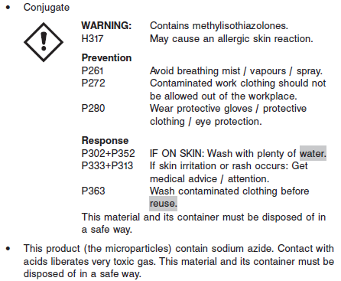

**Reagent Handling**

* Do not use reagent kits beyond the expiration date.
* **Do not pool reagents within a kit or between reagent kits.**
* Before loading the ARCHITECT Reagent Kit on the system for the first time, the microparticle bottle requires mixing to resuspend microparticles that have settled during shipment.
* **Septums MUST be used to prevent reagent evaporation and contamination and to ensure reagent integrity. Reliability of assay results cannot be guaranteed if septums are not used according to the instructions in the package insert.**
* To avoid contamination, wear clean gloves when placing a septum on an uncapped reagent bottle.
* Once a septum has been placed on the reagent bottle, **do not invert the bottle** as this will result in reagent leakage and maycompromise assay results.
* Over time, residual liquids may dry on the septum surface. These are typically dried salts and have no effect on assay efficacy.
* For a detailed discussion of handling precautions during system operation, refer to the ARCHITECT System Operations Manual, Section 7.

**Reagent Storage**

* The ARCHITECT Free T4 Reagent Kit must be stored at 2-8°C and may be used immediately after removal from 2‑8°C storage.
* When stored and handled as directed, reagents are stable until the expiration date.
* The ARCHITECT Free T4 Reagent Kit may be stored on-board the ARCHITECT *i* System for a maximum of 30 days. After 30 days, the reagent kit must be discarded. For information on tracking on‑board time, refer to the ARCHITECT System Operations Manual, Section 5.
* Reagents may be stored on or off the ARCHITECT *i* System. If reagents are removed from the system, store them at 2-8°C (with septums and replacement caps) in an upright position. For reagents stored off the system, it is recommended that they be stored in their original trays and boxes to ensure they remain upright.
* For information on unloading reagents, refer to the ARCHITECT System Operations Manual, Section 5.

Reagents

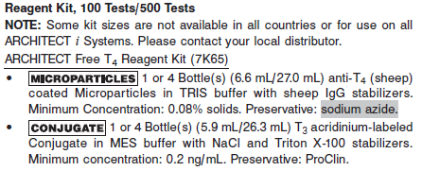

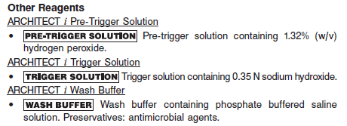

**Calibrator:** 7K65-01 ARCHITECT Free T4 Calibrators

**Quality Control:** 7K65-10 ARCHITECT Free T4 Controls or commercially available controls

**Calibration**

**Frequency:**

Recalibration is required with each new reagent lot number.

**A new calibration is required:**

1. If quality control results do not meet acceptance criteria defined by your laboratory, patient values may be suspect. Follow the established quality control procedures for your laboratory. Recalibration may be necessary.
2. Review quality control results and acceptance criteria following a change of reagent or calibrator lot.

**Calibrator Required:**

7K65-01 ARCHITECT Free T4 Calibrators

**Reagents:**

6 Bottles (4 mL each) of ARCHITECT Free T4 Calibrators prepared in human serum. Preservative: sodium azide.

**Calibrator Preparation:**

Ready to use.

**Calibration Procedure:**

To perform an ARCHITECT Free T4 calibration, test Calibrators 1 and 2 in duplicate. A single sample of all levels of Free T4 controls must be tested to evaluate the assay calibration. Ensure that assay control values are within the concentration ranges specified in the package insert. Calibrators should be priority loaded.

**•** Calibrator Range: 0.0 - 6.0 ng/dL.

**Troubleshooting and Overall Acceptance Criteria Failure**

See ARCHITECT Operations Manual for further calibration troubleshooting.

**Quality Control:**

Abbott recommends, refer to your laboratory standard operating procedure(s) and/or quality assurance plan for additional quality control requirements and potential corrective actions:

• At a minimum a single level of quality control are to be run every 24 hours

• If more frequent control monitoring is required, follow the established quality control procedures for your laboratory.

• If quality control results do not meet the acceptance criteria defined by your laboratory, patient values may be suspect. Follow the established quality control procedures for your laboratory.

Recalibration may be necessary.

• Review quality control results and acceptance criteria following a change of reagent or calibrator lot.

**Instrument Procedure**

* The ARCHITECT Free T4 assay is designed for use on the ARCHITECT *i* System
* The ARCHITECT Free T4 assay file must be installed on the ARCHITECT *i* System from an ARCHITECT *i* System Assay CD-ROM prior to performing the assay. For detailed information on assay file installation and on viewing and editing assay parameters, refer to the ARCHITECT System Operations Manual, Section 2.
* For detailed information on assay file installation and viewing and editing assay parameters, refer to the ARCHITECT System Operations Manual, Section 2.
* For information on printing assay parameters, refer to the ARCHITECT System Operations Manual, Section 5.
* For a detailed description of system procedures, refer to the ARCHITECT System Operations Manual.

**Assay Procedure**

For a detailed description of how to run an assay, refer to *Section 5* of the **ARCHITECT System Operations Manual**.

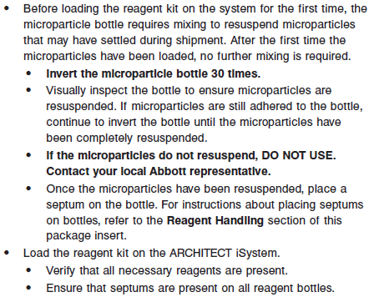

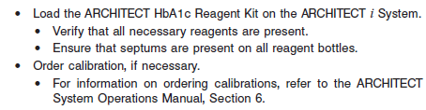

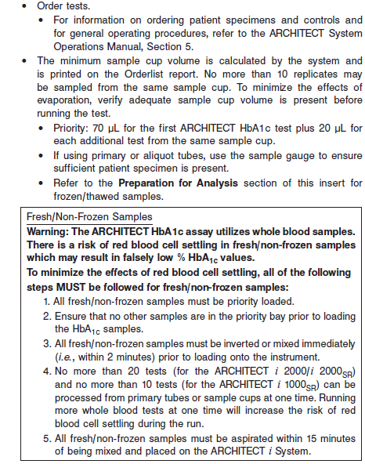

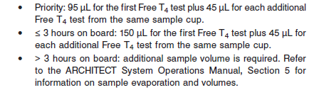

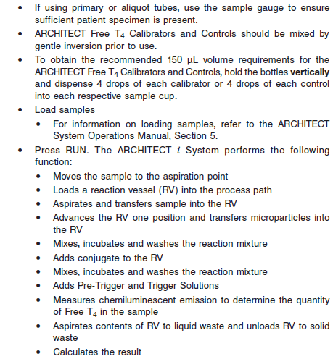

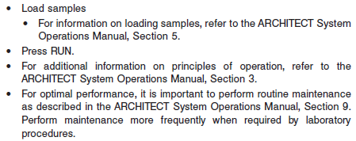

**Results**

The default result unit for the ARCHITECT Free T4 assay is ng/dL. An alternate result unit, pmol/L, may be selected for reporting results by editing assay parameter “Result concentration units”, to pmol/L. The conversion factor used by the system is 12.87.

**Flags**

Some results may contain information in the Flags field. For a description of the flags that may appear in this field, refer to the ARCHITECT System Operations Manual, Section 5.

**Specific Performance Characteristics**

**Expected Values**

It is recommended that each laboratory determine its own reference range based upon its particular locale and population characteristics.

**Serum/Plasma:** 0.70 – 1.48 ng/dL

**Critical Values: N/A**

**Performance Characteristics**

**Sensitivity**

The ARCHITECT Free T4 assay is designed to have an analytical sensitivity of ≤ 0.4 ng/dL.

**Linearity**

The assay is linear from 0.4 to 6 ng/mL

**Dilution:**

Samples cannot be diluted for Free T4 determinations. Samples which read > 6.00 ng/dL should be reported as such.

**Precision:**

The ARCHITECT Free T4 assay is designed to have a precision of ≤ 10% (total CV) for concentrations in the range of the low control (0.65 ng/dL), medium control (1.2 ng/dL) and high control (2.8 ng/dL).

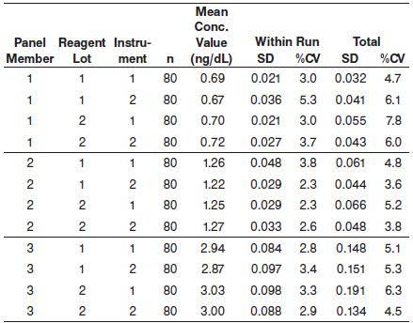

#### Limitations of Procedure

Performance of this test has not been established with neonatal specimens.

**Specificity**

The ARCHITECT Free T4 assay is designed to have a mean analytical specificity of ≤ 0.0035% cross reactivity with triiodothyronine (T3) at a concentration of 12,000 ng/dL in a sample containing 0.5 ng/dL of Free T4.

**Interference**

The ARCHITECT Free T4 assay is designed to have a mean potential interference from hemoglobin, bilirubin, triglycerides, and protein of < 10% at the levels indicated below.

**•** Hemoglobin - ≤ 500 mg/dL

**•** Bilirubin - ≤ 20 mg/dL

**•** Triglycerides - ≤ 3000 mg/dL

**•** Protein - ≤ 12 g/dL

**References:**

1. ABBOTT ARCHITECT Free T4 package insert

Abbott Laboratories

Diagnostics Division

Abbott Park, IL 60064

Oct 2012 G3-0706/R04

1. ABBOTT ARCHITECT Free T4 Calibrator package insert

Abbott Laboratories

Diagnostics Division

Abbott Park, IL 60064

1. Abbott ARCHITECT Operator’s Guide

**Related Documents:**

**Attachments:**