RUSH logo for emails

**HAVAB-M**

**SERUM OR PLASMA**

**ABBOTT ARCHITECT**

**Intended Use**

The ARCHITECT HAVAB-M assay is a chemiluminescent microparticle immunoassay (CMIA) for the qualitative detection of IgM antibody to hepatitis A virus (IgM anti-HAV) in human adult and pediatric serum and plasma (dipotassium EDTA, lithium heparin, and sodium heparin) and neonatal serum. A test for IgM anti-HAV is indicated for testing of specimens from individuals who have signs and symptoms consistent with acute hepatitis. Test results are used in conjunction with other laboratory results and clinical information as an aid in the diagnosis of acute or recent hepatitis A viral infection.

**Warning: Not intended for use in screening blood, plasma, or tissue donors.** The effectiveness of ARCHITECT HAVAB-M for use inscreening blood, plasma, or tissue donors has not been established.

Assay performance characteristics have not been established when the ARCHITECT HAVAB-M assay is used in conjunction with other manufacturers’ assays for specific hepatitis markers. Users are responsible for establishing their own performance characteristics.

**Clinical Significance**

The ARCHITECT HAVAB-M assay determines the presence of IgM anti-HAV in human serum and plasma. Hepatitis A is typically a self‑limiting disease and is often a subclinical disorder, particularly in children. Since symptomatic hepatitis A virus (HAV) infections can be clinically indistinguishable from infection with hepatitis B or C virus, serological testing is an important tool to achieve proper diagnosis.

During the acute phase of HAV infection, IgM anti-HAV appears in the patient’s serum and is nearly always detectable at the onset of symptoms. In most cases, IgM anti-HAV response peaks within the first month of illness and can persist for up to six months.

**Principle**

The ARCHITECT HAVAB-M assay is a two-step immunoassay for the qualitative detection of IgM anti-HAV in human serum and plasma using CMIA technology with flexible assay protocols, referred to as Chemiflex.

In the first step, prediluted sample, assay diluent, and hepatitis A virus (human) coated paramagnetic microparticles are combined. IgM anti-HAV present in the sample binds to the hepatitis A virus (human) coated microparticles. After washing, the IgM anti-HAV binds to the anti-human IgM acridinium-labeled conjugate that is added in the second step. Following another wash cycle, pre‑trigger and trigger solutions are added to the reaction mixture. The resulting chemiluminescent reaction is measured as relative light units (RLUs).

A direct relationship exists between the amount of IgM anti-HAV in the sample and the RLUs detected by the ARCHITECT *i* System optics.

The presence or absence of IgM anti-HAV in the specimen is determined by comparing the chemiluminescent signal in the reaction to the cutoff signal determined from an active ARCHITECT HAVAB-M calibration. Specimens with signal to cutoff (S/CO) values M 1.21 are considered reactive for IgM anti-HAV. Specimens with S/CO values of 0.80 to < 1.21 are considered grayzone. Specimens with S/CO values < 0.80 are considered nonreactive.

For additional information on system and assay technology, refer to the ARCHITECT System Operations Manual, Section 3.

**Specimen Collection and Handling**

**Suitable Specimens**

The following specimen tube types were verified for use with the ARCHITECT HAVAB-M assay:

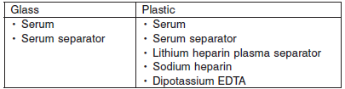

Do not use specimens with the following conditions:

• heat-inactivated

• pooled

• grossly hemolyzed

• obvious microbial contamination

• Performance has not been established for the use of cadaveric specimens or the use of body fluids other than human serum and plasma.

**Specimen Storage**

Serum or Plasma

Specimens may be stored on or off the clot, red blood cells, or separator gel.

• up to 3 days at room temperature (study performed at

21-30°C) or

• up to 7 days at 2-8°C.

• If testing will be delayed more than 3 days for specimens stored at room temperature or more than 7 days for specimens stored at 2-8°C, remove serum or plasma from the clot, red blood cells, or separator gel and store at -20°C or colder.

• Avoid more than three freeze/thaw cycles.

**NOTE:** Stored specimens must be inspected for particulates. If present, mix and centrifuge the specimen to remove particulates prior to testing.

**Materials and Equipment Required**

**TEST INSTRUMENT**: Abbott ARCHITECT System

**MATERIALS PROVIDED**

6L21 ARCHITECT HAVAB-M Reagent Kit

**MATERIALS REQUIRED BUT NOT PROVIDED**

**•** ARCHITECT *i* System

**•** ARCHITECT HAVAB-M Assay file, may be obtained from:

**•** ARCHITECT *i* System e-Assay CD-ROM found on www.abbottdiagnostics.com

**•** ARCHITECT *i* System Assay CD-ROM

**•** 6L21-01 ARCHITECT HAVAB-M Calibrator

• 6L21-10 ARCHITECT HAVAB-M Controls

**•** ARCHITECT *i* Pretrigger

**•** ARCHITECT *i* Trigger

**•** ARCHITECT *i i* Wash Buffer

**•** ARCHITECT *i* Reaction Vessels

**•** ARCHITECT *i* Sample Cups

**•** ARCHITECT *i* Septums

**•** ARCHITECT *i* Replacement Caps

**•** Pipettes or pipette tips (optional) to deliver the specified volumes.

**Reagent Handling and Storage:**

***CAUTION*:**

* For in vitro diagnostic use.

**CAUTION:** This product requires the handling of human specimens.

It is recommended that all human sourced materials be considered

potentially infectious and be handled in accordance with the OSHA

Standard on Bloodborne Pathogens. Biosafety Level 2 or other appropriate biosafety practices should be used for materials that contain or are suspected of containing infectious agents.

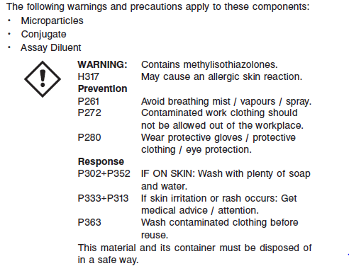

**Reagent Handling**

* Do not use reagent kits beyond the expiration date.
* **Do not pool reagents within a kit or between reagent kits.**
* Before loading the ARCHITECT HAVAB-M Reagent Kit on the system for the first time, the microparticle bottle requires mixing to resuspend microparticles that have settled during shipment.
* **Septums MUST be used to prevent reagent evaporation and contamination and to ensure reagent integrity. Reliability of assay results cannot be guaranteed if septums are not used according to the instructions in the package insert.**
* To avoid contamination, wear clean gloves when placing a septum on an uncapped reagent bottle.
* Once a septum has been placed on the reagent bottle, **do not invert the bottle** as this will result in reagent leakage and maycompromise assay results.
* Over time, residual liquids may dry on the septum surface. These are typically dried salts and have no effect on assay efficacy.
* For a detailed discussion of handling precautions during system operation, refer to the ARCHITECT System Operations Manual, Section 7.

**Reagent Storage**

* The ARCHITECT HAVAB-M Reagent Kit must be stored at 2-8°C in an upright position and may be used immediately after removal from 2-8°C storage.
* When stored and handled as directed, the reagents are stable until the expiration date.
* The ARCHITECT HAVAB-M Reagent Kit may be stored on board the ARCHITECT *i* System for a maximum of 30 days. After 30 days, the reagent kit must be discarded. For information on tracking onboard time, refer to the ARCHITECT System Operations Manual, Section 5.
* Reagents may be stored on or off the ARCHITECT *i* System. If reagents are removed from the system, store them at 2-8°C (with septums and replacement caps) in an upright position. For reagents stored off the system, it is recommended that they be stored in their original trays and boxes to ensure they remain upright. **If the microparticle bottle does** **not remain upright (with a septum installed) while in refrigerated** **storage off the system, the reagent kit must be discarded.** For information on unloading reagents, refer to the ARCHITECT System Operations Manual, Section 5.

Reagents

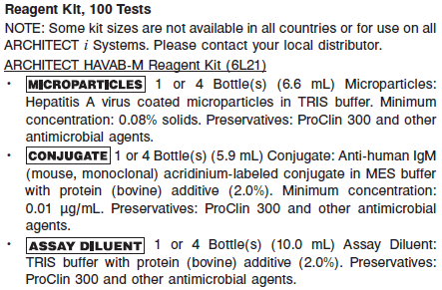

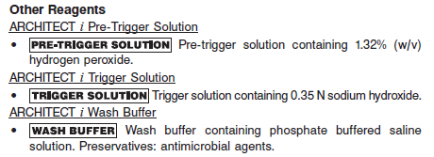

**Calibrator:** 6L21-01 ARCHITECT HAVAB-M Calibrator

**Quality Control:** 6L21-10 ARCHITECT HAVAB-M Controls or other control material

**Calibration**

**Frequency:**

Recalibration is required with each new reagent lot number.

**A new calibration is required:**

1. If quality control results do not meet acceptance criteria defined by your laboratory, patient values may be suspect. Follow the established quality control procedures for your laboratory. Recalibration may be necessary.
2. Review quality control results and acceptance criteria following a change of reagent or calibrator lot.

**Calibrator Required:** 6L21-01 ARCHITECT HAVAB-M Calibrator

The ARCHITECT *i* System calculates the cutoff Relative Light Units (RLU) from the mean chemiluminescent signal of three HAVAB-M Calibrator 1 replicates. The acceptability of the calibration is assessed against a parameter. If the calibration is acceptable, the cutoff RLU is calculated by multiplying the HAVAB-M Calibrator 1 mean RLU by 0.375.

Cutoff RLU = Calibrator 1 Mean RLU x 0.375

**Reagents:**

1 Bottle (4 mL) ARCHITECT HAVAB-M Calibrator 1 is recalcified anti-HAV positive human plasma in recalcified anti-HAV negative human plasma. Calibrator 1 is green and contains Acid Yellow No. 23 and Acid Blue No. 9 dyes. Preservatives: ProClin 300 and sodium azide.

**Calibrator Preparation:**

The calibrator is liquid ready-to-use. No preparation is required.

**Calibration Procedure:**

To perform an ARCHITECT HAVAB-M calibration, test the ARCHITECT HAVAB-M Calibrator in triplicate. Calibrator 1 should be priority loaded.

• A single sample of both levels of ARCHITECT HAVAB-M Controls must be tested to evaluate the assay calibration.

• Order controls as described in the **Assay Procedure** section.

• Ensure that assay control values are within the ranges specified in the control package insert.

**Troubleshooting and Overall Acceptance Criteria Failure**

See ARCHITECT Operations Manual for further calibration troubleshooting.

**Quality Control:**

The ARCHITECT HAVAB-M Controls are in a serum matrix made from recalcified plasma. The user should provide alternate control material for plasma when necessary.

Abbott recommends, refer to your laboratory standard operating procedure(s) and/or quality assurance plan for additional quality control requirements and potential corrective actions:

• At a minimum a single level of quality control are to be run every 24 hours

• If more frequent control monitoring is required, follow the established quality control procedures for your laboratory.

• If quality control results do not meet the acceptance criteria defined by your laboratory, patient values may be suspect. Follow the established quality control procedures for your laboratory.

Recalibration may be necessary.

• Review quality control results and acceptance criteria following a change of reagent or calibrator lot.

**Instrument Procedure**

* The ARCHITECT HAVAB-M assay is designed for use on the ARCHITECT *i* System.
* The ARCHITECT HAVAB-M assay file must be installed on the ARCHITECT *i* System from an ARCHITECT *i* System Assay CD-ROM prior to performing the assay. For detailed information on assay file installation and on viewing and editing assay parameters, refer to the ARCHITECT System Operations Manual, Section 2.
* For detailed information on assay file installation and viewing and editing assay parameters, refer to the ARCHITECT System Operations Manual, Section 2.
* For information on printing assay parameters, refer to the ARCHITECT System Operations Manual, Section 5.
* For a detailed description of system procedures, refer to the ARCHITECT System Operations Manual.

**Assay Procedure**

For a detailed description of how to run an assay, refer to *Section 5* of the **ARCHITECT System Operations Manual**.

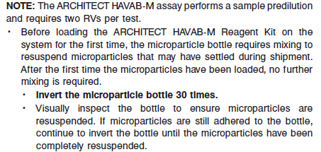

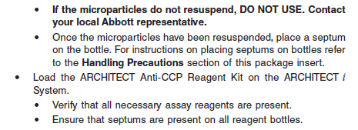

**•** Load the reagent kit on the ARCHITECT *i* System.

**•** Verify that all necessary reagents are present.

**•** Ensure that septums are present on all reagent bottles.

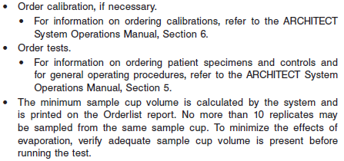

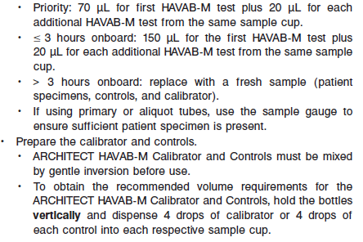

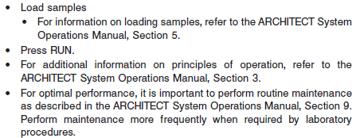

**Results**

**Calculations**

• The ARCHITECT *i* System calculates the cutoff RLU from the Calibrator mean RLU. The cutoff RLU is stored for each reagent lot calibration.

Cutoff RLU = 0.375 x (Calibrator mean RLU)

• The ARCHITECT *i* System calculates the S/CO result for each sample as follows:

S/CO = Sample RLU/Cutoff RLU

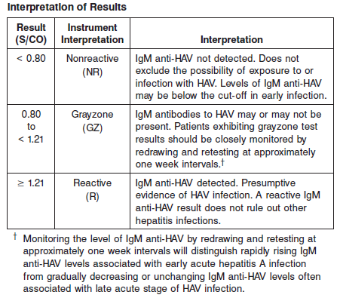

**Flags**

Some results may contain information in the Flags field. For a description of the flags that may appear in this field, refer to the ARCHITECT System Operations Manual, Section 5.

**Specific Performance Characteristics**

**Expected Values**

It is recommended that each laboratory determine its own reference range based upon its particular locale and population characteristics.

**Serum/Plasma:**

< 0.8 = Non reactive

0.8 – 1.20 = Indeterminant

> 1.21 = Reactive

**Critical Values: N/A**

**Performance Characteristics**

**Reportable Range**

See Data in the **SPECIFIC PERFORMANCE CHARACTERISTICS** section of the package insert

**Linearity**

See Data in the **SPECIFIC PERFORMANCE CHARACTERISTICS** section of the package insert

**Sensitivity/Limit of Detection (LOD)**

See Data in the **SPECIFIC PERFORMANCE CHARACTERISTICS** section of the package insert

**Dilution:**

Specimens cannot be diluted for the ARCHITECT HAVAB-M assay.

**Precision:**

The ARCHITECT HAVAB-M assay is designed to have a within-laboratory Total CV of m 10% for samples targeted to 1.20 S/CO (low positive panel) and the ARCHITECT HAVAB‑M Positive Control and to have a Total SD of m 0.10 S/CO for samples targeted to 0.80 S/CO (high negative panel). See reagent package insert for tables and more information.

#### Limitations of Procedure

* Specimens from patients who have received preparations of mouse monoclonal antibodies for diagnosis or therapy may contain human anti-mouse antibodies (HAMA). Specimens containing HAMA may produce anomalous values when tested with assay kits that employ mouse monoclonal antibodies.
* Heterophilic antibodies in human serum can react with reagent immunoglobulins, interfering with *in vitro* immunoassays. Patients routinely exposed to animals or to animal serum products can be prone to this interference and anomalous results may be observed. Additional information may be required for diagnosis.
* A reactive IgM anti-HAV result does not necessarily rule out other hepatitis infections.
* The results from this or any other diagnostic kit should be used and interpreted only in the context of the overall clinical picture. A negative test result does not exclude the possibility of exposure to hepatitis A virus. Levels of IgM anti-HAV may be below the cut-off in early infection and late acute infection.
* Specimens from individuals with Non-Hodgkin’s Lymphoma may cross-react with this assay.

**Interfering Substances**

At the concentrations listed below, bilirubin (conjugated and unconjugated), hemoglobin, total protein, and triglycerides showed less than 10% interference in the ARCHITECT HAVAB-M assay for high negative samples targeted to 0.80 S/CO and low positive samples targeted to 1.20 S/CO:

• Bilirubin < 20 mg/dL

• Hemoglobin < 500 mg/dL

• Total Protein < 12 g/dL

• Triglycerides < 3000 mg/dL

**Specificity**

The ARCHITECT HAVAB-M assay was evaluated for potential cross-reactivity for specimens from individuals with medical conditions unrelated to HAV infection and specimens containing potentially interfering substances. The data are summarized in the following table.

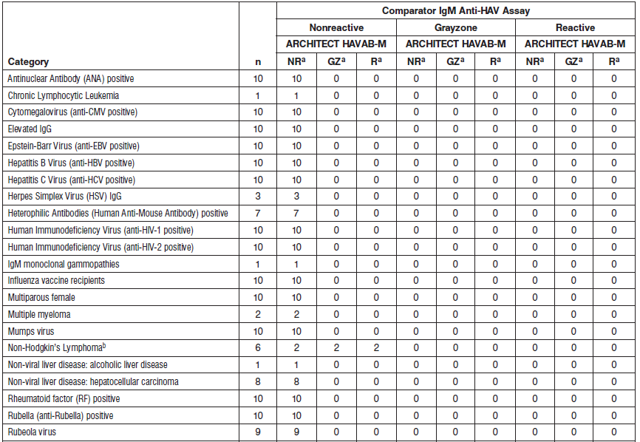

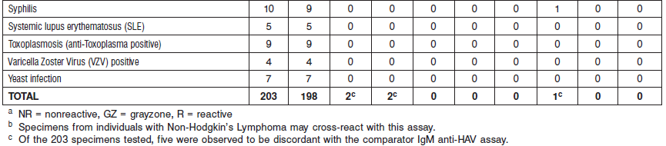

**References:**

1. ABBOTT ARCHITECT HAVAB-M package insert

Abbott Laboratories

Diagnostics Division

Abbott Park, IL 60064

Feb 2016 G6-5290/R05

1. ABBOTT ARCHITECT HAVAB-M Calibrator package insert

Abbott Laboratories

Diagnostics Division

Abbott Park, IL 60064

1. Abbott ARCHITECT Operator’s Guide

**Related Documents:**

**Attachments:**