RUSH logo for emails

**HBsAg QUALITATIVE**

**SERUM OR PLASMA**

**ABBOTT ARCHITECT**

**Intended Use**

The ARCHITECT HBsAg Qualitative assay is a chemiluminescent microparticle immunoassay (CMIA) for the qualitative detection of hepatitis B surface antigen (HBsAg) in human adult and pediatric serum and plasma and neonate serum. The assay may also be used to screen for HBV infection in pregnant women to identify neonates who are at risk for acquiring hepatitis B during the perinatal period. Assay results, in conjunction with other laboratory results and clinical information, may be used to provide presumptive evidence of infection with the hepatitis B virus (HBV) (state of infection or associated disease not determined) in persons with signs and symptoms of hepatitis and in persons at risk for hepatitis B infection.

**Not intended for use in screening blood, plasma, or tissue donors.**

**Clinical Significance**

The causative agent of serum hepatitis is hepatitis B virus (HBV) which is an enveloped DNA virus. During infection, HBV produces an excess of hepatitis B surface antigen (HBsAg), also known as Australia antigen, which can be detected in the blood of infected individuals. It is responsible for binding the virus to the liver cell and is the target structure of neutralizing antibodies. HBsAg is the first serological marker after infection with HBV, appearing one to ten weeks after exposure and two to eight weeks before the onset of clinical symptoms. HBsAg persists during this acute phase and clears late in the convalescence period. Failure to clear HBsAg within six months indicates a chronic HBsAg carrier state. HBsAg assays are used to identify persons infected with HBV and to monitor the status of infected individuals in combination with other hepatitis B serological markers. In most countries, testing for HBsAg is part of the antenatal screening program to identify HBV infected mothers and to prevent perinatal HBV infection by subsequent immunization. Specimens nonreactive by ARCHITECT HBsAg Qualitative are considered negative for HBsAg. A reactive specimen must be retested in duplicate by ARCHITECT HBsAg Qualitative to determine whether it is repeatedly reactive. Specimens found to be repeatedly reactive by the ARCHITECT HBsAg Qualitative assay should be confirmed using the ARCHITECT HBsAg Qualitative Confirmatory (4P54) assay, a neutralization procedure utilizing human anti-HBs. If the specimen is neutralized, the specimen is considered confirmed positive for HBsAg. It is recommended that confirmatory testing be performed before disclosing HBsAg status.

**Principle**

The ARCHITECT HBsAg Qualitative assay is a one-step immunoassay for the qualitative detection of HBsAg in human serum and plasma using CMIA technology, with flexible assay protocols, referred to as Chemiflex. (Note: Ancillary Wash Buffer is added in a second incubation step so the assay files perform a two-step assay.) In the ARCHITECT HBsAg Qualitative assay, sample, anti-HBs coated paramagnetic microparticles, and anti-HBs acridinium-labeled conjugate are combined to create a reaction mixture. HBsAg present in the sample binds to the anti-HBs coated microparticles and to the anti-HBs acridinium-labeled conjugate. After washing, ancillary wash buffer is added to the reaction mixture. Following another wash cycle, pre-trigger and trigger solutions are added to the reaction mixture. The resulting chemiluminescent reaction is measured as relative light units (RLUs). A

direct relationship exists between the amount of HBsAg in the sample and the RLUs detected by the ARCHITECT *i* System optics.

The presence or absence of HBsAg in the sample is determined by comparing the chemiluminescent signal in the reaction to the cutoff signal determined from an active calibration. If the chemiluminescent signal in the specimen is greater than or equal to the cutoff signal, the sample is considered reactive for HBsAg.

For additional information on system and assay technology, refer to the ARCHITECT System Operations Manual, Section 3.

**Specimen Collection and Handling**

**Suitable Specimens**

The specimen collection tubes listed below were verified for use with the ARCHITECT HBsAg Qualitative assay. Other specimen collection tubes have not been tested with this assay.

**•** Human serum (including serum collected in serum separator tubes)

**•** Human plasma collected in lithium heparin (including separator tubes), dipotassium EDTA, tripotassium EDTA, or sodium heparin

**•** Performance has not been established for the use of cadaveric specimens or the use of body fluids other than human serum and plasma.

**•** Liquid anticoagulants may have a dilution effect resulting in lower S/CO values for individual patient specimens.

**•** As specimens from heparinized patients may be partially coagulated and erroneous results could occur due to the presence of fibrin, draw the specimen prior to heparin therapy.

Do not use specimens with the following conditions:

• heat-inactivated

• pooled

• grossly hemolyzed

• obvious microbial contamination

**Specimen Storage**

Specimens may be stored on or off the clot, red blood cells, or separator gel for

**•** up to 24 hours at room temperature (15-30°C) or

**•** up to 6 days at 2-8°C.

**•** If testing will be delayed more than 6 days, remove serum or plasma from the clot, red blood cells, or separator gel and store at -20°C or colder.

**•** Avoid more than 3 freeze/thaw cycles.

**•** Lithium heparin tube type may demonstrate higher S/CO values for low positive specimens after freeze/thaw.

**NOTE:** Stored specimens must be inspected for particulates. If present, mix and centrifuge the specimen to remove particulates prior to testing.

**Materials and Equipment Required**

**TEST INSTRUMENT**: Abbott ARCHITECT System

**MATERIALS PROVIDED**

4P53 ARCHITECT HBsAg Qualitative Reagent Kit

**MATERIALS REQUIRED BUT NOT PROVIDED**

**•** ARCHITECT *i* System

**•** ARCHITECT HBsAg Assay file, may be obtained from:

**•** ARCHITECT *i* System e-Assay CD-ROM found on www.abbottdiagnostics.com

**•** ARCHITECT *i* System Assay CD-ROM

**•** 4P53-01 ARCHITECT HBsAg Qualitative Calibrators

**•** 4P53-10 ARCHITECT HBsAg Qualitative Controls (or other control material)

**•** ARCHITECT *i* Pretrigger

**•** ARCHITECT *i* Trigger

**•** ARCHITECT *i i* Wash Buffer

**•** ARCHITECT *i* Reaction Vessels

**•** ARCHITECT *i* Sample Cups

**•** ARCHITECT *i* Septums

**•** ARCHITECT *i* Replacement Caps

**•** Pipettes or pipette tips (optional) to deliver the specified volumes.

**Reagent Handling and Storage:**

***CAUTION*:**

* For in vitro diagnostic use.

**CAUTION:** This product requires the handling of human specimens.

It is recommended that all human sourced materials be considered

potentially infectious and be handled in accordance with the OSHA

Standard on Bloodborne Pathogens. Biosafety Level 2 or other appropriate biosafety practices should be used for materials that contain or are suspected of containing infectious agents.

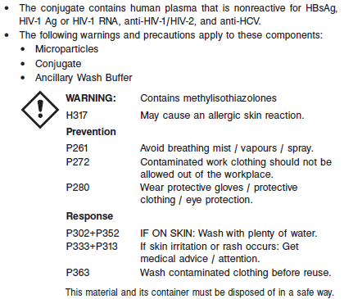

**Reagent Handling**

* Do not use reagent kits beyond the expiration date.
* **Do not pool reagents within a kit or between reagent kits.**
* Before loading the ARCHITECT Reagent Kit on the system for the first time, the microparticle bottle requires mixing to resuspend microparticles that have settled during shipment.
* **Septums MUST be used to prevent reagent evaporation and contamination and to ensure reagent integrity. Reliability of assay results cannot be guaranteed if septums are not used according to the instructions in the package insert.**
* To avoid contamination, wear clean gloves when placing a septum on an uncapped reagent bottle.
* Once a septum has been placed on the reagent bottle, **do not invert the bottle** as this will result in reagent leakage and maycompromise assay results.
* Over time, residual liquids may dry on the septum surface. These are typically dried salts and have no effect on assay efficacy.
* For a detailed discussion of handling precautions during system operation, refer to the ARCHITECT System Operations Manual, Section 7.

**Reagent Storage**

* The ARCHITECT HBsAg Reagent Kit must be stored at 2-8°C in an upright position and may be used immediately after removal from 2-8°C storage.
* When stored and handled as directed, the reagents are stable until the expiration date.
* The ARCHITECT HBsAg Reagent Kit may be stored on board the ARCHITECT *i* System for a maximum of 30 days. After 30 days, the reagent kit must be discarded. For information on tracking onboard time, refer to the ARCHITECT System Operations Manual, Section 5.
* Reagents may be stored on or off the ARCHITECT *i* System. If reagents are removed from the system, store them at 2-8°C (with septums and replacement caps) in an upright position. For reagents stored off the system, it is recommended that they be stored in their original trays and boxes to ensure they remain upright. **If the microparticle bottle does** **not remain upright (with a septum installed) while in refrigerated** **storage off the system, the reagent kit must be discarded.** For information on unloading reagents, refer to the ARCHITECT System Operations Manual, Section 5.

Reagents

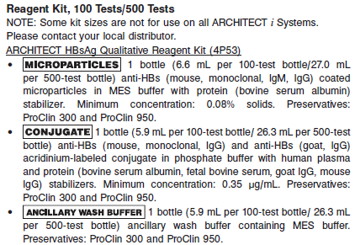

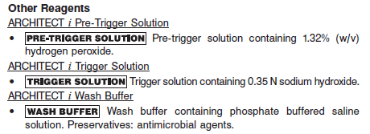

**Calibrator:** 4P53-01 ARCHITECT HBsAg Qualitative Calibrators

**Quality Control:** 4P53-10 ARCHITECT HBsAg Qualitative Controls (or other control material)

**Calibration**

**Frequency:**

Recalibration is required with each new reagent lot number.

**A new calibration is required:**

1. If quality control results do not meet acceptance criteria defined by your laboratory, patient values may be suspect. Follow the established quality control procedures for your laboratory. Recalibration may be necessary.
2. Review quality control results and acceptance criteria following a change of reagent or calibrator lot.

**Calibrator Required:** 4P53-01 ARCHITECT HBsAg Qualitative Calibrators

**Reagents:**

2 Bottles (4.0 mL each) of ARCHITECT HBsAg Qualitative Calibrators. Calibrator 1 contains inactivated purified human HBsAg (subtype *ad*) in phosphate buffer with human plasma and protein (bovine serum albumin) stabilizers. Preservatives: ProClin 300 and ProClin 950. Calibrator 2 contains recalcified human plasma. Preservatives: ProClin 950 and sodium azide.

**Calibrator Preparation:**

The calibrators are liquid ready-to-use. No preparation is required.

**Calibration Procedure:**

* To perform an ARCHITECT HBsAg Qualitative calibration, test calibrators 1 and 2 in replicates of 3. The calibrators should be priority loaded.
* A single sample of each control level must be tested to evaluate the assay calibration.
* Order controls as described in the Assay Procedure section.
* Ensure that assay control values are within the ranges specified in the control package insert.

**Troubleshooting and Overall Acceptance Criteria Failure**

See ARCHITECT Operations Manual for further calibration troubleshooting.

**Quality Control:**

Abbott recommends, refer to your laboratory standard operating procedure(s) and/or quality assurance plan for additional quality control requirements and potential corrective actions:

• At a minimum a single level of quality control are to be run every 24 hours

• If more frequent control monitoring is required, follow the established quality control procedures for your laboratory.

• If quality control results do not meet the acceptance criteria defined by your laboratory, patient values may be suspect. Follow the established quality control procedures for your laboratory.

Recalibration may be necessary.

• Review quality control results and acceptance criteria following a change of reagent or calibrator lot.

**Instrument Procedure**

* The ARCHITECT HBsAg assay is designed for use on the ARCHITECT *i* System.
* ARCHITECT System software version 7.00 or higher must be installed on the ARCHITECT *i* System.
* The ARCHITECT HBsAg Qualitative assay file (assay number 636) must be installed on the ARCHITECT *i* System before performing the assay.
* For detailed information on assay file installation and viewing and editing assay parameters, refer to the ARCHITECT System Operations Manual, Section 2.
* For information on printing assay parameters, refer to the ARCHITECT System Operations Manual, Section 5.
* For a detailed description of system procedures, refer to the ARCHITECT System Operations Manual.

**Assay Procedure**

For a detailed description of how to run an assay, refer to *Section 5* of the **ARCHITECT System Operations Manual**.

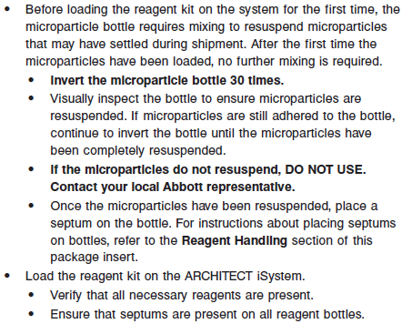

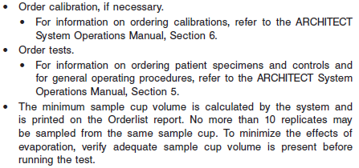

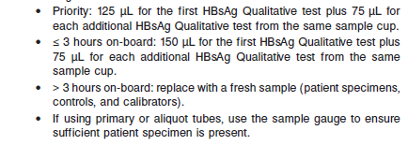

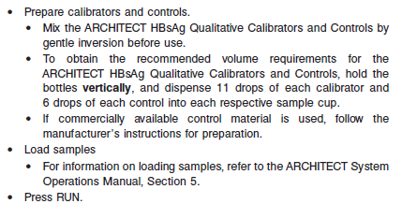

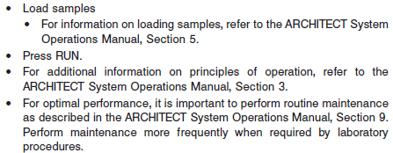

**Results**

**Calculations**

**•** The ARCHITECT *i* System calculates the result for the ARCHITECT HBsAg Qualitative assay using the ratio of the sample RLU to the cutoff RLU (S/CO) for each specimen and control.

• Cutoff RLU = (0.0575 x Calibrator 1 Mean RLU) + (0.8 x Calibrator 2 Mean RLU)

**•** S/CO = Sample RLU/Cutoff RLU

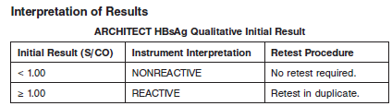

**•** A specimen with an S/CO of less than 1.00 is nonreactive; the specimen is considered negative for HBsAg.

**•** Initially reactive specimens require retesting. Specimens that contain particulate matter should be recentrifuged according to directions in the **SPECIMEN COLLECTION AND PREPARATION FOR ANALYSIS** section in the package insert.

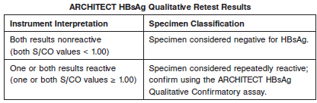

**•** Confirm repeatedly reactive specimens using the ARCHITECT HBsAg Qualitative Confirmatory assay before disclosing HBsAg status to the patient.

**Flags**

Some results may contain information in the Flags field. For a description of the flags that may appear in this field, refer to the ARCHITECT System Operations Manual, Section 5.

**Specific Performance Characteristics**

**Expected Values**

It is recommended that each laboratory determine its own reference range based upon its particular locale and population characteristics.

**Serum/Plasma:**

HBsAg Qualitative

<1.0 = Non Reactive

>1.0 = Reactive

**Critical Values: N/A**

**Performance Characteristics**

**Analytical Sensitivity (Detectable Concentration of HBsAg at the Cutoff)**

The ARCHITECT HBsAg Qualitative assay is designed to have an analytical sensitivity value of less than or equal to 0.20 ng/mL (0.036 IU/mL).

See Data in the **SPECIFIC PERFORMANCE CHARACTERISTICS** section of the package insert

**Dilution:**

Specimens cannot be diluted for the ARCHITECT HBsAg assay.

**Precision:**

The ARCHITECT HBsAg Qualitative assay is designed to have a Within-Laboratory (Total) imprecision %CV of ≤ 10% for the positive control and specimens at 1.20 S/CO (low positive panel) and 3.5 S/CO (moderate positive panel) and a Total Standard Deviation (SD) of ≤ 0.10 S/CO for specimens at 0.80 S/CO (high negative panel). See reagent package insert for tables and more information.

#### Limitations of Procedure

* Specimens from patients who have received preparations of mouse monoclonal antibodies for diagnosis or therapy may contain human anti-mouse antibodies (HAMA). Specimens containing HAMA may produce anomalous values when tested with assay kits that employ mouse monoclonal antibodies.
* Heterophilic antibodies in human serum can react with reagent immunoglobulins, interfering with *in vitro* immunoassays. Patients routinely exposed to animals or to animal serum products can be prone to this interference and anomalous results may be observed. Additional information may be required for diagnosis.
* The effectiveness of the ARCHITECT HBsAg Qualitative assay for use in screening blood, plasma, or tissue donors has not been established.
* Assay performance characteristics have not been established when the ARCHITECT HBsAg Qualitative assay is used in conjunction with other manufacturers’ assays for specific HBV markers. Users are responsible for establishing their own performance characteristics.
* Current methods for the detection of hepatitis B surface antigen may not detect all potentially infected individuals. A nonreactive test result does not exclude the possibility of exposure to or infection with hepatitis B virus. A nonreactive test result in individuals with prior exposure to hepatitis B may be due to antigen levels below the detection limit of this assay or lack of antigen reactivity to the antibodies in this assay.
* If the ARCHITECT HBsAg Qualitative results are inconsistent with clinical evidence, additional testing is suggested to confirm the result.
* For diagnostic purposes, results should be used in conjunction with patient history and other hepatitis markers for diagnosis of acute and chronic infection.
* Results obtained with the ARCHITECT HBsAg Qualitative assay may not be used interchangeably with values obtained with different manufacturers’ assay methods.
* A reactive HBsAg result does not exclude co-infection by another hepatitis virus.

**Interfering Substances**

At the concentrations listed below, the ARCHITECT HBsAg Qualitative assay showed interference from unconjugated bilirubin, conjugated bilirubin, protein, hemoglobin, and triglycerides for high negative samples (targeted to an S/CO of 0.80) of ≤ +0.15 S/CO and low positive samples (targeted to an S/CO of 1.20) of ≥ -15%.

Interferent Interferent Concentration

**•** Unconjugated bilirubin ≤ 20 mg/dL

**•** Conjugated bilirubin ≤ 20 mg/dL

**•** Triglycerides ≤ 3000 mg/dL

• Protein ≤ 12 g/dL

• Hemoglobin ≤ 500 mg/dL

**Specificity**

The ARCHITECT HBsAg Qualitative assay was evaluated for potential cross-reactivity for specimens from individuals with medical conditions unrelated to HBV infection.

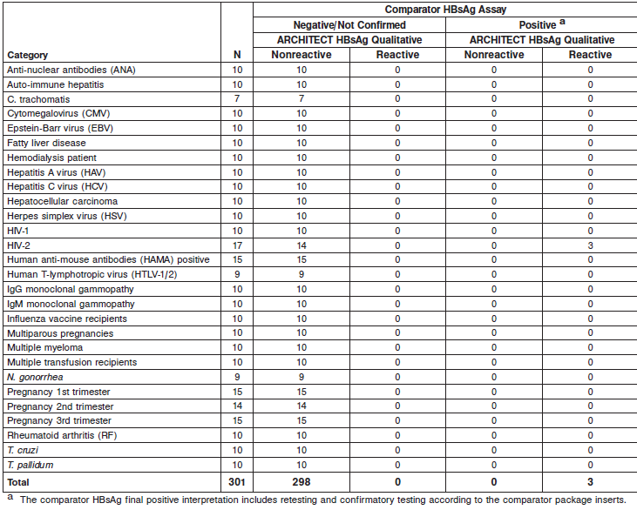

**See the reagent package insert for more information**

**References:**

1. ABBOTT ARCHITECT HBsAg package insert

Abbott Laboratories

Diagnostics Division

Abbott Park, IL 60064

July 2013 G4-2850/R03

1. ABBOTT ARCHITECT HBsAg Calibrator package insert

Abbott Laboratories

Diagnostics Division

Abbott Park, IL 60064

1. Abbott ARCHITECT Operator’s Guide

**Related Documents:**

**Attachments:**