RUSH logo for emails

**ANTI-HCV**

**SERUM OR PLASMA**

**ABBOTT ARCHITECT**

**Intended Use**

The ARCHITECT Anti-HCV assay is a chemiluminescent microparticle immunoassay (CMIA) for the qualitative detection of immunoglobulin G (IgG) and immunoglobulin M (IgM) antibodies to hepatitis C virus (anti‑HCV) in human adult serum and plasma (potassium EDTA, lithium heparin, and sodium heparin). Assay results, in conjunction with other laboratory results and clinical information, may be used to provide presumptive evidence of infection with HCV (state of infection or associated disease not determined) in persons with signs and symptoms of hepatitis and in persons at risk for hepatitis C infection.

**Warning: Not intended for use in screening blood, plasma, or tissue donors.** The effectiveness of ARCHITECT Anti-HCV for use in screeningblood, plasma, or tissue donors has not been established. Assay performance characteristics have not been established for immunocompromised or immunosuppressed patients. The user is responsible for establishing their own assay performance characteristics in these populations.

**Clinical Significance**

The ARCHITECT Anti-HCV assay is for the detection of antibodies to the hepatitis C virus (HCV). Chemiluminescent immunoassays are a variation of the enzyme immunoassay (EIA) principle. Solid phase EIAs, first described in the early 1970s, use antigens and/or antibodies coated on a surface to bind complementary analytes. The bound analyte is detected by a series of antigen-antibody reactions. EIAs are available to identify antigens and antibodies related to viral hepatitis infection. In the

ARCHITECT Anti-HCV final reaction, bound acridinylated conjugates are used to generate a chemiluminescent signal. HCV is a bloodborne virus. Serological studies employing EIAs for detection of antibodies to recombinant antigens of HCV have established HCV as the cause of most bloodborne as well as community-acquired non‑A, non‑B hepatitis. The presence of anti-HCV indicates that an individual may have been infected with HCV, may harbor infectious HCV, and/or may be capable of transmitting HCV infection. Although the majority of infected individuals may be asymptomatic, HCV infection may develop into chronic hepatitis, cirrhosis, and/or increased risk of hepatocellular carcinoma. The implementation of blood donation screening for anti-HCV by EIAs has led to a marked decline in the risk of transfusion-transmitted hepatitis.

ARCHITECT Anti-HCV has been designed to detect antibodies to putative structural and nonstructural proteins of the HCV genome. The relationship between the recombinant HCV proteins in ARCHITECT Anti-HCV and the putative structural and nonstructural proteins of the HCV genome is depicted below.

**•** HCr43: The HCr43 protein is expressed in *Escherichia coli* (*E. coli*) and is composed of two noncontiguous coding regions of the HCV genome sequence. The first region represents amino acids 1192 to 1457 (33c) of the HCV sequence. The second of the two regions represents amino acids 1 to 150 (core) of the HCV sequence. Because of the similarity of the genomic organization of the flaviviruses, it is suggested that the first sequence is from the NS3 coding region and the second sequence is from the core coding region of HCV.

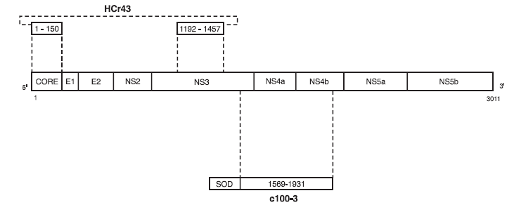

**•** c100-3: The c100-3 antigen is a recombinant HCV protein expressed in *Saccharomyces cerevisiae* (yeast). The genomic organization of flaviviruses suggests that the cloned sequence is contained within the putative nonstructural (NS3 and NS4) regions of HCV. The c100-3 protein is a chimeric fusion protein with 154 amino acids of human superoxide dismutase (hSOD), five linker amino acids, amino acids number 1569 to 1931 of the HCV polyprotein, and the additional five amino acid linker at the carboxyl terminus. Hepatitis C antigens HCr43 and c100-3 are prepared under US license by Chiron Corporation under a shared manufacturing agreement. The ARCHITECT Anti-HCV assay is manufactured under contract agreement from Ortho Diagnostic Systems and Chiron Corporation.

**Principle**

The ARCHITECT Anti-HCV assay is a two-step immunoassay for the qualitative detection of anti-HCV in human serum and plasma using CMIA technology with flexible assay protocols, referred to as Chemiflex. In the first step, sample, recombinant HCV antigen coated paramagnetic microparticles, and assay diluent are combined. Anti-HCV present in the sample binds to the HCV coated microparticles. After washing, antihuman IgG/IgM acridinium-labeled conjugate is added in the second step. Following another wash cycle, pre-trigger and trigger solutions are added to the reaction mixture. The resulting chemiluminescent reaction is measured as relative light units (RLUs). A relationship exists between the amount of anti-HCV in the sample and the RLUs detected by the ARCHITECT *i* optical system.

The presence or absence of anti-HCV in the sample is determined by comparing the chemiluminescent signal in the reaction to the cutoff signal determined from an active ARCHITECT Anti-HCV calibration curve. If the chemiluminescent signal of the sample is greater than or equal to the cutoff signal, the sample is considered reactive for anti-HCV.

For additional information on system and assay technology, refer to the

ARCHITECT System Operations Manual, Section 3.

**Specimen Collection and Handling**

**Suitable Specimens**

Verified Specimen types:

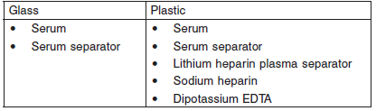

Do not use specimens with the following conditions:

• heat-inactivated

• pooled

• grossly hemolyzed

• obvious microbial contamination

• Performance has not been established for the use of cadaveric specimens or the use of body fluids other than human serum and plasma.

**Specimen Storage**

Specimens may be stored on or off the clot, red blood cells, or separator gel for

**•** up to 3 days at room temperature (study performed at 21°C to 22°C) or

**•** up to 7 days at 2-8°C.

**•** If testing will be delayed more than 3 days for specimens stored at room temperature or more than 7 days for specimens stored at 2-8°C, remove serum or plasma from the clot, red blood cells, or separator gel and store at -20°C or colder.

**•** Avoid more than three freeze/thaw cycles.

**NOTE:** Stored specimens must be inspected for particulates. If present, mix and centrifuge the specimen to remove particulates prior to testing.

**Materials and Equipment Required**

**TEST INSTRUMENT**: Abbott ARCHITECT System

**MATERIALS PROVIDED**

1L79 ARCHITECT Anti-HCV Reagent Kit

**MATERIALS REQUIRED BUT NOT PROVIDED**

**•** ARCHITECT *i* System

**•** ARCHITECT Anti-HCV Assay file, may be obtained from:

**•** ARCHITECT *i* System e-Assay CD-ROM found on www.abbottdiagnostics.com

**•** ARCHITECT *i* System Assay CD-ROM

**•** 1L79-01 ARCHITECT Anti-HCV Calibrator

**•** 1L79-10 ARCHITECT Anti-HCV Controls

**•** ARCHITECT *i* Pretrigger

**•** ARCHITECT *i* Trigger

**•** ARCHITECT *i i* Wash Buffer

**•** ARCHITECT *i* Reaction Vessels

**•** ARCHITECT *i* Sample Cups

**•** ARCHITECT *i* Septums

**•** ARCHITECT *i* Replacement Caps

**•** Pipettes or pipette tips (optional) to deliver the specified volumes.

**Reagent Handling and Storage:**

***CAUTION*:**

* For in vitro diagnostic use.

**CAUTION:** This product requires the handling of human specimens.

It is recommended that all human sourced materials be considered

potentially infectious and be handled in accordance with the OSHA

Standard on Bloodborne Pathogens. Biosafety Level 2 or other appropriate biosafety practices should be used for materials that contain or are suspected of containing infectious agents.

**Reagent Handling**

* Do not use reagent kits beyond the expiration date.
* **Do not pool reagents within a kit or between reagent kits.**
* Before loading the reagent kit on the system for the first time, the microparticle bottle requires mixing to resuspend microparticles that have settled during shipment.
* **Septums MUST be used to prevent reagent evaporation and contamination and to ensure reagent integrity. Reliability of assay results cannot be guaranteed if septums are not used according to the instructions in the package insert.**
* To avoid contamination, wear clean gloves when placing a septum on an uncapped reagent bottle.
* Once a septum has been placed on the reagent bottle, **do not invert the bottle** as this will result in reagent leakage and maycompromise assay results.
* Over time, residual liquids may dry on the septum surface. These are typically dried salts and have no effect on assay efficacy.
* For a detailed discussion of handling precautions during system operation, refer to the ARCHITECT System Operations Manual, Section 7.

**Reagent Storage**

**•** The ARCHITECT Anti-HCV Reagent Kit must be stored at 2‑8°C in an upright position and may be used immediately after removal from 2‑8°C storage.

**•** When stored and handled as directed, the reagents are stable until the expiration date.

**•** The ARCHITECT Anti-HCV Reagent Kit may be stored on board the ARCHITECT *i* System for a maximum of 30 days. After 30 days, the reagent kit must be discarded. For information on tracking onboard time, refer to the ARCHITECT System Operations Manual, Section 5.

**•** Reagents may be stored on or off the ARCHITECT *i* System. If reagents are removed from the system, store them at 2-8°C (with septums and replacement caps) in an upright position. For reagents stored off the system, it is recommended that they be stored in their original trays and boxes to ensure they remain upright. **If the microparticle bottle does** **not remain upright (with a septum installed) while in refrigerated** **storage off the system, the reagent kit must be discarded.** For information on unloading reagents, refer to the ARCHITECT System Operations Manual, Section 5.

Reagents

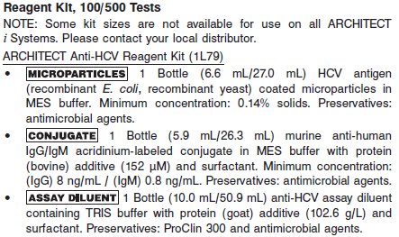

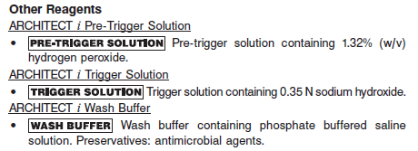

**Calibrator:** 1L79-01 ARCHITECT Anti-HCV Calibrator

**Quality Control:** 1L79-10 ARCHITECT Anti-HCV Controls or other control material

**Calibration**

**Frequency:**

Recalibration is required with each new reagent lot number.

**A new calibration is required:**

1. If quality control results do not meet acceptance criteria defined by your laboratory, patient values may be suspect. Follow the established quality control procedures for your laboratory. Recalibration may be necessary.
2. Review quality control results and acceptance criteria following a change of reagent or calibrator lot.

**Calibrator Required:** 1L79-01 ARCHITECT Anti-HCV Calibrator

The ARCHITECT *i* System calculates the cutoff Relative Light Units (RLU) from the mean chemiluminescent signal of three Anti-HCV Calibrator 1 replicates. The acceptability of the calibration is assessed against a parameter. If the calibration is acceptable, the cutoff RLU is calculated by multiplying the Anti-HCV Calibrator 1 mean RLU by 0.074.

Cutoff RLU = Calibrator 1 Mean RLU x 0.074

The acceptable calibration is stored by the ARCHITECT *i* System for use with any reagent kit of that lot. The calibration should be used in conjunction with control ranges to determine the validity of the calibration.

**Reagents:**

1 Bottle (4 mL) ARCHITECT Anti-HCV Calibrator 1 is recalcified, heat-inactivated anti-HCV positive human plasma in recalcified anti-HCV negative human plasma. Calibrator 1 is green and contains Acid Yellow No. 23 and Acid Blue No. 9 dyes. Preservative: sodium azide.

**Calibrator Preparation:**

The calibrator is liquid ready-to-use. No preparation is required.

**Calibration Procedure:**

To perform a calibration, test ARCHITECT Anti-HCV Calibrators 1 in triplicate. The calibrators should be priority loaded.

**•** A single sample of each control level must be tested to evaluate the assay calibration.

**•** Order controls as described above.

**•** Ensure that assay control values are within the concentration ranges specified in the control package insert.

**Troubleshooting and Overall Acceptance Criteria Failure**

See ARCHITECT Operations Manual for further calibration troubleshooting.

**Quality Control:**

The ARCHITECT Anti-HCV Controls are in a serum matrix made from recalcified plasma.

Abbott recommends, refer to your laboratory standard operating procedure(s) and/or quality assurance plan for additional quality control requirements and potential corrective actions:

• At a minimum a single level of quality control are to be run every 24 hours

• If more frequent control monitoring is required, follow the established quality control procedures for your laboratory.

• If quality control results do not meet the acceptance criteria defined by your laboratory, patient values may be suspect. Follow the established quality control procedures for your laboratory.

Recalibration may be necessary.

• Review quality control results and acceptance criteria following a change of reagent or calibrator lot.

**Instrument Procedure**

* The ARCHITECT Anti-HCV assay is designed for use on the ARCHITECT *i* System.
* The ARCHITECT Anti-HCV assay file must be installed on the ARCHITECT *i* System from an ARCHITECT *i* System Assay CD-ROM prior to performing the assay. For detailed information on assay file installation and on viewing and editing assay parameters, refer to the ARCHITECT System Operations Manual, Section 2.
* For detailed information on assay file installation and viewing and editing assay parameters, refer to the ARCHITECT System Operations Manual, Section 2.
* For information on printing assay parameters, refer to the ARCHITECT System Operations Manual, Section 5.
* For a detailed description of system procedures, refer to the ARCHITECT System Operations Manual.

**Assay Procedure**

For a detailed description of how to run an assay, refer to *Section 5* of the **ARCHITECT System Operations Manual**.

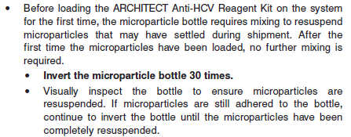

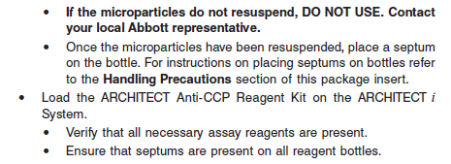

**•** Load the reagent kit on the ARCHITECT *i* System.

**•** Verify that all necessary reagents are present.

**•** Ensure that septums are present on all reagent bottles.

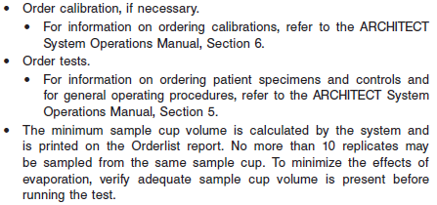

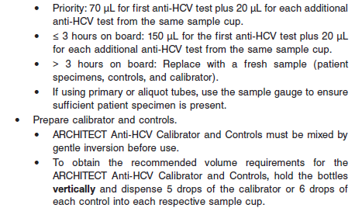

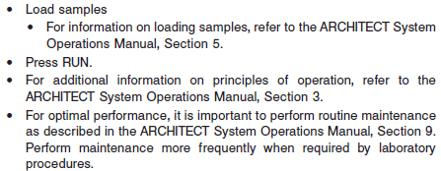

**Results**

**Calculation**

The ARCHITECT *i* System calculates the cutoff RLU from the mean chemiluminescent signal of three Anti-HCV Calibrator 1 replicates and stores the result. The cutoff RLU is determined by multiplying the Anti‑HCV Calibrator 1 mean RLU by 0.074. Cutoff RLU = Calibrator 1 Mean RLU x 0.074

**•** The ARCHITECT *i* System calculates a result based on the ratio of the sample RLU to the cutoff RLU (S/CO) for each specimen and control.

S/CO = Sample RLU/Cutoff RLU ratio

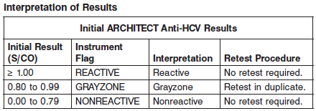

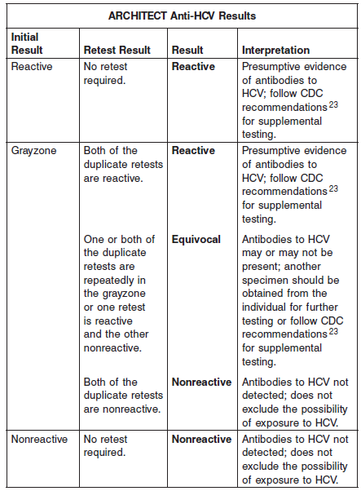

**Flags**

Some results may contain information in the Flags field. For a description of the flags that may appear in this field, refer to the ARCHITECT System Operations Manual, Section 5.

**Specific Performance Characteristics**

**Expected Values**

It is recommended that each laboratory determine its own reference range based upon its particular locale and population characteristics.

**Serum/Plasma:**

> 1.0 = Reactive

0.9 – 0.99 = Indeterminant

0.0 – 0.79 = Non Reactive

**Critical Values: N/A**

**Performance Characteristics**

**Reportable Range**

See Data in the **SPECIFIC PERFORMANCE CHARACTERISTICS** section of the package insert

**Linearity**

See Data in the **SPECIFIC PERFORMANCE CHARACTERISTICS** section of the package insert

**Sensitivity/Limit of Detection (LOD)**

See Data in the **SPECIFIC PERFORMANCE CHARACTERISTICS** section of the package insert

**Dilution:**

Specimens cannot be diluted for the ARCHITECT Anti-HCV assay.

**Precision:**

The ARCHITECT Anti-HCV assay is designed to have a Total CV of ≤ 10% for the ARCHITECT Anti-HCV Positive Control, a high negative panel targeted to 0.80 S/CO, and a low positive panel targeted to 1.20 S/CO. See reagent package insert for tables and more information.

#### Limitations of Procedure

**•** Current methods for the detection of antibodies to HCV may not detect all infected individuals. A nonreactive test result does not exclude the possibility of exposure to HCV.

**•** Nonreactive test results in individuals with prior exposure to HCV may be due to antibody levels being below the detection limit of this assay or to lack of antibody reactivity to the recombinant antigens used in this assay.

**•** Immunocompromised patients who have HCV may produce levels of antibody below the sensitivity of this assay and may not be detected as positive.

**•** The affinity or avidity differences of anti-human IgG/IgM for anti-HCV have not been determined with this assay. Therefore, there may not be a demonstration of a significant increase in antibody level between acute and convalescent specimens for a patient in the late acute stage of infection when IgM antibodies are decreasing.

**•** Results obtained with the ARCHITECT Anti-HCV assay may not be used interchangeably with values obtained with different manufacturers’ assay methods.

**•** Assay performance characteristics have not been established for newborns, infants, children, or populations of immunocompromised or immunosuppressed patients.

**•** Heterophilic antibodies in human serum can react with reagent immunoglobulins, interfering with *in vitro* immunoassays. 24 Patients routinely exposed to animals or to animal serum products can be prone to this interference and anomalous values may be observed. Additional information may be required for diagnosis.

**•** A reactive anti-HCV result does not exclude co-infection by another hepatitis virus.

**•** The magnitude of an ARCHITECT Anti-HCV assay result cannot be correlated to an end point titer.

**Interfering Substances**

At the concentrations listed below, bilirubin (conjugated and unconjugated), hemoglobin, total protein, and triglycerides showed less than 10% interference in the ARCHITECT Anti-HCV assay for high negative samples (S/CO range: 0.60 to 0.99) and low positive samples (S/CO range: 1.00 to 1.40):

**•** Bilirubin ≤ 20 mg/dL

**•** Hemoglobin ≤ 500 mg/dL

**•** Total Protein ≤ 12 g/dL

**•** Triglycerides ≤ 3000 mg/dL

**Specificity**

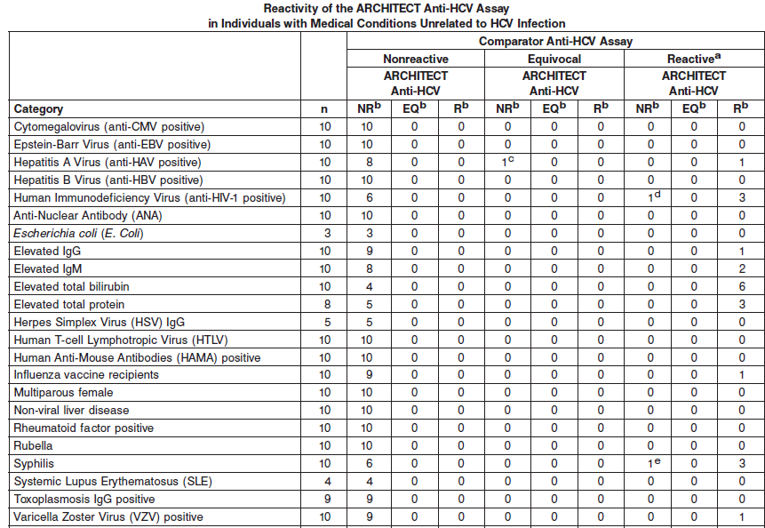

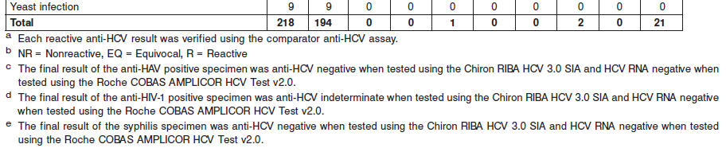

**References:**

1. ABBOTT ARCHITECT Anti-HCV package insert

Abbott Laboratories

Diagnostics Division

Abbott Park, IL 60064

Nov 2015 G6-2769/R06

1. ABBOTT ARCHITECT Anti-HCV Calibrator package insert

Abbott Laboratories

Diagnostics Division

Abbott Park, IL 60064

1. Abbott ARCHITECT Operator’s Guide

**Related Documents:**

**Attachments:**