RUSH logo for emails

**HIV AG/AB COMBO**

**SERUM OR PLASMA**

**ABBOTT ARCHITECT**

**Intended Use**

The ARCHITECT HIV Ag/Ab Combo assay is a chemiluminescent microparticle immunoassay (CMIA) for the simultaneous qualitative detection of human immunodeficiency virus (HIV) p24 antigen and antibodies to HIV type 1 (HIV‑1 group M and group O) and/or type 2 (HIV-2) in human serum and plasma (EDTA and heparin). The ARCHITECT HIV Ag/Ab Combo assay is intended to be used as an aid in the diagnosis of HIV-1/HIV-2 infection, including acute or primary HIV-1 infection. The assay may also be used as an aid in the diagnosis of HIV-1/HIV-2 infection in pediatric subjects (*i.e.*, children as young as two years of age) and in pregnant women.

An ARCHITECT HIV Ag/Ab Combo reactive result does not distinguish between the detection of HIV-1 p24 antigen, HIV-1 antibody, or HIV-2 antibody. **The ARCHITECT HIV Ag/Ab Combo assay is not intended for use in** **screening blood or plasma donors.** The effectiveness of ARCHITECT

HIV Ag/Ab Combo for use in screening blood or plasma donors has not been established. However, this assay can be used as a blood donor screening assay in urgent situations where traditional licensed blood donor screening tests are unavailable or their use is impractical.

**Clinical Significance**

Acquired immunodeficiency syndrome (AIDS) is caused by two types of human immunodeficiency viruses, collectively designated HIV. HIV is transmitted by sexual contact, exposure to blood or blood products, and prenatal or perinatal infection of a fetus or newborn. Antibodies against HIV are nearly always detected in AIDS patients and HIV‑infected asymptomatic individuals. Phylogenetic analysis classifies HIV type 1 (HIV-1) into groups M (major), N (non-M, non-O), O (outlier), and P. HIV‑1 group M is composed of genetic subtypes (A-D, F-H, J, and K) and circulating recombinant forms (CRFs). Group M viruses have spread throughout the world to cause the global AIDS pandemic. However, the geographic distribution and regional predominance of HIV‑1 subtypes and CRFs vary. HIV‑1 subtype B is the predominant subtype in North America, South America, Europe, Japan, and Australia, although other subtypes and CRFs are present in these regions as well. A significant percentage of new HIV-1 infections in Europe are caused by non-B subtype strains. All subtypes and many recombinant strains exist in Africa. In Asia, subtypes B and C, and CRF01_AE (formerly called subtype E) are found. HIV-1 groups N, O, and P are endemic to west central Africa and are relatively rare. However, group O infections have been identified in Europe and the USA.

HIV type 2 (HIV-2) is similar to HIV-1 in its structural morphology, genomic organization, cell tropism, *in vitro* cytopathogenicity, transmission routes, and ability to cause AIDS. HIV-2 is endemic to West Africa, but HIV-2 infections have been identified in North America and Europe at a low frequency compared to HIV-1.

Early after infection with HIV-1, but prior to seroconversion, HIV-1 core protein, p24 antigen, may be detected in HIV-1‑infected individuals. ARCHITECT HIV Ag/Ab Combo uses anti-HIV-1 p24 antibodies as reagents to detect HIV-1 p24 antigen, thereby decreasing the window period and improving early detection of HIV infection.

The key immunogenic protein for serodetection of HIV infection is the viral transmembrane protein (TMP). Antibodies against the TMP are consistently among the first to appear during seroconversion of HIV-infected individuals and remain relatively strong throughout the asymptomatic and symptomatic stages of HIV infection. ARCHITECT HIV Ag/Ab Combo detects antibodies to HIV-1 groups M and O, and HIV-2 through the use of five recombinant proteins and two synthetic peptides derived from native TMP sequences of HIV-1 groups M and O, and HIV-2.

**Principle**

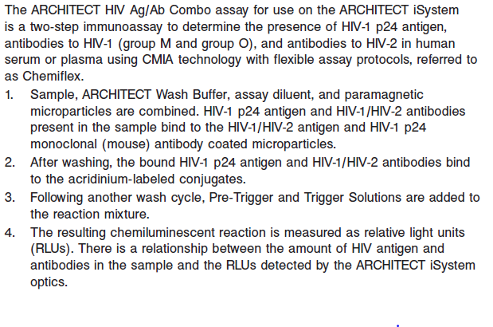

The presence or absence of HIV-1 p24 antigen or HIV-1/HIV-2 antibodies in the specimen is determined by comparing the chemiluminescent signal in the reaction to the cutoff signal determined from an ARCHITECT HIV Ag/Ab Combo calibration. Specimens with signal to cutoff (S/CO) values greater than or equal to 1.00 are considered reactive for HIV-1 p24 antigen or HIV-1/HIV-2 antibodies.

Specimens with S/CO values less than 1.00 are considered nonreactive for HIV-1 p24 antigen and HIV-1/ HIV-2 antibodies. Specimens that are initially reactive in the ARCHITECT HIV Ag/Ab Combo assay

should be retested in duplicate. Repeat reactivity is highly predictive of the presence of HIV-1 p24 antigen and/or HIV-1/HIV-2 antibodies. However, as with all immunoassays, the ARCHITECT HIV Ag/Ab Combo assay may yield nonspecific reactions due to other causes, particularly when testing in low prevalence populations. A repeatedly reactive specimen should be investigated further with

supplemental confirmatory HIV-specific tests, such as immunoblots, antigen tests, and HIV nucleic acid tests. Supplemental testing of repeatedly reactive specimens obtained from individuals with HIV infection usually confirms the presence of HIV antibodies, HIV antigen, or HIV nucleic acid. A full differential diagnostic work-up for the diagnosis of AIDS and AIDS-related conditions

includes an examination of the patient’s immune status and a clinical history. For additional information on system and assay technology, refer to the ARCHITECT System Operations Manual, Section 3.

**Specimen Collection and Handling**

**Suitable Specimens**

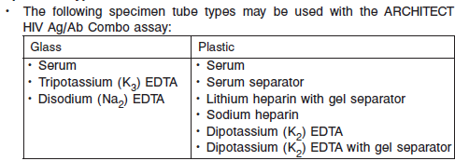

Although heparin tube types will demonstrate higher S/CO values than other tube types for specimens containing HIV antibody, there is no change to the interpretation of results. Specimens that do not contain HIV antibody do not demonstrate higher S/CO values in heparin tube types.

• For blood screening in urgent situations, do not use samples collected directly from whole blood bags as they contain anticoagulants other than EDTA and heparin.

• Liquid anticoagulants may have a dilution effect resulting in lower S/CO values for individual patient specimens.

Do not use specimens with the following conditions:

• heat-inactivated

• pooled

• grossly hemolyzed

• obvious microbial contamination

• Performance has not been established for the use of cadaveric specimens or the use of body fluids other than human serum and plasma.

• **For accurate results, serum and plasma specimens should be free of fibrin, red blood cells, and other particulate matter.** Serum specimensfrom patients receiving anticoagulant or thrombolytic therapy may containfibrin due to incomplete clot formation.

**Specimen Storage**

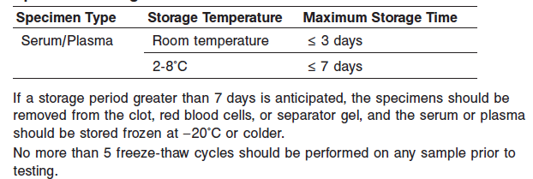

**NOTE:** Stored specimens must be inspected for particulates. If present, mix and centrifuge the specimen to remove particulates prior to testing.

**Materials and Equipment Required**

**TEST INSTRUMENT**: Abbott ARCHITECT System

**MATERIALS PROVIDED**

2P36 ARCHITECT HIV Ag/Ab Combo Reagent Kit

**MATERIALS REQUIRED BUT NOT PROVIDED**

**•** ARCHITECT *i* System

**•** ARCHITECT HIV Ag/Ab Combo Assay file, may be obtained from:

**•** ARCHITECT *i* System e-Assay CD-ROM found on www.abbottdiagnostics.com

**•** ARCHITECT *i* System Assay CD-ROM

**•** 2P36-01 ARCHITECT HIV Ag/Ab Combo Calibrator

• 2P36-10 ARCHITECT HIV Ag/Ab Combo Controls (or other control material)

**•** ARCHITECT *i* Pretrigger

**•** ARCHITECT *i* Trigger

**•** ARCHITECT *i i* Wash Buffer

**•** ARCHITECT *i* Reaction Vessels

**•** ARCHITECT *i* Sample Cups

**•** ARCHITECT *i* Septums

**•** ARCHITECT *i* Replacement Caps

**•** Pipettes or pipette tips (optional) to deliver the specified volumes.

**Reagent Handling and Storage:**

***CAUTION*:**

* For in vitro diagnostic use.

**CAUTION:** This product requires the handling of human specimens.

It is recommended that all human sourced materials be considered

potentially infectious and be handled in accordance with the OSHA

Standard on Bloodborne Pathogens. Biosafety Level 2 or other appropriate biosafety practices should be used for materials that contain or are suspected of containing infectious agents.

• This product contains sodium azide; for a specific listing, refer to the **REAGENTS** section. Contact with acids liberates very toxic gas. This material and its container must be disposed of in a safe way.

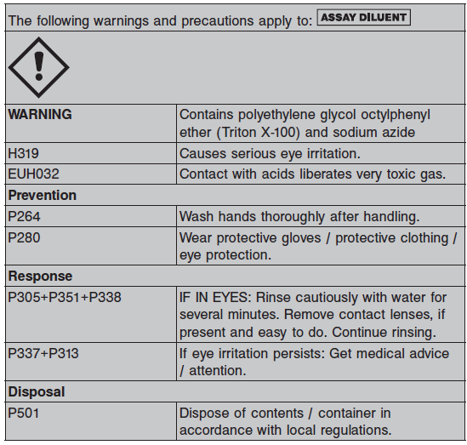

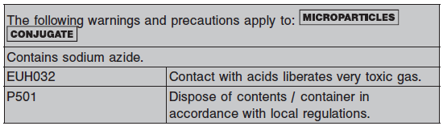

**Reagent Handling**

* Do not use reagent kits beyond the expiration date.
* **Do not pool reagents within a kit or between reagent kits.**
* Before loading the ARCHITECT Reagent Kit on the system for the first time, the microparticle bottle requires mixing to resuspend microparticles that have settled during shipment.
* **Septums MUST be used to prevent reagent evaporation and contamination and to ensure reagent integrity. Reliability of assay results cannot be guaranteed if septums are not used according to the instructions in the package insert.**
* To avoid contamination, wear clean gloves when placing a septum on an uncapped reagent bottle.
* Once a septum has been placed on the reagent bottle, **do not invert the bottle** as this will result in reagent leakage and maycompromise assay results.
* Over time, residual liquids may dry on the septum surface. These are typically dried salts and have no effect on assay efficacy.
* For a detailed discussion of handling precautions during system operation, refer to the ARCHITECT System Operations Manual, Section 7.

**Reagent Storage**

When stored and handled as directed, reagents are stable until the expiration date.

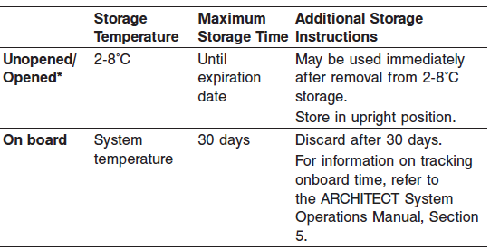

* Reagents may be stored on or off the ARCHITECT iSystem. If reagents are removed from the system, store them at 2-8°C (with septums and replacement caps) in an upright position. For reagents stored off the system, it is recommended that they be stored in their original trays and boxes to ensure they remain upright. **If the microparticle bottle does not remain upright (with** **a septum installed) while in refrigerated storage off the system, the reagent** **kit must be discarded.** For information on unloading reagents, refer to the ARCHITECT System Operations Manual, Section 5.

Reagents

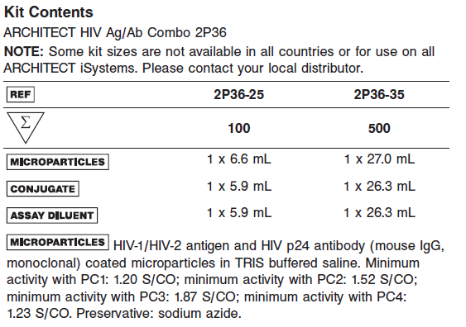

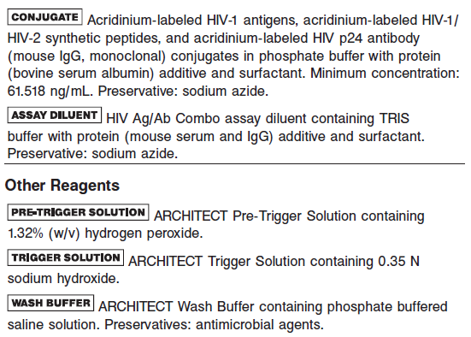

**Calibrator:** 2P36-01 ARCHITECT HIV Ag/Ab Combo Calibrator

**Quality Control:** 2P36-10 ARCHITECT HIV Ag/Ab Combo Controls (or other control material)

**Calibration**

**Frequency:**

Recalibration is required with each new reagent lot number.

**A new calibration is required:**

1. If quality control results do not meet acceptance criteria defined by your laboratory, patient values may be suspect. Follow the established quality control procedures for your laboratory. Recalibration may be necessary.
2. Review quality control results and acceptance criteria following a change of reagent or calibrator lot.

**Calibrator Required:** 2P36-01 ARCHITECT HIV Ag/Ab Combo Calibrator

**Reagents:**

1 Bottle (4.0 mL) ARCHITECT HIV Ag/Ab Combo Calibrator 1: Purified HIV‑1 viral lysate prepared in TRIS buffered saline with protein (bovine serum albumin) additive. Preservative: sodium azide. The calibrator is red and contains Red D&C No. 33.

**Calibrator Preparation:**

**•** The calibrator is liquid ready-to-use. No preparation is required.

**•** When stored and handled as directed, the calibrator is stable until the expiration date.

**•** The calibrator must be stored at 2-8°C in an upright position and may be used immediately after removal from 2-8°C storage.

**Calibration Procedure:**

To perform an ARCHITECT HIV Ag/Ab Combo calibration, test Calibrator 1 in replicates of three. The calibrator should be priority loaded.

**Troubleshooting and Overall Acceptance Criteria Failure**

See ARCHITECT Operations Manual for further calibration troubleshooting.

**Quality Control:**

Abbott recommends, refer to your laboratory standard operating procedure(s) and/or quality assurance plan for additional quality control requirements and potential corrective actions:

• The recommended control requirement for the ARCHITECT HIV Ag/Ab Combo assay is that a single sample of a negative control and of four positive controls (anti‑HIV-1, anti-HIV-2, HIV-1 antigen, and anti-HIV-1 group O) be tested once every 24 hours each day of use.

• If more frequent control monitoring is required, follow the established quality control procedures for your laboratory.

• If quality control results do not meet the acceptance criteria defined by your laboratory, patient values may be suspect. Follow the established quality control procedures for your laboratory.

Recalibration may be necessary.

• Review quality control results and acceptance criteria following a change of reagent or calibrator lot.

**Instrument Procedure**

* The ARCHITECT HIV Ag/Ab Combo assay is designed for use on the ARCHITECT *i* System.
* The ARCHITECT HIV Ag/Ab Combo assay file must be installed on the ARCHITECT *i* System from an ARCHITECT *i* System assay CD‑ROM before performing the assay.
* For detailed information on assay file installation and viewing and editing assay parameters, refer to the ARCHITECT System Operations Manual, Section 2.
* For information on printing assay parameters, refer to the ARCHITECT System Operations Manual, Section 5.
* For a detailed description of system procedures, refer to the ARCHITECT System Operations Manual.

**Assay Procedure**

For a detailed description of how to run an assay, refer to *Section 5* of the **ARCHITECT System Operations Manual**.

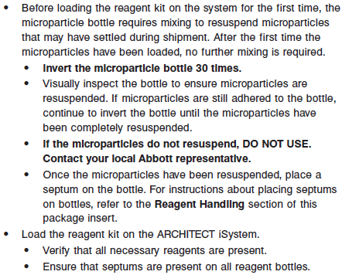

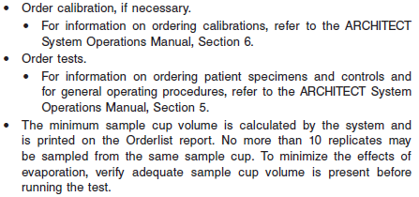

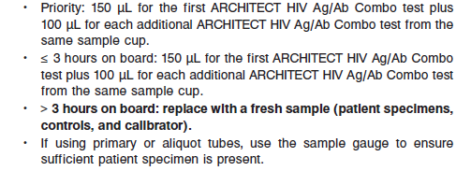

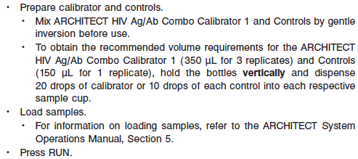

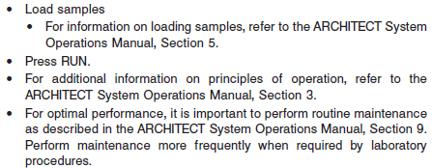

**Results**

**Calculations**

• The ARCHITECT *i* System calculates the cutoff RLU from the mean RLU of the three Calibrator 1 replicates and stores the result. The cutoff RLU is determined by multiplying the Calibrator 1 Mean RLU by 0.40.

Cutoff RLU = Calibrator 1 Mean RLU x 0.40

• The ARCHITECT *i* System calculates a result based on the ratio of sample RLU to the cutoff RLU (S/CO) for each specimen and control.

S/CO = Sample RLU/Cutoff RLU

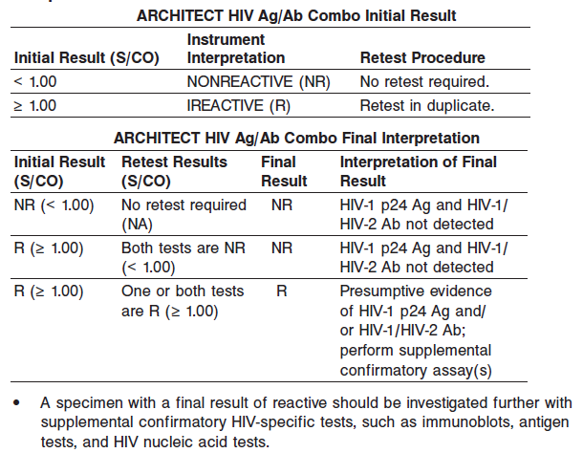

**Flags**

Some results may contain information in the Flags field. For a description of the flags that may appear in this field, refer to the ARCHITECT System Operations Manual, Section 5.

**Specific Performance Characteristics**

**Expected Values**

It is recommended that each laboratory determine its own reference range based upon its particular locale and population characteristics.

**Serum/Plasma**

< 1.0 = Non reactive

> 1.0 = Reactive

**Critical Values: N/A**

**Performance Characteristics**

**Analytical Sensitivity**

HIV-1 p24 Antigen Analytical Sensitivity

The ARCHITECT HIV Ag/Ab Combo assay was designed to have an analytical sensitivity of < 50 pg/mL for HIV-1 p24 antigen

Detection of HIV-1 Antigen

The sensitivity of the ARCHITECT HIV Ag/Ab Combo assay in this study was 100.00% (63/63) with an exact 95% confidence interval of 94.31% to 100.00%.

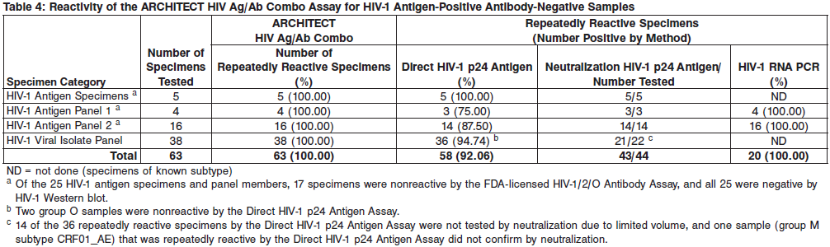

Detection of HIV-1 Antigen Subtypes

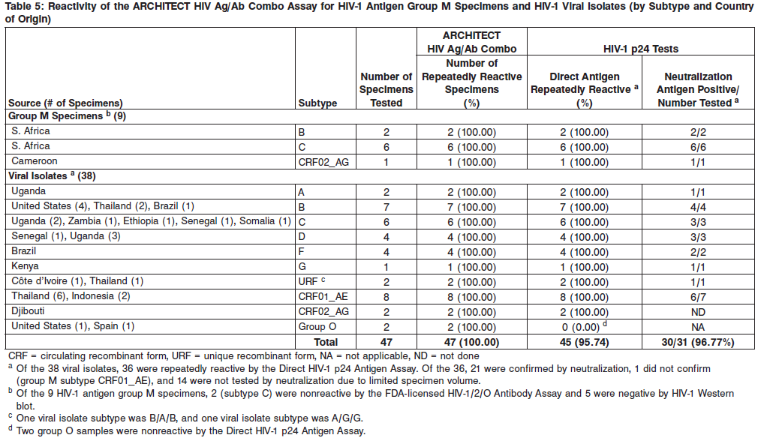

Detection of HIV Antibodies

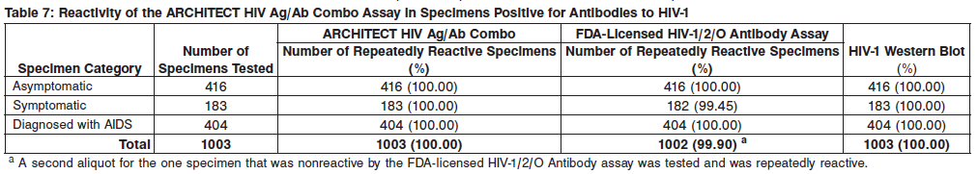

See Data in the **SPECIFIC PERFORMANCE CHARACTERISTICS** section of the package insert

**Dilution:**

Specimens cannot be diluted for the ARCHITECT HIV Ag/Ab Combo assay.

**Precision:**

The ARCHITECT HIV Ag/Ab Combo assay is designed to have a Within- Laboratory (Total) CV of ≤ 10% for positive controls and for reactive samples with S/CO ≤ 4, and a Within-Laboratory (Total) CV of ≤ 15% for samples with S/CO > 4. See Data in the **SPECIFIC PERFORMANCE CHARACTERISTICS** section of the package insert

#### Limitations of Procedure

• The interpretation of specimens with a final result of reactive by the ARCHITECT HIV Ag/Ab Combo assay and indeterminate by supplemental testing is not definitive; further clarification may be obtained by testing another specimen taken at least 1 month later.

• The ARCHITECT HIV Ag/Ab Combo assay result and supplemental assay results should be interpreted in conjunction with the patient’s clinical presentation, history, and other laboratory results. If the results are inconsistent with clinical evidence, additional testing is suggested to confirm the result.

• An individual who has antibodies to HIV is presumed to be infected with the virus; however, an individual who has participated in an HIV vaccine study may develop antibodies to the vaccine and may or may not be infected with HIV. Clinical correlation is indicated with appropriate counseling, medical evaluation, and possibly additional testing to determine whether a diagnosis of HIV infection is accurate.

• A test result that is nonreactive does not exclude the possibility of exposure to or infection with HIV-1 and/or HIV-2. Nonreactive results in this assay for individuals with prior exposure to HIV-1 and/or HIV-2 may be due to antigen and antibody levels that are below the limit of detection of this assay.

• The performance of this assay has not been established for individuals younger than 2 years of age. Nearly all infants born to HIV‑infected mothers passively acquire maternal antibody and, in some cases, will test antibody positive until age 18 months regardless of whether they are infected. Definitive diagnosis of HIV infection in early infancy requires other assays, including HIV nucleic acid tests or viral culture.

• Specimens from patients who have received preparations of mouse monoclonal antibodies for diagnosis or therapy may contain human anti‑mouse antibodies (HAMA). Such specimens may show either falsely elevated or depressed results when tested with assay kits (such as ARCHITECT HIV Ag/Ab Combo) that employ mouse monoclonal antibodies. ARCHITECT HIV Ag/Ab Combo reagents contain a component that reduces the effect of HAMA reactive specimens.

• Heterophilic antibodies in human serum can react with reagent immunoglobulins, interfering with *in vitro* immunoassays.35 Patients routinely exposed to animals or to animal serum products can be prone to this interference and anomalous results may be observed. Additional information may be required for diagnosis.

**Interfering Substances**

**Summary of Results for Potentially Cross-Reacting Specimens**

The ARCHITECT HIV Ag/Ab Combo assay was evaluated for potential cross-reactivity for specimens from individuals with medical conditions unrelated to HIV infection as summarized in Table 19. The specimens were tested using the ARCHITECT HIV Ag/Ab Combo assay and the FDA-licensed HIV-1/2/O Antibody Assay. The results for all 290 specimens were nonreactive with both assays.

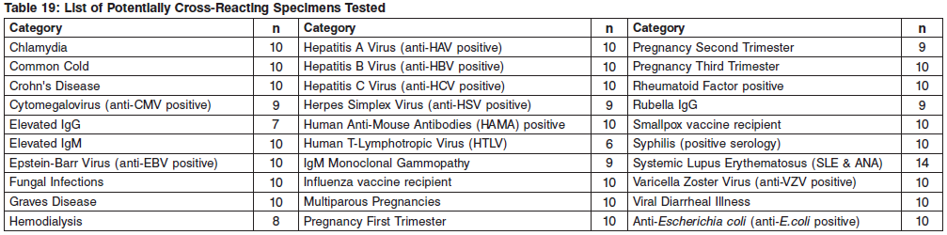

**Specificity**

Specificity was determined using presumed negative specimens from 448 pregnant females (age range: 16 to 44 years) based on the FDA-licensed HIV‑1/2/O antibody assay and supplemental testing. The pregnant females specimens were prospectively collected plasma specimens from pregnant females across all trimesters. Specificity of the ARCHITECT HIV Ag/Ab Combo assay in a pregnant female population in this study was 100.00% (448/448) with an exact 95% confidence interval of 99.18% to 100.00%.

**See the reagent package insert for more information**

**References:**

1. ABBOTT ARCHITECT HIV Ag/Ab Combo package insert

Abbott Laboratories

Diagnostics Division

Abbott Park, IL 60064

Sept 2015 G6-0482/R03

1. ABBOTT ARCHITECT HIV Ag/Ab Combo Calibrator package insert

Abbott Laboratories

Diagnostics Division

Abbott Park, IL 60064

1. Abbott ARCHITECT Operator’s Guide

**Related Documents:**

**Attachments:**