RUSH logo for emails

**INTACT PTH**

**SERUM OR PLASMA**

**ABBOTT ARCHITECT**

**Intended Use**

The ARCHITECT Intact PTH assay is an *in vitro* chemiluminescent microparticle immunoassay (CMIA) for the quantitative determination of intact parathyroid hormone (PTH) in human serum and plasma on the ARCHITECT *i* System.

**Clinical Significance**

PTH is a single chain polypeptide of 84 amino acids produced by the parathyroid gland. Intact PTH1-84 is secreted into the blood stream and undergoes extensive proteolytic modifications. In contrast to its degradation products, the concentration of intact PTH is relatively independent of glomerular filtration rate and reflects the biologically active portion of the hormone.

The primary role of PTH is to regulate the blood calcium level. PTH synthesis and secretion are stimulated within a few minutes by low concentrations of ionized calcium (Cai). The biological activity of PTH is to increase absorption of dietary calcium, decrease renal clearance and mobilize skeletal calcium stores. Abnormally high Cai concentrations suppress secretion of PTH.

In conjunction with serum calcium levels, the ARCHITECT Intact PTH assay may be used as an aid in the differential diagnosis of hypercalcemia, hypocalcemia and parathyroid disorders. PTH determination is important in monitoring dialysis patients to manage renal osteodystrophy.

**Principle**

The ARCHITECT Intact PTH assay is a two-step sandwich immunoassay for the quantitative determination of intact PTH in human serum and plasma using CMIA technology with flexible assay protocols, referred to as Chemiflex.

In the first step, sample, assay diluent, and anti-PTH coated paramagnetic microparticles are combined. Intact PTH present in the sample binds to the anti-PTH coated microparticles. After washing, anti-PTH acridiniumlabeled conjugate is added to create a reaction mixture in the second step. Following another wash cycle, pre-trigger and trigger solutions are added to the reaction mixture. The resulting chemiluminescent reaction is measured as relative light units (RLUs). A direct relationship exists between the amount of intact PTH in the sample and the RLUs detected by the ARCHITECT *i* System optics.

The ARCHITECT Intact PTH assay can be used with both *STAT* and Routine protocols. The *STAT* protocol has a shorter incubation time in comparison to the Routine protocol. *STAT* and Routine protocols require separate calibrations but require only one reagent kit. To account for differences between the *STAT* and Routine protocols, a correction factor has been added to the *STAT* protocol. The correction factor ensures that patient specimen results are consistent between the *STAT* and Routine protocols. As a consequence of the correction factor, controls read differently between the *STAT* and Routine protocols.

For additional information on system and assay technology, refer to the ARCHITECT System Operations Manual, Section 3.

**Specimen Collection and Handling**

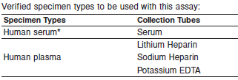

**\*** Use of serum separator tubes may result in a decrease in concentration values of up to 20% when compared with serum collected in serum tubes without additives.

**•** PTH degradation may be observed when using thrombinmediated serum tubes.

**•** Liquid anticoagulants may have a dilution effect resulting in lower concentrations for individual patient specimens.

**•** Sodium Citrate, Sodium Fluoride/Potassium Oxalate, and Ammonium Heparin tubes cannot be used with the ARCHITECT Intact PTH assay.

Do not use specimens with the following conditions:

**•** heat-inactivated

**•** pooled

**•** grossly hemolyzed (> 500 mg/dL)

• obvious microbial contamination

• cadaver specimens or body fluids other than human serum

* For optimal results, serum and plasma specimens should be free of fibrin, red blood cells or other particulate matter.

**•** PTH is relatively unstable: optimization of pre-analytical conditions, including specimen type, sampling time and storage conditions is essential. In order to minimize changes in PTH concentration, it is necessary to select the appropriate tube type and size and avoid multiple tube-to-tube transfers.

**Storage**



**•** Specimens may be stored on or off the clot, or red blood cells for up to 2 days refrigerated at 2-8°C.

**•** If testing will be delayed more than 2 days, remove serum or plasma from the clot, or red blood cells and store frozen.

**•** Specimens stored frozen for 6 months showed no performance difference.

**•** Avoid more than 5 freeze/thaw cycles.

**Materials and Equipment Required**

**TEST INSTRUMENT**: Abbott ARCHITECT System

**MATERIALS PROVIDED**

8K25 ARCHITECT Intact PTH Reagent Kit

**MATERIALS REQUIRED BUT NOT PROVIDED**

**•** ARCHITECT *i* System with *STAT* protocol

**•** ARCHITECT Intact PTH Assay file, may be obtained from:

**•** ARCHITECT *i* System e-Assay CD-ROM found on www.abbottdiagnostics.com

**•** ARCHITECT *i* System Assay CD-ROM

**•** 8K25-01 ARCHITECT Intact PTH Calibrators

**•** 8K25-10 ARCHITECT Intact PTH Controls

**•** 7D82-50 ARCHITECT *i* Multiassay Diluent

**•** ARCHITECT *i* Pretrigger

**•** ARCHITECT *i* Trigger

**•** ARCHITECT *i i* Wash Buffer

**•** ARCHITECT *i* Reaction Vessels

**•** ARCHITECT *i* Sample Cups

**•** ARCHITECT *i* Septums

**•** ARCHITECT *i* Replacement Caps

**•** Pipettes or pipette tips (optional) to deliver the specified volumes.

**Reagent Handling and Storage:**

***CAUTION*:**

* For in vitro diagnostic use.

**CAUTION:** This product requires the handling of human specimens.

It is recommended that all human sourced materials be considered

potentially infectious and be handled in accordance with the OSHA

Standard on Bloodborne Pathogens. Biosafety Level 2 or other appropriate biosafety practices should be used for materials that contain or are suspected of containing infectious agents.

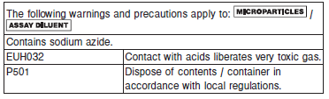

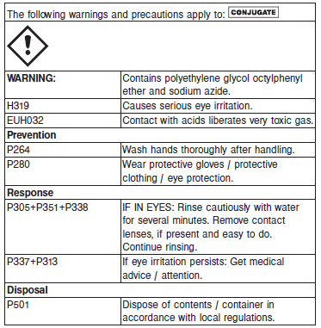

**Reagent Handling**

* Do not use reagent kits beyond the expiration date.
* **Do not pool reagents within a kit or between reagent kits.**
* Before loading the ARCHITECT Reagent Kit on the system for the first time, the microparticle bottle requires mixing to resuspend microparticles that have settled during shipment.
* **Septums MUST be used to prevent reagent evaporation and contamination and to ensure reagent integrity. Reliability of assay results cannot be guaranteed if septums are not used according to the instructions in the package insert.**
* To avoid contamination, wear clean gloves when placing a septum on an uncapped reagent bottle.
* Once a septum has been placed on the reagent bottle, **do not invert the bottle** as this will result in reagent leakage and maycompromise assay results.
* Over time, residual liquids may dry on the septum surface. These are typically dried salts and have no effect on assay efficacy.
* For a detailed discussion of handling precautions during system operation, refer to the ARCHITECT System Operations Manual, Section 7.

**Reagent Storage**

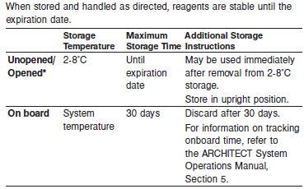

* The ARCHITECT Intact PTH Reagent Kit may be stored on board the ARCHITECT *i* System for a maximum of 30 days. After 30 days, the reagent kit must be discarded. For information on tracking onboard time, refer to the ARCHITECT System Operations Manual, Section 5.
* Reagents may be stored on or off the ARCHITECT *i* System. If reagents are removed from the system, store them at 2-8°C (with septums and replacement caps) in an upright position. For reagents stored off the system, it is recommended that they be stored in their original trays and boxes to ensure they remain upright.
* For information on unloading reagents, refer to the ARCHITECT System Operations Manual, Section 5.

Reagents

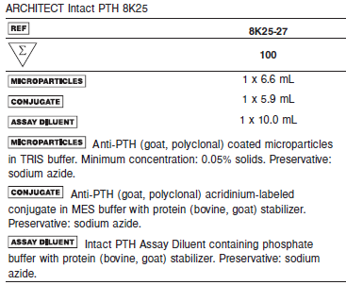

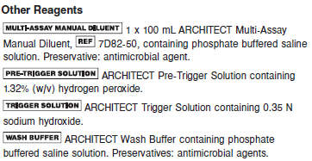

**Calibrator:** 8K25-01 ARCHITECT Intact PTH Calibrators

**Quality Control:** 8K25-10 ARCHITECT Intact PTH Controls

**Calibration**

**Frequency:**

Recalibration is required with each new reagent lot number.

**A new calibration is required:**

1. If quality control results do not meet acceptance criteria defined by your laboratory, patient values may be suspect. Follow the established quality control procedures for your laboratory. Recalibration may be necessary.
2. Review quality control results and acceptance criteria following a change of reagent or calibrator lot.

**Calibrator Required:**

8K25-01 ARCHITECT Intact PTH Calibrators

**Reagents:**

6 Bottles (4.0 mL each) of ARCHITECT Intact PTH Calibrators. Calibrator A contains Bis-Tris Propane buffer with protein (bovine) stabilizer. Calibrators B-F contain PTH (synthetic peptide) in Bis‑Tris Propane buffer with protein (bovine) stabilizer. Preservatives: sodium azide and ProClin 300.

**Calibrator Preparation:**

Calibrators may be used immediately after removal from 2-8°C storage. Prior to use mix gently by inversion (5-10 times). After each use, tightly close the caps and return the calibrators to 2-8°C storage.

**Calibration Procedure:**

To perform an ARCHITECT Intact PTH calibration, test calibrators A, B, C, D, E, and F in replicates of two. A single sample of each intact PTH control level must be tested to evaluate the assay calibration. Ensure that assay control values are within the concentration ranges specified in the control package insert. Calibrators should be priority loaded.

Calibration Range:

**•** *STAT* protocol: 0.0 – 2500.0 pg/mL

**•** Routine protocol: 0.0 – 3000.0 pg/mL

**Troubleshooting and Overall Acceptance Criteria Failure**

See ARCHITECT Operations Manual for further calibration troubleshooting.

**Quality Control:**

Abbott recommends, refer to your laboratory standard operating procedure(s) and/or quality assurance plan for additional quality control requirements and potential corrective actions:

• At a minimum a single level of each quality control are to be run every 24 hours

• If more frequent control monitoring is required, follow the established quality control procedures for your laboratory.

• If quality control results do not meet the acceptance criteria defined by your laboratory, patient values may be suspect. Follow the established quality control procedures for your laboratory.

Recalibration may be necessary.

• Review quality control results and acceptance criteria following a change of reagent or calibrator lot.

**Instrument Procedure**

**•** The ARCHITECT Intact PTH Routine assay file (assay number 581) must be installed on the ARCHITECT iSystem from an ARCHITECT iSystem Assay CD-ROM prior to performing the

assay.

**•** The ARCHITECT Intact PTH STAT assay file (assay number 585) must be installed on the ARCHITECT iSystem with STAT protocol capability from an ARCHITECT iSystem Assay CD-ROM prior to performing the assay.

**•** The Routine assay file may not be available on all ARCHITECT *i*Systems.

For detailed information on assay file installation and viewing and editing assay parameters, refer to the ARCHITECT System Operations Manual, Section 2.

For information on printing assay parameters, refer to the ARCHITECT System Operations Manual, Section 5.

For a detailed description of system procedures, refer to the ARCHITECT System Operations Manual.

**Assay Procedure**

For a detailed description of how to run an assay, refer to *Section 5* of the **ARCHITECT System Operations Manual**.

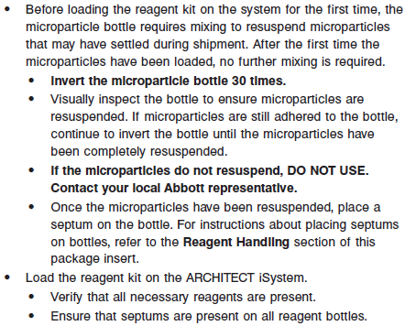

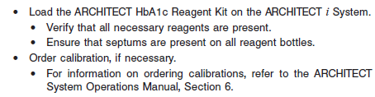

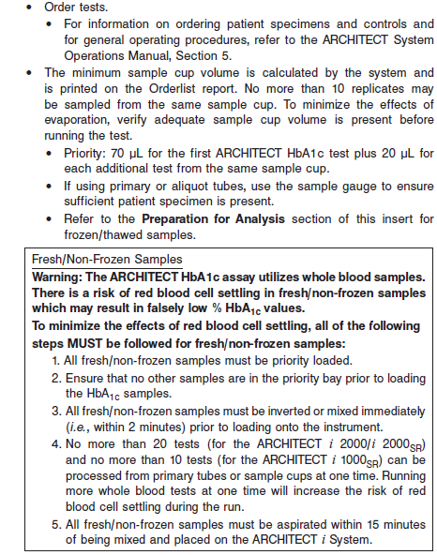

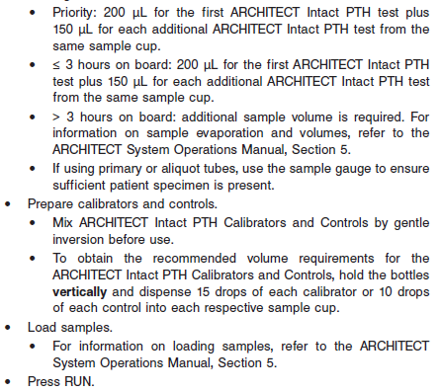

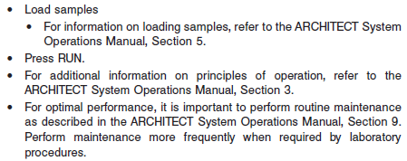

**Results**

Edit assay parameter "Result concentration units" to select an alternate unit.

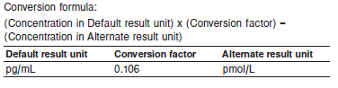

**Flags**

Some results may contain information in the Flags field. For a description of the flags that may appear in this field, refer to the ARCHITECT System Operations Manual, Section 5.

**Specific Performance Characteristics**

**Expected Values**

It is recommended that each laboratory determine its own reference range based upon its particular locale and population characteristics.

**Serum/Plasma (Abbott Package Insert)**

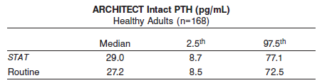

See the EXPECTED VALUES section of the reagent package insert for more information.

**Serum/Plasma:** < 150 years = 7.5 – 64.2 pg/mL

**Critical Values: N/A**

**Performance Characteristics**

**Measurement Range (Reportable Range)**

The measurement range for the ARCHITECT Intact PTH assay is

**•** *STAT* protocol: 4.0 pg/mL to 2500.0 pg/mL

**•** Routine protocol: 3.0 pg/mL to 3000.0 pg/mL

Results below the range of measurement should not be reported.

**Sensitivity**

The ARCHITECT Intact PTH assay is designed to have a functional sensitivity of ≤ 5 pg/mL at a total CV of 20%. The ARCHITECT Intact PTH assay is designed to have an analytical sensitivity of ≤ 1 pg/mL.

**Linearity**

The ARCHITECT Intact PTH assay is designed to be linear across the measurement range of 3.0 to 3000 pg/mL. See information in the **SPECIFIC PERFORMANCE CHARACTERISTICS** section of the package insert.

**Dilution:**

Specimens with an intact PTH concentration of > 2500.0 pg/mL (*STAT* protocol) or > 3000.0 pg/mL (Routine protocol) will be flagged as “>2500.0 pg/mL” or “>3000.0 pg/mL” and may be diluted with the Manual Dilution Procedure.

**•** Manual dilutions should be performed as follows:

**•** The suggested dilution for the ARCHITECT Intact PTH assay is 1:2.

**•** Add 150 μL of the patient specimen to 150 μL of ARCHITECT *i* Multi-Assay Manual Diluent.

**•** The operator must enter the dilution factor in the Patient or Control order screen. The system will use this dilution factor to automatically calculate the concentration of the sample before dilution and report the result. The result (before dilution factor is applied) should be greater than 1.0 pg/mL.

**•** For detailed information on ordering dilutions, refer to the ARCHITECT System Operations Manual, Section 5.

**Precision:**

The ARCHITECT Intact PTH assay is designed to have precision of ≤ 9% total CV for the Low Control and ≤ 7% total CV for the Medium and High Control.

See information in the **SPECIFIC PERFORMANCE CHARACTERISTICS** section of the package insert.

#### Limitations of Procedure

* Specimens from patients who have received preparations of mouse monoclonal antibodies for diagnosis or therapy may contain human anti-mouse antibodies (HAMA). Specimens containing HAMA may produce anomalous values when tested with assay kits that employ mouse monoclonal antibodies.
* Heterophilic antibodies in human serum can react with reagent immunoglobulins, interfering with *in vitro* immunoassays. Patients routinely exposed to animals or to animal serum products can be prone to this interference and anomalous results may be observed. Additional information may be required for diagnosis. Immunoassays are nonspecific and cross react with metabolites.
* This assay has not been clinically validated for intraoperative use.

**Specificity**

The specificity of the ARCHITECT Intact PTH assay is designed to have a cross-reactivity of ≤ 0.01% when tested with structurally similar compounds listed in the table below.

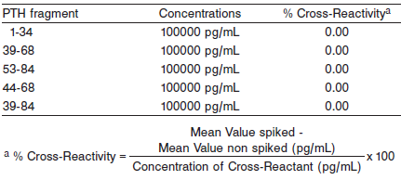

**Interference**

Potential interference in the ARCHITECT Intact PTH assay from hemoglobin, bilirubin, triglycerides, and protein at the levels indicated below is designed to be ≤ 10%.

There was no significant interference observed since the % mean recovery is within +/- 10% of the expected value. Data from this study are summarized in the following table*

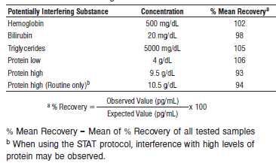

**References:**

1. ABBOTT ARCHITECT Intact PTH package insert

Abbott Laboratories

Diagnostics Division

Abbott Park, IL 60064

Jan 2016 G6-0480/ R05

1. ABBOTT ARCHITECT Intact PTH Calibrator package insert

Abbott Laboratories

Diagnostics Division

Abbott Park, IL 60064

1. Abbott ARCHITECT Operator’s Guide

**Related Documents:**

**Attachments:**