RUSH logo for emails

**PROGESTERONE**

**SERUM OR PLASMA**

**ABBOTT ARCHITECT**

**Intended Use**

The ARCHITECT Progesterone assay is a Chemiluminescent Microparticle Immunoassay (CMIA) for the quantitative determination of progesterone in human serum and plasma.

**Clinical Significance**

Progesterone is produced primarily by the corpus luteum of the ovary in normally menstruating women and to a lesser extent by the adrenal cortex. At approximately the 6th week of pregnancy, the placenta becomes the major producer of progesterone. The major functions of progesterone are in the preparation of the uterus for implantation and maintenance of pregnancy.

During the follicular phase of the cycle, progesterone levels remain low (0.2-1.5 ng/mL). Following the LH surge and ovulation, luteal cells in the ruptured follicle produce progesterone in response to LH.

During this luteal phase, progesterone rises rapidly to a maximum of 10-20 ng/mL at 5 to 7 days following ovulation. If conception does not occur, progesterone levels decrease during the last four days of the cycle due to the regression of the corpus luteum. If conception occurs, the levels of progesterone are maintained at mid-luteal levels by the corpus luteum until about week six. At that time, the placenta becomes the main source of progesterone and levels rise from approximately 10-50 ng/mL in the first trimester to 50-280 ng/mL in the third trimester.

Serum progesterone is a reliable indicator of either natural or induced ovulation because of its rapid rise following ovulation. Disorders of ovulation, including anovulation, are relatively frequent and are responsible for infertility in approximately 15-20% of patients. Progesterone levels are abnormally low in these patients during the mid-luteal phase.

Luteal phase deficiency is a reproductive disorder associated with infertility and spontaneous abortion and is thought to occur in 10% of infertile women. The infertility and pregnancy loss associated with this disorder are thought to be attributable to inadequate development of the endometrium. The failure of the endometrium to mature is thought to be caused by insufficient production of progesterone by the corpus luteum. Progesterone levels in the luteal phase are lower than normal in women with luteal phase deficiency. Measurement of progesterone in the first 10 weeks of gestation has been shown to be reliable and effective for the diagnosis and treatment of patients with threatened abortion and ectopic pregnancy. Suppressed progesterone levels (5 to 25 ng/mL) in the presence of detectable amounts of hCG is highly suggestive of patients with threatened abortion or ectopic pregnancy, regardless of gestational age.

**Principle**

The ARCHITECT Progesterone assay is a one-step immunoassay to determine the presence of progesterone in human serum and plasma using Chemiluminescent Microparticle Immunoassay (CMIA) technology with flexible assay protocols, referred to as Chemiflex. Sample, anti-fluorescein (mouse, monoclonal) fluorescein-progesterone complex coated paramagnetic microparticles, and anti-progesterone (sheep, monoclonal) acridinium labeled conjugate are combined to create the reaction mixture. Progesterone present in the sample competes with the anti-fluorescein (mouse, monoclonal) fluorescein-progesterone complex coated microparticles for binding with anti-progesterone (sheep, monoclonal) acridinium-labeled conjugate to form antibody-antigen-antibody complexes. After washing, Pre-Trigger and Trigger Solutions are then added to the reaction mixture; the resulting chemiluminescent reaction is measured as relative light units (RLUs). An inverse relationship exists between the amount of progesterone in the sample and the RLUs detected by the ARCHITECT *i* optical system.

For additional information on system and assay technology, refer to the ARCHITECT System Operations Manual, Section 3.

**Specimen Collection and Handling**

Human serum (including serum collected in serum separator tubes) or plasma collected in sodium heparin, lithium heparin or potassium EDTA may be used in the ARCHITECT Progesterone assay. Other anticoagulants have not been validated for use with the ARCHITECT Progesterone assay. Follow the tube manufacturer’s processing instructions for serum or plasma collection tubes.

**•** Literature suggests that measurable progesterone may decrease with time when stored in serum separator tubes.31 Serum collected in serum separator tubes and stored up to 24 hours on the gel showed (on average) a 13% loss.

Do not use specimens with the following conditions:

**•** obvious microbial contamination

For optimal results, serum and plasma specimens should be free of fibrin, red blood cells or other particulate matter.

**Storage**

If testing will be delayed more than 24 hours, remove serum or plasma from the clot, serum separator, or red blood cells. Specimens may be stored for up to 10 days at 2-8°C prior to being tested. If testing will be delayed more than 10 days, specimens should be frozen at -10°C or colder. Specimens stored frozen at -10°C or colder for 6 months showed no performance difference.

**•** Multiple freeze-thaw cycles of specimens should be avoided.

All samples (patient specimens, controls, and calibrators) should be tested within 3 hours of being placed on board the ARCHITECT System.

**Materials and Equipment Required**

**TEST INSTRUMENT**: Abbott ARCHITECT System

**MATERIALS PROVIDED**

7K77 ARCHITECT Progesterone Reagent Kit

**MATERIALS REQUIRED BUT NOT PROVIDED**

**•** ARCHITECT *i* System

**•** ARCHITECT Progesterone Assay file, may be obtained from:

**•** ARCHITECT *i* System e-Assay CD-ROM found on www.abbottdiagnostics.com

**•** ARCHITECT *i* System Assay CD-ROM

**•** 7K77-01 ARCHITECT Progesterone Calibrators

**•** 7K77-10 ARCHITECT Progesterone Controls

**•** 7K77-50 ARCHITECT Progesterone Manual Diluent

**•** ARCHITECT *i* Pretrigger

**•** ARCHITECT *i* Trigger

**•** ARCHITECT *i i* Wash Buffer

**•** ARCHITECT *i* Reaction Vessels

**•** ARCHITECT *i* Sample Cups

**•** ARCHITECT *i* Septums

**•** ARCHITECT *i* Replacement Caps

**•** Pipettes or pipette tips (optional) to deliver the specified volumes.

**Reagent Handling and Storage:**

***CAUTION*:**

* For in vitro diagnostic use.

**CAUTION:** This product requires the handling of human specimens.

It is recommended that all human sourced materials be considered

potentially infectious and be handled in accordance with the OSHA

Standard on Bloodborne Pathogens. Biosafety Level 2 or other appropriate biosafety practices should be used for materials that contain or are suspected of containing infectious agents.



**Reagent Handling**

* Do not use reagent kits beyond the expiration date.
* **Do not pool reagents within a kit or between reagent kits.**
* **The ARCHITECT Progesterone Reagent Kit must be maintained continuously at 2-8°C when not on-board the ARCHITECT *i* System. Performance differences may be seen if reagents are not at 2-8°C prior to loading them on the system.**
* Once the ARCHITECT Progesterone Reagent Kit has been removed from refrigerated storage (2-8°C), **immediately** place them on-board the ARCHITECT *i* System.
* Before loading the ARCHITECT Reagent Kit on the system for the first time, the microparticle bottle requires mixing to resuspend microparticles that have settled during shipment.
* **Septums MUST be used to prevent reagent evaporation and contamination and to ensure reagent integrity. Reliability of assay results cannot be guaranteed if septums are not used according to the instructions in the package insert.**
* To avoid contamination, wear clean gloves when placing a septum on an uncapped reagent bottle.
* Once a septum has been placed on the reagent bottle, **do not invert the bottle** as this will result in reagent leakage and maycompromise assay results.
* Over time, residual liquids may dry on the septum surface. These are typically dried salts and have no effect on assay efficacy.
* For a detailed discussion of handling precautions during system operation, refer to the ARCHITECT System Operations Manual, Section 7.

**Mixing Instructions**

Before loading the ARCHITECT Progesterone Reagent Kit on the system for the first time, the microparticle bottle requires mixing to resuspend microparticles that have settled during shipment:

**•** Invert the microparticle bottle 30 times.

**•** Visually inspect the bottle to ensure microparticles are resuspended. If microparticles are still adhered to the bottle, continue to invert the bottle until the microparticles have been completely resuspended.

**• If the microparticles do not resuspend, DO NOT USE. Contact your local Abbott representative.**

**Reagent Storage**

* The ARCHITECT Progesterone Reagent Kit must be stored at 2-8°C and may be used immediately after removal from 2-8°C storage.

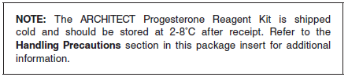

* When stored and handled as directed, reagents are stable until the expiration date.
* The ARCHITECT Progesterone Reagent Kit may be stored on-board the ARCHITECT *i* System for a maximum of 30 days. After 30 days, the reagent kit must be discarded. For information on tracking on‑board time, refer to the ARCHITECT System Operations Manual, Section 5.
* Reagents may be stored on or off the ARCHITECT *i* System. If reagents are removed from the system, store them at 2-8°C (with septums and replacement caps) in an upright position. For reagents stored off the system, it is recommended that they be stored in their original trays and boxes to ensure they remain upright.
* For information on unloading reagents, refer to the ARCHITECT System Operations Manual, Section 5.

Reagents

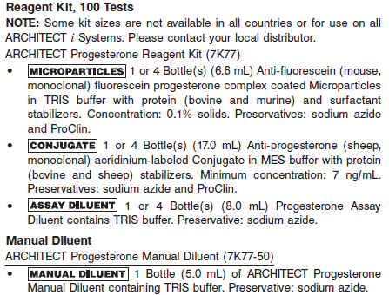

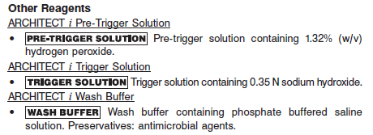

**Calibrator:** 7K77-01 ARCHITECT Progesterone Calibrators

**Quality Control:** 7K77-10 ARCHITECT Progesterone Controls

**Calibration**

**Frequency:**

Recalibration is required with each new reagent lot number.

**A new calibration is required:**

1. If quality control results do not meet acceptance criteria defined by your laboratory, patient values may be suspect. Follow the established quality control procedures for your laboratory. Recalibration may be necessary.
2. Review quality control results and acceptance criteria following a change of reagent or calibrator lot.

**Calibrator Required:**

7K77-01 ARCHITECT Progesterone Calibrators

**Reagents:**

2 Bottles (4 mL each) of ARCHITECT Progesterone Calibrators contain progesterone prepared in processed human serum. Preservative: sodium azide.

**Calibrator Preparation:**

**• Store at - 10°C or colder until first usage. To prepare the calibrators for use, thaw completely at room temperature (15-30°C) for 1 to 2 hours, or overnight at 2-8°C. Prior to use, mix THOROUGHLY by low speed vortex or inversion. After each use, immediately return the thawed calibrators to refrigerated storage (2-8°C). Thawed calibrators may be stored refrigerated at 2-8°C for up to three weeks.**

**• Do not exceed the expiration date printed on the bottle.**

**Calibration Procedure:**

To perform an ARCHITECT Progesterone calibration, test Calibrators 1 and 2 in duplicate. A single sample of all levels of progesterone controls must be tested to evaluate the assay calibration. Ensure that assay control values are within the concentration ranges specified in the control package insert. Calibrators should be priority loaded.

**•** Calibration Range: 0 - 40 ng/mL.

**Troubleshooting and Overall Acceptance Criteria Failure**

See ARCHITECT Operations Manual for further calibration troubleshooting.

**Quality Control:**

Abbott recommends, refer to your laboratory standard operating procedure(s) and/or quality assurance plan for additional quality control requirements and potential corrective actions:

• At a minimum a single control of each quality control level is to be run every 24 hours

• If more frequent control monitoring is required, follow the established quality control procedures for your laboratory.

• If quality control results do not meet the acceptance criteria defined by your laboratory, patient values may be suspect. Follow the established quality control procedures for your laboratory.

Recalibration may be necessary.

• Review quality control results and acceptance criteria following a change of reagent or calibrator lot.

**Instrument Procedure**

* The ARCHITECT Progesterone assay file must be installed on the ARCHITECT *i* System from the ARCHITECT *i* Assay CD-ROM prior to performing the assay. For detailed information on assay file installation and on viewing and editing assay parameters, refer to the ARCHITECT System Operations Manual, Section 2.
* For detailed information on assay file installation and viewing and editing assay parameters, refer to the ARCHITECT System Operations Manual, Section 2.
* For information on printing assay parameters, refer to the ARCHITECT System Operations Manual, Section 5.
* For a detailed description of system procedures, refer to the ARCHITECT System Operations Manual.

**Assay Procedure**

For a detailed description of how to run an assay, refer to *Section 5* of the **ARCHITECT System Operations Manual**.

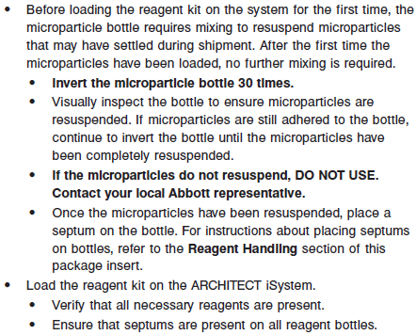

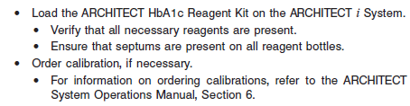

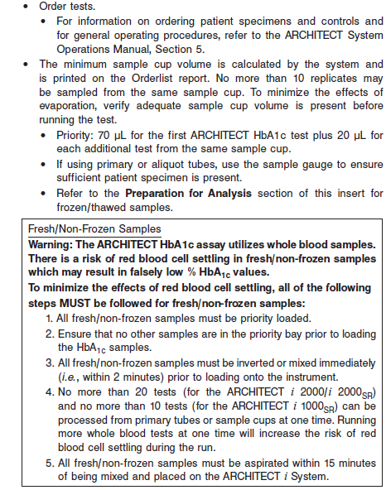

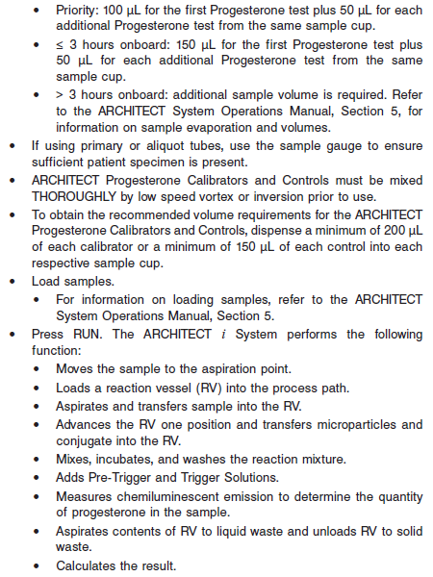

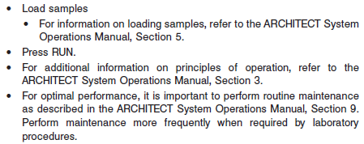

**Results**

The default result unit for the ARCHITECT Progesterone assay is ng/mL. When the alternate result unit, nmol/L, is selected, the conversion factor used by the system is 3.18.

**•** Conversion Formula: (Concentration in ng/mL) x (3.18) = nmol/L

**Flags**

Some results may contain information in the Flags field. For a description of the flags that may appear in this field, refer to the ARCHITECT System Operations Manual, Section 5.

**Specific Performance Characteristics**

**Expected Values**

It is recommended that each laboratory determine its own reference range based upon its particular locale and population characteristics.

**Serum/Plasma**

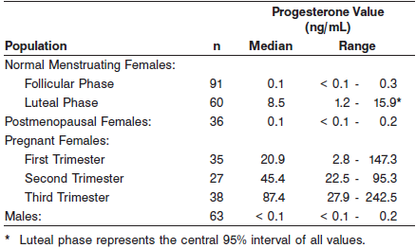

**Critical Values: N/A**

**Performance Characteristics**

**Sensitivity**

The ARCHITECT Progesterone assay is designed to have an analytical sensitivity of ≤ 0.1 ng/mL.

**Linearity**

The ARCHITECT Progesterone assay is designed to be linear across the measurement range of 0.1 to 40 ng/mL. See information in the **SPECIFIC PERFORMANCE CHARACTERISTICS** section of the package insert.

**Dilution:**

Specimens with a progesterone value exceeding 40 ng/mL are flagged with the code “ > 40” and may be diluted using either the Automated Dilution Protocol or the Manual Dilution Procedure.

Automated Dilution Procedure

**•** If using the Automated Dilution Protocol, the system performs a 1:10 dilution of the specimen and automatically calculates the concentration of the specimen before dilution and reports the result. Manual Dilution Procedure

**•** The suggested dilution for Progesterone is 1:10. It is recommended dilutions not exceed 1:15.

**•** For a 1:10 dilution, add 50 μL of the patient specimen to 450 μL of ARCHITECT Progesterone Manual Diluent (7K77-50).

**•** The operator must enter the dilution factor in the patient or control order screen. The system will use this dilution factor to automatically calculate the concentration of the specimen before dilution. This will be the reported result. The dilution should be performed so that the diluted result reads greater than 10.0 ng/mL for a 1:10 dilution.

**•** If the operator does not enter the dilution factor, the reported result will be that of the diluted sample. This result (before dilution factor is applied) should be greater than 1.0 ng/mL. **The reported result must** **be multiplied by the dilution factor to obtain the concentration of** **the undiluted sample.**

For detailed information on ordering dilutions, refer to the ARCHITECT System Operations Manual, Section 5.

**Precision:**

The ARCHITECT Progesterone assay is designed to have a precision of ≤ 10% total CV for concentrations in the range of the ARCHITECT Progesterone Low Control and ≤ 7% total CV for concentrations in the ranges of the ARCHITECT Progesterone Medium and High Controls.

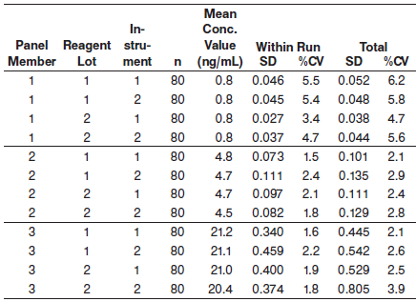

See information in the **SPECIFIC PERFORMANCE CHARACTERISTICS** section of the package insert.

#### Limitations of Procedure

* Specimens from patients who have received preparations of mouse monoclonal antibodies for diagnosis or therapy may contain human anti-mouse antibodies (HAMA). Specimens containing HAMA may produce anomalous values when tested with assay kits that employ mouse monoclonal antibodies.
* Heterophilic antibodies in human serum can react with reagent immunoglobulins, interfering with *in vitro* immunoassays. Patients routinely exposed to animals or to animal serum products can be prone to this interference and anomalous results may be observed. Additional information may be required for diagnosis. Immunoassays are nonspecific and cross react with metabolites.

**Specificity**

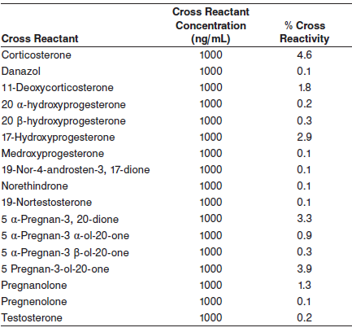

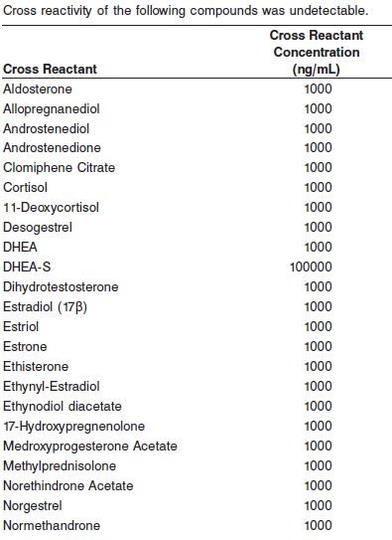

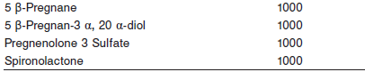

**Interference**

Potential interference from hemoglobin, bilirubin, triglycerides, and protein

was studied in the ARCHITECT Progesterone assay. The ARCHITECT

Progesterone assay demonstrated the interference stated below.

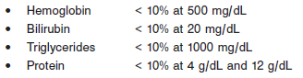

**References:**

1. ABBOTT ARCHITECT Progesterone package insert

Abbott Laboratories

Diagnostics Division

Abbott Park, IL 60064

July 2012 G2-7955/R05

1. ABBOTT ARCHITECT Progesterone Calibrator package insert

Abbott Laboratories

Diagnostics Division

Abbott Park, IL 60064

1. Abbott ARCHITECT Operator’s Guide

**Related Documents:**

**Attachments:**