RUSH logo for emails

**B∙R∙A∙H∙M∙S PCT**

**SERUM OR PLASMA**

**ABBOTT ARCHITECT**

**Intended Use**

The ARCHITECT B∙R∙A∙H∙M∙S PCT assay is a chemiluminescent microparticle immunoassay (CMIA) for the quantitative determination of procalcitonin (PCT) in human serum and plasma (lithium heparin and K2EDTA) on the ARCHITECT iSystem.

Used in conjunction with other laboratory findings and clinical assessments, the ARCHITECT B∙R∙A∙H∙M∙S PCT assay is intended for use as an:

**•** Aid in the risk assessment of critically ill patients on their first day of intensive care unit (ICU) admission for progression to severe sepsis and septic shock.

**•** Aid in assessing the cumulative 28-day risk of all-cause mortality for patients diagnosed with severe sepsis or septic shock in the ICU or when obtained in the emergency department or other medical wards

prior to ICU admission, using a change in PCT level over time.

**•** Aid in decision making on antibiotic therapy for patients with suspected or confirmed lower respiratory tract infections (LRTI) – defined as community-acquired pneumonia (CAP), acute bronchitis, and acute exacerbation of chronic obstructive pulmonary disease (AECOPD) – in an inpatient setting or an emergency department.

**•** Aid in decision making on antibiotic discontinuation for patients with suspected or confirmed sepsis.

**WARNINGS AND PRECAUTIONS – TEST INTERPRETATION**

**•** The ARCHITECT B∙R∙A∙H∙M∙S PCT assay is not indicated to be used as a stand-alone diagnostic assay and should be used in conjunction with clinical signs and symptoms of infection and other diagnostic evidence.

**• Decisions regarding antibiotic therapy should NOT be based solely on PCT concentrations.**

**•** PCT results should always be interpreted in the context of the clinical status of the patient and other laboratory results. Changes in PCT levels for the prediction of mortality, and overall mortality, are strongly dependent on many factors, including pre-existing patient risk factors and clinical course.

**•** The need to continue ICU care at Day 4 and other covariates (e.g., age and Sequential Organ Failure Assessment [SOFA] score) are also significant predictors of 28-day cumulative mortality risk.

**•** Certain patient characteristics, such as severity of renal failure or insufficiency, may influence PCT values and should be considered as potentially confounding clinical factors when interpreting PCT values.

**•** PCT levels may not be elevated in patients infected by certain atypical pathogens, such as *Chlamydophila pneumoniae* and *Mycoplasma pneumoniae*.

**• Low PCT levels do not always indicate absence of bacterial infection.** Falsely low PCT levels in the presence of bacterialinfection may occur during the early course of infections, in localizedinfections, and in subacute infectious endocarditis.

**• Increased PCT levels may not always be related to systemic bacterial infection.** There are a few situations where PCT levelsmay be elevated by non-bacterial causes. These include, but are notlimited to, the following:

**•** Neonates at < 48 hours of life (physiological elevation)

**•** Severe illness such as polytrauma, burns, major surgery, and prolonged or cardiogenic shock

**•** Treatment with OKT3 (muromonab-CD3) antibodies and other drugs stimulating the release of pro-inflammatory cytokines

**•** Patients with invasive fungal infections

**•** Patients with acute attacks of *Plasmodium falciparum* malaria

**•** Patients receiving peritoneal dialysis or hemodialysis treatment

**•** Patients with biliary pancreatitis, chemical pneumonitis, or heat stroke

**•** Patients with small cell lung cancer, severe liver cirrhosis and acute or chronic viral hepatitis,4 or medullary C-cell carcinoma of the thyroid

**•** The safety and performance of PCT-guided therapy for individuals younger than age 18 years, pregnant women, immunocompromised individuals, or those on immunomodulatory agents was not formally analyzed in the supportive clinical trials.

**•** ARCHITECT B∙R∙A∙H∙M∙S PCT results should not be used interchangeably with other methods for PCT determinations for monitoring patients.

**Clinical Significance**

Sepsis is a daily challenge in the hospital setting. Today various therapeutic strategies are known to improve survival in patients with sepsis. Early assessment is important for determination of the appropriate treatment.

PCT is a 116 amino acid protein prohormone of calcitonin (CT). Under normal metabolic conditions, hormonally active CT is produced and secreted in the C-cells of the thyroid gland after specific intracellular proteolytic activity. In healthy individuals, the intact PCT is not secreted

from the thyroid and levels in the blood are very low.

Response to inflammatory stimuli, including bacterial infections, induces an increased expression of the CALC-I gene with production and secretion of intact PCT from all parenchymal tissues and differentiated cell types throughout the body.

In healthy people, plasma PCT concentrations are found to be below 0.1 ng/mL. Depending on the clinical background, a PCT concentration above 0.1 ng/mL can indicate clinically relevant bacterial infection, requiring antibiotic treatment.8 PCT levels rise rapidly (within 6–12 hours) after an infectious bacterial insult with systemic consequences.

The magnitude of the increase in PCT concentration correlates with the severity of the bacterial infection. At a PCT concentration > 0.5 ng/mL, a patient should be considered at risk of developing severe sepsis or septic shock. On the other hand, the relief of the septic infection is accompanied by a decrease in the PCT concentration, which returns to normal with a half-life of 24 hours (i.e., the continuous decline of PCT is indicative of effective source control measures and has been

implicated in the safe de-escalation of antibiotic therapy).

By evaluating PCT concentrations, the physician may use the findings to aid in the risk assessment of critically ill patients for progression to severe sepsis and septic shock. In addition, the change of PCT levels over time offers information about the risk of mortality after diagnosis of severe sepsis or septic shock.

**Principle**

The ARCHITECT B∙R∙A∙H∙M∙S PCT assay is a two-step immunoassay for the quantitative determination of PCT in human serum and plasma (lithium heparin and K2EDTA) using CMIA technology with flexible assay protocols, referred to as Chemiflex.

1. Sample and anti-PCT coated paramagnetic microparticles are combined. The PCT present in the sample binds to the anti-PCT coated microparticles.

2. After washing, anti-PCT acridinium-labeled conjugate is added to create a reaction mixture.

3. Following another wash cycle, Pre-Trigger and Trigger Solutions are added to the reaction mixture.

4. The resulting chemiluminescent reaction is measured as relative light units (RLUs). There is a direct relationship between the amount of PCT in the sample and the RLUs detected by the ARCHITECT iSystem optics.

For additional information on system and assay technology, refer to the ARCHITECT System Operations Manual, Section 3.

**Specimen Collection and Handling**

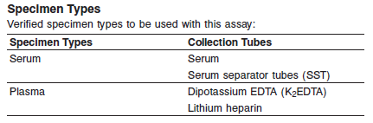

**•** Other specimen collection tube types have not been tested with this assay.

**• When monitoring patients, use the same specimen collection tube type throughout the evaluation.**

**•** Performance has not been established for the use of cadaveric specimens or the use of body fluids other than human serum/ plasma.

Do not use specimens with the following conditions:

**•** heat-inactivated

**•** pooled

**•** grossly hemolyzed

**•** obvious microbial contamination

**•** fungal growth.

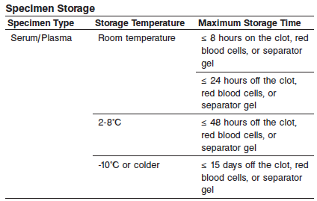

If stored beyond 8 hours, remove serum or plasma from the clot, red blood cells, or separator gel and store at 2-8°C or -10°C or colder. EDTA-plasma and serum specimens stored frozen at -70°C or colder have demonstrated stability up to 18 months.

Avoid more than 3 freeze/thaw cycles.

Testing of lithium heparin plasma specimens that were frozen and thawed up to 3 times resulted in a maximum mean % difference from fresh specimens of -11%. Testing of serum or plasma specimens from serum, SST, and dipotassium EDTA tubes that were frozen and thawed up to 3 times resulted in a maximum mean % difference from fresh specimens of -6%.

**NOTE:** Stored specimens must be inspected for particulates. If present, mix and centrifuge the specimen to remove particulates prior to testing.

**Materials and Equipment Required**

**TEST INSTRUMENT**: Abbott ARCHITECT System

**MATERIALS PROVIDED**

6P22 ARCHITECT B∙R∙A∙H∙M∙S PCT Reagent Kit

**MATERIALS REQUIRED BUT NOT PROVIDED**

**•** ARCHITECT B∙R∙A∙H∙M∙S PCT Assay file obtained from the ARCHITECT iSystem e-Assay CD-ROM found on www.abbottdiagnostics.com.

**•** 6P22-01 ARCHITECT B∙R∙A∙H∙M∙S PCT Calibrators

**•** 6P22-10 ARCHITECT B∙R∙A∙H∙M∙S PCT Controls or other control material

**•** ARCHITECT Pre-Trigger Solution

**•** ARCHITECT Trigger Solution

**•** ARCHITECT Wash Buffer

**•** ARCHITECT Reaction Vessels

**•** ARCHITECT Sample Cups

**•** ARCHITECT Septum

**•** ARCHITECT Replacement Caps

**•** Pipettes or pipette tips (optional) to deliver the volumes specified on the patient or control order screen.

**Reagent Handling and Storage:**

***CAUTION*:**



**CAUTION:** This product requires the handling of human specimens.

It is recommended that all human sourced materials be considered potentially infectious and be handled in accordance with the OSHA Standard on Bloodborne Pathogens. Biosafety Level 2 or other appropriate biosafety practices should be used for materials that contain or are suspected of containing infectious agents.

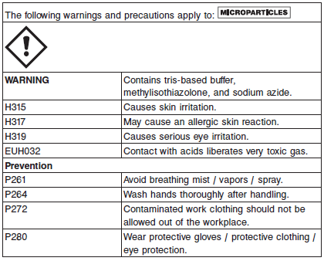

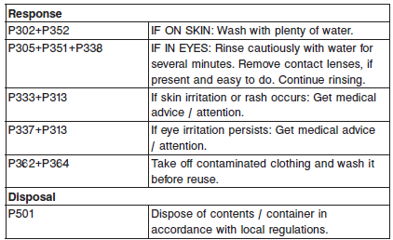

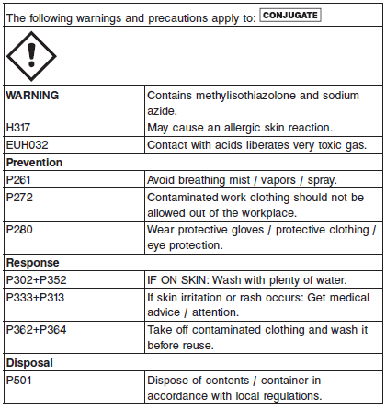

**Reagent Handling**

**•** Do not use reagent kits beyond the expiration date.

**• Do not pool reagents within a kit or between kits.**

**•** Before loading the reagent kit on the system for the first time, the microparticle bottle requires mixing to resuspend microparticles that may have settled during shipment. For microparticle mixing

instructions, refer to the **PROCEDURE, Assay Procedure** section of the package insert.

**• Septums MUST be used to prevent reagent evaporation and contamination and to ensure reagent integrity. Reliability of assay results cannot be guaranteed if septums are not used according to the instructions in the package insert.**

**•** To avoid contamination, wear clean gloves when placing a septum on an uncapped reagent bottle.

**•** Once a septum has been placed on an open reagent bottle, **do not invert the bottle** as this will result in reagent leakage andmay compromise assay results.

**•** Over time, residual liquids may dry on the septum surface. These are typically dried salts and have no effect on assay efficacy.

For a detailed discussion of handling precautions during system operation, refer to the ARCHITECT System Operations Manual, Section 7.

**Reagent Storage**

**•** Do not freeze.

When stored and handled as directed, reagents are stable until the expiration date.

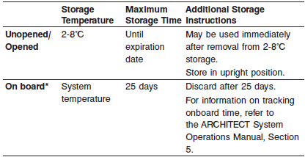

* On board stability is tracked only when the reagent kit is on board the processing module. To update the on board stability timer, a reagent scan must be performed every time a reagent kit is unloaded.

Reagents may be stored on or off the ARCHITECT iSystem. If reagents are removed from the system, store them at 2-8°C (with septums and replacement caps) in an upright position. For reagents stored off the system, it is recommended that they be stored in their original trays and boxes to ensure they remain upright. **If the microparticle bottle does not** **remain upright (with a septum installed) while in refrigerated storage** **off the system, the reagent kit must be discarded.** For information on unloading reagents, refer to the ARCHITECT System Operations Manual, Section 5.

Reagents

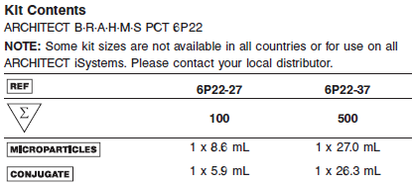

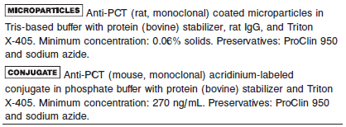

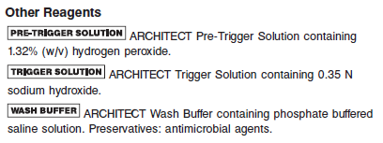

**Calibrator:** 6P22-01 ARCHITECT B∙R∙A∙H∙M∙S PCT Calibrators

**Quality Control:** 6P22-10 ARCHITECT B∙R∙A∙H∙M∙S PCT Controls or other control material

**Calibration**

**Frequency:**

Recalibration is required with each new reagent lot number.

**A new calibration is required:**

Once an ARCHITECT B∙R∙A∙H∙M∙S PCT calibration is accepted and stored, all subsequent samples may be tested without further calibration unless:

**•** A reagent kit with a new lot number is used.

**•** Daily quality control results are outside of statistically-based quality control limits, as described in the Quality Control Procedure section of this package insert, used to monitor and control system performance.

**•** If statistically-based quality control limits are not available then the calibration should not exceed a 30-day limit for recalibration frequency.

The ARCHITECT B∙R∙A∙H∙M∙S PCT assay may also need to be recalibrated after specified service procedures have been performed or maintenance to critical part or subsystems that might influence the performance of the assay.

**Calibrator Required:** 6P22-01 ARCHITECT B∙R∙A∙H∙M∙S PCT Calibrators

**Calibration Procedure:**

Test Calibrators A-F in duplicate. The calibrators should be priority loaded.

A single sample of each control level must be tested to evaluate the assay calibration. Ensure that assay control values are within the ranges specified in the respective control package insert.

**•** Calibration Range: 0.00 - 100.00 ng/mL (0.00 - 100.00 μg/L).

**Troubleshooting and Overall Acceptance Criteria Failure**

See ARCHITECT Operations Manual for further calibration troubleshooting.

**Quality Control:**

**•** The recommended control requirement for the ARCHITECT B∙R∙A∙H∙M∙S PCT assay is that a single sample of each control level be tested:

**•** Once every 24 hours each day of use

**•** After performing calibration

**•** After instrument service procedures or maintenance that may affect assay performance have been performed.

If the quality control procedures in your laboratory require more frequent use of controls to verify test results, follow your laboratory specific procedures.

**•** Additional controls may be tested in accordance with local, state, and/or federal regulations or accreditation requirements and your laboratory’s quality control policy.

**•** Each laboratory should establish control ranges to monitor the acceptable performance of the assay. If a control is out of its specified range, the associated sample results are invalid and the samples must be retested. Recalibration may be indicated.

**•** To establish statistically-based control limits, each laboratory should establish its own concentration target and ranges for new control lots at each control level. This can be accomplished by assaying a minimum of 20 replicates over several (3-5) days and using the reported results to establish the expected average (target) and variability about this average (ranges) for the laboratory. Sources of variation that should be included in this study in order to be representative of future system performance include:

**•** Multiple stored calibrations

**•** Multiple reagent lots

**•** Multiple calibrator lots

**•** Multiple processing modules

**•** Data points collected at different times of the day

**•** These results should be applied to your laboratory’s quality control practices. In addition, the laboratory must ensure that the matrix of the control material is suitable for use in the assay per the assay package insert.

**Instrument Procedure**

The ARCHITECT B∙R∙A∙H∙M∙S PCT assay file must be installed on the ARCHITECT iSystem from an ARCHITECT iSystem Assay CD-ROM prior to performing the assay.

For detailed information on assay file installation and viewing and editing assay parameters, refer to the ARCHITECT System Operations Manual, Section 2.

For information on printing assay parameters, refer to the ARCHITECT System Operations Manual, Section 5.

For a detailed description of system procedures, refer to the ARCHITECT System Operations Manual.

**Assay Procedure**

For a detailed description of how to run an assay, refer to *Section 5* of the **ARCHITECT System Operations Manual**.

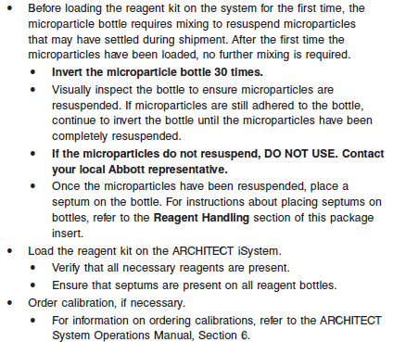

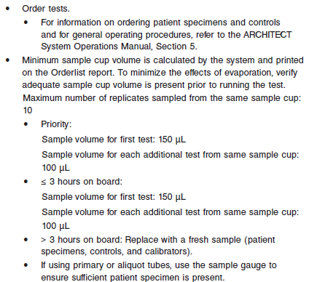

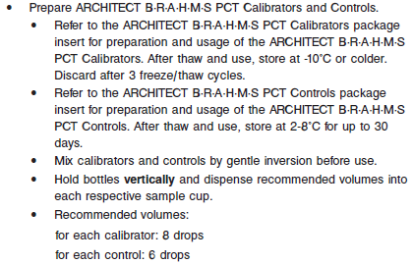

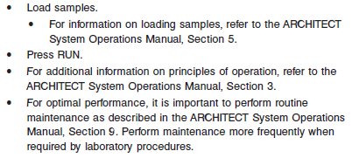

**Results**



**Interpretation of Results**

1. **Risk assessment for progression to severe sepsis and septic shock**

The ARCHITECT B∙R∙A∙H∙M∙S PCT assay is intended to aid in the risk assessment of critically ill patients on their first day of ICU admission for progression to severe sepsis and septic shock. Systemic inflammatory response syndrome (SIRS), sepsis, severe sepsis, and septic shock were categorized according to the criteria of the consensus conference of the American College of Chest Physicians / Society of Critical Care Medicine.

PCT should always be interpreted in the clinical context of the patient. Therefore, clinicians should use the PCT results in conjunction with other laboratory findings and clinical signs of the

patient.

Data support the following interpretative risk assessment criteria:

**• PCT > 2.0 ng/mL:** A PCT level above 2.0 ng/mL on the first day of ICU admission is associated with a high risk for progression to severe sepsis and/or septic shock.

**• PCT < 0.5 ng/mL:** A PCT level below 0.5 ng/mL on the first day of ICU admission is associated with a low risk for progression to severe sepsis and/or septic shock.

Note: PCT levels below 0.5 ng/mL do not exclude an infection, because localized infections (without systemic signs) may also be associated with such low levels. If the PCT measurement is done very early after the systemic infection process has started (usually < 6 hours), these values may still be low.

Various non-infectious conditions are known to induce changes in PCT level. PCT levels between 0.5 ng/mL and 2.0 ng/mL should be interpreted in the context of the specific clinical background and condition(s) of the individual patient. It is recommended to retest PCT within 6–24 hours if any concentrations < 2.0 ng/mL are obtained.

2. **Percent change in PCT level over time to aid in the prediction of cumulative 28-day mortality in patients with severe sepsis and septic shock**

In addition to the interpretative risk assessment criteria above, the change in PCT concentration over time provides prognostic information about the risk of mortality within 28 days for patients diagnosed with severe sepsis or septic shock coming from the Emergency Department, ICU, other medical wards, or directly from outside the hospital. Mortality rates found in an observational prospective study of 858 patients diagnosed with severe sepsis or septic shock showing an overall mortality of 22%.

**•** A PCT level that declines ≤ 80% from the day that severe sepsis or septic shock was clinically diagnosed (Day 0) to 4 days after clinical diagnosis (Day 4) is associated with higher cumulative

28-day risk of all-cause mortality than a decline > 80%.

**•** The combination of the first PCT level (≤ 2.0 ng/mL or > 2.0 ng/mL) at initial diagnosis of severe sepsis or septic shock with the patient’s clinical course and the change in PCT level

over time until Day 4 provides important additional information about the mortality risk.

**•** The PCT level on Day 1 (the day after severe sepsis or septic shock is first clinically diagnosed) can be used to calculate the percent change in PCT level at Day 4 if the Day 0 measurement

is unavailable.

Data support the use of PCT determinations from the day severe sepsis or septic shock is first diagnosed (Day 0) or day thereafter (Day 1) and the fourth day after diagnosis (Day 4) for the classification of patients into higher and lower risk for mortality within 28 days according to the workflow below:

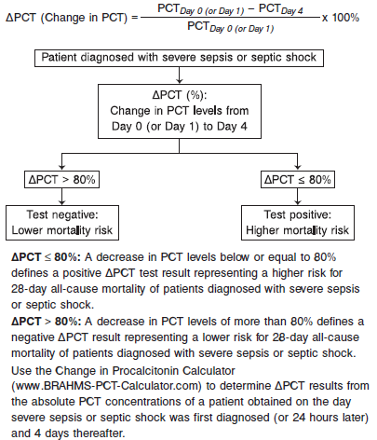

3. **Decision making on antibiotic therapy for patients with suspected or confirmed LRTI Initiation:**

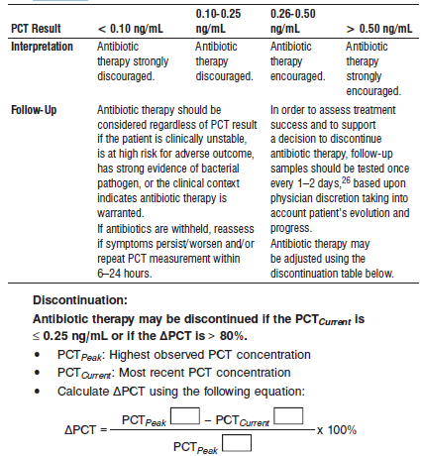

Antibiotic therapy may be continued based upon other clinical findings, such as apparent progression on chest x-ray or ongoing/ increasing toxicity.

**If clinical picture has not improved and PCT remains high, reevaluate and consider treatment failure or other causes.**

4. **Decision making on antibiotic discontinuation for suspected or confirmed septic patients**

In order to assess treatment success and to support a decision to discontinue antibiotic therapy, follow-up samples should be tested once every 1–2 days, based upon physician discretion taking into account the patients’ evolution and progress. Antibiotic therapy may be adjusted using the discontinuation table below:

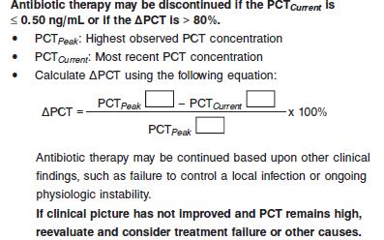

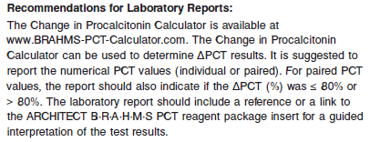

**Flags**

Some results may contain information in the Flags field. For a description of the flags that may appear in this field, refer to the ARCHITECT System Operations Manual, Section 5.

**Specific Performance Characteristics**

**Expected Values**

It is recommended that each laboratory determine its own reference range based upon its particular locale and population characteristics.

**Serum/Plasma:** < 0.10 ng/mL

**Critical Values: N/A**

**Performance Characteristics**

**Measuring Interval:**

Measuring interval is defined as the range of values in ng/mL (μg/L) which meets the limits of acceptable performance for both imprecision and bias for an undiluted sample.

The measuring interval of the ARCHITECT B∙R∙A∙H∙M∙S PCT assay is 0.02 to 100.00 ng/mL (0.02 to 100.00 μg/L). When using the 1:10 automated dilution protocol, the assay can report values up to 1000.00 ng/mL (1000.00 μg/L).

**Linearity**

The ARCHITECT B∙R∙A∙H∙M∙S PCT assay demonstrated linearity from 0.02 to 100.00 ng/mL (0.02 to 100.00 μg/L).

**Sensitivity**

The highest observed Limit of Blank (LoB) value was 0.00 ng/mL, and the highest observed Limit of Detection (LoD) value was 0.00 ng/mL.

The Limit of Quantitation (LoQ) is the lowest concentration observed at ≤ 20% CV. The highest observed LoQ value was 0.01 ng/mL with the ARCHITECT B∙R∙A∙H∙M∙S PCT assay.

**Dilution:**

Specimens with a PCT value exceeding 100 ng/mL (100 μg/L) are flagged with the code “> 100 ng/mL” (“> 100 μg/L”) and may be diluted using the Automated Dilution Protocol.

**Automated Dilution Protocol**

The system performs a 1:10 dilution of the specimen and automatically calculates the concentration of the specimen before dilution and reports the result.

For detailed information on ordering dilutions, refer to the ARCHITECT System Operations Manual, Section 5.

**Precision:**

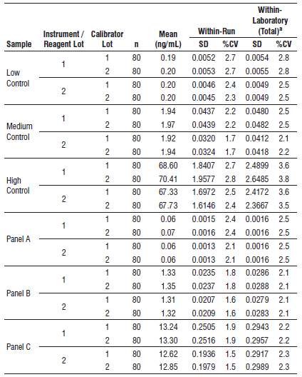

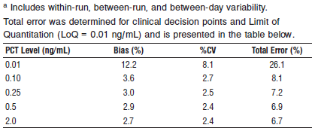

#### Limitations of Procedure

**•** Potential interference has not been evaluated for substances other than those described in the **SPECIFIC PERFORMANCE** **CHARACTERISTICS**, **Interference** section of the Package Insert.

**•** Specimens from patients who have received preparations of mouse monoclonal antibodies for diagnosis or therapy may contain human anti-mouse antibodies (HAMA). Such specimens may show either falsely elevated or depressed values when tested with assay kits such as ARCHITECT B∙R∙A∙H∙M∙S PCT that employ mouse monoclonal antibodies. Additional information may be required for diagnosis.

**•** Heterophilic antibodies in human serum can react with reagent immunoglobulins, interfering with *in vitro* immunoassays. Patients routinely exposed to animals or to animal serum products can be prone to this interference, and anomalous values may be observed. Additional information may be required for diagnosis.

**•** Rheumatoid factor (RF) in human serum can react with reagent immunoglobulins, interfering with *in vitro* immunoassays.

**Specificity**

Cross-Reactivity

The cross-reactants listed below were evaluated to determine whether PCT concentrations were affected when using the ARCHITECT B∙R∙A∙H∙M∙S PCT assay. Samples containing the cross-reactant were

prepared at 2 target PCT concentrations (0.5 and 2.0 ng/mL).

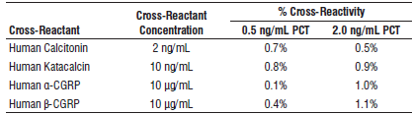

**Interference**

Potentially Interfering Drugs

The potentially interfering drugs evaluated with the ARCHITECT B∙R∙A∙H∙M∙S PCT assay were found not to affect the test performance at concentrations reasonably and consistently found in clinical situations. The drugs evaluated are presented in the table below.

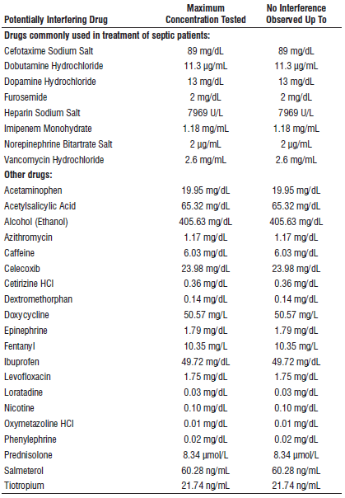

Potentially Interfering Substances

Potentially interfering substances were evaluated to determine whether PCT concentrations were affected when using the ARCHITECT B∙R∙A∙H∙M∙S PCT assay. Samples containing bilirubin, hemoglobin, total protein, and triglycerides were prepared at approximately 0 ng/mL,

0.3 ng/mL, and > 10 ng/mL PCT, and samples containing HAMA and RF were prepared at approximately 0 ng/mL, 1 ng/mL, and > 10 ng/Ml PCT. The samples were assayed, and the PCT concentrations of the spiked samples were compared to the reference samples. The observed differences for the zero level sample and the 0.3 ng/mL sample ranged from 0.00 to 0.05 ng/mL. The substances evaluated are presented in the following table.

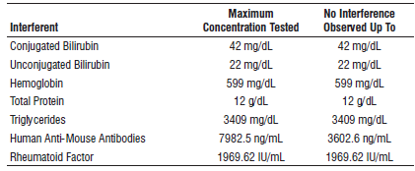

**References:**

1. ABBOTT ARCHITECT B∙R∙A∙H∙M∙S PCT package insert

Abbott Laboratories

Diagnostics Division

Abbott Park, IL 60064

June 2017 G1-0601/R01

1. Abbott ARCHITECT Operator’s Guide

**Related Documents:**

**Attachments:**