RUSH logo for emails

**SYPHILIS**

**SERUM OR PLASMA**

**ABBOTT ARCHITECT**

**Intended Use**

The ARCHITECT Syphilis TP assay is a chemiluminescent microparticle immunoassay (CMIA) for the qualitative detection of antibodies (IgG and IgM) directed against *Treponema pallidum* (TP) in human serum and plasma. The ARCHITECT Syphilis TP assay is intended to be used as an initial diagnostic test or in conjunction with a nontreponemal laboratory test and clinical findings to aid in the diagnosis of syphilis infection.

**Warning: The ARCHITECT Syphilis TP assay is not intended for use in screening blood, plasma, or tissue donors.** Theeffectiveness of the ARCHITECT Syphilis TP assay for use inscreening blood, plasma, or tissue donors has not been established.

**Clinical Significance**

Syphilis is caused by infection with the bacterium *Treponema pallidum* (TP), which is transmitted primarily by sexual contact orcongenitally. The disease can present in different clinically definedstages (primary, secondary, latent, and tertiary); the latent phase isasymptomatic.

Upon infection with TP, an immune response develops that is directed not only against antigens specific to TP but also antigens released during the TP-mediated cellular damage. Two types of tests have been developed as aids to diagnose syphilis, treponemal and nontreponemal. A positive treponemal test result is an indication for an acute, latent, or past infection with TP. Nontreponemal tests are especially valuable for monitoring disease activity and therapy response. It is common practice that reactive test results of either a treponemal or nontreponemal test are confirmed by a test of the complementary test type to enhance diagnostic accuracy. The ARCHITECT Syphilis TP assay is a treponemal test that detects IgG and IgM antibodies to TP. Two different algorithms, which combine a treponemal with a nontreponemal test, are used as aid in diagnosis of syphilis. The algorithm starting with the treponemal test is called reverse screening algorithm and has been implemented in laboratories due to the availability of automated treponemal tests. Samples reactive in a treponemal test are subjected to a

nontreponemal supplementary test (e.g., Rapid Plasma Reagin [RPR]). The reverse screening algorithm for syphilis testing can identify persons previously treated for syphilis and those with untreated or incompletely treated syphilis. Discordant treponemalreactive, RPR-nonreactive results should be reflexed to a second treponemal test (e.g., Treponema Pallidum Particle Agglutination [TP-PA]) for further evaluation.

**Principle**

The ARCHITECT Syphilis TP assay is a two-step immunoassay for the qualitative detection of antibodies (IgG and IgM) directed against TP in human serum or plasma using CMIA technology with flexible assay protocols, referred to as Chemiflex.

1. Sample, assay diluent, and recombinant TP antigen (TpN15, TpN17 and TpN47) coated microparticles are combined. Anti‑TP antibodies present in the sample bind to the TP coated microparticles.

2. After washing, anti-human IgG and IgM acridinium-labeled conjugate is added to create a reaction mixture.

3. Following another wash cycle, Pre-Trigger and Trigger Solutions are added to the reaction mixture.

4. The resulting chemiluminescent reaction is measured as relative light units (RLUs). There is a direct relationship between the amount of anti-TP antibodies in the sample and the RLUs detected by the ARCHITECT iSystem optics.

The presence or absence of anti-TP antibodies in the specimen is determined by comparing the chemiluminescent signal in the reaction to the cutoff signal determined from an active calibration. If the chemiluminescent signal in the reaction is greater than or equal to the cutoff signal, the specimen is considered reactive for anti-TP antibodies.

For additional information on system and assay technology, refer to the ARCHITECT System Operations Manual, Section 3.

**Specimen Collection and Handling**

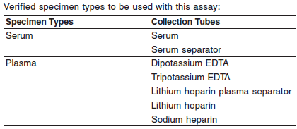

**•** Other specimen collection tube types have not been tested with this assay.

**•** Performance has not been established for the use of cadaveric specimens or the use of body fluids other than serum or plasma.

**•** Liquid anticoagulants may have a dilution effect resulting in lower concentrations for individual patient specimens.

**•** The instrument does not provide the capability to verify specimen type. It is the responsibility of the operator to verify that the correct specimen types are used in the assay.

Do not use specimens with the following conditions:

**•** heat-inactivated

**•** grossly hemolyzed (> 500 mg/dL hemoglobin)

**•** obvious microbial contamination

For optimal results, serum and plasma specimens should be free of fibrin, red blood cells or other particulate matter.

**Preparation for Analysis**

**•** Follow the tube manufacturer’s processing instructions for collection tubes. Gravity separation is not sufficient for specimen preparation.

**•** Frozen specimens must be completely thawed before mixing

**•** Mix thawed specimens thoroughly by low speed vortexing or by inverting 10 times. Visually inspect the specimens. If layering or stratification is observed, continue mixing until specimens are visibly homogeneous.

**•** To ensure consistency in results, centrifuge specimens before testing if

**•** they contain fibrin, red blood cells, or other particulate matter,

**•** they require repeat testing, or

**•** they were frozen and thawed.

**•** Examples of acceptable time and force ranges that meet this criterion are listed in the table below. Centrifugation time using alternate Relative Centrifugal Force values (RCF) can be calculated using the following formula:

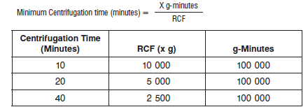

**•** Transfer clarified specimen to a sample cup or secondary tube for testing. Centrifuged specimens with a lipid layer on the top must be transferred to a sample cup or secondary tube. Care must be taken to transfer only the clarified specimen without the lipemic material.

**•** Inspect all specimens for bubbles. Remove bubbles with an applicator stick before analysis. Use a new applicator stick for each specimen to prevent cross contamination.

**Storage**

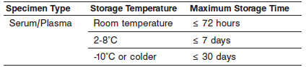

Specimens may be stored on or off the clot, red blood cells, or separator gel. For frozen storage, remove serum or plasma from the clot, red blood cells, or separator gel.

No qualitative performance differences were observed between experimental controls and 19 nonreactive or 17 spiked reactive specimens subjected to 6 freeze/thaw cycles; however, multiple freeze/thaw cycles should be avoided.

**Materials and Equipment Required**

**TEST INSTRUMENT**: Abbott ARCHITECT System

**MATERIALS PROVIDED**

8D06 ARCHITECT Syphilis TP Reagent Kit

**MATERIALS REQUIRED BUT NOT PROVIDED**

**•** ARCHITECT Syphilis TP Assay file obtained from the ARCHITECT iSystem e-Assay CD-ROM found on www.abbottdiagnostics.com.

**•** 8D06-04 ARCHITECT Syphilis TP Calibrator

**•** 8D06-13 ARCHITECT Syphilis TP Controls

**•** ARCHITECT *i* Pretrigger

**•** ARCHITECT *i* Trigger

**•** ARCHITECT *i i* Wash Buffer

**•** ARCHITECT *i* Reaction Vessels

**•** ARCHITECT *i* Sample Cups

**•** ARCHITECT *i* Septums

**•** ARCHITECT *i* Replacement Caps

**•** Pipettes or pipette tips (optional) to deliver the specified volumes.

**Reagent Handling and Storage:**

**CAUTION:** This product requires the handling of human specimens.

It is recommended that all human sourced materials be considered potentially infectious and be handled in accordance with the OSHA Standard on Bloodborne Pathogens. Biosafety Level 2 or other appropriate biosafety practices should be used for materials that contain or are suspected of containing infectious agents.

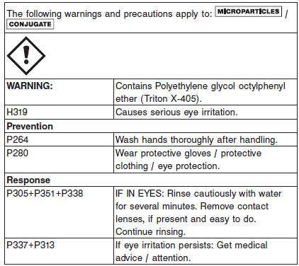

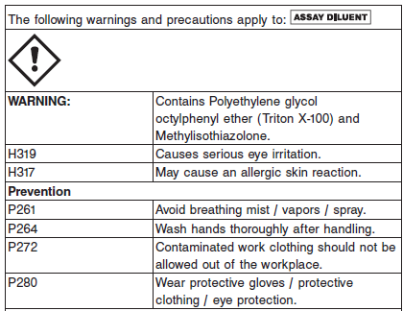

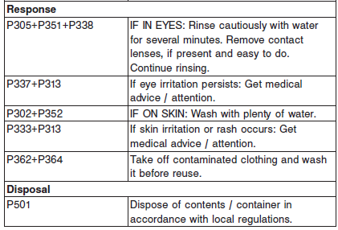

Microparticles and Conjugate contain sodium azide. Contact with acids liberates very toxic gas. This material and its container must be disposed of in accordance with local regulations.

**Reagent Handling**

**•** Do not use reagent kits beyond the expiration date.

**• Do not pool reagents within a kit or between kits.**

**•** Before loading the reagent kit on the system for the first time, the microparticle bottle requires mixing to resuspend microparticles that may have settled during shipment. For microparticle mixing instructions, refer to the **PROCEDURE, Assay Procedure** section of the package insert.

**• Septums MUST be used to prevent reagent evaporation and contamination and to ensure reagent integrity. Reliability of assay results cannot be guaranteed if septums are not used according to the instructions in this package insert.**

**•** To avoid contamination, wear clean gloves when placing a septum on an uncapped reagent bottle.

**•** Once a septum has been placed on an open reagent bottle, **do not invert the bottle** as this will result in reagent leakage and may compromise assay results.

**•** Over time, residual liquids may dry on the septum surface. These are typically dried salts and have no effect on assay efficacy.

**•** When handling conjugate vials, change gloves that have contacted human serum or plasma, since introduction of human IgG/IgM will result in a neutralized conjugate.

For a detailed discussion of handling precautions during system operation, refer to the ARCHITECT System Operations Manual, Section 7.

**Reagent Storage**

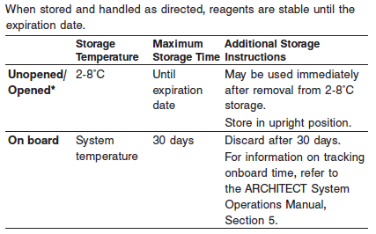

* Reagents may be stored on or off the ARCHITECT iSystem. If reagents are removed from the system, store them at 2-8°C (with septums and replacement caps) in an upright position. For reagents stored off the system, it is recommended that they be stored in their original trays and boxes to ensure they remain upright. **If the** **microparticle bottle does not remain upright (with a septum** **installed) while in refrigerated storage off the system, the reagent** **kit must be discarded.** For information on unloading reagents, refer to the ARCHITECT System Operations Manual, Section 5.

Reagents

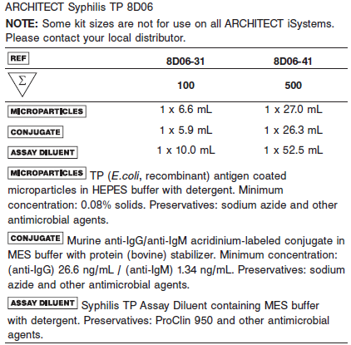

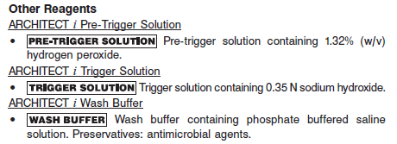

**Calibrator:** 8D06-04 ARCHITECT Syphilis TP Calibrator

**Quality Control:** 8D06-13 ARCHITECT Syphilis TP Controls

**Calibration**

**Frequency:**

Recalibration is required with each new reagent lot number.

**A new calibration is required:**

1. If quality control results do not meet acceptance criteria defined by your laboratory, patient values may be suspect. Follow the established quality control procedures for your laboratory. Recalibration may be necessary.
2. Review quality control results and acceptance criteria following a change of reagent or calibrator lot.

**Calibrator Required:**

8D06-04 ARCHITECT Syphilis TP Calibrator

**Reagents:**

1 Bottle (4.0 mL) of ARCHITECT Syphilis TP Calibrator is prepared in recalcified human plasma (inactivated); reactive for anti-TP.

Preservatives: Sodium Azide and other Antimicrobial Agents.

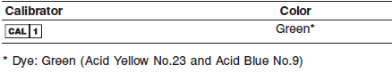

**Calibrator Preparation:**

**•** Calibrator is stable until the expiration date when stored and handled as directed.

**•** Do not use past expiration date.

**•** Calibrator must be stored at 2-8°C in an upright position and may be used immediately after removal from 2-8°C storage.

**Calibration Procedure:**

**•** Test the calibrator in replicates of three. The calibrator should be priority loaded.

A single sample of each control level must be tested to evaluate the assay calibration. Ensure that assay control values are within the ranges specified in the respective control package insert.

**Troubleshooting and Overall Acceptance Criteria Failure**

See ARCHITECT Operations Manual for further calibration troubleshooting.

**Quality Control:**

Abbott recommends, refer to your laboratory standard operating procedure(s) and/or quality assurance plan for additional quality control requirements and potential corrective actions:

• At a minimum a single control of each quality control level is to be run every 24 hours

• If more frequent control monitoring is required, follow the established quality control procedures for your laboratory.

• If quality control results do not meet the acceptance criteria defined by your laboratory, patient values may be suspect. Follow the established quality control procedures for your laboratory.

Recalibration may be necessary.

• Review quality control results and acceptance criteria following a change of reagent or calibrator lot.

**Instrument Procedure**

* The ARCHITECT Syphilis TP assay file must be installed on the ARCHITECT iSystem from an ARCHITECT iSystem Assay CD-ROM prior to performing the assay.
* For detailed information on assay file installation and viewing and editing assay parameters, refer to the ARCHITECT System Operations Manual, Section 2.
* For information on printing assay parameters, refer to the ARCHITECT System Operations Manual, Section 5.
* For a detailed description of system procedures, refer to the ARCHITECT System Operations Manual.

**Assay Procedure**

For a detailed description of how to run an assay, refer to *Section 5* of the **ARCHITECT System Operations Manual**.

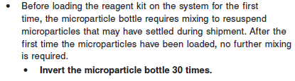

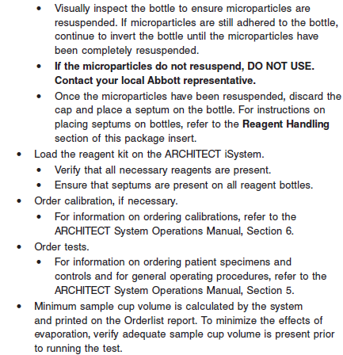

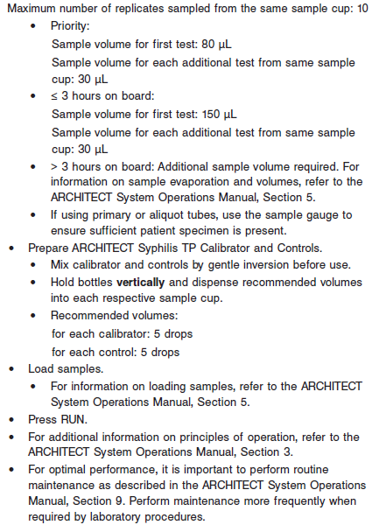

**Results**

The ARCHITECT iSystem calculates the cutoff (CO) using the mean chemiluminescent signal (RLU) from three replicates of the Calibrator 1 and stores the result.

**Calculation**

The ARCHITECT Syphilis TP assay calculates a result based on a cutoff determined by the following calculation.

**•** Cutoff RLU = Calibrator Mean RLU x 0.20

**•** The cutoff RLU is stored for each reagent lot calibration.

**•** S/CO = Sample RLU/Cutoff RLU

**Interpretation of Results**

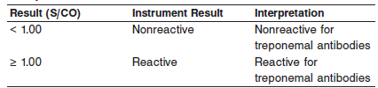

Test results are intended to aid in diagnosis only. As with all serological tests for syphilis, results should always be interpreted in conjunction with additional treponemal or nontreponemal serologic test results (as appropriate), the patient’s clinical symptoms, medical history, and other clinical and/or laboratory findings to produce a diagnosis of syphilis by disease stage.

Diagnostic considerations should be based on treponemal and nontreponemal testing as described in the Centers for Disease Control and Prevention (CDC) Sexually Transmitted Diseases Treatment Guidelines, 2015.

**Flags**

Some results may contain information in the Flags field. For a description of the flags that may appear in this field, refer to the ARCHITECT System Operations Manual, Section 5.

**Specific Performance Characteristics**

**Expected Values**

Due to geographic locations or demographics, assay results obtained in individual laboratories may vary from data presented. A total of 1145 specimens prospectively collected from the intended use population were tested using the ARCHITECT Syphilis TP assay; 673 (58.8%) were female and 472 (41.2%) were male. The mean age was 35 years (age range: 6 to 91 years).

The ARCHITECT Syphilis TP assay was reactive in 163 (14.2%) of the prospectively collected specimens in the intended use population. Testing of the specimens was performed at three clinical testing sites located in in San Antonio, Texas; Baltimore, Maryland; and Temple, Texas.

The distribution of ARCHITECT Syphilis TP reactive and nonreactive results by age and gender is summarized in the following table.

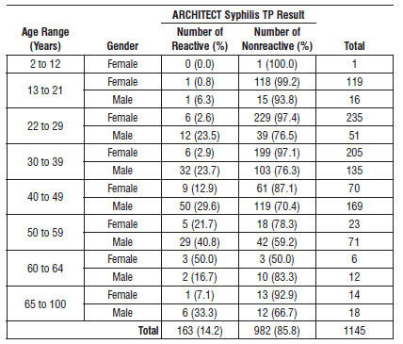

The ARCHITECT Syphilis TP results for each category in the intended use population are summarized in the following table

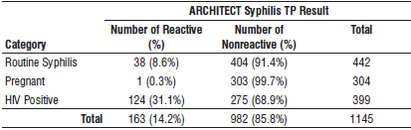

**Serum/Plasma:**

< 1.0 = Non Reactive

> 1.0 = Reactive

**Critical Values: N/A**

**Performance Characteristics**

See information in the **SPECIFIC PERFORMANCE CHARACTERISTICS** section of the package insert.

**Analytical Specificity**

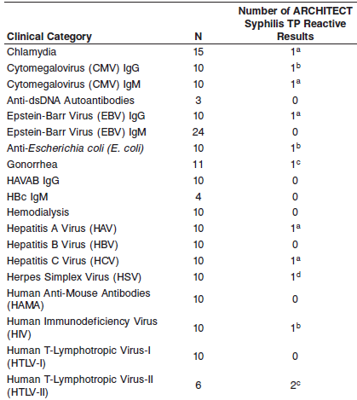

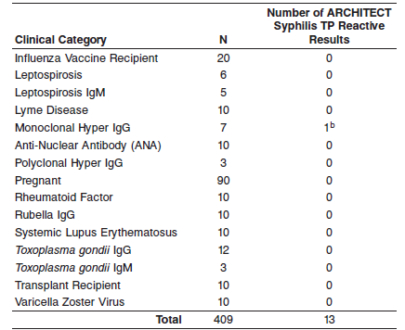

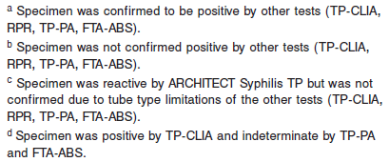

**Dilution:**

Specimens cannot be diluted for the ARCHITECT Syphilis TP assay.

**Precision:**

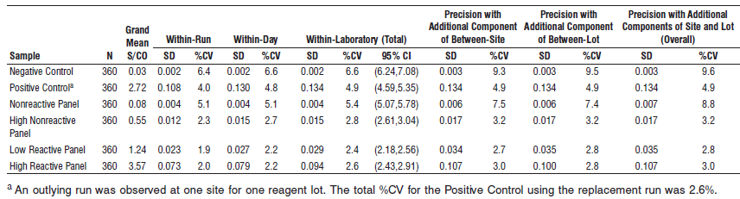

**Within Run Precision:**

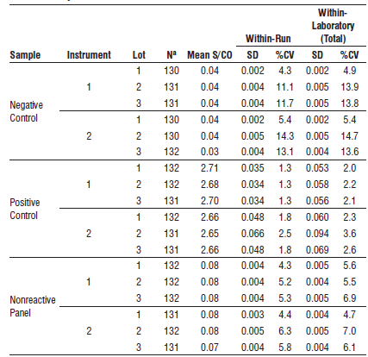

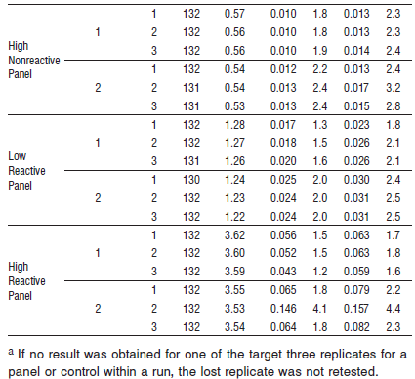

#### Limitations of Procedure

**•** If the ARCHITECT Syphilis TP results are inconsistent with clinical evidence, additional testing is suggested to confirm the result.

**•** A reactive test result for treponemal antibodies is not diagnostic of syphilis without additional serologic testing and a full clinical evaluation.

**•** False reactive results can be expected with any test kit. The proportion of these falsely reactive specimens is dependent upon the specificity of the test kit, specimen integrity, and the characteristics of the local population being screened.

**•** A nonreactive treponemal test result does not exclude the possibility of exposure to or infection with syphilis. Antibodies may be at low or undetectable levels in incubating or early primary disease and in some clinical conditions.

**•** Results in samples from immunosuppressed patients or from patients with disorders leading to immunosuppression should be interpreted with caution.

**•** The detection of treponemal antibodies may indicate recent, past, or successfully treated syphilis. This test cannot distinguish between active and treated infection, and therefore may not be used to determine response to therapy, relapse, or reinfection.

**•** Assay interference due to circulating antibodies against yaws, pinta, and bejel has not been evaluated. Cross-reactivity with these treponemal disease conditions is to be expected.

**See the Reagent Package Insert for information on Clinical Performance**

**Interference**

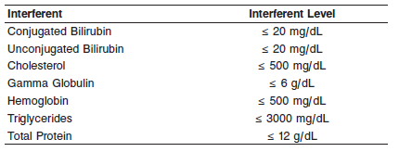

**References:**

1. ABBOTT ARCHITECT Syphilis package insert

Abbott Laboratories

Diagnostics Division

Abbott Park, IL 60064

June 2016 G5-6810/ R01

1. ABBOTT ARCHITECT Syphilis Calibrator package insert

Abbott Laboratories

Diagnostics Division

Abbott Park, IL 60064

1. Abbott ARCHITECT Operator’s Guide

**Related Documents:**

**Attachments:**