RUSH logo for emails

**TOTAL PSA**

**SERUM**

**ABBOTT ARCHITECT**

**Intended Use**

The ARCHITECT Total PSA assay is a Chemiluminescent Microparticle Immunoassay (CMIA) for the quantitative determination of total PSA (both free PSA and PSA complexed to alpha-1-antichymotrypsin) in human serum:

1. As an aid in the detection of prostate cancer when used in conjunction with digital rectal exam (DRE) in men 50 years or older. Prostatic biopsy is required for diagnosis of cancer.

2. As an adjunctive test to aid in the management of prostate cancer patients.

**Clinical Significance**

Prostate specific antigen (PSA), a member of the human kallikrein gene family, is a serine protease with chymotrypsin-like activity. The mature form of PSA is a single chain glycoprotein of 237 amino acids containing 7-8% carbohydrate as a single N-linked oligosaccharide side chain. PSA has a molecular weight of approximately 30,000 daltons. The major site of PSA production is the glandular epithelium of the prostate. PSA has also been found in breast cancers, salivary gland neoplasms, periurethral and anal glands, cells of the male urethra, breast milk, blood and urine.PSA produced in the prostate is secreted into the seminal fluid in high concentrations. A major function of PSA is the proteolytic cleavage of gel-forming proteins in the seminal fluid, resulting in the liquification of the seminal gel and increased sperm mobility. Low levels of PSA are found in the blood as a result of leakage of PSA from the prostate gland. Increasing levels of serum PSA are associated with prostatic pathology, including prostatitis, benign prostatic hyperplasia (BPH), and cancer of the prostate. PSA occurs in three major forms in blood. The major immunodetectable form is PSA complexed with the serine protease inhibitor, alpha‑1‑antichymotrypsin (PSA-ACT). Uncomplexed, or free PSA, is the other immunodetectable form of PSA in serum. The majority of free PSA in serum appears to be an inactive form that cannot complex with protease inhibitors and may be either a PSA zymogen or an enzymatically‑inactive, cleaved form of PSA. Equimolar-response PSA assays have an equivalent response to both free PSA and PSA-ACT.1 The ARCHITECT Total PSA assay is an equimolar assay. A third form of PSA, a complex with

alpha‑2‑macroglobulin, is not detectable with current immunoassays for PSA due to the engulfment and subsequent masking of PSA epitopes by the alpha‑2-macroglobulin molecule. Prostate cancer is the most frequently diagnosed cancer and the second leading cause of cancer deaths in men in the United States. Early diagnosis of carcinoma of the prostate is hindered by the lack of symptoms in men with localized tumors. Therefore, early detection requires a simple, safe, and inexpensive test for the disease in asymptomatic men. The traditional method for detection of prostate cancer is the digital rectal examination (DRE). However, only 30 to 40% of cancers detected by DRE screening are expected to be confined to the prostate. The frequent finding of locally advanced prostate cancer in screened patients may be due to the inability of DRE to detect tumors of small volume that are most likely to be confined to the prostate. Since patients with small tumors are believed to have the best prognosis, it can be concluded that DRE has limited sensitivity in detecting those tumors with the greatest potential for cure.

In a 1990 publication by Cooner *et al.*, data was presented regarding the clinical use of other diagnostic modalities such as prostate ultrasonography and serum prostate specific antigen for early detection of prostate cancer. This study found that there was a significant increase in predictability for cancer when the DRE and PSA tests were abnormal. Several other studies have shown that the measurement of serum PSA concentrations offers several advantages in the early detection of prostate cancer. The procedure is more acceptable to patients, the result is objective and quantitative, and is independent of the examiners skill. In several recent studies of healthy men 50 years or older, serum PSA levels had the greatest ability to predict prostate cancer. These studies concluded that not only is serum PSA measurement a useful addition to rectal examination and ultrasonography in the detection of prostate cancer, but that it is also the most accurate of the three tests for this purpose. In January 1992, the American Urological Association endorsed annual examination with DRE and PSA, for early detection of prostate cancer, beginning at age 50. This was reaffirmed by the American Cancer Society in November 1992. The combined use of DRE and PSA has been shown to result in an increased detection of early stage prostate cancer; however, the benefit of early detection on patient outcome has not been proven and is the subject of ongoing clinical trials. PSA testing can have significant value in detecting metastatic or persistent disease in patients following surgical or medical treatment of prostate cancer. Persistent elevation of PSA following treatment, or an increase in a post-treatment PSA level is indicative of recurrent or residual disease. PSA testing is widely accepted as an adjunctive test in the management of prostate cancer patients.

**Principle**

The ARCHITECT Total PSA assay is a two-step immunoassay to determine the presence of total PSA (both free PSA and PSA complexed to alpha‑1‑antichymotrypsin) in human serum, using Chemiluminescent Microparticle Immunoassay (CMIA) technology with flexible assay protocols, referred to as Chemiflex. In the first step, sample and anti-PSA coated paramagnetic microparticles are combined. PSA present in the sample binds to the anti-PSA coated microparticles. After washing, anti-PSA acridinium-labeled conjugate is added in the second step. Pre-Trigger and Trigger Solutions are then added to the reaction mixture; the resulting chemiluminescent reaction is measured as relative light units (RLUs). A direct relationship exists between the amount of total PSA in the sample and the RLUs detected by the ARCHITECT *i*\* optical system.

For additional information on system and assay technology, refer to the ARCHITECT System Operations Manual, Section 3.

* *i* = immunoassay

**Specimen Collection and Handling**

**Suitable Specimens**

* Only human serum may be used in the ARCHITECT Total PSA assay. Follow the tube manufacturer’s processing instructions for serum collection tubes.
* It is recommended to obtain specimens for PSA testing prior to procedures involving manipulation of the prostate.
* Ensure that complete clot formation in serum specimens has taken place prior to centrifugation. Some specimens, especially those from patients receiving anticoagulant or thrombolytic therapy may exhibit increased clotting time. If specimens are centrifuged before a complete clot forms, the presence of fibrin or particulate matter may cause erroneous results. Centrifuge specimens containing fibrin, red blood cells, or particulate matter. Note that interfering levels of fibrin may be present in samples that do not have obvious or visible particulate matter.

Do not use specimens with the following conditions:

**•** grossly hemolyzed

**•** obvious microbial contamination

**Storage**

Specimens may be stored for up to 24 hours at 2-8°C prior to being tested. If testing will be delayed more than 24 hours, specimens should be removed from the clot or serum separator and stored frozen

at -20°C or colder.

**NOTE:** Samples which may be tested for free PSA should be removed from the clot within 3 hours. Multiple freeze-thaw cycles of specimens should be avoided.

ARCHITECT Total PSA Calibrators and Controls should be mixed by gentle inversion prior to use.

**NOTE:** Stored specimens must be inspected for particulates. If present, mix and centrifuge the specimen to remove particulates prior to testing.

**Materials and Equipment Required**

**TEST INSTRUMENT**: Abbott ARCHITECT System

**MATERIALS PROVIDED**

6C06 ARCHITECT Total PSA Reagent Kit

**MATERIALS REQUIRED BUT NOT PROVIDED**

**•** ARCHITECT *i* System

**•** ARCHITECT Total PSA Assay file, may be obtained from:

**•** ARCHITECT *i* System e-Assay CD-ROM found on www.abbottdiagnostics.com

**•** ARCHITECT *i* System Assay CD-ROM

**•** 6C06-01 ARCHITECT Total PSA Calibrators

**•** 6C07-10 ARCHITECT Total PSA Controls or other commercially available control material

**•** 7D82-50 Multi-Assay Manual Diluent

**•** ARCHITECT *i* Pretrigger

**•** ARCHITECT *i* Trigger

**•** ARCHITECT *i i* Wash Buffer

**•** ARCHITECT *i* Reaction Vessels

**•** ARCHITECT *i* Sample Cups

**•** ARCHITECT *i* Septums

**•** ARCHITECT *i* Replacement Caps

**•** Pipettes or pipette tips (optional) to deliver the specified volumes.

**Reagent Handling and Storage:**

***CAUTION*:**

* For in vitro diagnostic use.

**CAUTION:** This product requires the handling of human specimens.

It is recommended that all human sourced materials be considered

potentially infectious and be handled in accordance with the OSHA

Standard on Bloodborne Pathogens. Biosafety Level 2 or other appropriate biosafety practices should be used for materials that contain or are suspected of containing infectious agents.

**Reagent Handling**

* Do not use reagent kits beyond the expiration date.
* **Do not pool reagents within a kit or between reagent kits.**
* Before loading the ARCHITECT Reagent Kit on the system for the first time, the microparticle bottle requires mixing to resuspend microparticles that have settled during shipment.
* **Septums MUST be used to prevent reagent evaporation and contamination and to ensure reagent integrity. Reliability of assay results cannot be guaranteed if septums are not used according to the instructions in the package insert.**
* To avoid contamination, wear clean gloves when placing a septum on an uncapped reagent bottle.
* Once a septum has been placed on the reagent bottle, **do not invert the bottle** as this will result in reagent leakage and maycompromise assay results.
* Over time, residual liquids may dry on the septum surface. These are typically dried salts and have no effect on assay efficacy.
* For a detailed discussion of handling precautions during system operation, refer to the ARCHITECT System Operations Manual, Section 7.

**Reagent Storage**

* The ARCHITECT Total PSA Reagent Kit must be stored at 2-8°C and may be used immediately after removal from 2‑8°C storage.
* When stored and handled as directed, reagents are stable until the expiration date.
* The ARCHITECT Total PSA Reagent Kit may be stored on-board the ARCHITECT *i* System for a maximum of 30 days. After 30 days, the reagent kit must be discarded. For information on tracking on‑board time, refer to the ARCHITECT System Operations Manual, Section 5.
* Reagents may be stored on or off the ARCHITECT *i* System. If reagents are removed from the system, store them at 2-8°C (with septums and replacement caps) in an upright position. For reagents stored off the system, it is recommended that they be stored in their original trays and boxes to ensure they remain upright.
* For information on unloading reagents, refer to the ARCHITECT System Operations Manual, Section 5.

Reagents

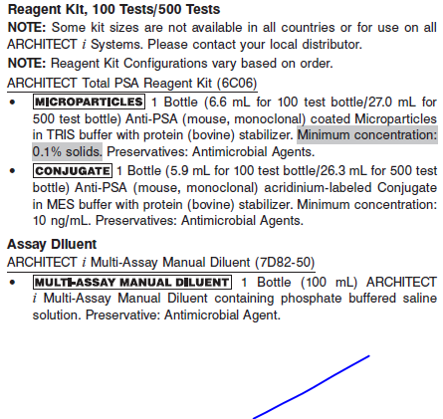

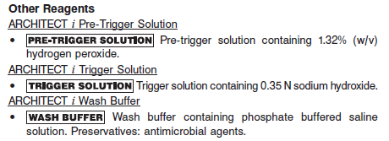

**Calibrator:** 6C06-01 ARCHITECT Total PSA Calibrators

**Quality Control:** 6C06-10 ARCHITECT Total PSA Controls or commercially available controls

**Calibration**

**Frequency:**

Recalibration is required with each new reagent lot number.

**A new calibration is required:**

1. If quality control results do not meet acceptance criteria defined by your laboratory, patient values may be suspect. Follow the established quality control procedures for your laboratory. Recalibration may be necessary.
2. Review quality control results and acceptance criteria following a change of reagent or calibrator lot.

**Calibrator Required:**

6C06-01 ARCHITECT Total PSA Calibrators

**Reagents:**

2 Bottles (4.0 mL each) of ARCHITECT Total PSA Calibrators. Calibrator 1 contains TRIS buffer with protein (bovine) stabilizer. Calibrator 2 contains PSA (human) prepared in TRIS buffer with protein (bovine) stabilizer. Preservatives: Sodium Azide and Antimicrobial Agents.

**Calibrator Preparation:**

Ready to use.

**Calibration Procedure:**

To perform an ARCHITECT Total PSA calibration, test calibrators 1 and 2 in duplicate. A single sample of all levels of total PSA controls must be tested to evaluate the assay calibration. Ensure that assay control values are within the concentration ranges specified in the control package insert. Calibrators should be priority loaded.

**•** Calibration range: 0 - 50 ng/mL.

**•** The assay protocol allows for the range to be extended to 100 ng/mL.

**Troubleshooting and Overall Acceptance Criteria Failure**

See ARCHITECT Operations Manual for further calibration troubleshooting.

**Quality Control:**

Abbott recommends, refer to your laboratory standard operating procedure(s) and/or quality assurance plan for additional quality control requirements and potential corrective actions:

• At a minimum a single level of quality control are to be run every 24 hours

• If more frequent control monitoring is required, follow the established quality control procedures for your laboratory.

• If quality control results do not meet the acceptance criteria defined by your laboratory, patient values may be suspect. Follow the established quality control procedures for your laboratory.

Recalibration may be necessary.

• Review quality control results and acceptance criteria following a change of reagent or calibrator lot.

**Instrument Procedure**

* The ARCHITECT Total PSA assay is designed for use on the ARCHITECT *i* System
* The ARCHITECT Total PSA assay file must be installed on the ARCHITECT *i* System from an ARCHITECT *i* System Assay CD-ROM prior to performing the assay. For detailed information on assay file installation and on viewing and editing assay parameters, refer to the ARCHITECT System Operations Manual, Section 2.
* For detailed information on assay file installation and viewing and editing assay parameters, refer to the ARCHITECT System Operations Manual, Section 2.
* For information on printing assay parameters, refer to the ARCHITECT System Operations Manual, Section 5.
* For a detailed description of system procedures, refer to the ARCHITECT System Operations Manual.

**Assay Procedure**

For a detailed description of how to run an assay, refer to *Section 5* of the **ARCHITECT System Operations Manual**.

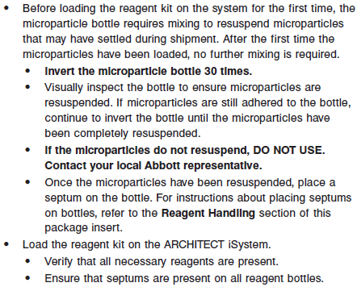

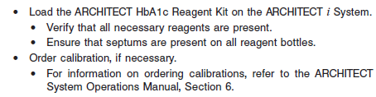

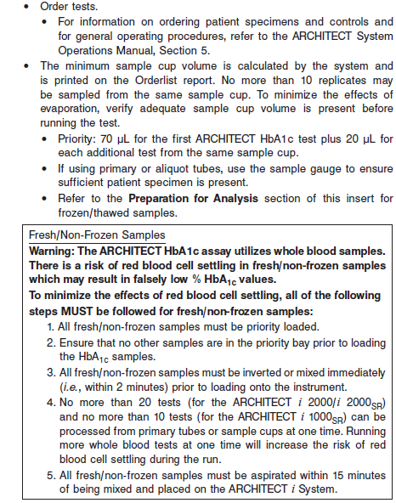

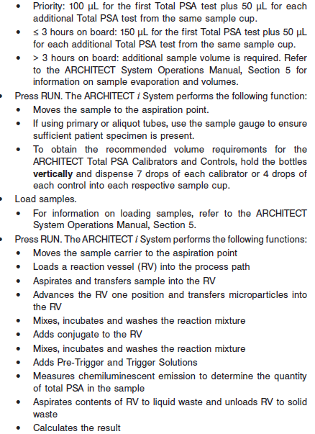

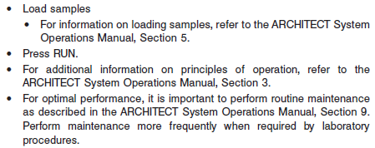

**Results**

The default result unit for the ARCHITECT Total PSA assay is ng/mL. An alternate result unit, μg/L, may be selected for reporting results by editing assay parameter “Result concentration units”, to μg/L. The conversion factor used by the system is 1.0.

**Flags**

Some results may contain information in the Flags field. For a description of the flags that may appear in this field, refer to the ARCHITECT System Operations Manual, Section 5.

**Specific Performance Characteristics**

**Expected Values**

It is recommended that each laboratory determine its own reference range based upon its particular locale and population characteristics.

**Serum/Plasma:** < 4.0 ng/mL

**Critical Values: N/A**

**Performance Characteristics**

**Measuring Interval**

The range was 0.1 ng/mL (Limit of Quantitation - LoQ) to 100.0 ng/mL.

**Sensitivity**

The ARCHITECT Total PSA assay is designed to have a functional sensitivity ≤ 0.05 ng/mL.

The ARCHITECT Total PSA assay is designed to have an analytical sensitivity of < 0.008 ng/mL.

**Limit of Blank, Limit of Detection, and Limit of Quantitation**

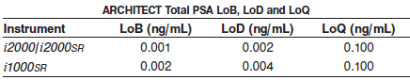

**Linearity**

The assay is linear from 0.02 ng/mL to 100.0 ng/mL with an observed deviation from linearity of not more than 10.2%.

**Dilution:**

Specimens with a total PSA value exceeding 100 ng/mL are flagged with the code “>100.000” and may be diluted using either the Automated Dilution Protocol or the Manual Dilution Procedure.

**•** If using the Automated Dilution Protocol, the system performs a 1:10 dilution of the specimen and automatically calculates the concentration of the sample before dilution and reports the result.

**•** Dilutions other than 1:10 should be done manually.

**•** For example, to perform a 1:20 dilution, add 50 μL of the patient specimen to 950 μL of ARCHITECT *i* Multi-Assay Manual Diluent (7D82-50).

**•** The operator must enter the dilution factor in the Patient or Control order screen. All assays selected for that order will be diluted. The system will use this dilution factor to automatically calculate the concentration of the sample before dilution and report the result. The dilution should be performed so that the diluted result reads greater than 0.4 ng/mL.

**•** For detailed information on ordering dilutions, refer to the ARCHITECT System Operations Manual, Section 5.

**Precision:**

The ARCHITECT Total PSA assay is designed to have a Total CV of ≤ 10%.

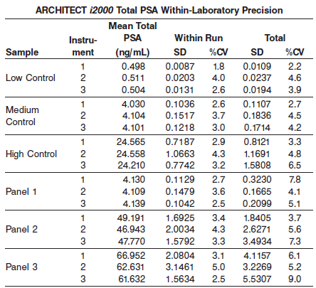.

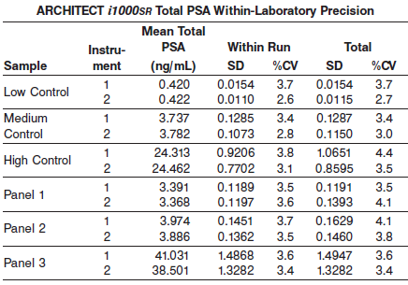

#### Limitations of Procedure

* Specimens from patients who have received preparations of mouse monoclonal antibodies for diagnosis or therapy may contain human anti-mouse antibodies (HAMA). Specimens containing HAMA may produce anomalous values when tested with assay kits that employ mouse monoclonal antibodies.
* Heterophilic antibodies in human serum can react with reagent immunoglobulins, interfering with *in vitro* immunoassays. Patients routinely exposed to animals or to animal serum products can be prone to this interference and anomalous results may be observed. Additional information may be required for diagnosis. Immunoassays are nonspecific and cross react with metabolites.
* The concentration of total PSA in a given specimen, determined with assays from different manufacturers, can vary due to differences in assay methods and reagent specificity. The results reported by the laboratory to the physician must include the identity of the total PSA assay used. Values obtained with different assay methods, including Abbott PSA assays, cannot be used interchangeably. If, in the course of monitoring a patient, the assay method used for determining total PSA levels serially is changed, additional sequential testing should be carried out. Prior to changing assays, the laboratory MUST confirm baseline values for patients being serially monitored.
* Quality control samples may be produced by introducing seminal fluid PSA into a human serum matrix. PSA in serum and seminal fluid may exist in different forms. The concentration of PSA in these controls, determined with assays from different manufacturers, can vary due to differences in assay methods, calibration, reagent specificity, and the form of PSA that is present; therefore, it is important to use assay specific values to evaluate control results.
* Hormonal therapy may affect PSA expression; therefore, a low PSA level after any treatment that includes hormonal therapy may not adequately reflect the presence of residual or recurrent disease.
* In most instances, specimens obtained from patients immediately following digital rectal examination show no clinically significant increases in PSA levels. However, prostatic massage, ultrasonography, and needle biopsy may cause clinically significant elevations. PSA levels may also be increased following ejaculation.
* Active free PSA in the serum at the time of blood sampling can continue to complex with serum protease inhibitors, especially alpha‑2-macroglobulin, resulting in a rapid decrease in PSA levels of the active form of free PSA.

**Specificity**

The analytical specificity of the ARCHITECT Total PSA assay was determined by testing sera containing the following compounds. These compounds showed less than or equal to 10% interference in the ARCHITECT Total PSA assay at the levels indicated.

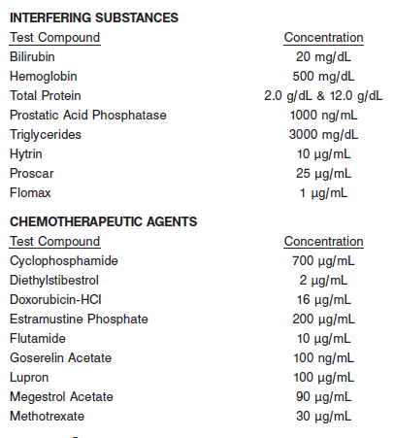

**References:**

1. ABBOTT ARCHITECT Total PSA package insert

Abbott Laboratories

Diagnostics Division

Abbott Park, IL 60064

Aug 2013 G4-3204/R13

1. ABBOTT ARCHITECT Total PSA Calibrator package insert

Abbott Laboratories

Diagnostics Division

Abbott Park, IL 60064

1. Abbott ARCHITECT Operator’s Guide

**Related Documents:**

**Attachments:**