RUSH logo for emails

**25-OH VITAMIN D**

**SERUM OR PLASMA**

**ABBOTT ARCHITECT**

**Intended Use**

The ARCHITECT 25-OH Vitamin D assay is a chemiluminescent microparticle immunoassay (CMIA) for the quantitative determination of 25-hydroxyvitamin D (25-OH vitamin D) in human serum and plasma.

The ARCHITECT 25-OH Vitamin D assay is to be used as an aid in the assessment of vitamin D sufficiency.

**Clinical Significance**

Vitamin D is a fat-soluble steroid prohormone mainly produced photochemically in the skin from 7-dehydrocholesterol. Two forms of vitamin D are biologically relevant - vitamin D3 (Cholecalciferol) and vitamin D2 (Ergocalciferol). Both vitamins D3 and D2 can be absorbed from food, with vitamin D2 being an artificial source, but only an estimated 10-20% of vitamin D is supplied through nutritional intake.1 Vitamins D3 and D2 can be found in vitamin supplements. Vitamin D is converted to the active hormone 1,25-(OH)2-vitamin D (Calcitriol) through two hydroxylation reactions. The first hydroxylation converts vitamin D into 25-OH vitamin D and occurs in the liver. The second hydroxylation converts 25-OH vitamin D into the biologically active 1,25-(OH)2-vitamin D and occurs in the kidneys as well as in many other cells of the body. Most cells express the vitamin D receptor and about 3% of the human genome is directly or indirectly regulated by the vitamin D endocrine system.

The major storage form of vitamin D is 25-OH vitamin D and is present in the blood at up to 1,000 fold higher concentration compared to the active 1,25-(OH)2-vitamin D. 25-OH vitamin D has a half-life of 2-3 weeks vs. 4 hours for 1,25-(OH)2-vitamin D. Therefore, 25-OH vitamin D is the analyte of choice for determination of the vitamin D status.

Epidemiological studies have shown a high global prevalence of vitamin D insufficiency and deficiency. Risk factors for vitamin D deficiency include low sun exposure, malnutrition, some malabsorption syndromes, and liver or kidney diseases. The measurement of vitamin D status provides opportunities for preventive and therapeutic interventions. Vitamin D deficiency is a cause of secondary hyperparathyroidism and diseases resulting in impaired bone metabolism (like rickets, osteoporosis, osteomalacia). The ARCHITECT 25-OH Vitamin D assay is standardized against NIST SRM 2972 (National Institute of Standards & Technology Standard Reference Material 2972).

**PRINCIPLE**

The ARCHITECT 25-OH Vitamin D assay is a quantitative delayed one-step competitive immunoassay to determine the presence of vitamin D in human serum and plasma using CMIA technology with flexible assay protocols, referred to as Chemiflex.

1. Sample, assay diluent and paramagnetic anti-vitamin D coated microparticles are combined. 25-OH vitamin D present in the sample is displaced from the vitamin D binding protein and binds to anti-vitamin D coated microparticles, forming an antigenantibody complex.

2. After incubation, a conjugate containing acridinium-labeled vitamin D is added to the reaction mixture and binds to unoccupied binding sites of the anti-vitamin D coated microparticles.

3. After further incubation and washing, Pre-Trigger and Trigger Solutions are added to the reaction mixture.

4. The resulting chemiluminescent reaction is measured as relative light units (RLUs). There is a relationship between the amount of 25-OH vitamin D in the sample and the RLUs detected by the ARCHITECT iSystem optics.

Results are calculated automatically based on the previously established calibration curve.

For additional information on system and assay technology, refer to the ARCHITECT System Operations Manual, Section 3.

**Specimen Collection and Handling**

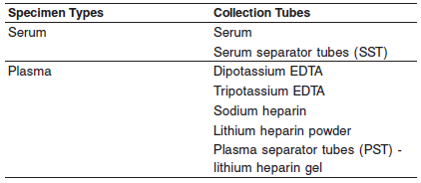

Do not use:

**•** heat-inactivated

**•** pooled

**•** grossly hemolyzed (> 500 mg/dL hemoglobin)

**•** obvious microbial contamination

**•** fungal growth

**•** Other specimen collection tube types have not been tested with this assay.

**•** Performance has not been established for the use of cadaveric specimens or the use of body fluids other than human serum or plasma.

**•** Liquid anticoagulants may have a dilution effect resulting in lower concentrations for individual patient specimens.

For optimal results, serum and plasma specimens should be free of fibrin, red blood cells or other particulate matter.

**Storage**

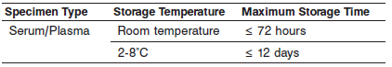

Remove serum or plasma from the clot, red blood cells, or separator gel if stored longer than the maximum room temperature storage time.

Remove serum or plasma from the clot, red blood cells, or separator gel if stored longer than the maximum 2-8°C storage time and store frozen. Storage of frozen serum samples at -20°C for up to one year has been reported to cause no loss in vitamin D metabolites. Other studies showed sample stability for longer periods than one year.

**Materials and Equipment Required**

**TEST INSTRUMENT**: Abbott ARCHITECT System

**MATERIALS PROVIDED**

5P02 ARCHITECT 25-OH Vitamin D Reagent Kit

**MATERIALS REQUIRED BUT NOT PROVIDED**

**•** ARCHITECT *i* System

**•** ARCHITECT 25-OH Vitamin D Assay file, may be obtained from:

**•** ARCHITECT *i* System e-Assay CD-ROM found on www.abbottdiagnostics.com

**•** ARCHITECT *i* System Assay CD-ROM

**•** 5P02-02 ARCHITECT 25-OH Vitamin D Calibrators (for use in

USA only)

**•** 5P02-12 ARCHITECT 25-OH Vitamin D Controls (for use in USA

only)

**•** ARCHITECT *i* Pretrigger

**•** ARCHITECT *i* Trigger

**•** ARCHITECT *i* Wash Buffer

**•** ARCHITECT *i* Reaction Vessels

**•** ARCHITECT *i* Sample Cups

**•** ARCHITECT *i* Septums

**•** ARCHITECT *i* Replacement Caps

**•** Pipettes or pipette tips (optional) to deliver the specified volumes.

**Reagent Handling and Storage:**

***CAUTION*:**

* For in vitro diagnostic use.

**CAUTION:** This product requires the handling of human specimens.

It is recommended that all human sourced materials be considered potentially infectious and be handled in accordance with the OSHA Standard on Bloodborne Pathogens. Biosafety Level 2 or other appropriate biosafety practices should be used for materials that contain or are suspected of containing infectious agents.

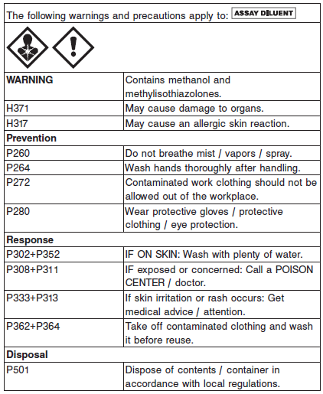

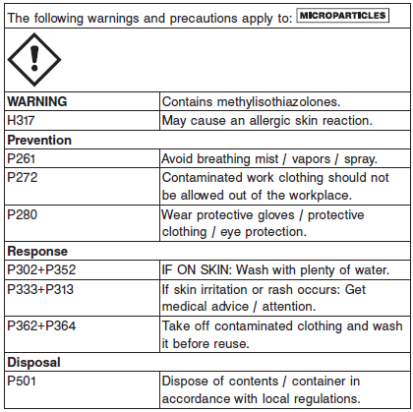

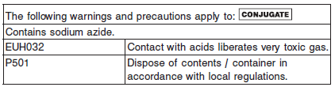

**Reagent Handling**

**•** Do not use reagent kits beyond the expiration date.

**• Do not pool reagents within a kit or between kits.**

**•** Before loading the reagent kit on the system for the first time, the microparticle bottle requires mixing to resuspend microparticles that may have settled during shipment. For microparticle mixing instructions, refer to the **PROCEDURE, Assay Procedure** section of the package insert.

**• Septums MUST be used to prevent reagent evaporation and contamination and to ensure reagent integrity. Reliability of assay results cannot be guaranteed if septums are not used according to the instructions in this package insert.**

**•** To avoid contamination, wear clean gloves when placing a septum on an uncapped reagent bottle.

**•** Once a septum has been placed on an open reagent bottle, **do not invert the bottle** as this will result in reagent leakage and may compromise assay results.

For a detailed discussion of handling precautions during system operation, refer to the ARCHITECT System Operations Manual, Section 7.

**Reagent Storage**

Do not freeze.

May be used immediately after removal from 2-8°C storage.

When stored and handled as directed, reagents are stable until the expiration date.

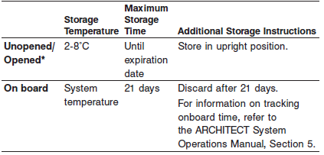

* Reagents may be stored on or off the ARCHITECT iSystem. If

reagents are removed from the system, store them at 2-8°C (with

septums and replacement caps) in an upright position. For reagents

stored off the system, it is recommended that they be stored in

their original trays and boxes to ensure they remain upright. **If the**

**microparticle bottle does not remain upright (with a septum**

**installed) while in refrigerated storage off the system, the reagent**

**kit must be discarded.** For information on unloading reagents, refer

to the ARCHITECT System Operations Manual, Section 5.

Reagents

**Kit Contents**

ARCHITECT 25-OH Vitamin D 5P02

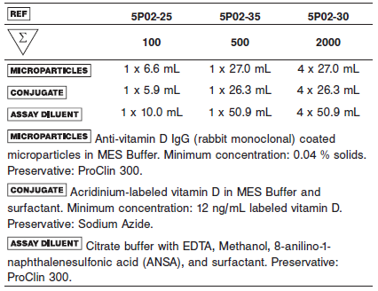

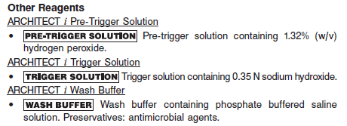

**Calibrator:** 5P02-02 ARCHITECT 25-OH Vitamin D Calibrators (for use in

USA only)

**Quality Control:** 5P02-12 ARCHITECT 25-OH Vitamin D Controls (for use in

USA only)

**Calibration**

**Frequency:**

Recalibration is required with each new reagent lot number.

**A new calibration is required:**

**The calibration is older than 30 days.**

A reagent kit with a new lot number is used.

Daily quality control results are outside of quality control limits used to monitor and control system performance.

The ARCHITECT 25-OH Vitamin D assay may also need to be recalibrated after specified service procedures have been performed or maintenance to critical part or subsystems that might influence the performance of the assay.

**Calibrator Required:** 5P02-02 ARCHITECT 25-OH Vitamin D Calibrators (for use in

USA only)

**Reagents:**

6 Bottles (4.0 mL each) of ARCHITECT 25-OH Vitamin D Calibrators.

Calibrators A-F contain PBS buffer and human serum. Calibrators B-F also contain different concentrations of 25-OH vitamin D. Preservatives: ProClin 950, Sodium Azide.

**Calibrator Preparation:**

Calibrators may be used immediately after removal from 2-8°C storage.

Prior to each use, mix by gentle inversion.

After each use, tightly close the caps and return the calibrators to 2-8°C storage.

Once opened, calibrators are stable for up to 90 days when stored and handled as directed.

**•** Do not use past expiration date.

**Calibration Procedure:**

Test Calibrators A-F in duplicate. The calibrators should be priority loaded.

A single replicate of each control level must be tested to evaluate the assay calibration.

Ensure that assay control values are within the ranges specified in the respective control package insert.

**•** Calibration Range: 0.0 - 160.0 ng/mL (0.0 - 400.0 nmol/L)

**Troubleshooting and Overall Acceptance Criteria Failure**

See ARCHITECT Operations Manual for further calibration troubleshooting.

**Quality Control:**

Abbott recommends, refer to your laboratory standard operating procedure(s) and/or quality assurance plan for additional quality control requirements and potential corrective actions:

• At a minimum a single level of each quality control are to be run every 24 hours

• If more frequent control monitoring is required, follow the established quality control procedures for your laboratory.

• If quality control results do not meet the acceptance criteria defined by your laboratory, patient values may be suspect. Follow the established quality control procedures for your laboratory.

Recalibration may be necessary.

• Review quality control results and acceptance criteria following a change of reagent or calibrator lot.

**Instrument Procedure**

The ARCHITECT 25-OH Vitamin D assay file must be installed on the ARCHITECT iSystem from an ARCHITECT iSystem Assay CD-ROM prior to performing the assay.

For detailed information on assay file installation and viewing and editing assay parameters, refer to the ARCHITECT System Operations Manual, Section 2.

For information on printing assay parameters, refer to the ARCHITECT System Operations Manual, Section 5.

For a detailed description of system procedures, refer to the

* ARCHITECT System Operations Manual.

**Assay Procedure**

For a detailed description of how to run an assay, refer to *Section 5* of the **ARCHITECT System Operations Manual**.

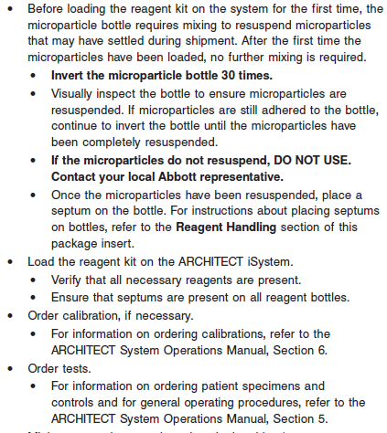

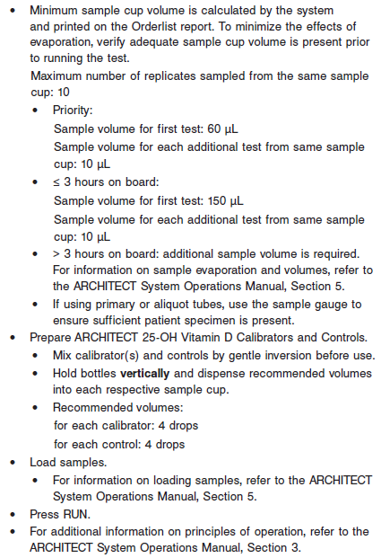

**Results**

The default result unit for the ARCHITECT 25-OH Vitamin D assay is ng/mL. The corresponding SI result unit is nmol/L. The conversion factor used by the system is 2.5.

**Flags**

Some results may contain information in the Flags field. For a description of the flags that may appear in this field, refer to the ARCHITECT System Operations Manual, Section 5.

**Specific Performance Characteristics**

**Expected Values**

It is recommended that each laboratory determine its own reference range based upon its particular locale and population characteristics.

**Serum/Plasma:** 30 – 40 mg/dL

**Critical Values: N/A**

**Performance Characteristics**

**Sensitivity**

Limit of Blank and Limit of Detection

The highest observed Limit of Blank (LoB) value was 1.6 ng/mL (4.0 nmol/L), and the highest observed Limit of Detection (LoD) value was 2.2 ng/mL (5.5 nmol/L).

Limit of Quantitation

The highest observed LoQ value at ≤ 20% CV was 2.4 ng/mL (6.0 nmol/L).

**Linearity**

The ARCHITECT 25-OH Vitamin D assay demonstrated linearity from

3.4 to 155.9 ng/mL (8.5 to 389.8 nmol/L). See information in the **SPECIFIC PERFORMANCE CHARACTERISTICS** section of the package insert.

**Dilution:**

Samples with a 25-OH vitamin D value exceeding 155.9 ng/mL (389.8 nmol/L) may be diluted using the Manual Dilution Procedure.

**Manual Dilution Procedure**

Suggested dilution: 1:2

1. Add 100 μL of the sample to 100 μL of ARCHITECT 25-OH Vitamin D Calibrator A.

2. The operator must enter the dilution factor in the Patient or Control order screen.

The system will use this dilution factor to automatically calculate the concentration of the sample before dilution and report the result. For detailed information on ordering dilutions, refer to the ARCHITECT System Operations Manual, Section 5.

**Precision:**

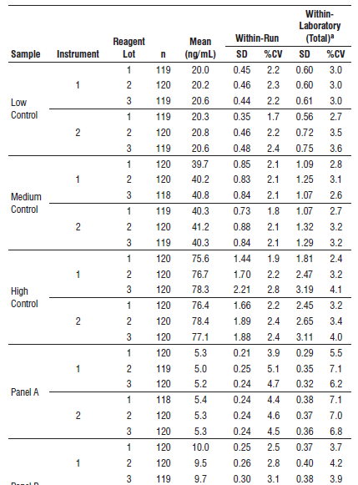

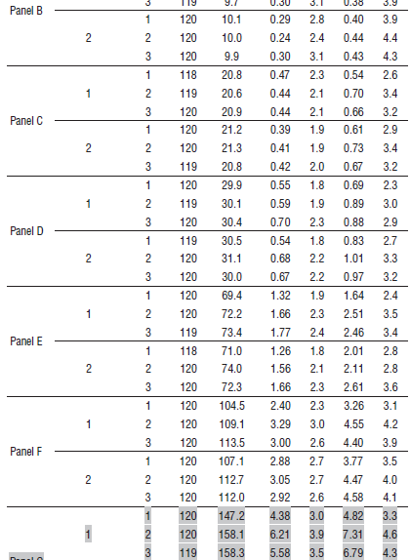

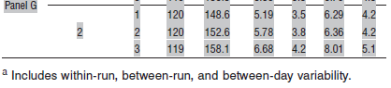

#### Limitations of Procedure

**•** When testing samples from patients whose predominant form of vitamin D is vitamin D2, such as patients receiving vitamin D2 supplementation, results that are subtherapeutic should be confirmed with another method, such as LC-MS/MS, before being used for patient management.

**•** Results should be used in conjunction with other data; e.g., symptoms, results of other tests, and clinical impressions.

**•** If the 25-OH vitamin D results are inconsistent with clinical evidence, additional testing is recommended.

**•** Specimens from patients who have received preparations of rabbit monoclonal antibodies for diagnosis or therapy may contain human anti-rabbit antibodies (HARA). Such specimens may show either falsely elevated or depressed values when tested with assay kits such as ARCHITECT 25-OH Vitamin D that employ rabbit monoclonal antibodies. Additional information may be required for diagnosis.

**•** Heterophilic antibodies in human serum can react with reagent immunoglobulins, interfering with *in vitro* immunoassays. Patients routinely exposed to animals or to animal serum products can

be prone to this interference, and anomalous values may be observed. Additional information may be required for diagnosis.

**•** Rheumatoid factor (RF) in human serum can react with reagent immunoglobulins, interfering with *in vitro* immunoassays. Additional information may be required for diagnosis.

**•** The ARCHITECT 25-OH Vitamin D assay is susceptible to interference effects from triglycerides at > 500 mg/dL. A triglyceride concentration of 800 mg/dL resulted in -13.8%, -10.2%, and -17.5% bias in results for 25-OH vitamin D concentration at approximately 20 ng/mL, 30 ng/mL, and 40 ng/mL 25-OH vitamin D, respectively.

**Specificity**

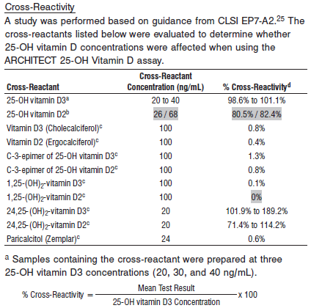

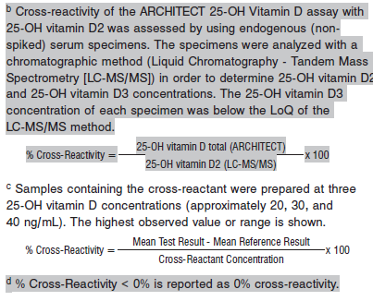

**Interference**

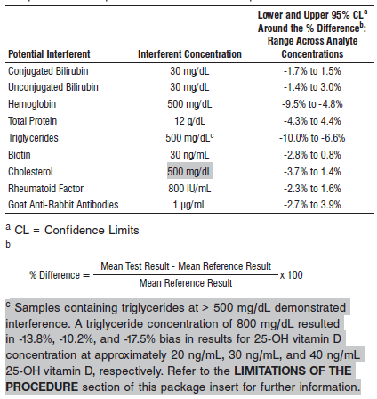

Specimens from pregnant females and hemodialysis patients were evaluated by comparing the ARCHITECT 25-OH Vitamin D results to the results generated using LC-MS/MS, which is

not susceptible to interference from these specimens.

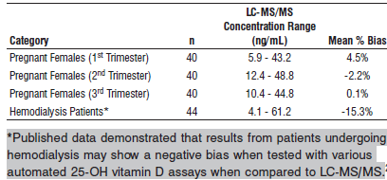

**References:**

1. ABBOTT ARCHITECT 25-OH Vitamin D package insert

Abbott Laboratories

Diagnostics Division

Abbott Park, IL 60064

Aug 2016 **G5-6832**/ **R03**

1. ABBOTT ARCHITECT 25-OH Vitamin D Calibrator package insert

Abbott Laboratories

Diagnostics Division

Abbott Park, IL 60064

1. Abbott ARCHITECT Operator’s Guide

**Related Documents:**

**Attachments:**

*.*