RUSH logo for emails

**HEMOGLOBIN A1c (ARCHITECT *c* 4000 and *c* 8000 Systems)**

**WHOLE BLOOD**

**ABBOTT ARCHITECT**

**Intended Use**

The Hemoglobin A1c assay is used in clinical laboratories for the quantitative in vitro measurement of percent hemoglobin A1c or HbA1c fraction in human whole blood and hemolysate on the ARCHITECT

*c* 4000 and *c* 8000 Systems.

Hemoglobin A1c measurements are used as an aid in the diagnosis of diabetes mellitus, to identify patients who may be at risk for developing diabetes mellitus, and for the monitoring of long-term blood glucose control in individuals with diabetes mellitus.

**WARNING:** The Hemoglobin A1c assay should not be used to diagnose diabetes during pregnancy. Hemoglobin A1c reflects the average blood glucose levels over the preceding 3 months (i.e., the average life span of a red blood cell) and therefore may be falsely low during pregnancy or any other condition associated with recent onset of hyperglycemia and/or decreased red blood cell survival.

**Clinical Significance**

HbA1c is the fraction of hemoglobin A that is first reversibly, then irreversibly glycated at one or both *N*-terminal valines of the *β*-chain. The longer red blood cells are in circulation and the higher the ambient glucose levels, the higher the concentration of HbA1c. This biology makes HbA1c a good marker for estimation of the average blood glucose levels in the preceding 3 months. The HbA1c assay is useful in the:

• diagnosis of diabetes mellitus,

• identification of patients at risk for developing diabetes, and

• monitoring of patients with diabetes mellitus.

For monitoring diabetic patients, it is recommended that glycemic goals are individualized following current professional society recommendations. As recommended by the American Diabetes Association (ADA), patients in the range of 5.7 to 6.4% HbA1c (39 to 46 mmol/mol) would be in the category of increased risk for diabetes and results ≥ 6.5% (48 mmol/mol) may aid in the diagnosis of diabetes.

Several studies, including the Diabetes Control and Complications Trial (DCCT), have shown that long-term control of diabetes can prevent complications such as cardiovascular disease, retinopathy, nephropathy, and neuropathy. Measurement of HbA1c can be invaluable in the monitoring of glycemic control of diabetic patients.

The Hemoglobin A1c assay results can be used to manually calculate the estimated Average Glucose (eAG).

This method is certifiable by the National Glycohemoglobin Standardization Program (NGSP), standardized to International Federation of Clinical Chemistry and Laboratory Medicine (IFCC), and traceable to DCCT.

**Principle**

The Hemoglobin A1c assay consists of two separate concentration measurements: glycated hemoglobin (HbA1c) and total hemoglobin (THb). The two concentrations are used to determine the percent HbA1c (NGSP units) or the hemoglobin fraction in mmol/mol (IFCC units).

The individual concentration values of HbA1c and THb generated by the Hemoglobin A1c assay are used only for calculating the percent hemoglobin A1c or HbA1c fraction, and must not be used individually for diagnostic purposes.

The anticoagulated whole blood specimen is lysed automatically on the system for the Whole Blood application or may be lysed manually using the Hemoglobin A1c Diluent ( ) for the Hemolysate application.

**Glycated Hemoglobin (HbA1c)**

The Hemoglobin A1c assay utilizes an enzymatic method that specifically measures *N*-terminal fructosyl dipeptides of the *β*-chain of HbA1c.

• In the pretreatment process, the erythrocytes are lysed and the hemoglobin is transformed to methemoglobin by reaction with sodium nitrite.

• With the addition of Reagent 1 (R1) to the sample, the glycosylated *N*-terminal dipeptide (fructosyl-VH) of the *β*-chain of hemoglobin is cleaved by the action of protease. The hemoglobin is transformed to stable methemoglobin azide by the action of sodium azide and the concentration of the hemoglobin is determined by measuring absorbance.

• Addition of Reagent 2 (R2) starts a reaction and fructosyl peptide oxidase (FPOX) is allowed to react with fructosyl-VH. The HbA1c concentration is measured by determining the resultant hydrogen peroxide.

**Total Hemoglobin (THb)**

The hemoglobin is oxidized to stable methemoglobin azide by the action of sodium nitrite and sodium azide and the concentration of the hemoglobin is determined by measuring absorbance (sample +).

**Hemoglobin A1c Calculations**16

The final result is expressed as %HbA1c (NGSP) or mmol/mol HbA1c (IFCC) and is automatically calculated by the system from the HbA1c/THb ratio as follows:

**mmol/mol HbA1c IFCC:**

HbA1c (mmol/mol) = (HbA1c/THb) × 1000

**%HbA1c DCCT/NGSP:**

HbA1c (%) = IFCC x 0.09148 + 2.152

**Methodology:** Enzymatic

**Specimen Collection and Handling**

Use only whole blood specimens collected by standard venipuncture techniques into plastic tubes. Acceptable anticoagulants are:

• Dipotassium EDTA

• Lithium heparin

• Sodium heparin

• Sodium fluoride/disodium EDTA

• Tripotassium EDTA

**Preparation for Analysis**

• Follow the tube manufacturer’s collection instructions for specimen collection tubes.

• Do not overfill specimen collection tubes. Whole blood samples greater than 78 mm in height from the bottom of tube will result in an instrument error and results will not be generated. Refer to *Section 10* of the **ARCHITECT System Operations Manual**.

• For testing whole blood samples less than 600 μL, use 12 x 75 mm polypropylene conical bottom tubes.

• **Do not centrifuge samples.**

• Visually inspect the specimens. If fibrin clots or particulate matter is observed, remove with a clean applicator stick.

• Mix all specimens thoroughly by low speed vortexing or gently inverting 10 times prior to loading onto the ARCHITECT *c* System.

• Frozen specimens must be completely thawed prior to mixing. Visually inspect the specimens. If layering or stratification is observed, continue mixing until specimens are visibly homogeneous.

**Specimen Storage**

**Serum and Plasma:**

Analyze fresh specimens if possible. If testing will be delayed, store specimens per the instructions below.

**Whole Blood**

• Specimens may be stored for:

– up to 8 hours at room temperature or

– up to 7 days at 2 to 8°C.

• If testing will be delayed more than 7 days, store at -70°C or colder.

**CAUTION: Frozen specimens must be stored at -70°C or colder.**

• Avoid more than one freeze/thaw cycle.

• **NOTE:** During storage, specimens may settle. It is good laboratory practice to mix specimens thoroughly prior to loading onto the system.

**Hemolysate**

• Hemolyzed specimens may be stored for:

– up to 4 hours at room temperature or

– up to 24 hours at 2 to 8°C.

• Do not freeze hemolyzed specimens.

• **NOTE:** During storage, hemolyzed specimens may settle. It is good laboratory practice to mix specimens thoroughly prior to loading onto the system.

**Materials and Equipment Required**

**TEST INSTRUMENT**: Abbott ARCHITECT System

**MATERIALS PROVIDED**

4P52-21 Hemoglobin A1c Reagent Kit

**MATERIALS REQUIRED BUT NOT PROVIDED**

• 4P52-02 Hemoglobin A1c Calibrators

The concentration of each calibrator is value-assigned and can change for each lot manufactured. Refer to the Hemoglobin A1c Calibrator Value Sheet.

• 4P52-10 Hemoglobin A1c Controls*

The concentration of each control is value-assigned with NGSP and IFCC values and can change for each lot manufactured. Refer to the Hemoglobin A1c Control Value Sheet.

• Commercially available whole blood controls**

• 12 x 75 mm polypropylene conical bottom tubes**

• Calibrated adjustable pipette capable of measuring 222 μL*

• Calibrated micropipette capable of measuring 10 μL*

• 1G48-04 *c* 4000/*c* 8000 Sample Probe

• Vortex (optional)

* Hemolysate application

** Whole Blood application

**Reagent Handling and Storage:**

***CAUTION*:**

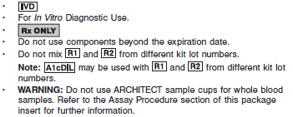

**CAUTION:** This product requires the handling of human specimens.

It is recommended that all human sourced materials be considered

potentially infectious and be handled in accordance with the OSHA

Standard on Bloodborne Pathogens. Biosafety Level 2 or other appropriate biosafety practices should be used for materials that contain or are suspected of containing infectious agents.

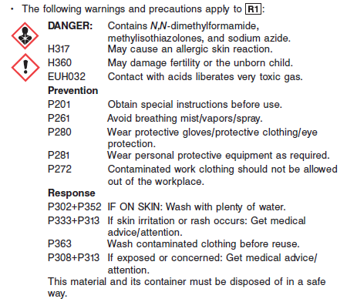

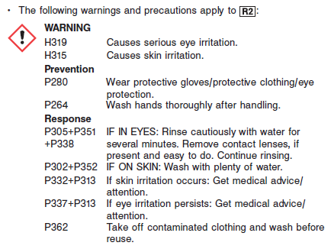

**Reagent Handling**

R1, R2, A1cDIL are ready for use.

• Remove air bubbles, if present in the reagent cartridge, with a new applicator stick. Alternatively, allow the reagent to sit at the appropriate storage temperature to allow the bubbles to dissipate.

To minimize volume depletion, do not use a transfer pipette to remove the bubbles.

**CAUTION:** Reagent bubbles may interfere with proper detection of reagent level in the cartridge, causing insufficient reagent aspiration that could impact results.

**Reagent Storage**

• Reagent stability is 50 days if the reagent is uncapped and onboard.

• Unopened reagents are stable until the expiration date when stored at 2 to 8°C.

• A1cDIL can be replaced independently of R1 or R2

Reagent Preparation:

4P52-21 Hemoglobin A1c is supplied as a liquid, ready-to-use, three-component kit which contains: **R1, R2 & A1cDIL**

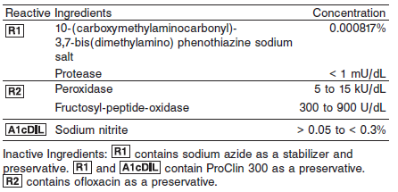

**Calibrator:** 4P52-02 Hemoglobin A1c Calibrators

**Quality Control:** Recommended - 4P52-10 Hemoglobin A1c Controls* or Commercially available whole blood controls**

* Hemolysate application

** Whole Blood application

**Calibration**

**Frequency:**

Calibration is stable for 50 days for any one lot. Calibration is required with each change in reagent lot number.

**A new calibration is required:**

1. If quality control results do not meet acceptance criteria defined by your laboratory, patient values may be suspect. Follow the established quality control procedures for your laboratory. Recalibration may be necessary.
2. Review quality control results and acceptance criteria following a change of reagent or calibrator lot.

**Calibrator Required:** 4P52-02 Hemoglobin A1c Calibrators

• Both the Whole Blood and Hemolysate applications use the Hemoglobin A1c Calibrators (4P52-02), which are supplied separately.

• Hemoglobin A1c Calibrators are traceable to NGSP and IFCC reference methods.

**Reagents:**

A1c Calibrators (lyophilized) contain hemoglobin and glycated hemoglobin from human whole blood. Prior to lyophilization, the calibrator matrix is an MES-buffered solution. CAL 1 and CAL 2 contain ofloxacin as a preservative.

**Calibrator Preparation:**

The lyophilized calibrators should be reconstituted as follows:

1. Add 1.6 mL of purified or deionized water.

2. Close bottle and allow the contents of the bottle to sit at room temperature for at least 10 minutes.

3. Mix thoroughly by low speed vortexing or by gently inverting 10 times before use. Avoid the formation of foam.

**NOTE: After reconstitution, the calibrators do not require pretreatment.**

**Calibration Procedure:**

To perform a calibration:

1. Enter the calibrator values for HbA1c and THb into the calibration file from the Hemoglobin A1c Calibrator Value Sheet.

**IMPORTANT:** Calibrator values are defined in the Configure calibrator set screen. For the Hemoglobin A1c assay, it is also necessary to configure the Blank concentration in the Configure assay parameters - Calibration screen.

2. Mix calibrators several times by gently inverting to ensure homogeneity. Avoid the formation of foam.

3. Open the bottles, place an appropriate amount of each calibrator into a separate sample cup.

4. Cap bottles and store at 2 to 8°C after use.

5. Remove air bubbles, if present in the sample cup, with a new applicator stick. To minimize volume depletion, do not use a transfer pipette to remove the bubbles.

**CAUTION:** Bubbles in calibrators may interfere with proper detection of calibrator level in the sample cup causing insufficient calibrator aspiration that could impact results.

6. Place each sample cup in the assigned position.

7. Perform calibration as indicated in *Section 6* of the **ARCHITECT System Operations Manual**.

**Troubleshooting and Overall Acceptance Criteria Failure**

See ARCHITECT Operations Manual for further calibration troubleshooting.

**Quality Control:**

Abbott recommends, refer to your laboratory standard operating procedure(s) and/or quality assurance plan for additional quality control requirements and potential corrective actions:

• Two levels of controls (normal and abnormal) are to be run every 24 hours.

– Commercially available whole blood controls for the Whole Blood application. Follow the manufacturer’s instructions for preparation of commercially available whole blood controls.

– Hemoglobin A1c Controls (4P52-10) for the Hemolysate application. Refer to the Hemoglobin A1c Control Value Sheet for NGSP and IFCC ranges.

• If more frequent control monitoring is required, follow the established quality control procedures for your laboratory.

• If quality control results do not meet the acceptance criteria defined by your laboratory, patient values may be suspect. Follow the established quality control procedures for your laboratory.

Recalibration may be necessary.

• Review quality control results and acceptance criteria following a change of reagent or calibrator lot.

**Procedure**

For a detailed description of how to run an assay, refer to *Section 5* of the **ARCHITECT System Operations Manual**.

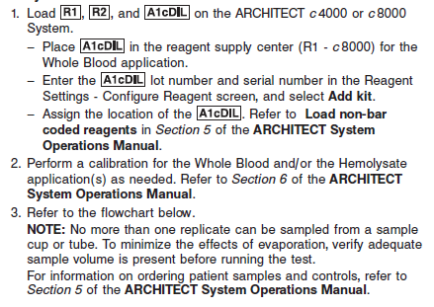

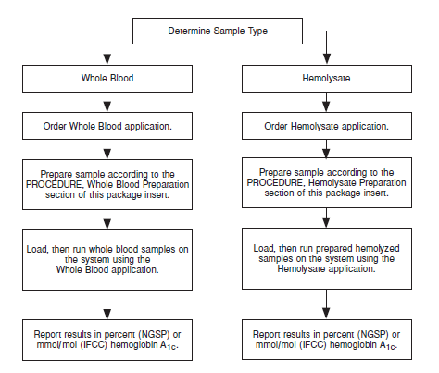

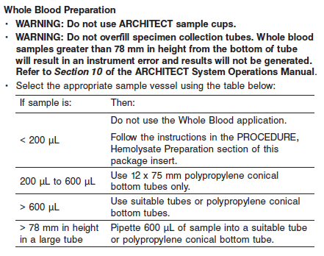

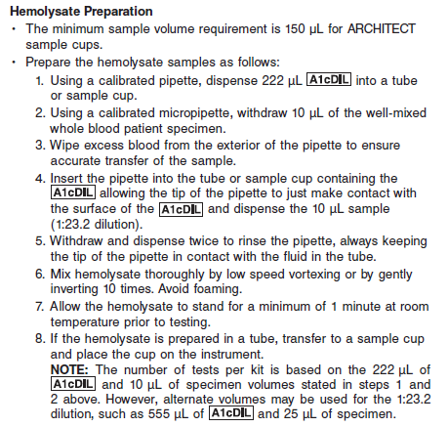

**Calculations**

Refer to *Appendix C* of the **ARCHITECT System Operations Manual** for information on results calculations.

**Reporting Results**

• The individual concentrations of the Whole Blood and Hemolysate applications are measured by the system.

**NOTE: HbA1c or THb concentrations must not be used individually for clinical purposes.**

**IMPORTANT:** Assay parameters must be configured exactly as defined in the ASSAY PARAMETERS section of the package insert.

**Conventional Units (NGSP)**

The percent HbA1c (%HbA1c) is automatically calculated by the system per the calculation provided in the Hemoglobin A1c Calculations section.

**SI Units (IFCC)**

The hemoglobin A1c fraction (mmol/mol HbA1c) is automatically calculated by the system per the calculation provided in the Hemoglobin A1c Calculations section.

**Specific Performance Characteristics**

**Reference Ranges**

It is recommended that each laboratory determine its own reference range based upon its particular locale and population characteristics.

**Whole Blood:**

As recommended by the ADA, patients in the range of 5.7 to 6.4 %HbA1c would be in the category of increased risk for diabetes and results ≥ 6.5 %HbA1c may aid in the diagnosis of diabetes.

**Critical Values: N/A**

**Performance Characteristics**

**Measuring Interval**

The measuring interval of the Hemoglobin A1c assay is 4.0 to 15.0 %HbA1c (20.22 to 140.45 mmol/mol HbA1c).

**Linearity**

IFCC

The Hemoglobin A1c assay is linear across the measuring interval of 20.22 to 140.45 mmol/mol HbA1c

NGSP

The Hemoglobin A1c assay is linear across the measuring interval of 4.0 to 15.0 %HbA1c

**Limit of Blank and Limit of Detection**

The HbA1c constituent assay had an LoB of 31.9005 μmol/L and LoD of 33.2230 μmol/L. The THb constituent assay had an LoB of 129.5129 μmol/L and LoD of 295.5947 μmol/L.

**Dilution:**

Specimens must not be diluted since the result is a calculated ratio.

**Precision:**

IFCC

The Hemoglobin A1c assay is designed to have an imprecision of SD ≤ 1.42 mmol/mol HbA1c for samples < 38.78 mmol/mol HbA1c, ≤ 3% within-laboratory (Total) %CV for samples targeted to 47.53 mmol/mol HbA1c (38.78 to 53.00 mmol/mol HbA1c, inclusive), and ≤ 5.0% within-laboratory (Total) %CV for samples > 53.00 mmol/mol HbA1c.

NGSP

The Hemoglobin A1c assay is designed to have an imprecision of SD ≤ 0.13 %HbA1c for samples < 5.7 %HbA1c, ≤ 2% within-laboratory (Total) %CV for samples targeted to 6.5 %HbA1c (5.7 to 7.0 %HbA1c, inclusive), and ≤ 3.5% within-laboratory (Total) %CV for samples > 7.0 %HbA1c. For the ARCHITECT *c* 8000 System, the data in %HbA1c (NGSP) are summarized in the following table:

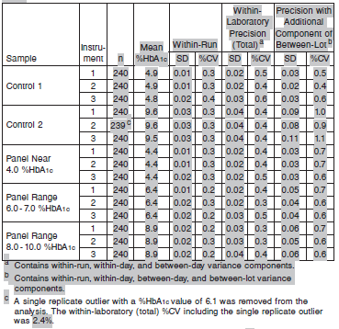

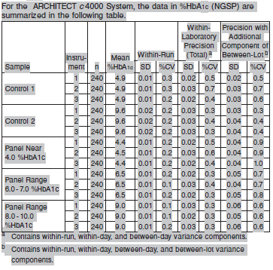

#### Limitations of Procedure

• The Hemoglobin A1c assay must not be used on the ARCHITECT *c* 16000 System.

• This assay must be performed by qualified laboratory personnel, under appropriate laboratory conditions, solely for the intended use of the assay.

• Do not centrifuge samples.

• Do not freeze specimens that have been hemolyzed with the A1cDIL.

• Whole blood specimens that require freezing must be stored at -70°C or colder.

• Do not overfill specimen collection tubes. Whole blood samples greater than 78 mm in height from the bottom of tube will result in an instrument error and results will not be generated. Refer to *Section 10* of the **ARCHITECT System Operations Manual**.

• Whole blood samples cannot be run in sample cups.

• Use specimen collection tubes, or for sample volumes < 600 μL use the 12 x 75 mm polypropylene conical bottom tubes as recommended in the Materials Required but not Provided section of the package insert.

• The observed bias for samples containing HbC, HbD, HbE, HbS and HbA2 may be impacted by the method used to determine the reference Hemoglobin A1c concentration.

• The Hemoglobin A1c assay should not be used to diagnose or monitor diabetes in patients with the following conditions:

– hemoglobinopathy but normal red blood cell turnover (e.g., sickle cell trait)

– abnormal red blood cell turnover (e.g., anemias from hemolysis and iron deficiency)

– iron deficiency and hemolytic anemia, various hemoglobinopathies, thalassemias, hereditary spherocytosis, malignancies, and severe chronic hepatic and renal disease

• This test should not replace glucose testing for patients with Type 1 diabetes, pediatric patients, or pregnant women.

• The Hemoglobin A1c assay is susceptible to interference effects from conjugated and unconjugated bilirubin at ≥ 20.0 mg/dL (240 μmol/L and 342 μmol/L, respectively).

• The Hemoglobin A1c assay is susceptible to interference effects from HbA2 at > 5% and HbF at > 20%.

**Interfering Substances**

IFCC

The Hemoglobin A1c assay is designed to have a difference of +/- 5% for samples within the range of 38.78 to 53.00 mmol/mol HbA1c (inclusive) and +/- 7% for samples > 53.00 mmol/mol HbA1c.

NGSP

The Hemoglobin A1c assay is designed to have a difference of +/- 3% for samples within the range of 5.7 to 7.0 %HbA1c (inclusive) and +/- 5% for samples > 7.0 %HbA1c.

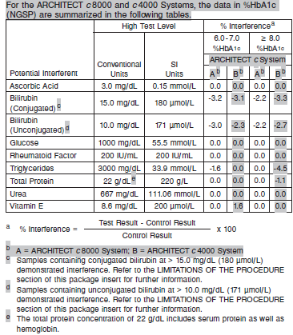

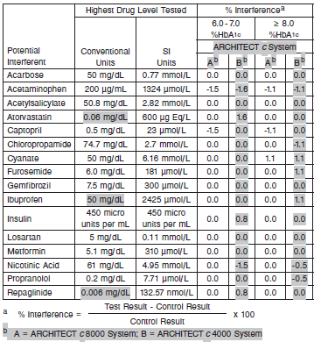

**Specificity**

***Hemoglobin Derivatives***

IFCC

The Hemoglobin A1c assay is designed to have a difference of +/- 5% for samples within the range of 38.78 to 53.00 mmol/mol HbA1c (inclusive) and +/- 7% for samples > 53.00 mmol/mol HbA1c.

NGSP

The Hemoglobin A1c assay is designed to have a difference of +/- 3% for samples within the range of 5.7 to 7.0 %HbA1c (inclusive) and +/- 5% for samples > 7.0 %HbA1c.

***Hemoglobin Variants***

The Hemoglobin A1c assay is designed to have a difference of +/- 1.53 mmol/mol HbA1c for samples < 38.78 mmol/mol HbA1c, +/- 5% for samples within the range of 38.78 to 53.00 mmol/mol HbA1c (inclusive), and +/- 7% for samples > 53.00 mmol/mol HbA1c.

NGSP

The Hemoglobin A1c assay is designed to have a difference of +/- 0.14 %HbA1c for samples < 5.7 %HbA1c, +/- 3% for samples within the range of 5.7 to 7.0 %HbA1c, (inclusive), and +/- 5% for samples > 7.0 %HbA1c. The data in %HbA1c (NGSP) are summarized in the following tables.

Heterozygous hemoglobin variants (HbAS, HbAC, HbAD, HbAE, HbA2) do not interfere with the Hemoglobin A1c assay.

For the ARCHITECT *c* 8000 System, the data in %HbA1c (NGSP) are summarized in the following table.

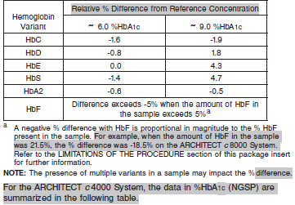

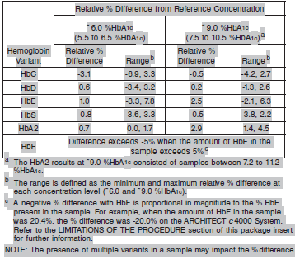

**References:**

1. ABBOTT ARCHITECT Hemoglobin A1c package insert (ARCHITECT c4000 or c8000)

Abbott Laboratories

Diagnostics Division

Abbott Park, IL 60064

June 2015 G1-0465/ R03

1. ABBOTT ARCHITECT Hemoglobin A1c Calibrator package insert

Abbott Laboratories

Diagnostics Division

Abbott Park, IL 60064

1. Abbott ARCHITECT Operator’s Guide

**Related Documents:**

**Attachments:**