RUSH logo for emails

**TRANSFERRIN**

**SERUM OR PLASMA**

**ABBOTT ARCHITECT**

**Intended Use**

The Transferrin assay is used for the quantitation of transferrin in human serum or plasma.

**Clinical Significance**

Transferrin is a β-globulin, synthesized primarily in the liver, which is the principal protein responsible for iron transport. Transferrin transports ferric ions from the iron stores of intracellular or mucosal ferritin to bone marrow where erythrocyte precursors and other cells have transferrin surface receptors. Transferrin is responsible for 50% to 70% of the iron binding capacity of serum. Since other proteins may bind iron, transferrin concentration correlates with, but is not identical to, Total Iron Binding Capacity (TIBC).

Indications for transferrin quantitation include: screening for nutritional status; differential diagnosis of anemia; and monitoring anemia treatment. Iron deficiency and iron overload are best diagnosed using a combination of iron, transferrin, and ferritin determinations.

Transferrin is considered to belong to a group of proteins, along with albumin, prealbumin, and β-lipoprotein, referred to as negative acute phase reactants (APRs). Negative APRs are found in decreased levels in response to inflammation, necrosis, or malignancy. Decreased levels of transferrin are also associated with conditions involving chronic liver disease, malnutrition, nephrotic syndrome, protein-losing enteropathies, iron overload due to multiple transfusion or hereditary hemochromatosis, and congenital atransferrinemia. Transferrin Index calculated as serum iron/transferrin) has been suggested as a better screen for iron overload.

Elevated levels of transferrin are associated with iron deficiency anemia where elevated transferrin often precedes the appearance of anemia by days to months. Transferrin levels are also elevated with increased estrogen due to pregnancy, oral contraceptives, etc.

**Principle**

The Transferrin assay is an immunoturbidimetric procedure that increasing sample turbidity caused by the formation of insoluble immune complexes when antibody to transferrin is added to the sample. Sample containing transferrin is incubated with a buffer (R1) and a sample blank determination is performed prior to the addition of transferrin antibody (R2). In the presence of an appropriate antibody in excess, the transferrin concentration is measured as a function of turbidity.

**Methodology:** Immunoturbidimetric

**Specimen Collection and Handling**

**Suitable Specimens**

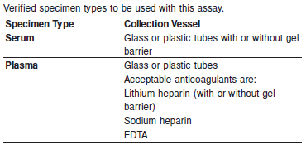

**Specimen Storage**

**Serum and Plasma:** Analyze fresh specimens if possible. Repeated freeze/thaw cycles should be avoided to minimize potential protein degradation.

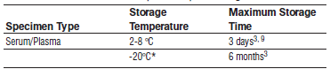

Frozen specimens must be completely thawed before mixing.

Mix thawed specimens thoroughly.

Visually inspect thawed specimens. If layering or stratification is observed, mix until specimens are visibly homogeneous. If specimens are not mixed thoroughly, inconsistent results may be obtained.

*A tolerance of } 10% (} 2°C) is assumed not to change the stability of the specimen. (W. Guder, personal communication, August 6, 2001).

**NOTE:** Stored specimens must be inspected for particulates. If present, mix and centrifuge the specimen to remove particulates prior to testing.

**Materials and Equipment Required**

**TEST INSTRUMENT**: Abbott ARCHITECT System

**MATERIALS PROVIDED**

1E04 Transferrin Reagent Kit

**MATERIALS REQUIRED BUT NOT PROVIDED**

• 1E78 Specific Proteins Multiconstituent Calibrator

• Control Material

• Saline (0.85% to 0.90% NaCl) for specimens that require dilution

**Reagent Handling and Storage:**

***CAUTION*:**

1. For in vitro diagnostic use.

2. Do not use components beyond the expiration date.

3. Do not mix materials from different kit lot numbers.

4. Do not mix fresh reagent with in-use reagents.

5. Do not pool reagents within a kit or between kits.

**CAUTION:** This product requires the handling of human specimens.

It is recommended that all human sourced materials be considered

potentially infectious and be handled in accordance with the OSHA

Standard on Bloodborne Pathogens. Biosafety Level 2 or other appropriate biosafety practices should be used for materials that contain or are suspected of containing infectious agents.

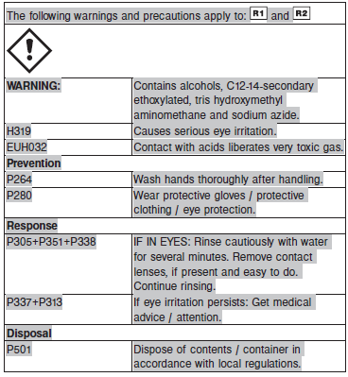

**Reagent Handling**

• Remove air bubbles, if present in the reagent cartridge, with a new applicator stick. Alternatively, allow the reagent to sit at the appropriate storage temperature to allow the bubbles to dissipate.

To minimize volume depletion, do not use a transfer pipette to remove the bubbles.

**CAUTION:** Reagent bubbles may interfere with proper detection of reagent level in the cartridge, causing insufficient reagent aspiration that could impact results.

**Reagent Storage**

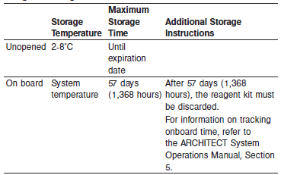

Reagents may be stored on or off the ARCHITECT cSystem.

If reagents are removed from the system, store at 2-8°C (with replacement caps) in their original boxes. When reagent is placed back on the system, run controls and if appropriate criteria are not met, recalibration may be required. For information on unloading reagents, refer to the ARCHITECT System Operations Manual, Section 5.

Reagent Preparation:

Transferrin is supplied as a liquid, ready-to-use, two-reagent kit which contains: **R1 & R2**

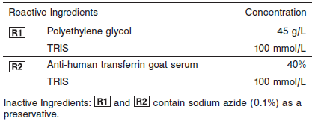

**Calibrator:** 1E78 Specific Proteins Multiconstituent Calibrator

**Quality Control:** Chemistry Controls

**Calibration**

**Frequency:**

Calibration is stable for 57 days for any one lot. Recalibration is required with each new reagent lot number.

**A new calibration is required:**

1. If quality control results do not meet acceptance criteria defined by your laboratory, patient values may be suspect. Follow the established quality control procedures for your laboratory. Recalibration may be necessary.
2. Review quality control results and acceptance criteria following a change of reagent or calibrator lot.

**Calibrator Required:** 1E78 Specific Proteins Multiconstituent Calibrator

**Reagents:**

Specific Proteins Multiconstituent Calibrator is prepared from human IgA, IgG, IgM, C3, C4, haptoglobin, and transferrin fractions in human serum.

**Calibrator Preparation:**

Specific Proteins Multiconstituent Calibrator requires no preparation prior to use.

**Calibration Procedure:**

Calibration is performed by running a water blank and the Specific Proteins Multiconstituent Calibrator set. Water for the blank is provided by the instrument.

1. Verify that the correct calibrator values have been entered into the calibration file.

2. Mix bottle several times by gentle inversion.

3. Open bottle, place an appropriate amount of each calibrator in a separate sample cup, and place in the assigned positions.

4. Cap bottle tightly and return to refrigerated storage immediately after use.

5. Perform calibration as indicated in the **ARCHITECT System Operations Manual**.

**Troubleshooting and Overall Acceptance Criteria Failure**

See ARCHITECT Operations Manual for further calibration troubleshooting.

**Quality Control:**

Abbott recommends, refer to your laboratory standard operating procedure(s) and/or quality assurance plan for additional quality control requirements and potential corrective actions:

• Three levels of quality control are to be run every 24 hours

• Run three levels of quality control with each cartridge change.

• If more frequent control monitoring is required, follow the established quality control procedures for your laboratory.

• If quality control results do not meet the acceptance criteria defined by your laboratory, patient values may be suspect. Follow the established quality control procedures for your laboratory.

Recalibration may be necessary.

• Review quality control results and acceptance criteria following a change of reagent or calibrator lot.

**Procedure**

For a detailed description of how to run an assay, refer to *Section 5* of the **ARCHITECT System Operations Manual**.

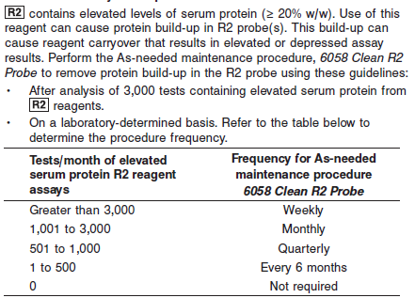

**NOTE:** Non-Abbott R2 reagents must be evaluated for inclusion in the test count calculation. This procedure is available beginning with ARCHITECT System Software v8.00. Refer to *Section 9* of the

**ARCHITECT System Operations Manual**.

The Transferrin assay file must be installed on the ARCHITECT cSystem prior to performing the assay.

For detailed information on assay file installation and viewing and editing assay parameters, refer to the ARCHITECT System Operations Manual, Section 2.

For information on printing assay parameters or for a detailed description of system procedures, refer to the ARCHITECT System Operations Manual, Section 5.

**Calculations**

Refer to *Appendix C* of the **ARCHITECT System Operations Manual** for information on results calculations.

**Reporting Results**

The Conventional result unit for the Transferrin assay is mg/dL. The corresponding SI result unit is g/L. To convert from mg/dL to g/L, divide mg/dL by 100. To convert from g/L to mg/dL, multiply g/L by

100.

**Specific Performance Characteristics**

**Reference Ranges**

It is recommended that each laboratory determine its own reference range based upon its particular locale and population characteristics.

**Serum/Plasma:**

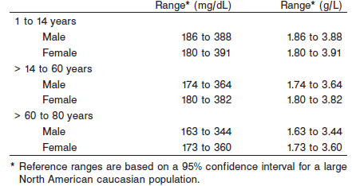

**Critical Values: N/A**

**Performance Characteristics**

**Reportable Range**

The Transferrin assay reportable range (analytical measurement range) is from 19 mg/dL (0.19 g/L) to the highest calibrator concentration.

**Limit of Quantitation (LOQ)** The LOQ for Transferrin is ≤ 9 mg/dL (0.09 g/L).

**Dilution:**

**Serum and Plasma:** Specimens with transferrin values exceeding the highest calibrator are flagged and may be diluted by following either the Automated Dilution Protocol or the Manual Dilution Procedure.

**Automated Dilution Protocol**

If using the Automated Dilution Protocol, the system performs a 1:2 dilution of the specimen and automatically corrects the concentration by multiplying the result by the appropriate dilution factor.

**Manual Dilution Procedure**

Manual dilutions should be performed as follows:

• Use saline (0.85% to 0.90% NaCl) to dilute the sample.

• The operator must enter the dilution factor in the patient or control order screen. The system uses this dilution factor to automatically correct the concentration by multiplying the result by the entered factor.

• If the operator does not enter the dilution factor, the result must be multiplied by the appropriate dilution factor before reporting the result.

**NOTE:** If a diluted sample result is flagged indicating it is less than the linear low limit, do not report the result. Rerun using an appropriate dilution.

For detailed information on ordering dilutions, refer to *Section 5* of the

**ARCHITECT System Operations Manual**.

The patient result flag “>” may indicate antigen excess. Dilute sample and rerun. Samples were tested for antigen excess up to 2,851.5 mg/dL (28.515 g/L).

**Precision:**

The imprecision of the Transferrin assay is ≤ 5.0% Total CV.

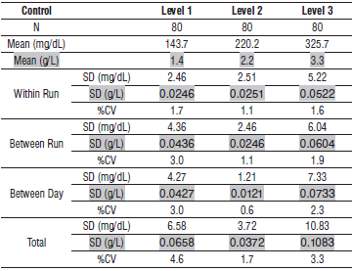

#### Limitations of Procedure

The performance characteristics of Transferrin on an analyzer other than the ARCHITECT *c* Systems must be validated and verified. Samples containing paraproteins (abnormal monoclonal antibodies) may interfere with test results. Samples with elevated total protein concentrations or samples from patients with suspected paraproteinemia can be screened using other laboratory methods such as protein electrophoresis.

Elevated fibrinogen levels in EDTA plasma samples may yield a depressed result. Haptoglobin results should be evaluated by comparing to other clinically relevant information. R2 contains elevated levels of serum protein (≥ 20% w/w). Use of this reagent can cause protein build-up in R2 probe(s). This build-up can cause reagent carryover that results in elevated or depressed assay results. To remove protein build-up, perform the As-needed maintenance procedure, *6058 Clean R2 Probe.* Refer to the PROCEDURE section of the package insert.

Turbidity and particles in the samples can interfere with the assay. Therefore, particulate matter should be removed by centrifugation prior to running the assay.

**Interfering Substances**

Interference effects were assessed by Dose Response and Paired Difference methods, at two medical decision levels of the analyte.

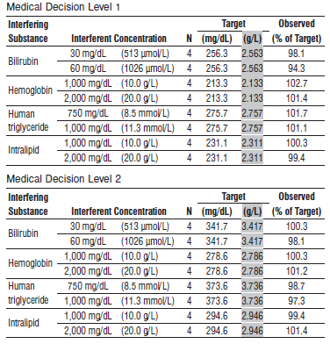

**References:**

1. ABBOTT ARCHITECT Transferrin package insert

Abbott Laboratories

Diagnostics Division

Abbott Park, IL 60064

Jan 2016 306746 / R05

1. ABBOTT ARCHITECT Specific Proteins Multiconstituent Calibrator package insert

Abbott Laboratories

Diagnostics Division

Abbott Park, IL 60064

1. Abbott ARCHITECT Operator’s Guide

**Related Documents:**

**Attachments:**