RUSH logo for emails

**ACETAMINOPHEN**

**SERUM OR PLASMA**

**ABBOTT ARCHITECT**

**Intended Use**

The MULTIGENT Acetaminophen assay is intended for the quantitative determination of acetaminophen in human serum or plasma on the ARCHITECT *c* Systems.

**Clinical Significance**

Acetaminophen (paracetamol) is used as an analgesic in many different formulations.1 While therapeutic doses rarely cause adverse side effects, the effect of long term treatment with acetaminophen is unclear. Cases have been reported where chronic excessive use of acetaminophen led to hepatotoxicity and nephrotoxicity. In cases of acute overdosage, acetaminophen can cause severe hepatic damage leading to hepatic failure if untreated.

The management of acetaminophen overdose requires early recognition of the drug in the bloodstream. Toxicity is generally reported at concentrations over 200 μg/mL (1,324 μmol/L). *N*-acetylcysteine has been used as an antidote in conjunction with intensive support care. Early diagnosis of acetaminophen-induced hepatotoxicity is important since initiation of therapy within 8 hours of ingestion lessens the potential for hepatic injury, and decreases the mortality rate.

**Principle**

The enzyme, aryl acylamidase, cleaves the amide bond of the acetaminophen molecule, leaving *p*-aminophenol and acetate. The *p*-aminophenol is reacted with 8-hydroxyquinoline-5-sulfonic acid in the presence of manganese ions to form a colored compound, 5‑(4‑iminophenol)-8-quinolone. The increased absorbance at 615 nm due to the formation of 5-(4-iminophenol)-8-quinolone is directly proportional to the concentration of acetaminophen in the sample.

**Methodology:** Enzymatic/Colorimetric

**Specimen Collection and Handling**

**Suitable Specimens**

• **Serum:** Use serum collected by standard venipuncture techniques into glass or plastic tubes with or without gel barriers. Ensure complete clot formation has taken place prior to centrifugation.

Centrifuge according to tube manufacturer’s instructions to ensure proper separation of serum from blood cells.

• **Plasma:** Use plasma collected by standard venipuncture techniques into glass or plastic tubes. Acceptable anticoagulants are lithium heparin (with or without gel barrier) and sodium heparin. EDTA is not suitable for use. Ensure centrifugation is adequate to remove platelets. Centrifuge according to tube manufacturer’s instructions to ensure proper separation of plasma from blood cells.

Some specimens, especially those from patients receiving anticoagulant or thrombolytic therapy, may take longer to complete their clotting processes. Fibrin clots may subsequently form in these sera and the clots could cause erroneous test results.

It is the responsibility of the operator to verify that the correct sample type(s) is (are) used in the MULTIGENT Acetaminophen assay.

Specimens containing particulate matter or red blood cells may give inconsistent results and should be centrifuged before testing (recommended 8,000 to 10,000 RCF* x 10 minutes).

*Relative Centrifugal Force

Separated samples may be stored for up to 14 days at 4 to 8°C prior to being tested. If testing will be delayed more than 14 days, separated samples may be stored frozen at ≤ ‑20°C for up to 45 days.

**NOTE:** Stored specimens must be inspected for particulates. If present, mix and centrifuge the specimen to remove particulates prior to testing.

**Materials and Equipment Required**

**TEST INSTRUMENT**: Abbott ARCHITECT System

**MATERIALS PROVIDED**

2K99 MULTIGENT Acetaminophen Reagent Kit

**MATERIALS REQUIRED BUT NOT PROVIDED**

• 2K99-01 MULTIGENT Acetaminophen Calibrator

• Control Material

• Saline (0.85% to 0.90% NaCl) for specimens that require dilution

**Reagent Handling and Storage:**

***CAUTION*:**

1. For in vitro diagnostic use.

2. Do not use components beyond the expiration date.

3. Do not mix materials from different kit lot numbers.

**CAUTION:** This product requires the handling of human specimens.

It is recommended that all human sourced materials be considered

potentially infectious and be handled in accordance with the OSHA

Standard on Bloodborne Pathogens. Biosafety Level 2 or other

appropriate biosafety practices should be used for materials that contain or are suspected of containing infectious agents.

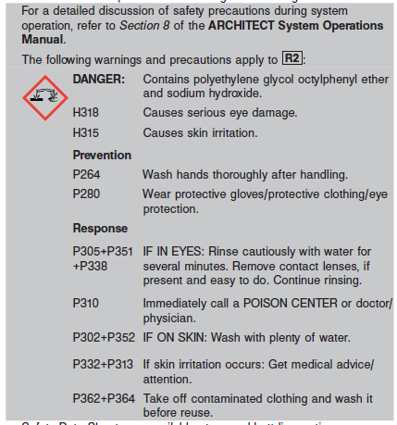

**Reagent Handling**

• R1 Ready for use. Before use, invert several times, avoiding the formation of bubbles.

• R2 Ready for use. Before use, invert several times, avoiding the formation of bubbles.

• Remove air bubbles, if present in the reagent cartridge, with a new applicator stick. Alternatively, allow the reagent to sit at the appropriate storage temperature to allow the bubbles to dissipate.

To minimize volume depletion, do not use a transfer pipette to remove the bubbles.

**CAUTION:** Reagent bubbles may interfere with proper detection of reagent level in the cartridge, causing insufficient reagent aspiration that could impact results.

• When either the R1 or the R2 reagent cartridge becomes empty, replace both cartridges.

**Reagent Storage**

• Reagent stability is 12 days if the reagent is uncapped and onboard.

• Unopened reagents are stable until the expiration date when stored at 2 to 8°C.

Reagent Preparation:

2K99 Acetaminophen is supplied as a liquid, ready-to-use, two- reagent kit which contains: **R1 & R2**

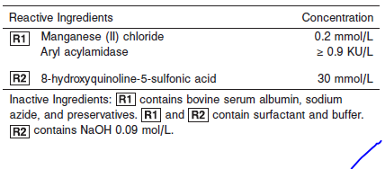

**Calibrator:** ARCHITECT Acetaminophen Calibrator 2K99-01

**Quality Control:** Minimum 2 levels of ChemistryControl (Normal and Abnormal)

**Calibration**

**Frequency:**

Calibration is stable for 12 days (288 hours) for any one lot.

**A new calibration is required:**

1. If quality control results do not meet acceptance criteria defined by your laboratory, patient values may be suspect. Follow the established quality control procedures for your laboratory. Recalibration may be necessary.
2. Review quality control results and acceptance criteria following a change of reagent or calibrator lot.

**Calibrator Required:** ARCHITECT Acetaminophen Calibrator 2K99-01

**Reagents:**

2K99-01 MULTIGENT Acetaminophen Calibrator, 2 x 5 mL MULTIGENT Acetaminophen Calibrator consists of:

• Acetaminophen 151 μg/mL (1,000 μmol/L)

• Buffer (pH 5.0 at 25°C)

• 0.10% sodium azide as a preservative

**Calibrator Preparation:**

The calibrator is supplied in liquid form and is ready to use. Invert bottle several times before use, avoiding the formation of foam.

**Calibration Procedure:**

Before performing the assay, refer to the ASSAY PARAMETERS, which are included in the MULTIGENT Acetaminophen reagent package insert. For further instructions, refer to the CALIBRATION and QUALITY CONTROL sections of the MULTIGENT Acetaminophen reagent package insert.

1. Verify that the calibrator values are correct in the instrument parameter files.

2. Mix bottles several times by gentle inversion.

3. Open the bottle, place an appropriate amount of the calibrator in a separate sample cup, and place in the assigned position.

4. Calibrate as outlined in *Section 6* of the **ARCHITECT System Operations Manual**.

5. Follow the established quality control procedures for your laboratory and the instructions found in *Section 5* of the **ARCHITECT System** **Operations Manual**.

6. Cap bottle tightly and return to refrigerated storage after use.

7. Verify control results are within acceptable limits before reporting patient results.

**Troubleshooting and Overall Acceptance Criteria Failure**

See ARCHITECT Operations Manual for further calibration troubleshooting.

**Quality Control:**

Abbott recommends, refer to your laboratory standard operating procedure(s) and/or quality assurance plan for additional quality control requirements and potential corrective actions:

• Two levels of controls (normal and abnormal) are to be run every 24 hours.

• If more frequent control monitoring is required, follow the established quality control procedures for your laboratory.

• If quality control results do not meet the acceptance criteria defined by your laboratory, patient values may be suspect. Follow the established quality control procedures for your laboratory.

Recalibration may be necessary.

• Review quality control results and acceptance criteria following a change of reagent or calibrator lot.

**Procedure**

For a detailed description of how to run an assay, refer to *Section 5* of the **ARCHITECT System Operations Manual**.

**Calculations**

Refer to *Appendix C* of the **ARCHITECT System Operations Manual** for information on results calculations.

**Reporting Results**

The result unit for the MULTIGENT Acetaminophen assay can be reported as μg/mL or μmol/L. To convert results from μg/mL to μmol/L, multiply μg/mL by 6.62.

**Specific Performance Characteristics**

**Reference Ranges**

It is recommended that each laboratory determine its own reference range based upon its particular locale and population characteristics.

**Serum/Plasma:**

**Therapeutic:** 10 – 30 μg/mL

**Toxic:** >200μg/mL

Treatment of acetaminophen poisoning is primarily based on serum levels and patient information about ingestion. Nomograms have been devised to determine patient’s status with one serum level; the time after ingestion is plotted on the abscissa vs. drug level on the ordinate. Patient ingestion information is not always reliable and a more accurate method to estimate toxicity is to determine drug half-life. Acetaminophen half-life is normally 2 to 3 hours and hepatic damage is likely if it exceeds 4 hours. Significant liver damage is also considered likely if drug levels are greater than 300 μg/mL at 4 hours after ingestion or 50 μg/mL after 12 hours. To determine acetaminophen half-life, the first of two samples should be drawn at least 4 hours after poisoning to ensure peak levels have been achieved.

**Reference Interval**

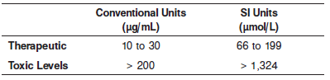

**Critical Values: >150 μg/mL**

**Performance Characteristics**

**Analytical Measurement Range (AMR): Abbott Package Insert**

**Serum/Plasma:** 3 to 377 μg/mL (20 to 2,500 μmol/L).

*This is the range of analyte values that can be measured directly from the specimen without any dilution or pretreatment that is not part of the usual analytical process and is equivalent to the assay range.*

**Dilution:**

Specimens with acetaminophen values exceeding 377 μg/mL (2,500 μmol/L) are flagged and may be diluted by following either the Automated Dilution Protocol or the Manual Dilution Procedure.

***Automated Dilution Protocol***

If using the Automated Dilution Protocol, the system performs a 1:10 dilution of the specimen and automatically corrects the concentration by multiplying the result by the appropriate dilution factor.

***Manual Dilution Procedure***

A manual dilution can be performed on patient samples with acetaminophen concentrations reported as greater than 377 μg/mL (2,500 μmol/L) by making a dilution of the specimen with saline before pipetting the sample into the sample cup. The dilution must be performed so the diluted test results read greater than the assay sensitivity of 3 μg/mL (20 μmol/L).



The operator must enter the manual dilution factor in the patient or control order screen. The system uses this dilution factor to automatically correct the concentration by multiplying the result by the entered factor. The printed result is the reportable result if no errors are present.

**NOTE:** If the operator does not enter the manual dilution factor, the printed result must be multiplied by the manual dilution factor before reporting the result.

**Limit of Quantitation (LOQ):** The LOQ for the MULTIGENT Acetaminophen assay was calculated to be 3 μg/mL (20 μmol/L). LOQ is defined as the concentration at which the CV is ≤ 20% and the recovery is within +/- 6.7% or +/- 1.25 μg/mL.

**Precision:**

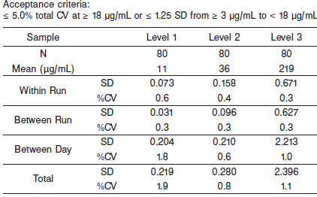

#### Limitations of Procedure

Reagent cross contamination testing for the MULTIGENT Acetaminophen assay was performed on an ARCHITECT *c* System.

Configure Acetaminophen SmartWash parameters in the following assay files on an ARCHITECT *c* System.

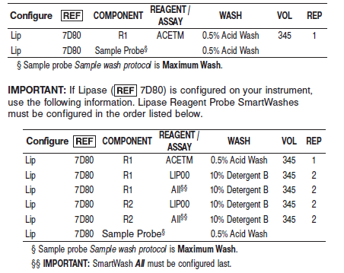

#### Interfering Substances:

**Interfering Substances**

The following compounds, when tested with the MULTIGENT Acetaminophen assay at the concentrations indicated, resulted in less than 7.5% error in detecting acetaminophen. Interference effects were assessed by Dose Response method. Representative results are shown below.

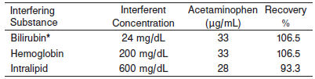

*Hyperbilirubinemic serum has been demonstrated to show positive interference with enzymatic assays for acetaminophen.

**NOTE:** Significantly reduced acetaminophen recovery has been demonstrated in situations where testing has been performed immediately after the introduction of NAC. It is recommended that laboratories review NAC treatment and monitoring protocols to determine the extent of the potential interference.

**Specificity**

This method does not measure the common metabolites of acetaminophen (glucuronide, cysteine, and mercapturate).

**References:**

1. ABBOTT ARCHITECT Acetaminophen package insert

Abbott Laboratories

Diagnostics Division

Abbott Park, IL 60064

May 2015 306711/R08

1. ABBOTT ARCHITECT Acetaminophen Calibrator package insert

Abbott Laboratories

Diagnostics Division

Abbott Park, IL 60064

1. Abbott ARCHITECT Operator’s Guide

**Related Documents:**

**Attachments:**