RUSH logo for emails

**COCAINE**

**URINE**

**ABBOTT ARCHITECT**

**Intended Use**

The MULTIGENT Cocaine assay is intended for the qualitative and semiquantitative determination of benzoylecgonine (cocaine metabolite) in human urine on the ARCHITECT *c* Systems. The cutoffs for the qualitative applications are 150 ng/mL and 300 ng/mL.

The assay is intended for use in clinical laboratories. This assay provides only a preliminary analytical test result. A more specific alternate chemical method must be used to obtain a confirmed analytical result. Gas Chromatography/Mass Spectrometry (GC/MS) is the preferred confirmatory method. Clinical consideration and professional judgment should be applied to any drug of abuse test result, particularly when preliminary positive results are used.

**Clinical Significance**

Cocaine is a very common illicit drug. When ingested, it is rapidly metabolized and excreted into urine as benzoylecgonine (the major metabolite of cocaine) within four hours. Detection of benzoylecgonine in urine indicates use of cocaine. Excretion rate patterns vary with the mode of administration and from individual to individual. Cocaine is almost completely metabolized, primarily in the liver, with only about 1% to 9% excreted unchanged in the urine (dependent on urine pH). Thirty-five to fifty-four percent is eliminated as benzoylecgonine, the major metabolite of cocaine. Cocaine is also excreted in relatively lesser amounts as ecgonine methyl ester (32% to 49%) and ecgonine.3 Cocaine metabolites may be detected in urine up to several days after cocaine use. Benzoylecgonine can be detected in urine within four hours after cocaine inhalation and remain detectable in concentrations greater than 1,000 ng/mL for as long as 48 hours.

**Principle**

The MULTIGENT Cocaine assay is a homogeneous enzyme immunoassay using ready-to-use liquid reagents. The assay uses monoclonal antibodies that detect benzoylecgonine in urine. The assay is based on the competition between an enzyme labeled drug and the drug from the urine for a fixed number of specific antibody binding sites. In the absence of drug from the sample, the specific antibody binds to the drug labeled with glucose-6-phosphate dehydrogenase (G6PDH) and the enzyme activity is inhibited. This phenomenon creates a direct relationship between the drug concentration in the urine and the enzyme activity. The G6PDH enzyme activity is determined spectrophotometrically at 340/412 nm (416 nm for *c* 4000 and *c* 16000) by measuring its ability to convert nicotinamide adenine dinucleotide (NAD) to NADH.

**Methodology:** Enzyme Immunoassay

**Specimen Collection and Handling**

Collect urine specimens in clean plastic or glass containers. Testing of fresh urine specimens is suggested. Samples within a pH range of 3 to 11 are suitable for testing with this assay.

The Clinical and Laboratory Standards Institute (formerly NCCLS) Urine Drug Testing in the Clinical Laboratory; Approved Guideline states that prior to analysis, urine specimens may be stored at 2 to 8°C for five working days. For longer storage prior to analysis, or for sample retention after analysis, this document recommends freezing at –20°C or less. Laboratories following the Substance Abuse and Mental Health Services Administration (SAMHSA) mandatory guidelines should refer to SAMHSA “Short-Term Refrigerated Storage” and “Long-Term Storage” requirements. Thaw and mix frozen specimens prior to analysis.

**NOTE:** Stored specimens must be inspected for particulates. If present, mix and centrifuge the specimen to remove particulates prior to testing. An effort should be made to keep pipetted samples free of gross debris. It is recommended that highly turbid specimens be centrifuged before analysis. Adulteration of the urine sample may cause erroneous results. If adulteration is suspected, obtain another sample and forward both specimens to the laboratory for testing.

**Materials and Equipment Required**

**TEST INSTRUMENT**: Abbott ARCHITECT System

**MATERIALS PROVIDED**

3L40 MULTIGENT Cocaine

**MATERIALS REQUIRED BUT NOT PROVIDED**

* 3L43-05 MULTIGENT DOA MC Neg Cal
* 3L43-02 MULTIGENT DOA MC I Cal 2

**Reagent Handling and Storage:**

***CAUTION*:**

1. For in vitro diagnostic use.

2. Do not use components beyond the expiration date.

3. Do not mix materials from different kit lot numbers.

**CAUTION:** This product requires the handling of human specimens.

It is recommended that all human sourced materials be considered

potentially infectious and be handled in accordance with the OSHA

Standard on Bloodborne Pathogens. Biosafety Level 2 or other appropriate biosafety practices should be used for materials that contain or are suspected of containing infectious agents.

• The following warning and precaution apply to R1 and R2:

Contains sodium azide.

EUH032 Contact with acids liberates very toxic gas.

These materials and their containers must be disposed of in a safe way.

**Reagent Handling**

• R1 Ready for use. Before use, invert several times, avoiding the formation of bubbles.

• R2 Ready for use. Before use, invert several times, avoiding the formation of bubbles.

• Remove air bubbles, if present in the reagent cartridge, with a new applicator stick. Alternatively, allow the reagent to sit at the appropriate storage temperature to allow the bubbles to dissipate.

To minimize volume depletion, do not use a transfer pipette to remove the bubbles.

**CAUTION:** Reagent bubbles may interfere with proper detection of reagent level in the cartridge, causing insufficient reagent aspiration that could impact results.

• When either the R1 or the R2 reagent cartridge becomes empty, replace both cartridges and verify with controls according to the established quality control requirements for your laboratory.

**Reagent Storage**

• Reagent stability is 56 days if the reagent is uncapped and onboard.

• Unopened reagents are stable until the expiration date when stored at 2 to 8°C.

Reagent Preparation:

3L40-20 MULTIGENT Cocaine is supplied as a liquid, ready-to-use, two-reagent kit which contains: **R1 & R2**

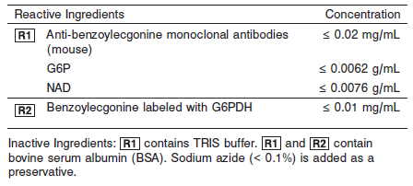

**Calibrator:**

* 3L43-05 MULTIGENT DOA MC Neg Cal
* 3L43-02 MULTIGENT DOA MC I Cal 2

**Quality Control:** Minimum 2 levels of DOA UrineControl run every 24 hours

Abbott recommends:

3L43-10 MULTIGENT DOA MC I Control Set

4P51-10 MULTIGENT DOA MC III Control Set

**Calibration**

**Frequency:**

Calibration is stable for 13 days (312 hours) for any one lot. Calibration is required with each change in reagent lot number.

**A new calibration is required:**

1. If quality control results do not meet acceptance criteria defined by your laboratory, patient values may be suspect. Follow the established quality control procedures for your laboratory. Recalibration may be necessary.
2. Review quality control results and acceptance criteria following a change of reagent or calibrator lot.

**Calibrator Required:**

* 3L43-05 MULTIGENT DOA MC Neg Cal
* 3L43-02 MULTIGENT DOA MC I Cal 2

**Reagents:**

The MULTIGENT DOA MC I Calibrators and Controls are liquid and ready-to-use. They are prepared by spiking negative human urine with known quantities of compounds indicated in Table 1.

For qualitative analysis, the MULTIGENT DOA MC Neg Cal and the MULTIGENT DOA MC I Cal 2 are used for system calibration. The concentration of the MULTIGENT DOA MC I Cal 2 determines the cutoff between “positive” and “negative” samples.

When an estimate of drug concentration is required, a calibration curve can be established with the MULTIGENT DOA MC Neg Cal and the MULTIGENT DOA MC I Cal 1, 2, 3, and 4.

The MULTIGENT DOA MC I Control Set is used to validate assay performance.

The MULTIGENT DOA MC Neg Cal is a drug-free human urine pool that is used as zero drug calibrator and can also be used for dilution of samples with levels exceeding the highest calibrator.

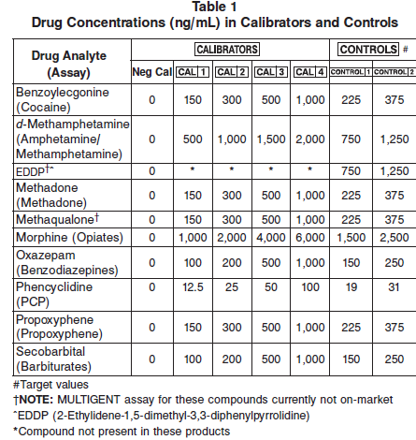

**Calibrator Preparation:**

Liquid, ready to use

**Calibration Procedure:**

Before performing the assay, refer to the ASSAY PARAMETERS which are included in the specific MULTIGENT DOA reagent package inserts.

The parameters contain additional instructions for using qualitative and semiquantitative protocols. For further instructions refer to the CALIBRATION and QUALITY CONTROL sections of the MULTIGENT DOA reagent inserts.

1. Verify that the calibrator values are correct in the instrument parameter files.

2. Mix bottles by gentle inversion several times.

3. Open the bottles, place appropriate amounts of the required calibrators and/or controls in separate sample cups, and place in the assigned positions.

4. Calibrate as outlined in *Section 6* of the **ARCHITECT System Operations Manual**.

5. Follow the established quality control procedures for your laboratory and the instructions found in *Section 5* of the **ARCHITECT System** **Operations Manual**.

6. Cap bottles tightly and return to refrigerated storage after use.

7. Verify control results are within acceptable limits before reporting patient results.

**RESULTS**

The MULTIGENT DOA MC I Cal 2 is used as a qualitative cutoff reference for distinguishing between “positive” and “negative” samples.

A sample that gives a change in absorbance rate (ΔmAU/min) equal to or greater than the MULTIGENT DOA MC I Cal 2 is considered positive.

A sample that gives a change in absorbance rate (ΔmAU/min) less than that obtained with the MULTIGENT DOA MC I Cal 2 is considered negative.

When an estimate of the drug concentration is required, a calibration curve can be established with the MULTIGENT DOA MC Neg Cal and MULTIGENT DOA MC I Cal 1, 2, 3, and 4. The concentration of the sample can be obtained by quantitation from the calibration curve.

When the sample concentration is greater than the highest calibrator, it may be diluted with the MULTIGENT DOA MC Neg Cal and retested.

The MULTIGENT DOA MC I Control Set should be used to validate assay performance. The result of the controls should be within the range established by each laboratory.

**Troubleshooting and Overall Acceptance Criteria Failure**

See ARCHITECT Operations Manual for further calibration troubleshooting.

**Quality Control:**

Abbott recommends, refer to your laboratory standard operating procedure(s) and/or quality assurance plan for additional quality control requirements and potential corrective actions:

• Two levels of controls (normal and abnormal) are to be run every 24 hours.

• If more frequent control monitoring is required, follow the established quality control procedures for your laboratory.

• If quality control results do not meet the acceptance criteria defined by your laboratory, patient values may be suspect. Follow the established quality control procedures for your laboratory.

Recalibration may be necessary.

• Review quality control results and acceptance criteria following a change of reagent or calibrator lot.

**Procedure**

For a detailed description of how to run an assay, refer to *Section 5* of the **ARCHITECT System Operations Manual**.

**Qualitative Analysis**

The following are used for qualitative analysis:

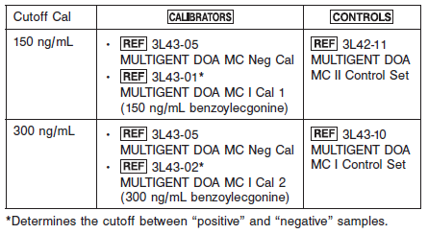

**Calculations**

Refer to *Appendix C* of the **ARCHITECT System Operations Manual** for information on results calculations.

**Reporting Results**

**Qualitative Results:** Cutoff = 300 ng/mL

A sample that exhibits a change in absorbance rate (ΔmAU/min) equal to or greater than the value obtained with the cutoff calibrator is considered positive.

A sample that exhibits a change in absorbance rate (ΔmAU/min) lower than that obtained with the cutoff calibrator is considered negative.

**Specific Performance Characteristics**

**Performance Characteristics**

**Sensitivity**

Sensitivity, defined as the lowest concentration that can be differentiated from the negative urine calibrator with 99% confidence, is 40.0 ng/mL. Performance studies for Cocaine using the parameters for the semiquantitative range up to 1,000 ng/mL and 150 ng/mL as the cutoff produced a sensitivity of 10.4 ng/mL on an ARCHITECT *c* System. Performance studies for Cocaine using the parameters for the semiquantitative range up to 1,000 ng/mL and 300 ng/mL as the cutoff produced a sensitivity of 12.7 ng/mL on an ARCHITECT *c* System.

**Accuracy**

*300 ng/mL Cutoff*

For both qualitative and semiquantitative applications, using the 300 ng/mL cutoff, 209 clinical urine specimens were tested with a commercially available cocaine metabolite assay and the Cocaine assay. One hundred four were tested positive and 105 were tested negative by both assays. In addition, all positive specimens were confirmed by the GC/MS to contain cocaine metabolites.

**Qualitative**

*300 ng/mL Cutoff*

There was 98% overall agreement between the two methods. Fifty-three samples were positive and 73 were negative on both analyzers. Seven samples had results between the cutoff calibrator and –50% of the cutoff calibrator. Twenty-one samples had results between the cutoff calibrator and +50% of the cutoff calibrator. Discordant samples were not tested by GC/MS due to insufficient sample volume.

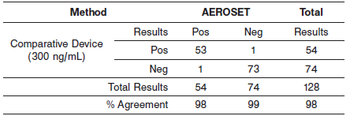

**Dilution:**

Samples with semiquantitative results that exceed the highest calibrator may be manually diluted and rerun. Acceptable sample diluents are the MULTIGENT DOA MC Neg Cal or drug-free human urine.

The dilution must be performed so the diluted test results read greater than the assay sensitivity of 40.0 ng/mL. The operator must enter the manual dilution factor in the patient or control order screen. The system uses this dilution factor to automatically correct the concentration by multiplying the result by the entered factor. The printed result is the reportable result if no errors are present.

**NOTE:** If the operator does not enter the manual dilution factor, the printed result must be multiplied by the manual dilution factor before reporting the result.



For detailed information on ordering dilutions, refer to *Section 5* of the **ARCHITECT System Operations Manual**.

**Precision:**

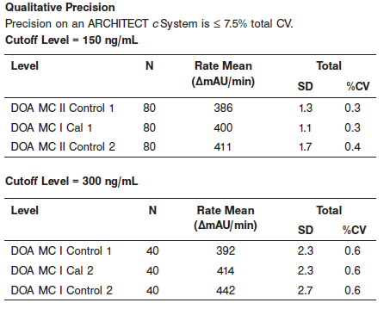

#### Limitations of Procedure

• The assay is designed for use with human urine only.

• A positive result indicates only the presence of cocaine metabolites and does not necessarily correlate with the extent of physiological and psychological effects.

• A positive result by this assay should be confirmed by another chemical method such as GC, Thin Layer Chromatography (TLC), or GC/MS.

• It is possible that other substances and/or factors (e.g., technical or procedural) not listed in the specificity table may interfere with the test and cause false results.

**Specificity**

Various potentially interfering substances were tested for cross-reactivity with the assay. The compounds listed in the table below produced a positive result using 300 ng/mL as a cutoff calibrator.

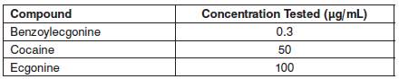

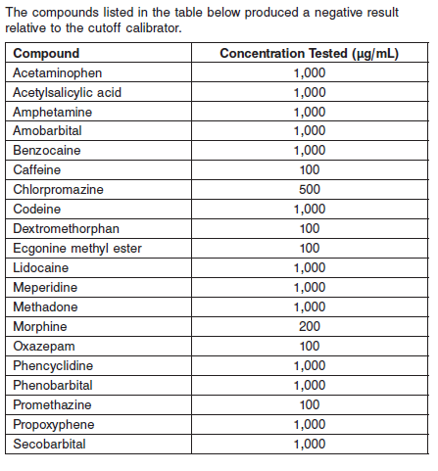

**References:**

1. ABBOTT ARCHITECT Cocaine package insert

Abbott Laboratories

Diagnostics Division

Abbott Park, IL 60064

May 2014 306425/R08

1. ABBOTT ARCHITECT DOA Multiconstituent Calibrator package insert

Abbott Laboratories

Diagnostics Division

Abbott Park, IL 60064

1. Abbott ARCHITECT Operator’s Guide

**Related Documents:**

**Attachments:**