RUSH logo for emails

***i*CARBAMAZEPINE**

**SERUM OR PLASMA**

**ABBOTT ARCHITECT**

**Intended Use**

The ARCHITECT *i* Carbamazepine assay is an *in vitro* chemiluminescent microparticle immunoassay (CMIA) for the quantitative measurement of carbamazepine, an anticonvulsant drug, in human serum or plasma (collected in lithium heparin, sodium heparin, dipotassium EDTA or sodium EDTA tubes) on the ARCHITECT *i* System with *STAT* protocol capability. The measurements obtained are used in monitoring levels of carbamazepine to help ensure appropriate therapy.

**Clinical Significance**

Carbamazepine is an iminostilbine derivative structurally related to the tricyclic antidepressants. Carbamazepine is used in the treatment of both generalized tonic-clonic and simple and complex partial seizures because of its inhibition of repetitive firing of neurons. About 75% of the carbamazepine in plasma is protein bound. Carbamazepine is metabolized by hepatic oxidases, primarily CYP3A4,

yielding the 10,11-epoxide. This metabolite is also pharmacologically active and is found in plasma and tissues at concentrations up to 50% of the parent drug. The 10,11-epoxide is further metabolized to inactive compounds that are excreted in the urine, mostly as glucuronides.

**Principle**

The ARCHITECT *i* Carbamazepine assay is a one-step immunoassay for the quantitative measurement of carbamazepine in human serum or plasma using CMIA technology, with flexible assay protocols, referred to as Chemiflex.

In the ARCHITECT *i* Carbamazepine assay, the sample, anti‑carbamazepine coated paramagnetic microparticles, and carbamazepine acridiniumlabeled conjugate are combined to create a reaction mixture. The anti‑carbamazepine coated microparticles bind to carbamazepine present in the sample and to the carbamazepine acridinium-labeled conjugate.

After washing, pre-trigger and trigger solutions are added to the reaction mixture. The resulting chemiluminescent reaction is measured as relative light units (RLUs). An indirect relationship exists between the amount of carbamazepine in the sample and the RLUs detected by the ARCHITECT *i* System optics.

For additional information on system and assay technology, refer to the ARCHITECT System Operations Manual, Section 3.

**Specimen Collection and Handling**

**Suitable Specimens**

The specimen collection tubes listed below were verified to be used with the assay.

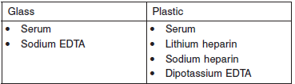

Do not use specimens with the following conditions:

**•** heat-inactivated

**•** pooled

**•** grossly hemolyzed

**•** obvious microbial contamination

**•** cadaver specimens or body fluids other than human serum or plasma

**Specimen Storage**

Serum or Plasma

Specimens may be stored on or off the clot or red blood cells for

**•** up to 24 hours at room temperature or

**•** up to 7 days at 2-8°C.

If testing will be delayed more than 7 days, remove serum or plasma from the clot or red blood cells and store at -20°C or colder.

**•** Avoid more than 3 freeze/thaw cycles.

**NOTE:** Stored specimens must be inspected for particulates. If present, mix and centrifuge the specimen to remove particulates prior to testing.

**Materials and Equipment Required**

**TEST INSTRUMENT**: Abbott ARCHITECT System

**MATERIALS PROVIDED**

1P36 ARCHITECT *i* Carbamazepine Reagent Kit

**MATERIALS REQUIRED BUT NOT PROVIDED**

**•** ARCHITECT *i* System

**•** ARCHITECT *i* Carbamazepine Assay file, may be obtained from:

**•** ARCHITECT *i* System e-Assay CD-ROM found on www.abbottdiagnostics.com

**•** ARCHITECT *i* System Assay CD-ROM

**•** 1P36-01 ARCHITECT *i* Carbamazepine Calibrators

**•** 1P36-50 ARCHITECT *i* Carbamazepine Calibrator A Multi-Pack

**•** Commercially available control material containing carbamazepine

**•** ARCHITECT *i* Pretrigger

**•** ARCHITECT *i* Trigger

**•** ARCHITECT *i i* Wash Buffer

**•** ARCHITECT *i* Reaction Vessels

**•** ARCHITECT *i* Sample Cups

**•** ARCHITECT *i* Septums

**•** ARCHITECT *i* Replacement Caps

**•** Pipettes or pipette tips (optional) to deliver the specified volumes.

**Reagent Handling and Storage:**

***CAUTION*:**

* For in vitro diagnostic use.

**CAUTION:** This product requires the handling of human specimens.

It is recommended that all human sourced materials be considered

potentially infectious and be handled in accordance with the OSHA

Standard on Bloodborne Pathogens. Biosafety Level 2 or other appropriate biosafety practices should be used for materials that contain or are suspected of containing infectious agents.

.

**Reagent Handling**

* Do not use reagent kits beyond the expiration date.
* **Do not pool reagents within a kit or between reagent kits.**
* Before loading the ARCHITECT Reagent Kit on the system for the first time, the microparticle bottle requires mixing to resuspend microparticles that have settled during shipment.
* **Septums MUST be used to prevent reagent evaporation and contamination and to ensure reagent integrity. Reliability of assay results cannot be guaranteed if septums are not used according to the instructions in the package insert.**
* To avoid contamination, wear clean gloves when placing a septum on an uncapped reagent bottle.
* Once a septum has been placed on the reagent bottle, **do not invert the bottle** as this will result in reagent leakage and maycompromise assay results.
* Over time, residual liquids may dry on the septum surface. These are typically dried salts and have no effect on assay efficacy.
* For a detailed discussion of handling precautions during system operation, refer to the ARCHITECT System Operations Manual, Section 7.

**Reagent Storage**

* The ARCHITECT iCarbamazepine Reagent Kit must be stored at 2-8°C in an upright position and may be used immediately after removal from 2-8°C storage.
* When stored and handled as directed, the reagents are stable until the expiration date.
* The ARCHITECT iCarbamazepine Reagent Kit may be stored on board the ARCHITECT *i* System for a maximum of 30 days. After 30 days, the reagent kit must be discarded. For information on tracking onboard time, refer to the ARCHITECT System Operations Manual, Section 5.
* Reagents may be stored on or off the ARCHITECT *i* System. If reagents are removed from the system, store them at 2-8°C (with septums and replacement caps) in an upright position. For reagents stored off the system, it is recommended that they be stored in their original trays and boxes to ensure they remain upright. **If the microparticle bottle does** **not remain upright (with a septum installed) while in refrigerated** **storage off the system, the reagent kit must be discarded.** For information on unloading reagents, refer to the ARCHITECT System Operations Manual, Section 5.

Reagents

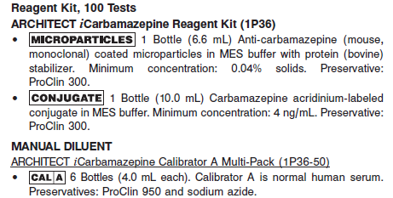

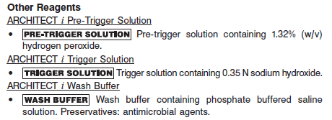

**Calibrator:**

**•** 1P36-01 ARCHITECT *i* Carbamazepine Calibrators

**•** 1P36-50 ARCHITECT *i* Carbamazepine Calibrator A Multi-Pack

**Quality Control:** Commercially available controls

**Calibration**

**Frequency:**

Recalibration is required with each new reagent lot number.

**A new calibration is required:**

1. If quality control results do not meet acceptance criteria defined by your laboratory, patient values may be suspect. Follow the established quality control procedures for your laboratory. Recalibration may be necessary.
2. Review quality control results and acceptance criteria following a change of reagent or calibrator lot.

**Calibrator Required:**

**•** 1P36-01 ARCHITECT *i* Carbamazepine Calibrators

**•** 1P36-50 ARCHITECT *i* Carbamazepine Calibrator A Multi-Pack

**Reagents:**

1P36-01 ARCHITECT *i* Carbamazepine Calibrators

6 Bottles ARCHITECT *i* Carbamazepine Calibrators A - F (A - F) (4.0 mL each). Calibrator A is normal human serum. Calibrators B through F are different concentrations of carbamazepine in normal human serum. Preservatives: ProClin 950 and sodium azide

1P36-50 ARCHITECT *i* Carbamazepine Calibrator A Multi-Pack

6 Bottles ARCHITECT *i* Carbamazepine Calibrator A (4.0 mL each). Calibrator A is normal human serum. Preservatives: ProClin 950 and sodium azide.

**Calibrator Preparation:**

**•** ARCHITECT *i* Carbamazepine Calibrator A and iCarbamazepine calibrators are liquid ready-to-use. No preparation is required.

**•** Mix Calibrator A by gentle inversion before use.

**•** After each use, tightly close the caps and return the calibrator to 2-8°C storage.

**Calibration Procedure:**

To perform an ARCHITECT *i* Carbamazepine calibration, test Calibrators A, B, C, D, E, and F in duplicate. The calibrators should be priority loaded.

**•** Calibration Range: 0.00 to 20.00 μg/mL.

To obtain the recommended volume requirements for the calibrators, hold the bottles **vertically** and dispense a minimum of 5 drops of each calibrator into each respective sample cup.

**Troubleshooting and Overall Acceptance Criteria Failure**

See ARCHITECT Operations Manual for further calibration troubleshooting.

**Quality Control:**

Abbott recommends, refer to your laboratory standard operating procedure(s) and/or quality assurance plan for additional quality control requirements and potential corrective actions:

• At a minimum a single level of quality control are to be run every 24 hours

• If more frequent control monitoring is required, follow the established quality control procedures for your laboratory.

• If quality control results do not meet the acceptance criteria defined by your laboratory, patient values may be suspect. Follow the established quality control procedures for your laboratory.

Recalibration may be necessary.

• Review quality control results and acceptance criteria following a change of reagent or calibrator lot.

**Instrument Procedure**

* The ARCHITECT iCarbamazepine assay is designed for use on the ARCHITECT *i* System.
* The ARCHITECT iCarbamazepine assay file must be installed on the ARCHITECT *i* System from an ARCHITECT *i* System Assay CD-ROM prior to performing the assay. For detailed information on assay file installation and on viewing and editing assay parameters, refer to the ARCHITECT System Operations Manual, Section 2.
* For detailed information on assay file installation and viewing and editing assay parameters, refer to the ARCHITECT System Operations Manual, Section 2.
* For information on printing assay parameters, refer to the ARCHITECT System Operations Manual, Section 5.
* For a detailed description of system procedures, refer to the ARCHITECT System Operations Manual.

**Assay Procedure**

For a detailed description of how to run an assay, refer to *Section 5* of the **ARCHITECT System Operations Manual**.

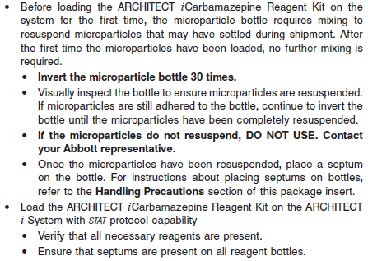

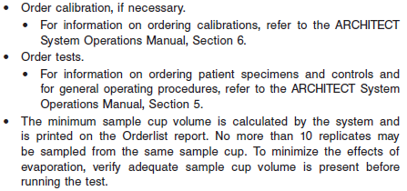

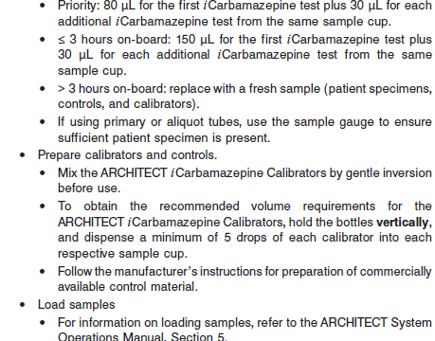

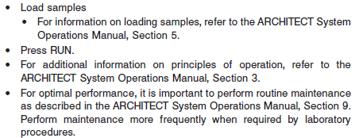

**Results**

The default result unit for the ARCHITECT iCarbamazepine assay is ug/mL

**Flags**

Some results may contain information in the Flags field. For a description of the flags that may appear in this field, refer to the ARCHITECT System Operations Manual, Section 5.

**Specific Performance Characteristics**

**Expected Values**

It is recommended that each laboratory determine its own reference range based upon its particular locale and population characteristics.

**Serum/Plasma:** 4 – 12 ug/mL

Plasma concentrations between 4 and 12 μg/mL of carbamazepine have been associated with optimal seizure control in adults. Toxicity associated with carbamazepine therapy is generally relatively minor. The most serious problem is concerned with carbamazepine’s ability to suppress bone marrow function. This serious toxic effect, potentially leading to aplastic anemia, is rare. More frequently encountered side effects such as drowsiness, incoordination, vertigo, and diplopia are dose-related and not of a life threatening nature.

See Data in the **EXPECTED VALUES** section of the package insert

**Critical Values:** > 15ug/mL

**Performance Characteristics**

**Measuring Interval**

Measuring Interval is defined as the range of values in μg/mL which meets the limits of acceptable performance for both imprecision and bias for an undiluted sample. For the studies described in this package insert, the range is 2.00 μg/mL (Limit of Quantitation) to 15.00 μg/mL.

**Linearity**

A linearrange of 0.56 μg/mL to 22.34 μg/mL was established for the ARCHITECT*i* Carbamazepine assay.

**Sensitivity**

Limit of Quantitation

The ARCHITECT *i* Carbamazepine assay is designed to have a Limit of Quantitation (LoQ) of ≤ 2.0 μg/mL.

Limit of Blank and Limit of Detection

In the same study, the Limit of Blank (LoB) and Limit of Detection (LoD) were determined. The LoB was 0.06 μg/mL and the LoD was 0.13 μg/mL.

**Dilution:**

**•** Specimens with a carbamazepine concentration greater than 15.00 μg/mL will be flagged as “> 15.00 μg/mL” and may be diluted using the Manual Dilution Procedure below.

Manual Dilution Procedure

**•** The suggested dilution for the ARCHITECT *i* Carbamazepine assay is 1:4.

**•** For example, add 50 μL of the patient specimen to 150 μL of ARCHITECT *i* Carbamazepine Calibrator A.

**•** The result should be greater than 2.00 μg/mL before the dilution factor is applied.

**•** The operator must enter the dilution factor in the Patient or Control order screen. The system will use this dilution factor to automatically calculate the concentration of the sample before dilution.

**•** For detailed information on ordering dilutions, refer to the ARCHITECT System Operations Manual, Section 5.

**Precision:**

The ARCHITECT *i* Carbamazepine assay is designed to have an imprecision of ≤ 7% Total CV for samples with carbamazepine concentrations across the range of 2.00 μg/mL to 15.00 μg/mL.. See reagent package insert for tables and more information.

#### Limitations of Procedure

* Specimens from patients who have received preparations of mouse monoclonal antibodies for diagnosis or therapy may contain human anti-mouse antibodies (HAMA). Specimens containing HAMA may produce anomalous values when tested with assay kits that employ mouse monoclonal antibodies.
* Heterophilic antibodies in human serum can react with reagent immunoglobulins, interfering with *in vitro* immunoassays. Patients routinely exposed to animals or to animal serum products can be prone to this interference and anomalous results may be observed. Additional information may be required for diagnosis.

**Interfering Substances**

Potentially Interfering Endogenous Substances

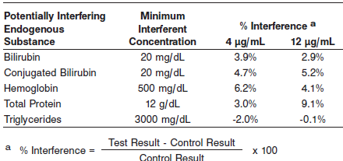

Potentially Interfering Clinical Conditions

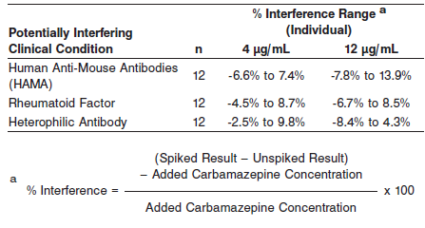

Potentially Interfering Drugs

See Reagent package insert for complete list

**References:**

1. ABBOTT ARCHITECT iCarbamazepine package insert

Abbott Laboratories

Diagnostics Division

Abbott Park, IL 60064

Dec 2011 G2-3001/R01

1. ABBOTT ARCHITECT iCarbamazepine Calibrator package insert

Abbott Laboratories

Diagnostics Division

Abbott Park, IL 60064

1. Abbott ARCHITECT Operator’s Guide

**Related Documents:**

**Attachments:**