RUSH logo for emails

***i*DIGOXIN**

**SERUM OR PLASMA**

**ABBOTT ARCHITECT**

**Intended Use**

The ARCHITECT iDigoxin assay is an *in vitro* chemiluminescent microparticle immunoassay (CMIA) for the quantitative measurement of digoxin in human serum or plasma on the ARCHITECT iSystem with STAT protocol capability. The measurements obtained are used to aid in the diagnosis and treatment of digoxin overdose and in monitoring levels of digoxin to help ensure appropriate therapy.

**Clinical Significance**

Digoxin is a potent cardiac glycoside prescribed for the treatment of patients suffering from congestive heart failure1 or from some types of cardiac arrhythmias. Monitoring of serum or plasma digoxin levels is performed because the drug has a low therapeutic ratio (a small difference between therapeutic and tissue toxic levels) and because the symptoms of drug overdose may resemble the original condition for which the drug was prescribed. Also, digoxin dosage may require adjustment when renal function is impaired or when drugs known to alter the pharmacokinetics of digoxin (e.g., quinidine, verapamil, or amiodarone) are coadministered. Monitoring serum or plasma digoxin levels along with other clinical data can aid the physician in adjusting patient dosage to achieve optimal therapeutic effect while avoiding subtherapeutic or toxic dosage levels.

**Principle**

The ARCHITECT iDigoxin assay is a one-step STAT immunoassay for the quantitative measurement of digoxin in human serum or plasma using CMIA technology with flexible assay protocols, referred to as Chemiflex.

1. Sample, anti-digoxin coated paramagnetic microparticles, assay diluent, and digoxigenin acridinium-labeled conjugate are combined to create a reaction mixture. The anti-digoxin coated microparticles bind to digoxin present in the sample and to the digoxigenin acridinium-labeled conjugate.

2. After washing, Pre-Trigger and Trigger Solutions are added to the reaction mixture.

3. The resulting chemiluminescent reaction is measured as relative light units (RLUs). There is an indirect relationship between the amount of digoxin in the sample and the RLUs detected by the ARCHITECT iSystem optics.

For additional information on system and assay technology, refer to the ARCHITECT System Operations Manual, Section 3.

**Specimen Collection and Handling**

**Suitable Specimens**

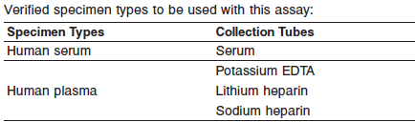

**•** Liquid anticoagulants may have a dilution effect resulting in lower concentrations for individual patient specimens.

Do not use specimens with the following conditions:

**•** heat-inactivated

**•** pooled

**•** grossly hemolyzed (> 750 mg/dL)

**•** obvious microbial contamination

**•** cadaver specimens or body fluids other than human serum or plasma

**Specimen Storage**

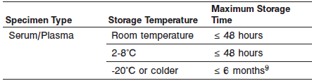

Serum or plasma should be separated from the clot or red blood cells as soon after collection as possible.

Avoid more than 3 freeze/thaw cycles.

**NOTE:** Stored specimens must be inspected for particulates. If present, mix and centrifuge the specimen to remove particulates prior to testing.

**Materials and Equipment Required**

**TEST INSTRUMENT**: Abbott ARCHITECT System

**MATERIALS PROVIDED**

1P32 ARCHITECT iDigoxin Reagent Kit

**MATERIALS REQUIRED BUT NOT PROVIDED**

**•** ARCHITECT *i* System

**•** ARCHITECT *i* Digoxin Assay file, may be obtained from:

**•** ARCHITECT *i* System e-Assay CD-ROM found on www.abbottdiagnostics.com

**•** ARCHITECT *i* System Assay CD-ROM

**•** 1P32-01 ARCHITECT *i* Digoxin Calibrators

**•** **•** Commercially available control material

**•** ARCHITECT *i* Pretrigger

**•** ARCHITECT *i* Trigger

**•** ARCHITECT *i i* Wash Buffer

**•** ARCHITECT *i* Reaction Vessels

**•** ARCHITECT *i* Sample Cups

**•** ARCHITECT *i* Septums

**•** ARCHITECT *i* Replacement Caps

**•** Pipettes or pipette tips (optional) to deliver the specified volumes.

**Reagent Handling and Storage:**

***CAUTION*:**

* For in vitro diagnostic use.

**CAUTION:** This product requires the handling of human specimens.

It is recommended that all human sourced materials be considered

potentially infectious and be handled in accordance with the OSHA

Standard on Bloodborne Pathogens. Biosafety Level 2 or other appropriate biosafety practices should be used for materials that contain or are suspected of containing infectious agents.

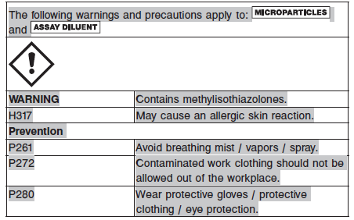

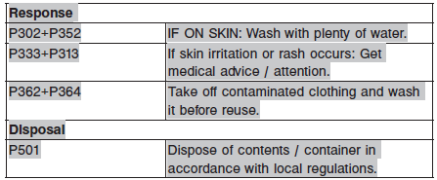

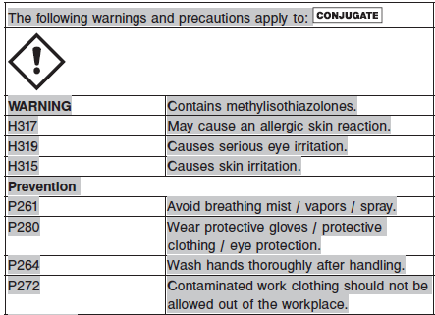 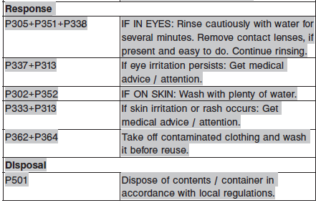

**Reagent Handling**

* Do not use reagent kits beyond the expiration date.
* **Do not pool reagents within a kit or between reagent kits.**
* Before loading the ARCHITECT Reagent Kit on the system for the first time, the microparticle bottle requires mixing to resuspend microparticles that have settled during shipment.
* **Septums MUST be used to prevent reagent evaporation and contamination and to ensure reagent integrity. Reliability of assay results cannot be guaranteed if septums are not used according to the instructions in the package insert.**
* To avoid contamination, wear clean gloves when placing a septum on an uncapped reagent bottle.
* Once a septum has been placed on the reagent bottle, **do not invert the bottle** as this will result in reagent leakage and maycompromise assay results.
* Over time, residual liquids may dry on the septum surface. These are typically dried salts and have no effect on assay efficacy.
* For a detailed discussion of handling precautions during system operation, refer to the ARCHITECT System Operations Manual, Section 7.

**Reagent Storage**

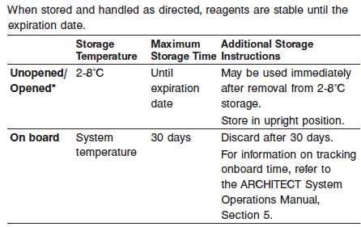

* Reagents may be stored on or off the ARCHITECT *i* System. If reagents are removed from the system, store them at 2-8°C (with septums and replacement caps) in an upright position. For reagents stored off the system, it is recommended that they be stored in their original trays and boxes to ensure they remain upright. **If the microparticle bottle does** **not remain upright (with a septum installed) while in refrigerated** **storage off the system, the reagent kit must be discarded.** For information on unloading reagents, refer to the ARCHITECT System Operations Manual, Section 5.

Reagents

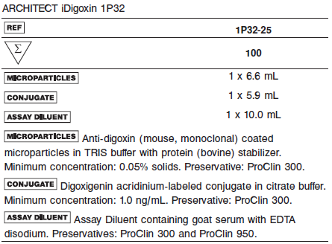

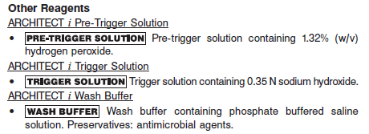

**Calibrator:**

**•** 1P32-01 ARCHITECT *i* Digoxin Calibrators

**Quality Control:** Commercially available controls

**Calibration**

**Frequency:**

Recalibration is required with each new reagent lot number.

**A new calibration is required:**

1. If quality control results do not meet acceptance criteria defined by your laboratory, patient values may be suspect. Follow the established quality control procedures for your laboratory. Recalibration may be necessary.
2. Review quality control results and acceptance criteria following a change of reagent or calibrator lot.

**Calibrator Required:**

1P32-01 ARCHITECT *i* Digoxin Calibrators

**Reagents:**

6 Bottles (4.0 mL each) of *i* Digoxin Calibrators. Calibrator A contains normal human serum. Calibrators B-F contain normal human serum with digoxin.

**Calibrator Preparation:**

ARCHITECT *i* Digoxin Calibrators may be used immediately after removal from 2-8°C storage. Prior to use, mix by gentle inversion (5‑10 times). After each use, tightly close the caps and return the calibrators to 2-8°C storage.

**Calibration Procedure:**

**•** Test Calibrators A-F in duplicate. The calibrators should be priority loaded.

A single sample of each control level must be tested to evaluate the assay calibration. Ensure that assay control values are within the ranges specified in the respective control package insert.

**•** Calibration Range: 0.0 to 4.0 ng/mL.

**Troubleshooting and Overall Acceptance Criteria Failure**

See ARCHITECT Operations Manual for further calibration troubleshooting.

**Quality Control:**

Abbott recommends, refer to your laboratory standard operating procedure(s) and/or quality assurance plan for additional quality control requirements and potential corrective actions:

• At a minimum a single level of quality control are to be run every 24 hours

• If more frequent control monitoring is required, follow the established quality control procedures for your laboratory.

• If quality control results do not meet the acceptance criteria defined by your laboratory, patient values may be suspect. Follow the established quality control procedures for your laboratory.

Recalibration may be necessary.

• Review quality control results and acceptance criteria following a change of reagent or calibrator lot.

**Instrument Procedure**

* The ARCHITECT *i* Digoxin assay is designed for use on the ARCHITECT *i* System.
* The ARCHITECT *i* Digoxin assay file must be installed on the ARCHITECT *i* System from an ARCHITECT *i* System Assay CD-ROM prior to performing the assay. For detailed information on assay file installation and on viewing and editing assay parameters, refer to the ARCHITECT System Operations Manual, Section 2.
* For detailed information on assay file installation and viewing and editing assay parameters, refer to the ARCHITECT System Operations Manual, Section 2.
* For information on printing assay parameters, refer to the ARCHITECT System Operations Manual, Section 5.
* For a detailed description of system procedures, refer to the ARCHITECT System Operations Manual.

**Assay Procedure**

For a detailed description of how to run an assay, refer to *Section 5* of the **ARCHITECT System Operations Manual**.

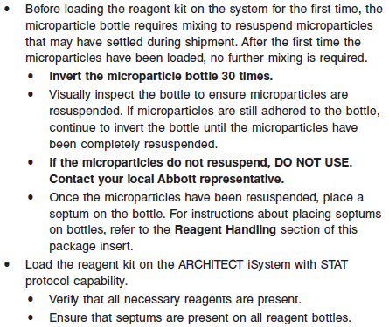

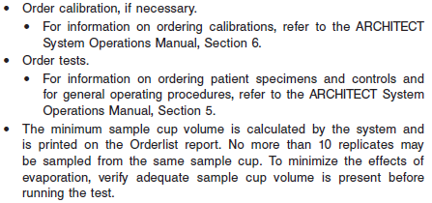

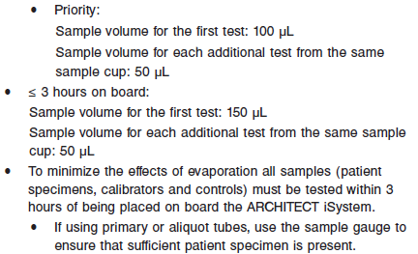

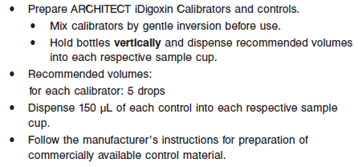

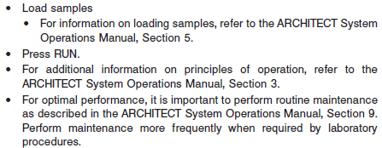

**Results**

The default result unit for the ARCHITECT *i* Digoxin assay is ng/mL

**Flags**

Some results may contain information in the Flags field. For a description of the flags that may appear in this field, refer to the ARCHITECT System Operations Manual, Section 5.

**Specific Performance Characteristics**

**Expected Values**

It is recommended that each laboratory determine its own reference range based upon its particular locale and population characteristics.

**Serum/Plasma:** 0.8 – 2.0 ng/mL

The ARCHITECT *i* Digoxin assay accurately quantitates digoxin concentrations in human serum or plasma at concentrations up to 4.0 ng/mL. Numerous studies have shown a relationship between serum levels of digoxin and its concentration in myocardial and other tissues. In a study in which serum digoxin levels were determined by radioimmunoassay, optimum therapeutic effects usually are observed when serum levels are in the range from 0.8 to 2.0 ng/mL, although some clinical benefit may be realized at serum or plasma concentrations below 0.8 ng/mL. The risk of toxicity increases at serum or plasma levels above 2.0 ng/mL. Symptoms of digoxin toxicity may include gastrointestinal disturbances such as anorexia, nausea, vomiting and diarrhea, central nervous system disturbances manifested by blurred or yellow vision, headache, weakness, dizziness, apathy, and confusion, and cardiac rhythm disturbances and tachycardia. There is some evidence that children may tolerate slightly higher serum or plasma concentrations than adults. It is important to note that the distinction between adequate digitalization and toxicity in patients cannot be made on the basis of digoxin concentrations alone. Most studies show a significant overlap between the toxic and nontoxic groups. Additional factors to consider when evaluating the correct therapeutic dosage for each patient are lean body weight, age, renal function, concomitant disease states, concurrent medications, and other clinical factors. Refer to the drug manufacturer’s package insert. Each laboratory should establish its own therapeutic (reference) range for digoxin.

**Critical Values:** > 2.0 ng/mL for all ages

**Performance Characteristics**

**Linearity**

The linear range of the assay is 0.3 to 4.0 ng/mL.

**Sensitivity**

The ARCHITECT *i* Digoxin assay is designed to have a Limit of Detection of ≤ 0.3 ng/mL.

**Dilution:**

Specimens with a digoxin value exceeding 4.00 ng/ mL are flagged with the code “>4.00 ng/mL”and may be diluted using the Manual Dilution Procedure.

**Manual Dilution Procedure**

Suggested dilution: 1:10

1. Add 20 μL of the patient specimen to 180 μL of Calibrator A.

2. The operator must enter the dilution factor in the Patient or Control order screen. The system will use this dilution factor to automatically calculate the concentration of the sample before dilution and report the result. The result should be > 0.30 ng/mL before the dilution factor is applied.

For detailed information on ordering dilutions, refer to the ARCHITECT System Operations Manual, Section 5.

**Precision:**

The ARCHITECT *i* Digoxin assay is designed to have an assay precision of ≤ 10% total CV.

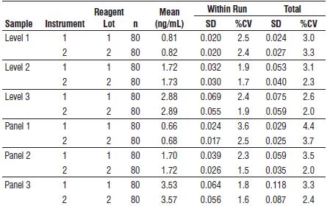

#### Limitations of Procedure

* Specimens from patients who have received preparations of mouse monoclonal antibodies for diagnosis or therapy may contain human anti-mouse antibodies (HAMA). Specimens containing HAMA may produce anomalous values when tested with assay kits that employ mouse monoclonal antibodies.
* Heterophilic antibodies in human serum can react with reagent immunoglobulins, interfering with *in vitro* immunoassays. Patients routinely exposed to animals or to animal serum products can be prone to this interference and anomalous results may be observed. Additional information may be required for diagnosis.
* Plasma samples from different anticoagulant tube types should not be used interchangeably for monitoring digoxin.
* Some immunoassays for digoxin may cross-react with metabolites, which can lead to a positive bias in patient results. Refer to the **SPECIFIC PERFORMANCE CHARACTERISTICS**, **Specificity** section of the package insert for estimates of crossreactivity of ARCHITECT *i* Digoxin to some metabolites of digoxin.
* Digoxin values for specimens from patients who have received DIGIBIND or DIGIFAB therapy may be impacted. See the **SPECIFIC PERFORMANCE CHARACTERISTICS**, **Interfering** **Substances** section.

**Interfering Substances**

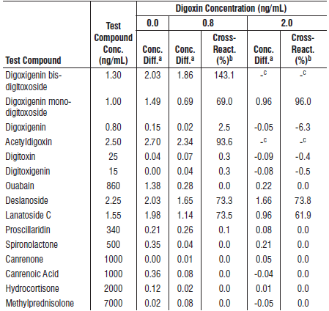

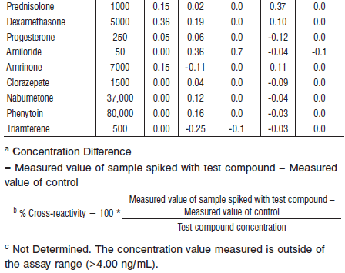

It has been reported in the literature that one in ten patients converts 40% or more of oral digoxin to an inactive reduction product (dihydrodigoxin) via bacteria in the gut. There is little or no crossreactivity reported for dihydrodigoxin

**Interfering Substances**

Potential interference in the ARCHITECT *i* Digoxin assay from the following compounds is designed to have a mean recovery of 100 +/- 10% of the control results at the levels indicated.

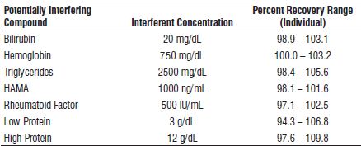

The manufacturer of Digoxin Immune Fab has stated that no immunoassay technique is suitable for quantitating digoxin in serum from patients on antibody fragment therapy. According to the manufacturer’s insert, DIGIBIND will interfere with digitalis immunoassay measurements

**References:**

1. ABBOTT ARCHITECT *i* Digoxin package insert

Abbott Laboratories

Diagnostics Division

Abbott Park, IL 60064

Jan 2015 G1-0314/ R06

1. ABBOTT ARCHITECT *i* Digoxin Calibrator package insert

Abbott Laboratories

Diagnostics Division

Abbott Park, IL 60064

1. Abbott ARCHITECT Operator’s Guide

**Related Documents:**

**Attachments:**