RUSH logo for emails

***i*GENTAMICIN**

**SERUM OR PLASMA**

**ABBOTT ARCHITECT**

**Intended Use**

The ARCHITECT *i* Gentamicin assay is an *in vitro* chemiluminescent microparticle immunoassay (CMIA) for the quantitative determination of gentamicin, an antibiotic drug, in human serum or plasma on the ARCHITECT *i* System with *STAT* protocol capability. The measurements obtained are used in the diagnosis and treatment of gentamicin overdose and in monitoring levels of gentamicin to help ensure appropriate therapy.

**Clinical Significance**

Gentamicin is an aminoglycoside antibiotic which exhibits high potency and a broad spectrum bacterial action against both gram-negative and gram-positive organisms. It exhibits a narrow therapeutic index which makes its use hazardous, especially in patients with impaired renal function. In addition, the dose-serum level profile curve of gentamicin is unpredictable, both in terms of peak-serum levels and elimination half-life from plasma.

**Principle**

The ARCHITECT *i* Gentamicin assay is a one-step immunoassay for the quantitative determination of gentamicin in human serum or plasma using CMIA technology with flexible assay protocols, referred to as Chemiflex. In the ARCHITECT *i* Gentamicin assay, sample, anti-gentamicin coated paramagnetic microparticles, and gentamicin acridinium‑labeled conjugate are combined to create a reaction mixture. The anti-gentamicin coated microparticles bind to the gentamicin present in the sample and to the acridinium-labeled conjugate. After washing, pre-trigger and trigger solutions are added to the reaction mixture. The resulting chemiluminescent reaction is measured as relative light units (RLUs). An indirect relationship exists between the amount of gentamicin in the sample and the RLUs detected by the ARCHITECT *i* System optics.

For additional information on system and assay technology, refer to the ARCHITECT System Operations Manual, Section 3.

**Specimen Collection and Handling**

**Suitable Specimens**

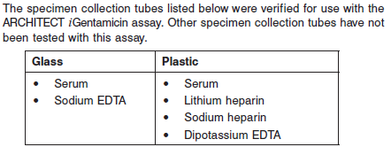

.

Do not use specimens with the following conditions:

**•** heat-inactivated

**•** pooled

**•** grossly hemolyzed (> 750 mg/dL)

**•** obvious microbial contamination

**•** cadaver specimens or body fluids other than human serum or plasma

**Specimen Storage**

**•** Specimens may be stored on or off the clot or red blood cells for

**•** up to 24 hours at room temperature (15-30°C) or

**•** up to 7 days at 2-8°C.

**•** If testing will be delayed more than 7 days, remove serum or plasma from the clot or red blood cells and store at -20°C or colder.

**•** Avoid more than three freeze/thaw cycles.

**•** Samples containing β-lactam antibiotics should be stored frozen if a delay in analysis of more than 8 hours is anticipated. Failure to freeze samples containing these antibiotics may result in falsely low gentamicin levels due to *in vitro* inactivation

**NOTE:** Stored specimens must be inspected for particulates. If present, mix and centrifuge the specimen to remove particulates prior to testing.

**Materials and Equipment Required**

**TEST INSTRUMENT**: Abbott ARCHITECT System

**MATERIALS PROVIDED**

1P31 ARCHITECT *i* Gentamicin Reagent Kit

**MATERIALS REQUIRED BUT NOT PROVIDED**

**•** ARCHITECT *i* System

**•** ARCHITECT *i* Gentamicin Assay file, may be obtained from:

**•** ARCHITECT *i* System e-Assay CD-ROM found on www.abbottdiagnostics.com

**•** ARCHITECT *i* System Assay CD-ROM

**•** 1P31-01 ARCHITECT *i* Gentamicin Calibrators

**•** Commercially available control material

**•** ARCHITECT *i* Pretrigger

**•** ARCHITECT *i* Trigger

**•** ARCHITECT *i* Wash Buffer

**•** ARCHITECT *i* Reaction Vessels

**•** ARCHITECT *i* Sample Cups

**•** ARCHITECT *i* Septums

**•** ARCHITECT *i* Replacement Caps

**•** Pipettes or pipette tips (optional) to deliver the specified volumes.

**Reagent Handling and Storage:**

***CAUTION*:**

* For in vitro diagnostic use.

**CAUTION:** This product requires the handling of human specimens.

It is recommended that all human sourced materials be considered

potentially infectious and be handled in accordance with the OSHA

Standard on Bloodborne Pathogens. Biosafety Level 2 or other appropriate biosafety practices should be used for materials that contain or are suspected of containing infectious agents.

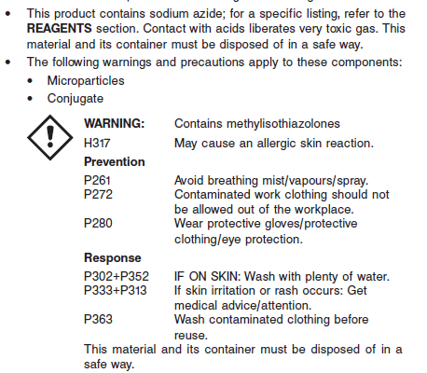

**Reagent Handling**

* Do not use reagent kits beyond the expiration date.
* Do not freeze ARCHITECT *i* Gentamicin reagents.
* **Do not pool reagents within a kit or between reagent kits.**
* Before loading the ARCHITECT Reagent Kit on the system for the first time, the microparticle bottle requires mixing to resuspend microparticles that have settled during shipment.
* **Septums MUST be used to prevent reagent evaporation and contamination and to ensure reagent integrity. Reliability of assay results cannot be guaranteed if septums are not used according to the instructions in the package insert.**
* To avoid contamination, wear clean gloves when placing a septum on an uncapped reagent bottle.
* Once a septum has been placed on the reagent bottle, **do not invert the bottle** as this will result in reagent leakage and maycompromise assay results.
* Over time, residual liquids may dry on the septum surface. These are typically dried salts and have no effect on assay efficacy.
* For a detailed discussion of handling precautions during system operation, refer to the ARCHITECT System Operations Manual, Section 7.

**Reagent Storage**

* The ARCHITECT *i* Gentamicin Reagent Kit must be stored at 2-8°C in an upright position and may be used immediately after removal from 2-8°C storage.
* When stored and handled as directed, the reagents are stable until the expiration date.
* The ARCHITECT *i* Gentamicin Reagent Kit may be stored on board the ARCHITECT *i* System with *STAT* protocol capability for a maximum of 30 days. After 30 days, the reagent kit must be discarded. Recalibration may be required to obtain maximum onboard reagent stability. For information on tracking onboard time, refer to the ARCHITECT System Operations Manual, Section 5.
* Reagents may be stored on or off the ARCHITECT *i* System. If reagents are removed from the system, store them at 2-8°C (with septums and replacement caps) in an upright position. For reagents stored off the system, it is recommended that they be stored in their original trays and boxes to ensure they remain upright. **If the microparticle bottle does** **not remain upright (with a septum installed) while in refrigerated** **storage off the system, the reagent kit must be discarded.** For information on unloading reagents, refer to the ARCHITECT System Operations Manual, Section 5.

Reagents

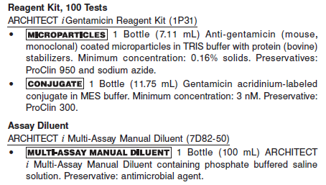

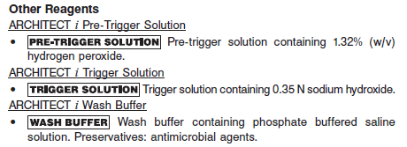

**Calibrator:**

**•** 1P31-01 ARCHITECT *i* Gentamicin Calibrators

**Quality Control:** Commercially available controls

**Calibration**

**Frequency:**

Recalibration is required with each new reagent lot number.

**A new calibration is required:**

1. If quality control results do not meet acceptance criteria defined by your laboratory, patient values may be suspect. Follow the established quality control procedures for your laboratory. Recalibration may be necessary.
2. Review quality control results and acceptance criteria following a change of reagent or calibrator lot.

**Calibrator Required:**

1P31-01 ARCHITECT *i* Gentamicin Calibrators

**Reagents:**

6 Bottles ARCHITECT *i* Gentamicin Calibrators A - F Calibrator A (6.0 mL) is recalcified human plasma. Calibrators B through F (4.0 mL each) are different concentrations of gentamicin in recalcified human plasma. Preservatives: ProClin 950 and sodium azide.

**Calibrator Preparation:**

**•** The ARCHITECT *i* Gentamicin Calibrators are liquid ready-to-use. No preparation is required.

**•** ARCHITECT *i* Gentamicin Calibrators must be mixed by gentle inversion before use.

**•** To perform a calibration, test the calibrators in duplicate. The calibrators should be priority loaded.

**•** To obtain the recommended volume requirements for the calibrators, hold the bottles **vertically** and dispense a minimum of 5 drops of each calibrator into each respective sample cup.

**•** After each use, tightly close the caps and return the calibrators to 2-8°C storage.

**•** For information on ordering calibrations, refer to the ARCHITECT System Operations Manual, Section 6.

**Calibration Procedure:**

**•** To perform an ARCHITECT *i* Gentamicin calibration, test the calibrators in duplicate. The calibrators should be priority loaded.

**•** Calibration Range: 0.0 - 10.0 μg/mL.

**Troubleshooting and Overall Acceptance Criteria Failure**

See ARCHITECT Operations Manual for further calibration troubleshooting.

**Quality Control:**

Abbott recommends, refer to your laboratory standard operating procedure(s) and/or quality assurance plan for additional quality control requirements and potential corrective actions:

• At a minimum a single level of quality control are to be run every 24 hours

• If more frequent control monitoring is required, follow the established quality control procedures for your laboratory.

• If quality control results do not meet the acceptance criteria defined by your laboratory, patient values may be suspect. Follow the established quality control procedures for your laboratory.

Recalibration may be necessary.

• Review quality control results and acceptance criteria following a change of reagent or calibrator lot.

When using commercially available controls, each laboratory should establish its own concentration ranges for new control lots at each clinically relevant control level. This can be accomplished by assaying a minimum of 20 replicates over several (3-5) days. Sources of variation that can be expected should be included in this study in order to be representative of future system performance. These may include:

**•** Multiple stored calibrations

**•** Multiple reagent lots

**•** Multiple calibrator lots

**•** Multiple processing modules

**•** Data points collected at different times of the day

**Instrument Procedure**

* The ARCHITECT *i* Gentamicin assay is designed for use on the ARCHITECT *i* System.
* The ARCHITECT *i* Gentamicin assay file must be installed on the ARCHITECT *i* System from an ARCHITECT *i* System Assay CD-ROM prior to performing the assay. For detailed information on assay file installation and on viewing and editing assay parameters, refer to the ARCHITECT System Operations Manual, Section 2.
* ARCHITECT *i* Gentamicin samples analyzed in the presence of some ARCHITECT hepatitis assays may generate Error Code *1700 Unable* *to process test, due to interference from Assay number (x)* (*x* = Assay number).
* For detailed information on assay file installation and viewing and editing assay parameters, refer to the ARCHITECT System Operations Manual, Section 2.
* For information on printing assay parameters, refer to the ARCHITECT System Operations Manual, Section 5.
* For a detailed description of system procedures, refer to the ARCHITECT System Operations Manual.

**Assay Procedure**

For a detailed description of how to run an assay, refer to *Section 5* of the **ARCHITECT System Operations Manual**.

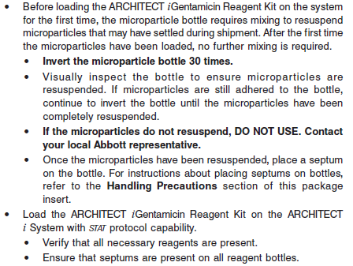

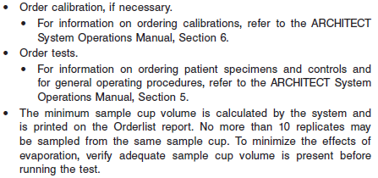

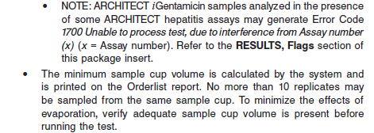

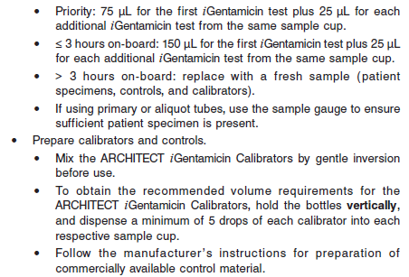

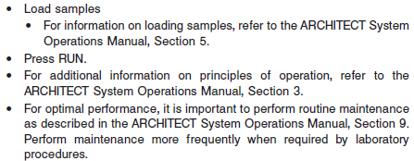

**Results**

The default result unit for the ARCHITECT *i* Gentamicin assay is ug/mL

**Flags**

Some results may contain information in the Flags field. For a description of the flags that may appear in this field, refer to the ARCHITECT System Operations Manual, Section 5.

Some results may contain information in the Flags field. For a description of the flags that may appear in this field, refer to the ARCHITECT System Operations Manual, Section 5.

Exception: Error Code 1700 (For ARCHITECT Systems running hepatitis assay(s) only)

**•** The ARCHITECT assays that contain gentamicin as a preservative are listed in the table below. ARCHITECT *i* Gentamicin samples analyzed in the presence of any of the assays listed in the table below may generate an exception, Error Code *1700 Unable to process test, due to* *interference from Assay number (x)* (*x* = Assay number).

**•** If a sample generates Error Code 1700 the first time, do the following:

**•** Reorder and run the ARCHITECT *i* Gentamicin test.

**•** Reorder and run any remaining tests for the sample.

**• NOTE: DO NOT** reorder the ARCHITECT *i* Gentamicin test with any of the assays listed below.

**•** In the event that the **RETESTED** sample described above generates Error Code 1700, do the following:

**•** Perform the ARCHITECT maintenance procedure below **two times**:

**•** For ARCHITECT *i* 2000SR, perform *2130 Flush Fluids.*

**•** For ARCHITECT *i* 1000SR, perform *2137 Flush Fluids.*

**•** Reorder and run the ARCHITECT *i* Gentamicin test.

**•** Refer to ARCHITECT System Operations Manual, Section 9.

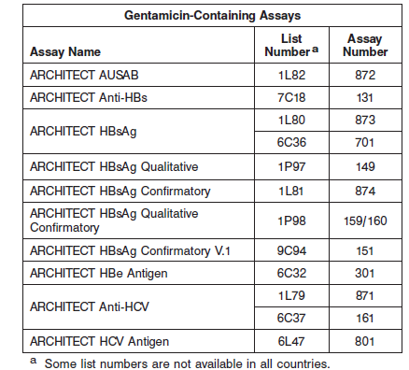

**Specific Performance Characteristics**

**Expected Values**

It is recommended that each laboratory determine its own reference range based upon its particular locale and population characteristics.

**Serum/Plasma:**

Trough: 0.0 – 2.0 μg/mL

Peak: < 2 months = 5.0 – 10.0 μg/mL

< 150 years = 4.0 – 8.0 μg/mL

Strong correlations have been shown between serum levels and both therapeutic effect and toxicity in specific patient types. Peak serum levels of gentamicin in the range of 5 to 10 μg/mL are suggested for optimal therapeutic effectiveness. Persistently elevated peak concentrations (10 μg/mL) have been shown to cause renal and eighth cranial nerve toxicity. Nephrotoxicity takes the form of damage to the proximal renal tubules, and is associated with impaired renal function. Central nervous system toxicity is most often manifested as damage to the vestibular and auditory branches of the eighth cranial nerve. Trough levels offer a more discrete indication of impending toxicity since they more closely correspond to tissue levels and are less affected by sampling errors. Slowly rising trough levels have been shown to correspond to tissue accumulation of the drug, and trough levels greater than 2 μg/mL have been associated with renal failure in some patients. Refer to the drug manufacturer’s package insert or the Physicians’ Desk Reference (PDR) for proper drug dosage and for gentamicin measurement sampling times.

**Critical Values:** Trough: > 2.0 μg/mL

Peak: >10 for all ages

**Performance Characteristics**

**Measuring Interval (Reportable Range)**

The measuring interval of the ARCHITECT *i* Gentamicin assay is 0.3 μg/mL to 10.0 μg/mL When using the manual dilution procedure, the assay can report values up to 50.0 μg/mL.

**Linearity**

A linear range of 0.11 to 11.16 μg/mL was established for the ARCHITECT *i* Gentamicin assay.

**Sensitivity**

Limit of Quantitation

The ARCHITECT *i* Gentamicin assay is designed to have a Limit of Quantitation (LoQ) of ≤ 0.3 μg/mL.

Limit of Blank and Limit of Detection

In the same study, the Limit of Blank (LoB) and Limit of Detection (LoD) were determined. The LoB was 0.00 μg/mL and the LoD was 0.05 μg/mL.

**Dilution:**

Specimens with gentamicin concentrations of > 10.00 μg/mL will be flagged as “>10.00 μg/mL” and may be diluted using the Manual Dilution Procedure.

**•** Manual dilutions should be performed as follows:

**•** The suggested dilution for the ARCHITECT *i* Gentamicin assay is 1:5.

**•** Add 50 μL of the patient specimen to 200 μL of the ARCHITECT *i* Gentamicin Calibrator A or ARCHITECT *i* Multi-Assay Manual Diluent.

**•** The operator must enter the dilution factor in the Patient or Control order screen. The system will use this dilution factor to automatically calculate the concentration of the sample before dilution and report the result. The result should be greater than 0.3 μg/mL before the dilution factor is applied.

**•** For detailed information on ordering dilutions, refer to the ARCHITECT System Operations Manual, Section 5.

**Precision:**

The ARCHITECT *i* Gentamicin assay is designed to have an imprecision of ≤ 8% total CV for samples with gentamicin concentrations ranging from 2 μg/mL to 10 μg/mL. See reagent package insert for more information

#### Limitations of Procedure

* Specimens from patients who have received preparations of mouse monoclonal antibodies for diagnosis or therapy may contain human anti-mouse antibodies (HAMA). Specimens containing HAMA may produce anomalous values when tested with assay kits that employ mouse monoclonal antibodies.
* Heterophilic antibodies in human serum can react with reagent immunoglobulins, interfering with *in vitro* immunoassays. Patients routinely exposed to animals or to animal serum products can be prone to this interference and anomalous results may be observed. Additional information may be required for diagnosis.
* Samples containing β-lactam antibiotics should be stored frozen if a delay in analysis of more than 8 hours is anticipated. Failure to freeze samples containing these antibiotics may result in falsely low gentamicin levels due to *in vitro* inactivation.
* Patient samples which contain the drugs cephalexin, netilmicin, sisomicin and sagamicin will yield falsely elevated values for gentamicin. However, these drugs are not usually coadministered with gentamicin. High concentration of penicillins or cephalosporins have been shown to inactivate gentamicin *in vitro*. The degree of inactivation is dependent on the particular aminoglycoside being measured, the type and concentration of the penicillin or cephalosporin that is also present and the storage conditions of the sample. Samples from patients receiving additional antibiotics of these types should be assayed immediately or stored frozen.
* Patient samples which contain the drugs kanamycin B, neomycin, and tobramycin may yield falsely elevated values for gentamicin.

**Interfering Substances**

Potentially Interfering Endogenous Substances

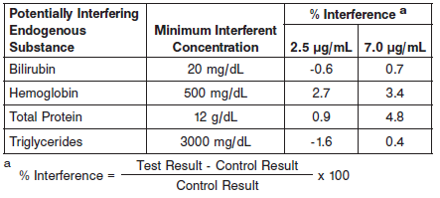

Potentially Interfering Clinical Conditions

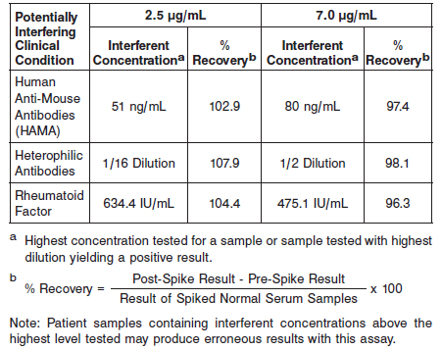

Potentially Interfering Drugs

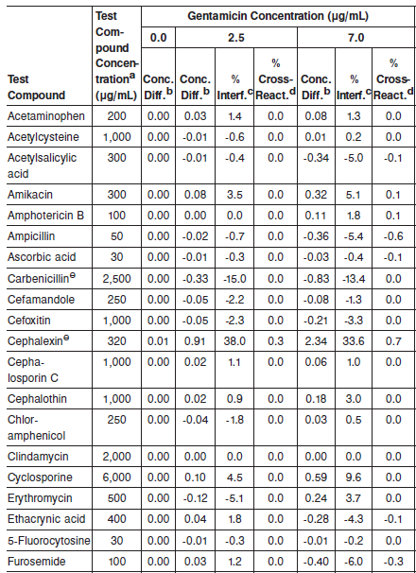

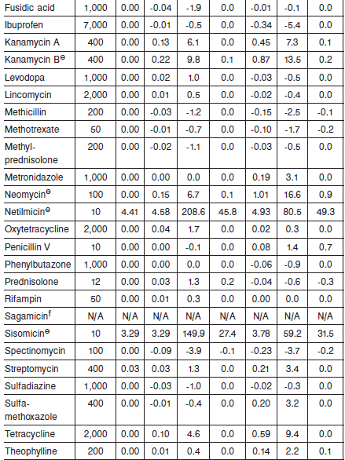

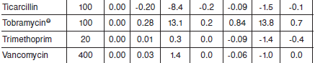

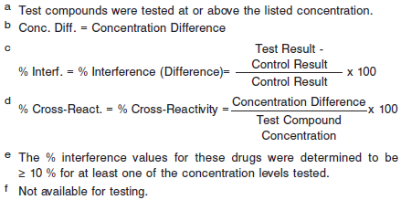

**References:**

1. ABBOTT ARCHITECT *i* Gentamicin package insert

Abbott Laboratories

Diagnostics Division

Abbott Park, IL 60064

March 2012 G2-6097/R06

1. ABBOTT ARCHITECT *i* Gentamicin Calibrator package insert

Abbott Laboratories

Diagnostics Division

Abbott Park, IL 60064

1. Abbott ARCHITECT Operator’s Guide

**Related Documents:**

**Attachments:**