RUSH logo for emails

***i*PHENYTOIN**

**SERUM OR PLASMA**

**ABBOTT ARCHITECT**

**Intended Use**

The ARCHITECT *i* Phenytoin assay is an *in vitro* chemiluminescent microparticle immunoassay (CMIA) for the quantitative measurement of phenytoin, an anticonvulsant drug, in human serum or plasma on the ARCHITECT *i* System with *STAT* protocol capability. The measurements obtained are used in monitoring levels of phenytoin to help ensure appropriate therapy.

**Clinical Significance**

Phenytoin (Dilantin) is one of the most widely prescribed anticonvulsants and is occasionally used as a myocardial antiarrhythmic. In the treatment of epilepsy, phenytoin is indicated for grand mal epilepsy (major motor) and cortical focal seizures and temporal lobe epilepsy.

The main pathway (about 90%) for disposition of phenytoin is by excretion of the glucuronide of para-hydroxyphenylphenyl-hydantoin (HPPH) in the urine. It is hydroxylated in the liver and eliminated. The metabolic conversion to HPPH is a saturable process and in many cases small increments in dosage can cause a large increase in phenytoin plasma level. Because of the narrow therapeutic index and the wide interindividual variability in the rate of phenytoin metabolism and clearance, the determination of blood levels of phenytoin for patients receiving therapy is appropriate.

**Principle**

The ARCHITECT *i* Phenytoin assay is a one-step *STAT* immunoassay for the quantitative measurement of phenytoin in human serum or plasma using CMIA technology, with flexible assay protocols, referred to as Chemiflex. Sample, anti-phenytoin coated paramagnetic microparticles, and phenytoin acridinium-labeled conjugate are combined to create a reaction mixture. The anti-phenytoin coated microparticles bind to phenytoin present in the sample and to the phenytoin acridinium-labeled conjugate. After washing, pre-trigger and trigger solutions are added to the reaction mixture. The resulting chemiluminescent reaction is measured as relative light units (RLUs). An indirect relationship exists between the amount of phenytoin in the sample and the RLUs detected by the ARCHITECT *i* System optics. For additional information on system and assay technology, refer to the ARCHITECT System Operations Manual, Section 3.

**Specimen Collection and Handling**

**Suitable Specimens**

The specimen collection tubes listed below were verified to be used with the ARCHITECT *i* Phenytoin assay. Other specimen collection tubes, including gel separation tubes, have not been tested with this assay.

**•** Human serum

**•** Human plasma collected in:

**•** lithium heparin **•** sodium heparin

**•** potassium EDTA **•** sodium EDTA

**•** sodium citrate **•** potassium oxalate

**•** Plasma samples from different anticoagulant tube types should not be used interchangeably for monitoring phenytoin. Use of citrate tubes may cause dilution effects.

**•** Liquid anticoagulants may have a dilution effect resulting in lower concentrations for individual patient specimens.

Do not use specimens with the following conditions:

**•** heat-inactivated

**•** pooled

**•** grossly hemolyzed (> 500 mg/dL)

**•** obvious microbial contamination

**•** cadaver specimens or body fluids other than human serum or plasma

**Specimen Storage**

**•** Specimens may be stored on or off the clot or red blood cells for up to two days at room temperature (20-25°C).9 Specimens removed from the clot or red blood cells may be stored up to eight days refrigerated at 2-8°C.

**•** Serum or plasma specimens can be stored up to five months at -20°C or colder.

**•** Avoid more than five freeze/thaw cycles.

**NOTE:** Stored specimens must be inspected for particulates. If present, mix and centrifuge the specimen to remove particulates prior to testing.

**Materials and Equipment Required**

**TEST INSTRUMENT**: Abbott ARCHITECT System

**MATERIALS PROVIDED**

1P34 ARCHITECT *i* Phenytoin Reagent Kit

**MATERIALS REQUIRED BUT NOT PROVIDED**

**•** ARCHITECT *i* System

**•** ARCHITECT *i* Phenytoin Assay file, may be obtained from:

**•** ARCHITECT *i* System e-Assay CD-ROM found on www.abbottdiagnostics.com

**•** ARCHITECT *i* System Assay CD-ROM

**•** 1P34-01 ARCHITECT *i* Phenytoin Calibrators

**•** Commercially available control material

**•** ARCHITECT *i* Pretrigger

**•** ARCHITECT *i* Trigger

**•** ARCHITECT *i i* Wash Buffer

**•** ARCHITECT *i* Reaction Vessels

**•** ARCHITECT *i* Sample Cups

**•** ARCHITECT *i* Septums

**•** ARCHITECT *i* Replacement Caps

**•** Pipettes or pipette tips (optional) to deliver the specified volumes.

**Reagent Handling and Storage:**

***CAUTION*:**

* For in vitro diagnostic use.

**CAUTION:** This product requires the handling of human specimens.

It is recommended that all human sourced materials be considered

potentially infectious and be handled in accordance with the OSHA

Standard on Bloodborne Pathogens. Biosafety Level 2 or other appropriate biosafety practices should be used for materials that contain or are suspected of containing infectious agents.

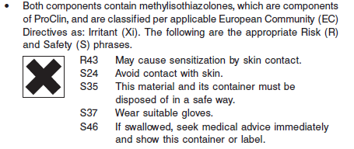

**Reagent Handling**

* Do not use reagent kits beyond the expiration date.
* **Do not pool reagents within a kit or between reagent kits.**
* Before loading the ARCHITECT Reagent Kit on the system for the first time, the microparticle bottle requires mixing to resuspend microparticles that have settled during shipment.
* **Septums MUST be used to prevent reagent evaporation and contamination and to ensure reagent integrity. Reliability of assay results cannot be guaranteed if septums are not used according to the instructions in the package insert.**
* To avoid contamination, wear clean gloves when placing a septum on an uncapped reagent bottle.
* Once a septum has been placed on the reagent bottle, **do not invert the bottle** as this will result in reagent leakage and maycompromise assay results.
* Over time, residual liquids may dry on the septum surface. These are typically dried salts and have no effect on assay efficacy.
* For a detailed discussion of handling precautions during system operation, refer to the ARCHITECT System Operations Manual, Section 7.

**Reagent Storage**

* The ARCHITECT *i* Phenytoin Reagent Kit must be stored at 2-8°C in an upright position and may be used immediately after removal from 2-8°C storage.
* When stored and handled as directed, reagents are stable until the expiration date.
* The ARCHITECT *i* Phenytoin Reagent Kit may be stored on board the ARCHITECT *i* System with *STAT* protocol capability for a maximum of 30 days. After 30 days, the reagent kit must be discarded. For information on tracking onboard time, refer to the ARCHITECT System Operations Manual, Section 5.
* Reagents may be stored on or off the ARCHITECT *i* System. If reagents are removed from the system, store them at 2-8°C (with septums and replacement caps) in an upright position. For reagents stored off the system, it is recommended that they be stored in their original trays and boxes to ensure they remain upright. **If the microparticle bottle does** **not remain upright (with a septum installed) while in refrigerated** **storage off the system, the reagent kit must be discarded.** For information on unloading reagents, refer to the ARCHITECT System Operations Manual, Section 5.

Reagents

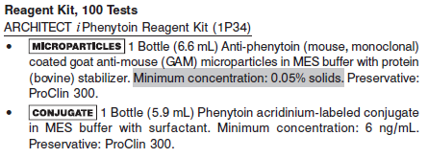

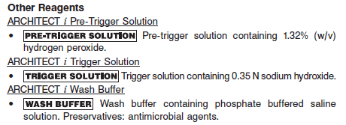

**Calibrator:** 1P34-01 ARCHITECT *i* Phenytoin Calibrators

**Quality Control:** Commercially available controls

**Calibration**

**Frequency:**

Recalibration is required with each new reagent lot number.

**A new calibration is required:**

1. If quality control results do not meet acceptance criteria defined by your laboratory, patient values may be suspect. Follow the established quality control procedures for your laboratory. Recalibration may be necessary.
2. Review quality control results and acceptance criteria following a change of reagent or calibrator lot.

**Calibrator Required:**

1P34-01 ARCHITECT *i* Phenytoin Calibrators

**Reagents:**

6 Bottles (4 mL each) of ARCHITECT *i* Phenytoin Calibrators. Calibrators A-F contain human serum. Calibrators B-F contain phenytoin. Preservatives: sodium azide, ProClin 300 and ProClin 950.

**Calibrator Preparation:**

**•** Calibrators may be used immediately after removal from 2-8°C storage.

**•** Prior to use, mix by gentle inversion (5-10 times). After each use, tightly close the caps and return the calibrators to 2-8°C storage.

**Calibration Procedure:**

To perform an ARCHITECT *i* Phenytoin calibration, test calibrators A, B, C, D, E, and F in duplicate. A single sample of each phenytoin control level must be tested to evaluate the assay calibration. Ensure that assay control values are within established ranges. Calibrators should be priority loaded.

**•** Calibration Range: 0.0 - 40.0 μg/mL.

**Troubleshooting and Overall Acceptance Criteria Failure**

See ARCHITECT Operations Manual for further calibration troubleshooting.

**Quality Control:**

Abbott recommends, refer to your laboratory standard operating procedure(s) and/or quality assurance plan for additional quality control requirements and potential corrective actions:

• At a minimum a single level of quality control are to be run every 24 hours

• If more frequent control monitoring is required, follow the established quality control procedures for your laboratory.

• If quality control results do not meet the acceptance criteria defined by your laboratory, patient values may be suspect. Follow the established quality control procedures for your laboratory.

Recalibration may be necessary.

• Review quality control results and acceptance criteria following a change of reagent or calibrator lot.

**Instrument Procedure**

* The ARCHITECT *i* Phenytoin assay is designed for use on the ARCHITECT *i* System.
* The ARCHITECT *i* Phenytoin assay file must be installed on the ARCHITECT *i* System from an ARCHITECT *i* System Assay CD-ROM prior to performing the assay. For detailed information on assay file installation and on viewing and editing assay parameters, refer to the ARCHITECT System Operations Manual, Section 2.
* For detailed information on assay file installation and viewing and editing assay parameters, refer to the ARCHITECT System Operations Manual, Section 2.
* For information on printing assay parameters, refer to the ARCHITECT System Operations Manual, Section 5.
* For a detailed description of system procedures, refer to the ARCHITECT System Operations Manual.

**Assay Procedure**

For a detailed description of how to run an assay, refer to *Section 5* of the **ARCHITECT System Operations Manual**.

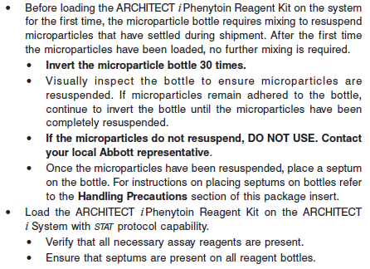

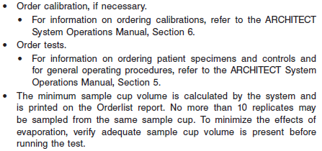

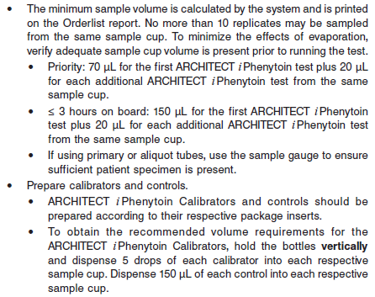

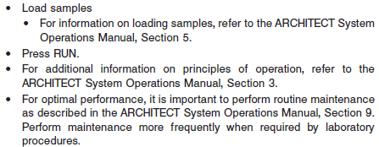

**Results**

The default result unit for the ARCHITECT *i* Phenytoin assay is μg/mL

**Flags**

Some results may contain information in the Flags field. For a description of the flags that may appear in this field, refer to the ARCHITECT System Operations Manual, Section 5.

:

**Specific Performance Characteristics**

**Expected Values**

It is recommended that each laboratory determine its own reference range based upon its particular locale and population characteristics.

**Serum/Plasma:** 10 – 20 μg/mL.

Strong correlations have been shown between phenytoin serum levels for both therapeutic and toxic effects. Clinical observations indicate that toxicity of phenytoin is increased in patients with renal disease. Phenytoin toxicity primarily affects the central nervous system. Toxic levels can lead to nystagmus, vertigo, ataxia, psychoses and even convulsions. Chronic treatment leads to hyperplasia of gums, anemia and osteomalacia. The frequency and severity of dose-dependent toxic effects increases as the serum level rises above 20 μg/mL. Most patients will receive maximum seizure control when serum levels of phenytoin are in the range of 10‑20 μg/mL.

Refer to the drug manufacturer’s package insert or the Physicians’ Desk Reference (PDR) for proper drug dosage and for phenobarbital measurement sampling time.

**Critical Values:** >30 μg/mL for all ages

**Performance Characteristics**

**Measuring Interval (Reportable Range)**

The measurement range of the ARCHITECT *i* Phenytoin assay is 0.50 μg/mL to 40.00 μg/mL.

**Linearity**

See reagent package insert for information.

**Sensitivity**

See Reagent Package insert

**Dilution:**

Specimens with a phenytoin value exceeding 40.00 μg/mL are flagged with the code “>40.00” and may be diluted with the Manual Dilution Procedure.

**•** Manual dilutions should be performed as follows:

**•** The suggested dilution for a phenytoin test is 1:10.

**•** Add 10 μL of the patient specimen to 90 μL of ARCHITECT *i* Phenytoin Calibrator A.

**•** The operator must enter the dilution factor in the Patient or Control order screen. The system will use this dilution factor to automatically calculate the concentration of the sample before dilution. The result (before the dilution factor is applied) should be greater than 0.50 μg/mL.

**•** For detailed information on ordering dilutions, refer to the ARCHITECT System Operations Manual, Section 5.

**Precision:**

The ARCHITECT *i* Phenytoin assay is designed to have an assay precision of ≤ 10% total CV.

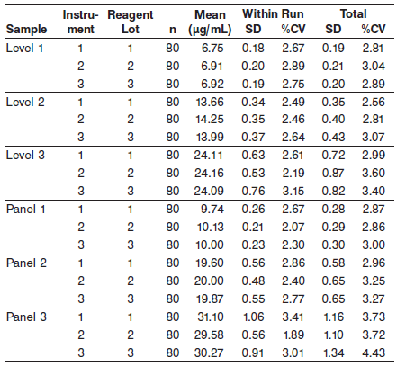

#### Limitations of Procedure

* Specimens from patients who have received preparations of mouse monoclonal antibodies for diagnosis or therapy may contain human anti-mouse antibodies (HAMA). Specimens containing HAMA may produce anomalous values when tested with assay kits that employ mouse monoclonal antibodies.
* Heterophilic antibodies in human serum can react with reagent immunoglobulins, interfering with *in vitro* immunoassays. Patients routinely exposed to animals or to animal serum products can be prone to this interference and anomalous results may be observed. Additional information may be required for diagnosis.
* **Samples from patients receiving fosphenytoin should be drawn at least 2 hours following IV administration and 4 hours following IM administration according to the recommendations of the manufacturer. Phenytoin concentrations measured before complete conversion of fosphenytoin will not reflect phenytoin concentrations ultimately achieved.**

**Interfering Substances**

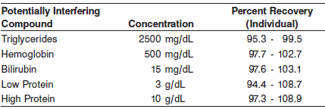

See the reagent package insert for further information on other potentially interfering substances.

**Specificity**

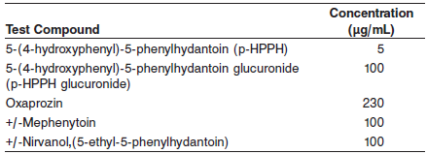

Other Test Compound

Specificity of the assay was determined by spiking fosphenytoin, a phosphate ester of the anti-convulsant phenytoin, into serum specimens at 40 and 60 μg/mL. The average amount of interference observed was 1.0%

**References:**

1. ABBOTT ARCHITECT *i* Phenytoin package insert

Abbott Laboratories

Diagnostics Division

Abbott Park, IL 60064

Nov 2012 F5-Y305-2/R04

1. ABBOTT ARCHITECT *i* Phenytoin Calibrator package insert

Abbott Laboratories

Diagnostics Division

Abbott Park, IL 60064

1. Abbott ARCHITECT Operator’s Guide

**Related Documents:**

**Attachments:**