RUSH logo for emails

***i*THEOPHYLLINE**

**SERUM OR PLASMA**

**ABBOTT ARCHITECT**

**Intended Use**

The ARCHITECT *i* Theophylline assay is an *in vitro* chemiluminescent microparticle immunoassay (CMIA) for the quantitative measurement of theophylline in human serum or plasma on the ARCHITECT iSystem with STAT protocol capability. Theophylline is used in the treatment of bronchospasm associated with bronchial asthma, chronic bronchitis and pulmonary emphysema. The measurements obtained are used in the diagnosis and treatment of theophylline overdose or in monitoring levels of theophylline to help ensure appropriate therapy.

**Clinical Significance**

Theophylline (1,3-dimethylxanthine) is a naturally occurring compound with bronchodilator effects that is used in the treatment of asthma. Because of the narrow therapeutic index and the wide interindividual variability in the rate of theophylline metabolism and clearance, virtually every patient receiving theophylline should have serum concentrations monitored.

**Principle**

The ARCHITECT *i* Theophylline assay is a one-step STAT immunoassay for the quantitative determination of theophylline in human serum or plasma using CMIA technology with flexible assay protocols, referred to as Chemiflex.

1. Sample, anti-theophylline coated paramagnetic microparticles, and theophylline acridinium-labeled conjugate are combined to create a reaction mixture. The anti-theophylline coated microparticles bind to theophylline present in the sample and to the theophylline acridinium-labeled conjugate.

2. After washing, Pre-Trigger and Trigger Solutions are added to the reaction mixture.

3. The resulting chemiluminescent reaction is measured as relative light units (RLUs). There is an indirect relationship between the amount of theophylline in the sample and the RLUs detected by the ARCHITECT iSystem optics. For additional information on system and assay technology, refer to the ARCHITECT System Operations Manual, Section 3.

**Specimen Collection and Handling**

**Suitable Specimens**

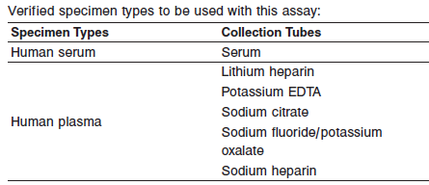

**•** Liquid anticoagulants may have a dilution effect resulting in lower concentrations for individual patient specimens.

Do not use specimens with the following conditions:

**•** heat-inactivated

**•** grossly hemolyzed

**•** obvious microbial contamination

**•** cadaver specimens or body fluids other than human serum or plasma

**Specimen Storage**

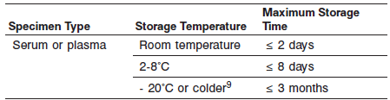

Specimens may be stored on or off the clot or red blood cells for up to two days at room temperature. Specimens removed from the clot or red blood cells may be stored up to eight days at 2-8°C.

**NOTE:** Stored specimens must be inspected for particulates. If present, mix and centrifuge the specimen to remove particulates prior to testing.

**Materials and Equipment Required**

**TEST INSTRUMENT**: Abbott ARCHITECT System

**MATERIALS PROVIDED**

1P29 ARCHITECT *i* Theophylline Reagent Kit

**MATERIALS REQUIRED BUT NOT PROVIDED**

**•** ARCHITECT *i* System

**•** ARCHITECT *i* Theophylline Assay file, may be obtained from:

**•** ARCHITECT *i* System e-Assay CD-ROM found on www.abbottdiagnostics.com

**•** ARCHITECT *i* System Assay CD-ROM

**•** 1P29-01 ARCHITECT iTheophylline Calibrators

**•** Commercially available control material

**•** ARCHITECT *i* Pretrigger

**•** ARCHITECT *i* Trigger

**•** ARCHITECT *i i* Wash Buffer

**•** ARCHITECT *i* Reaction Vessels

**•** ARCHITECT *i* Sample Cups

**•** ARCHITECT *i* Septums

**•** ARCHITECT *i* Replacement Caps

**•** Pipettes or pipette tips (optional) to deliver the specified volumes.

**Reagent Handling and Storage:**

***CAUTION*:**

* For in vitro diagnostic use.

**CAUTION:** This product requires the handling of human specimens.

It is recommended that all human sourced materials be considered

potentially infectious and be handled in accordance with the OSHA

Standard on Bloodborne Pathogens. Biosafety Level 2 or other appropriate biosafety practices should be used for materials that contain or are suspected of containing infectious agents.

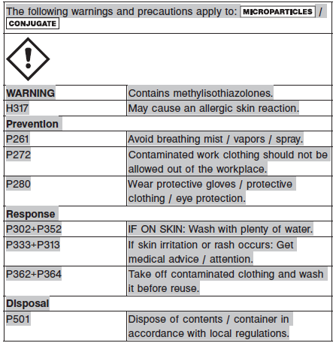

**Reagent Handling**

* Do not use reagent kits beyond the expiration date.
* **Do not pool reagents within a kit or between reagent kits.**
* Before loading the ARCHITECT Reagent Kit on the system for the first time, the microparticle bottle requires mixing to resuspend microparticles that have settled during shipment.
* **Septums MUST be used to prevent reagent evaporation and contamination and to ensure reagent integrity. Reliability of assay results cannot be guaranteed if septums are not used according to the instructions in the package insert.**
* To avoid contamination, wear clean gloves when placing a septum on an uncapped reagent bottle.
* Once a septum has been placed on the reagent bottle, **do not invert the bottle** as this will result in reagent leakage and maycompromise assay results.
* Over time, residual liquids may dry on the septum surface. These are typically dried salts and have no effect on assay efficacy.
* For a detailed discussion of handling precautions during system operation, refer to the ARCHITECT System Operations Manual, Section 7.

**Reagent Storage**

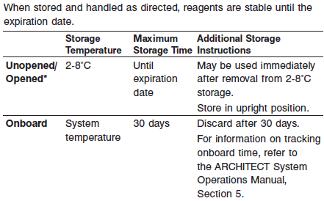

* Reagents may be stored on or off the ARCHITECT *i* System. If reagents are removed from the system, store them at 2-8°C (with septums and replacement caps) in an upright position. For reagents stored off the system, it is recommended that they be stored in their original trays and boxes to ensure they remain upright. **If the microparticle bottle does** **not remain upright (with a septum installed) while in refrigerated** **storage off the system, the reagent kit must be discarded.** For information on unloading reagents, refer to the ARCHITECT System Operations Manual, Section 5.

Reagents

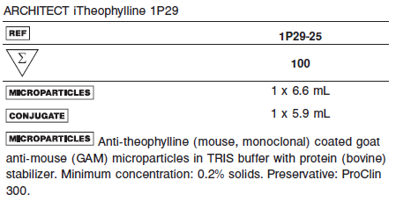 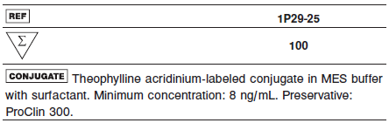

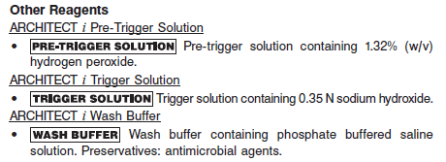

**Calibrator:** 1P29-01 ARCHITECT iTheophylline Calibrators

**Quality Control:** Commercially available controls

**Calibration**

**Frequency:**

Recalibration is required with each new reagent lot number.

**A new calibration is required:**

1. If quality control results do not meet acceptance criteria defined by your laboratory, patient values may be suspect. Follow the established quality control procedures for your laboratory. Recalibration may be necessary.
2. Review quality control results and acceptance criteria following a change of reagent or calibrator lot.

**Calibrator Required:**

1P29-01 ARCHITECT iTheophylline Calibrators

**Reagents:**

6 Bottles (4.0 mL each) of ARCHITECT *i* Theophylline Calibrators. Calibrators A - F contain normal human serum. Calibrators B to F also contain theophylline. Preservative: sodium azide.

**Calibrator Preparation:**

**•** Calibrators may be used immediately after removal from 2-8°C storage. Prior to use, mix by gentle inversion (5-10 times). After each use, tightly close the caps and return the calibrators to 2-8°C storage.

**Calibration Procedure:**

Test calibrators A-F in duplicate. The calibrators should be priority loaded.

A single sample of each control level must be tested to evaluate the assay calibration. Ensure that assay control values are within established ranges.

**•** Calibration Range: 0.0 - 40.0 μg/mL.

.

**Troubleshooting and Overall Acceptance Criteria Failure**

See ARCHITECT Operations Manual for further calibration troubleshooting.

**Quality Control:**

Abbott recommends, refer to your laboratory standard operating procedure(s) and/or quality assurance plan for additional quality control requirements and potential corrective actions:

• At a minimum a single level of quality control are to be run every 24 hours

• If more frequent control monitoring is required, follow the established quality control procedures for your laboratory.

• If quality control results do not meet the acceptance criteria defined by your laboratory, patient values may be suspect. Follow the established quality control procedures for your laboratory.

Recalibration may be necessary.

• Review quality control results and acceptance criteria following a change of reagent or calibrator lot.

**Instrument Procedure**

* The ARCHITECT *i* Theophylline assay is designed for use on the ARCHITECT *i* System with STAT capability from a CD-ROM.
* The ARCHITECT *i* Theophylline assay file must be installed on the ARCHITECT *i* System from an ARCHITECT *i* System Assay CD-ROM prior to performing the assay. For detailed information on assay file installation and on viewing and editing assay parameters, refer to the ARCHITECT System Operations Manual, Section 2.
* For detailed information on assay file installation and viewing and editing assay parameters, refer to the ARCHITECT System Operations Manual, Section 2.
* For information on printing assay parameters, refer to the ARCHITECT System Operations Manual, Section 5.
* For a detailed description of system procedures, refer to the ARCHITECT System Operations Manual.

**Assay Procedure**

For a detailed description of how to run an assay, refer to *Section 5* of the **ARCHITECT System Operations Manual**.

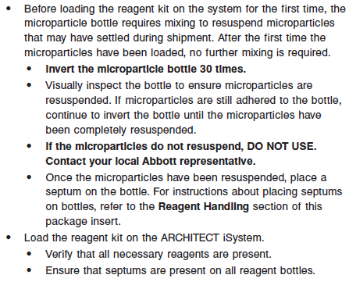

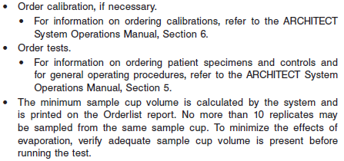

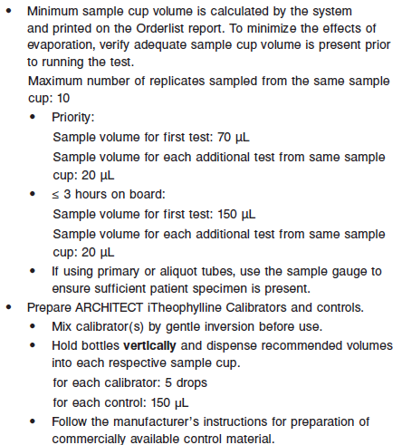

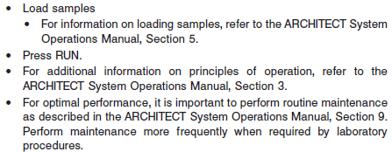

**Results**

The default result unit for the ARCHITECT *i* Theophylline assay is μg/mL

**Flags**

Some results may contain information in the Flags field. For a description of the flags that may appear in this field, refer to the ARCHITECT System Operations Manual, Section 5.

:

**Specific Performance Characteristics**

**Expected Values**

It is recommended that each laboratory determine its own reference range based upon its particular locale and population characteristics.

**Serum/Plasma:** 10.0 – 20.0 μg/mL

Strong correlations have been shown between theophylline serum levels for both therapeutic and toxic effects. In most patients, theophylline serum concentrations of 10 to 20 μg/mL effectively suppress chronic asthmatic and other bronchospastic symptoms. Serum concentrations of 5 to 10 μg/mL theophylline reportedly control apneic spells in neonates without causing apparent side effects. Peak concentrations above 20 μg/mL are often associated with toxicity. Adverse effects associated with serum concentrations above 20 μg/mL include nausea, headache, diarrhea, and at higher levels, vomiting, gastrointestinal bleeding, seizures and cardiac arrhythmias. Refer to the drug manufacturer’s package insert or the Physicians’ Desk Reference (PDR) for proper drug dosage and for theophylline measurement sampling time.

For effective treatment, some patients may require theophylline levels outside these ranges. Therefore, this information is provided only as a guide, and individual patient results should be interpreted in light of other clinical signs and symptoms.

**Critical Values:** > 20.0μg/mL

**Performance Characteristics**

**Measuring Interval (Reportable Range)**

The measurement range for the ARCHITECT *i* Theophylline assay is 0.05 μg/mL to 40 μg/mL.

**Linearity**

See reagent package insert for information.

**Sensitivity**

See Reagent Package insert

**Dilution:**

Specimens with a theophylline value exceeding 40.0 μg/mL are flagged with the code “>40.0” and may be diluted with the Manual Dilution Procedure.

**Manual Dilution Procedure**

Suggested dilution: 1:2

1. Add 100 μL of the patient specimen to 100 μL of ARCHITECT *i* Theophylline Calibrator A.

2. The operator must enter the dilution factor in the Patient or Control order screen. The system will use this dilution factor to automatically calculate the concentration of the sample before dilution and report the result.

For detailed information on ordering dilutions, refer to the ARCHITECT

System Operations Manual, Section 5.

**Precision:**

The ARCHITECT iTheophylline assay is designed to have an assay precision of ≤ 10% total CV

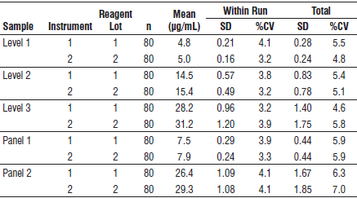

#### Limitations of Procedure

* Specimens from patients who have received preparations of mouse monoclonal antibodies for diagnosis or therapy may contain human anti-mouse antibodies (HAMA). Specimens containing HAMA may produce anomalous values when tested with assay kits that employ mouse monoclonal antibodies.
* Heterophilic antibodies in human serum can react with reagent immunoglobulins, interfering with *in vitro* immunoassays. Patients routinely exposed to animals or to animal serum products can be prone to this interference and anomalous results may be observed. Additional information may be required for diagnosis.
* Some immunoassays may cross-react with metabolites, which can lead to a positive bias in patient results. Refer to the following **Specificity** section for estimates of cross-reactivity of ARCHITECT iTheophylline to some metabolites of theophylline.

**Interfering Substances**

Potential interference in the ARCHITECT *i* Theophylline assay from the following compounds is designed to have a mean recovery of 100 +/- 10% of the control results at the levels indicated.

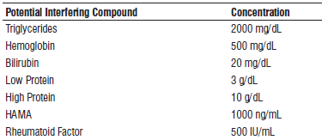

See the reagent package insert for further information on other potentially interfering substances.

**Specificity**

The specificity of the ARCHITECT *i* Theophylline assay is designed to have a cross-reactivity concentration less than 0.82 μg/mL when tested with the compounds listed in the following table.

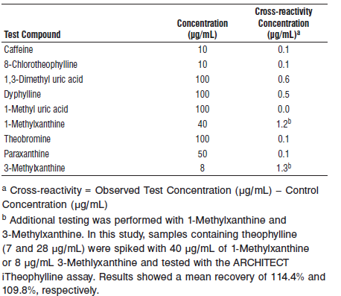

**References:**

1. ABBOTT ARCHITECT *i* Theophylline package insert

Abbott Laboratories

Diagnostics Division

Abbott Park, IL 60064

Dec 2014 G5-1251/R05

1. ABBOTT ARCHITECT *i* Theophylline Calibrator package insert

Abbott Laboratories

Diagnostics Division

Abbott Park, IL 60064

1. Abbott ARCHITECT Operator’s Guide

**Related Documents:**

**Attachments:**